MARY
MANAGEMENT AND RESOURCES YIELD

User Manual
Construction ERP — complete guide for every role
Marquez Project Solutions LLC
www.marquezprojectsolutions.com

Contents
1. Welcome to MARY 5
1.1 What this manual covers 5
1.2 The idea behind MARY 5
1.3 Two languages, one system 6
2. Getting started 7
2.1 Signing in 7
2.2 The first time you sign in 7
2.3 The screen at a glance 8
The sidebar 8
The header 9
2.4 Notifications 9
2.5 Changing your language 10
2.6 Light and dark mode 10
3. Roles and permissions 11
3.1 The roles 11
3.2 What each role can open 11
4. Projects 13
4.1 Creating a project 13
The fields 14
4.2 Project statuses 15
4.3 Opening a project 15
4.4 Deleting a project 15
5. Budget 16
5.1 How a budget is structured 16
5.2 Adding budget lines 16
5.3 The three cost components 16
5.4 Indirect cost 17
5.5 The budget summary 17
5.6 Importing a budget from Excel 18
6. Budgeted Materials 19
6.1 Adding a budgeted material 19
6.2 Reading the columns 19
7. Purchases 21
7.1 How the flow works 21
7.2 Raising a purchase request 21
7.3 Request statuses 22
7.4 Creating and approving a purchase order 23
7.5 Printing 23
8. Inventory 25
8.1 Catalog 25
8.2 Entries — receiving material 25
8.3 Exits — issuing material 26
8.4 Movements 27
8.5 Correcting a mistake 28
9. Change Orders 29
9.1 Raising a change order 29
Two kinds of change line 29
9.2 The approval path 30
10. Valuations 31
10.1 Creating a valuation 31
10.2 Reading a valuation 32
10.3 How the money is built up 32
11. Financial 34
11.1 Contingencies 34
11.2 Payroll 34
11.3 Subcontracts 35
Setting up a contract 36
Subcontractor valuations 36
Retention and payment orders 36
11.4 Equipment 36
11.5 Administration 37
11.6 Petty Cash 38
Opening a fund 38
Recording expenses 39
Settling and closing 39
12. S Curve 40
12.1 Reading the chart 40
12.2 Deviations by activity 40
13. Reports 42
13.1 The four reports 42
13.2 About the Excel files 44
14. Chat 45
15. Settings 46
15.1 Company users 46
Adding someone 46
Editing, permissions and deactivating 46
15.2 Deletion requests 47
15.3 My account 47
15.4 Subscription 48
16. Audit Log 50
17. Everyday workflows 51
17.1 Starting a new project (Administrator or Coordinator) 51
17.2 Getting material to the crew (Site Supervisor → Warehouse Manager) 51
17.3 Closing the month (Accountant) 51
17.4 Billing the owner (Manager or Administrator) 52
17.5 Handling a scope change (Manager or Coordinator) 52
18. Troubleshooting 53
18.1 Common questions 53
18.2 Good habits 53
19. Glossary 54

1. Welcome to MARY
MARY is the system your company uses to run construction projects — from the first budget line to the last invoice to the owner. Everything your team records in the field flows into the same place, so the budget, the warehouse, the purchase orders and the financial reports always agree with each other.
The name stands for Management And Resources Yield.

1.1 What this manual covers
This manual walks through every screen in MARY, in the order you are most likely to use them. It is written for everyone on the project team, so some chapters will not apply to your role — the system only shows you the modules your role is allowed to open. Chapter 3 explains which role sees what.
Every screenshot in this manual was taken from a working MARY account with sample project data, so what you see here is what you will see on your own screen.

1.2 The idea behind MARY
Most construction companies keep the budget in one spreadsheet, the warehouse in another, purchase orders in a folder, and the real cost in the accountant's head until month-end. MARY replaces that with a single chain where each step feeds the next:
Step | What happens | Where it lives
1. Plan | You break the job into stages, sub-stages and activities, and price each activity. | Budget
2. Forecast materials | You say how much of each material each activity should consume. | Budgeted Materials
3. Ask | The field asks for material against a specific activity. | Purchases → Requests
4. Buy or issue | MARY checks the warehouse. What is in stock is issued; what is missing becomes a purchase order. | Purchases → POs
5. Receive and consume | The warehouse logs what arrives and what goes out to the field. | Inventory
6. Cost | Payroll, subcontracts, equipment and overhead are recorded against the same activities. | Financial
7. Compare | Budget versus real cost, cumulative, over time. | S Curve
8. Bill | You bill the owner for the progress actually completed. | Valuations

THE GOLDEN RULE
Everything in MARY hangs off a project, and almost everything hangs off a budget activity inside that project. If you take the time to build the budget properly at the start, every other screen fills itself in as the job runs.

1.3 Two languages, one system
MARY works in English and Spanish. The language is a personal setting, not a company setting: each person picks their own and sees the whole interface in it. Two people can look at the same purchase order at the same time, one in English and one in Spanish. Section 2.5 shows how to switch.

2. Getting started

2.1 Signing in
Open your company's MARY address in a web browser. There is nothing to install — MARY runs in Chrome, Edge, Firefox or Safari, on a desktop, a laptop or a tablet.
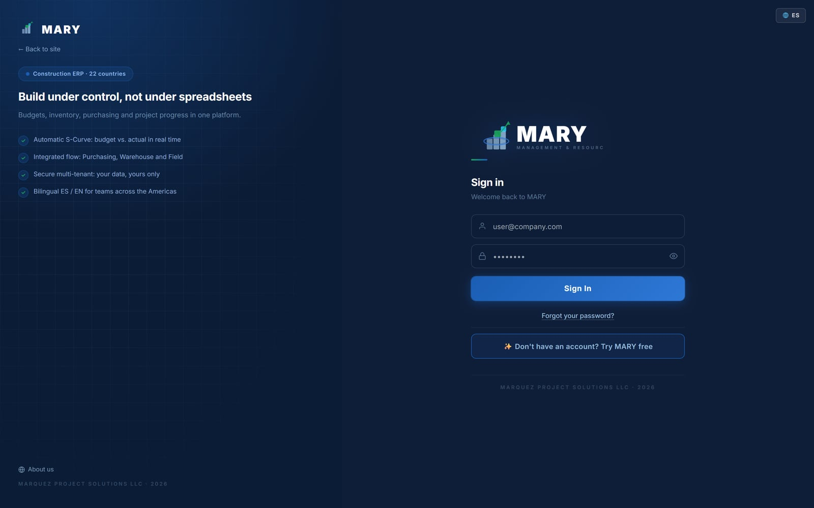
Figure 1. The sign-in screen. Use the ES / EN switch in the corner if the page opens in the wrong language.
- Type the email address your administrator registered for you.
- Type your password.
- Click Sign In.

If you have forgotten your password, click Forgot your password? MARY emails you a six-digit code, you enter the code, and then you choose a new password. Passwords must be at least 8 characters.
TIP
MARY detects the language of your browser the first time you arrive, so if your computer is set to English the sign-in page already appears in English. Once you choose a language it is remembered for your account on any device.

2.2 The first time you sign in
The very first time anyone opens MARY, a short welcome tour introduces the main modules. You can step through it or skip it — it will not appear again.
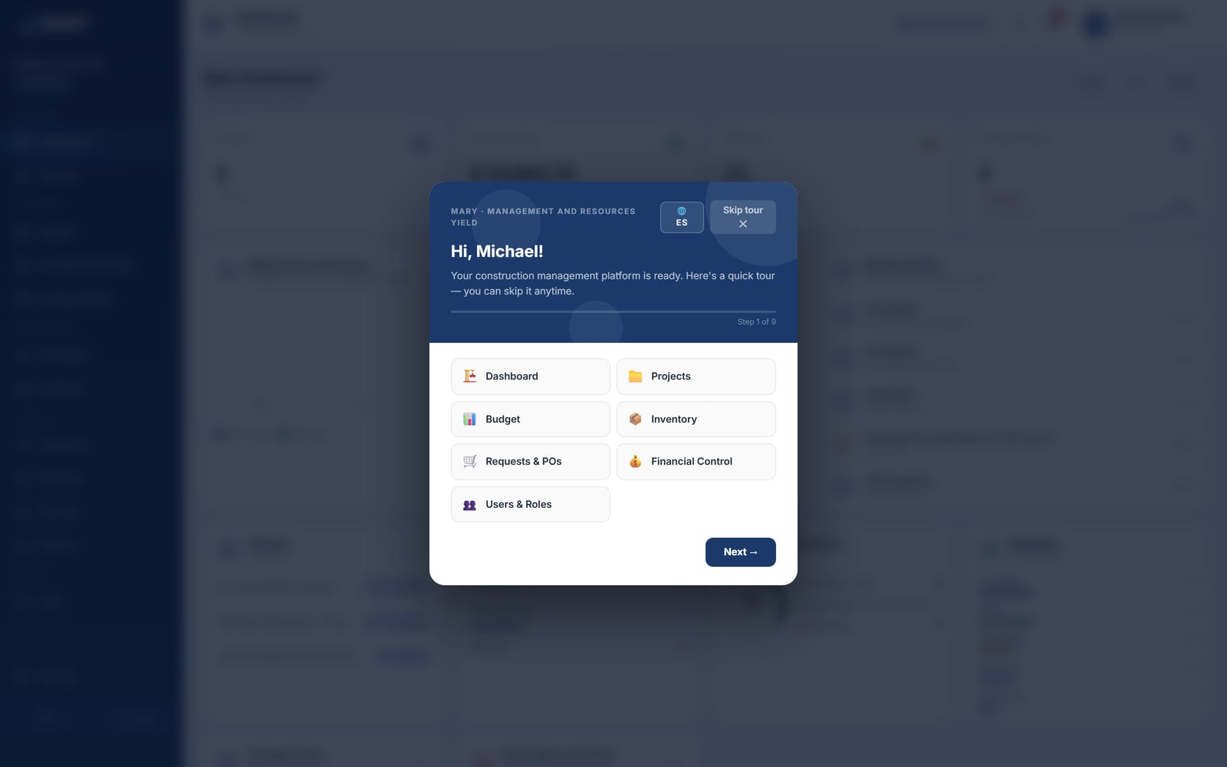
Figure 2. The welcome tour. Click Skip tour to go straight to the Dashboard.

2.3 The screen at a glance
Every screen in MARY has the same three parts, so once you learn one you can find your way around all of them.
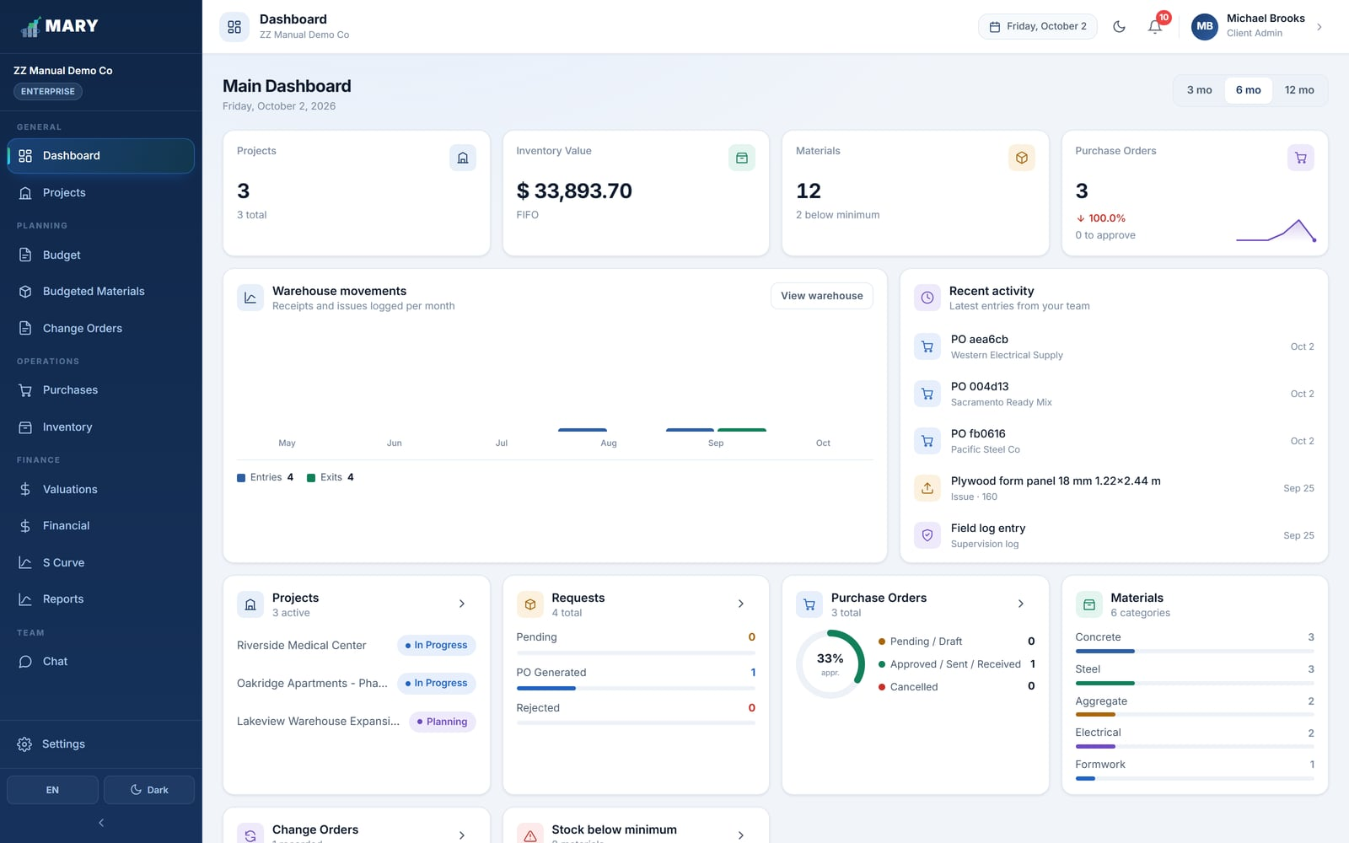
Figure 3. The Dashboard, with the sidebar on the left and the header across the top.

The sidebar
The dark column on the left is how you move between modules. It is grouped by the kind of work you are doing:
Group | Modules | Who mostly uses it
General | Dashboard, Projects | Everyone
Planning | Budget, Budgeted Materials, Change Orders | Manager, Coordinator
Operations | Purchases, Inventory | Site Supervisor, Warehouse Manager
Finance | Valuations, Financial, S Curve, Reports | Accountant, Manager, Administrator
Team | Chat | Everyone

Your company name and current plan appear at the top of the sidebar. Settings sits at the bottom, and below it are the two switches for language and for light/dark mode. The small arrow at the very bottom collapses the sidebar to icons only, which is useful on a small screen.

The header
Across the top you will find, from left to right: the name of the module you are in, today's date, the light/dark switch, the notification bell, and your own name and role. Clicking your name opens a menu with Settings and Sign out.

2.4 Notifications
The bell in the header turns red with a number when something needs your attention — a new purchase request, a purchase order that was approved or rejected, a valuation that was signed off. Click it to see the list, and click any item to jump straight to the record it refers to.
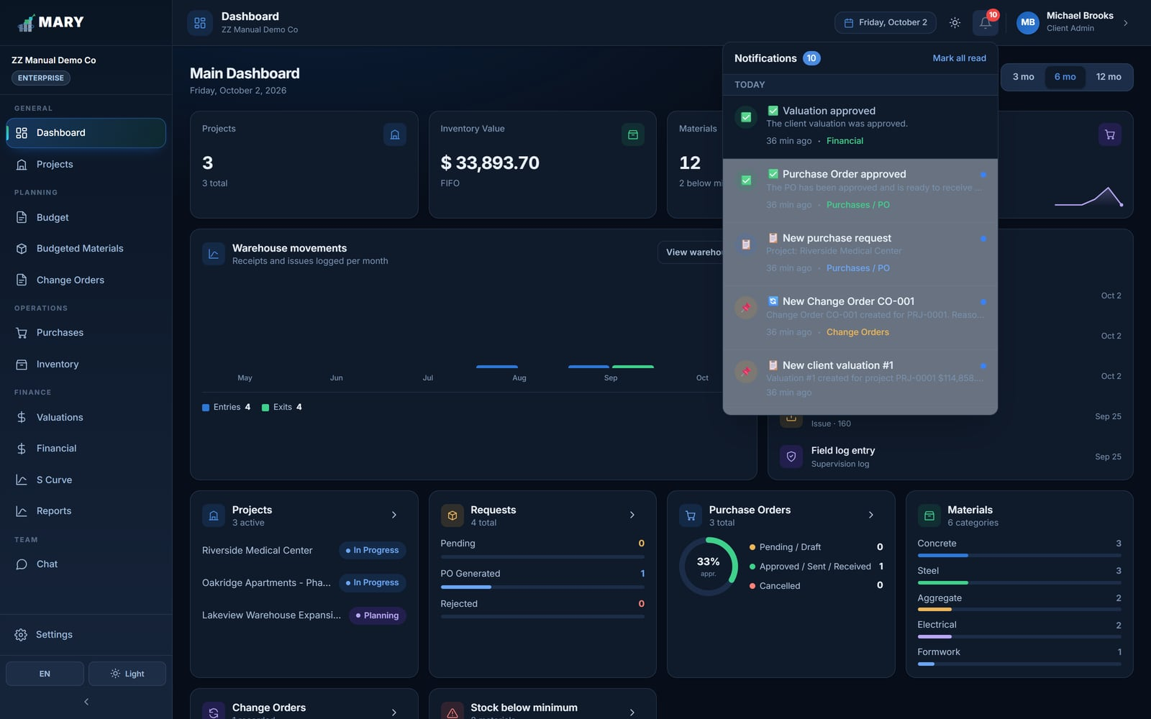
Figure 4. The notification panel, grouped into Today, Yesterday and Earlier.
Notifications are stored for each person, so you only ever see the ones meant for your role. Reading one marks it as read and clears it from the counter.

2.5 Changing your language
There are two ways to switch between English and Spanish, and both do the same thing:
- Click the ES / EN button at the bottom of the sidebar.
- Go to Settings → My account and choose the language there.

The change applies immediately to the whole interface and is saved to your account, so it follows you to any computer you sign in from. It does not affect anyone else on your team.
WHAT DOES NOT GET TRANSLATED
The language setting changes MARY's own labels, buttons and reports. It does not translate the text your team types in — a material description entered in Spanish stays in Spanish for everyone. Agree with your team on one language for data entry.

2.6 Light and dark mode
The sun/moon switch at the bottom of the sidebar (and in the header) toggles between a light and a dark appearance. This is purely personal preference and has no effect on your data or your printouts.
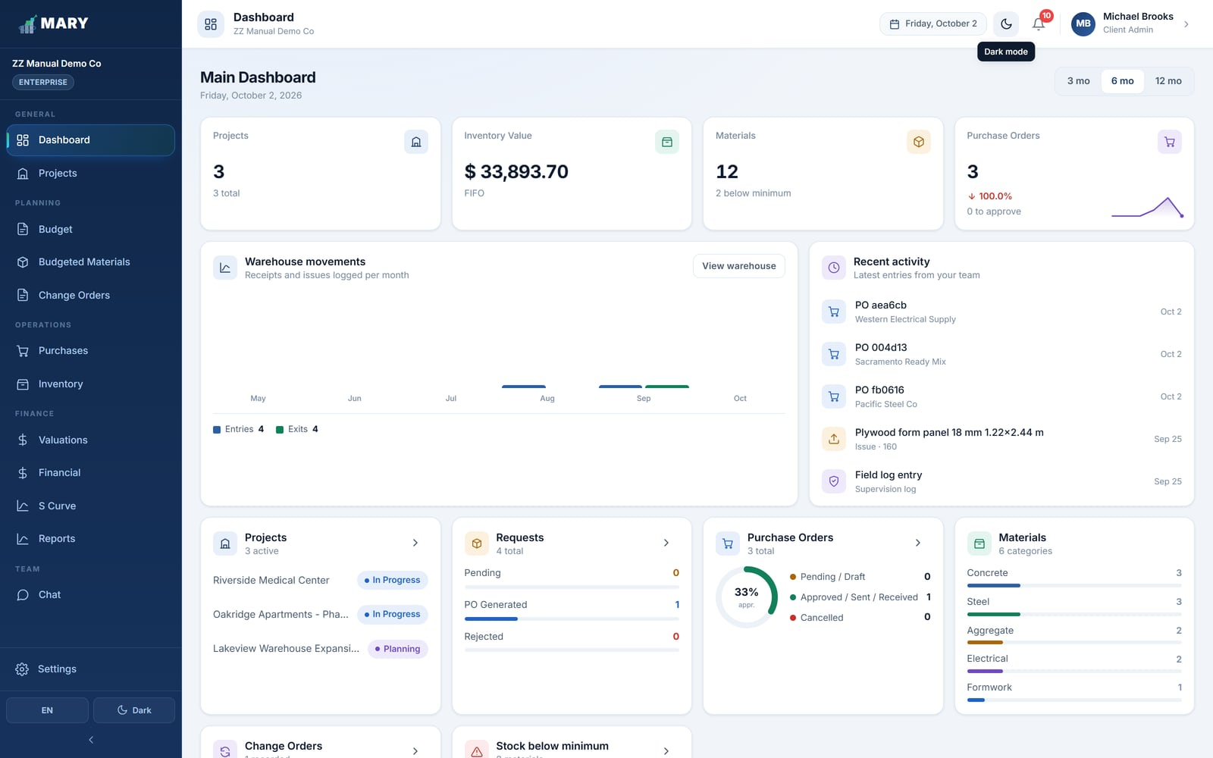
Figure 5. The same Dashboard in dark mode.

3. Roles and permissions
MARY decides what you can see and do based on the role your administrator gave you. Modules you are not allowed to open simply do not appear in your sidebar, so you will never be stopped by an error message after clicking something.

3.1 The roles
Role | Typical job title | What this role is for
Administrator | Owner, Project Director | Full access to everything, including users, billing and the audit log. Approves purchase orders and change orders.
Project Coordinator | Planner, Estimator | Builds and maintains budgets, budgeted materials and change orders across projects. Does not touch the warehouse or payroll.
Project Manager | Construction Manager | Oversees budget, purchasing, finances and the S Curve. Can create purchase orders.
Site Supervisor | Superintendent, Resident Engineer | Raises material requests from the field, records costs and progress for the jobs they run.
Warehouse Manager | Storekeeper | Runs the material catalog, receives deliveries and issues material to the field.
Accountant | Controller, Bookkeeper | Records payroll, subcontracts, equipment and overhead, and pulls the financial reports.
Read Only | Owner's rep, Auditor | Can look at everything they are given access to, but cannot change anything.

3.2 What each role can open
A tick means the module appears in that role's sidebar. "View" means they can open it but not change anything in it.
Module | Admin | Coord. | Manager | Site Sup. | Warehouse | Account. | Read Only
Dashboard | ✓ | ✓ | ✓ | ✓ | ✓ | ✓ | ✓
Projects | ✓ | ✓ | View | Own | Own | View | View
Budget | ✓ | ✓ | ✓ | — | — | View | View
Budgeted Materials | ✓ | ✓ | View | — | — | View | View
Purchases | ✓ | ✓ | ✓ | ✓ | ✓ | View | View
Inventory | ✓ | — | View | — | ✓ | View | View
Change Orders | ✓ | ✓ | ✓ | ✓ | — | View | View
Valuations | ✓ | ✓ | View | ✓ | — | View | View
Financial | ✓ | — | ✓ | ✓ | — | ✓ | View
S Curve | ✓ | ✓ | ✓ | — | — | ✓ | View
Reports | ✓ | ✓ | ✓ | — | — | ✓ | —
Audit Log | ✓ | — | — | — | — | — | —
Settings (users) | ✓ | — | — | — | — | — | —
Chat | ✓ | ✓ | ✓ | ✓ | ✓ | ✓ | ✓

"Own" means the person only sees the projects they have been assigned to, rather than every project in the company.
PER-PERSON EXCEPTIONS
Beyond the role, an administrator can grant or remove individual permissions for one person — for example, letting one Site Supervisor also approve purchase orders. See section 15.1.

4. Projects
A project in MARY behaves like a small company of its own: it has its own budget, its own warehouse movements, its own staff costs and its own profit and loss. Nothing can be recorded in MARY without belonging to a project, so this is always the first thing you create.
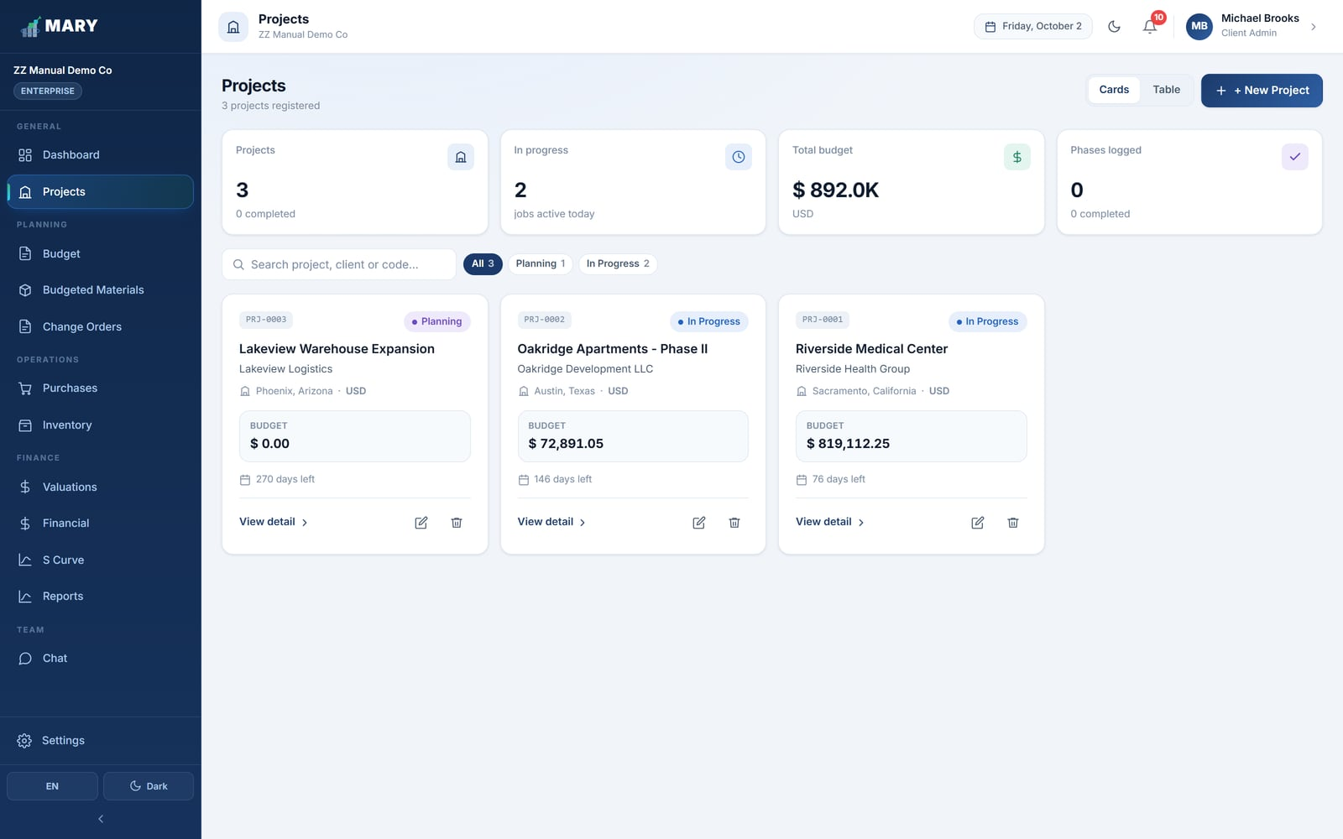
Figure 6. The Projects screen in card view, with a status filter across the top.
Use the Cards / Table buttons to switch between the two views. The table view is better when you have many projects and want to compare them.
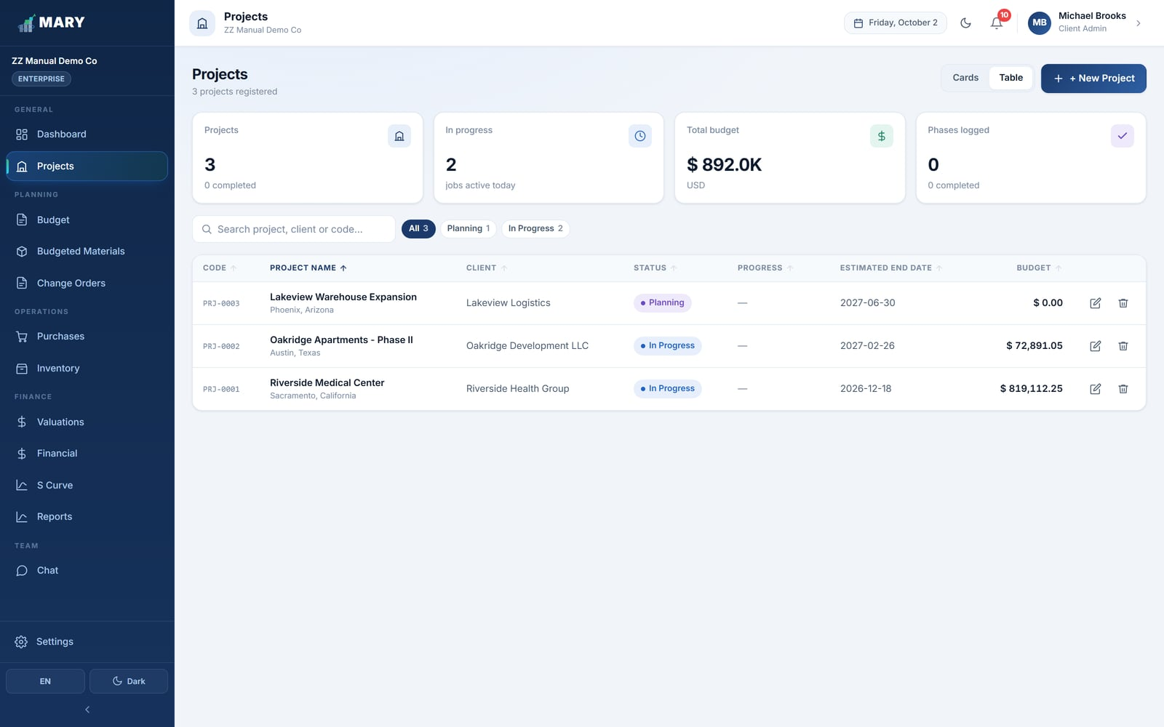
Figure 7. The same projects in table view.

4.1 Creating a project
- Click + New Project.
- Fill in the form (the fields are explained below).
- Click Save.

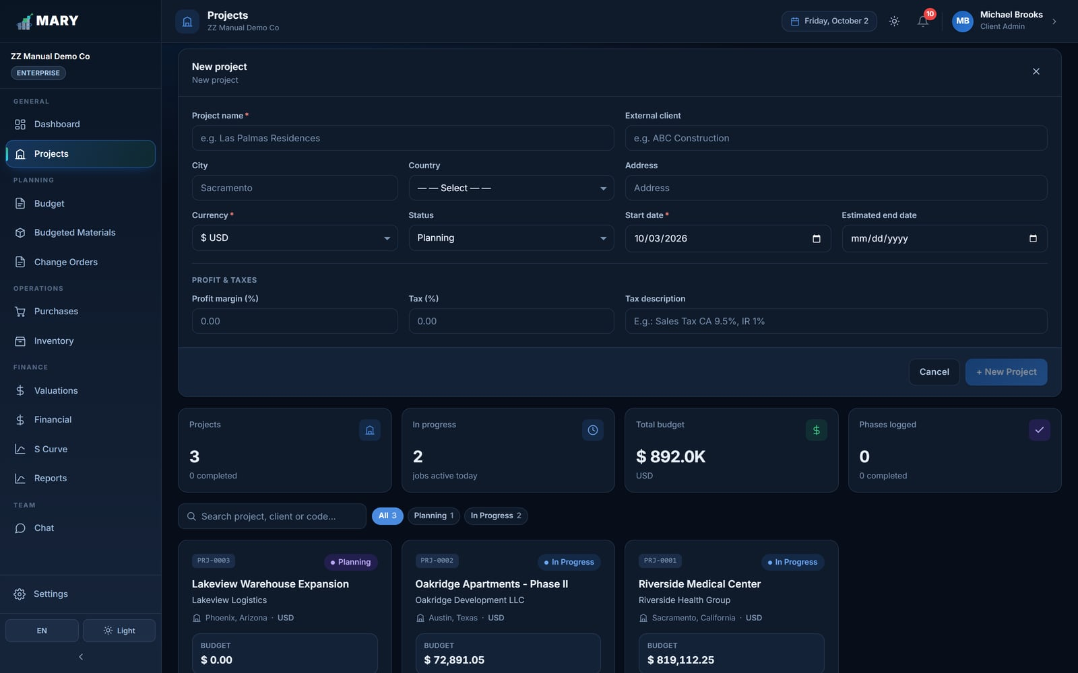
Figure 8. The new project form.

The fields
Field | What to put in it
Project name | How your team refers to the job, e.g. "Riverside Medical Center".
External client | The owner you are building for. This name appears on valuations and change orders.
City / State / Country | Where the job is. Choosing the country sets the currency automatically; if the country is the United States, a State field appears.
Address | Street address of the site. Optional, but it prints on the purchase request form the warehouse uses.
Currency | Every amount on this project is in this currency. Set it before you start entering money.
Status | Planning, In Progress, On Hold, Completed or Cancelled.
Start / Estimated end date | Drives the time axis of the S Curve.
Profit margin (%) | Your markup. Added on top of cost when MARY works out what to bill the owner.
Tax (%) and description | Sales tax or VAT, and what to call it on printed documents.
Indirect cost (%) | Overhead as a percentage of direct cost. See section 5.4.

SET THE CURRENCY FIRST
The currency cannot be changed meaningfully once costs have been entered, because MARY does not convert existing amounts. Decide it when you create the project.

4.2 Project statuses
Status | What it means
Planning | Being estimated. The budget is still being built and no real cost is expected yet.
In Progress | Under construction. This is the status that counts as "active" on the Dashboard.
On Hold | Temporarily stopped. Records stay, nothing is deleted.
Completed | Finished. Kept for reporting and history.
Cancelled | Abandoned. Use this to archive a project you cannot delete.

4.3 Opening a project
Click View detail on any project card to see a summary: client, location, dates, direct budget, indirect cost, profit and tax, plus the phases of the job.
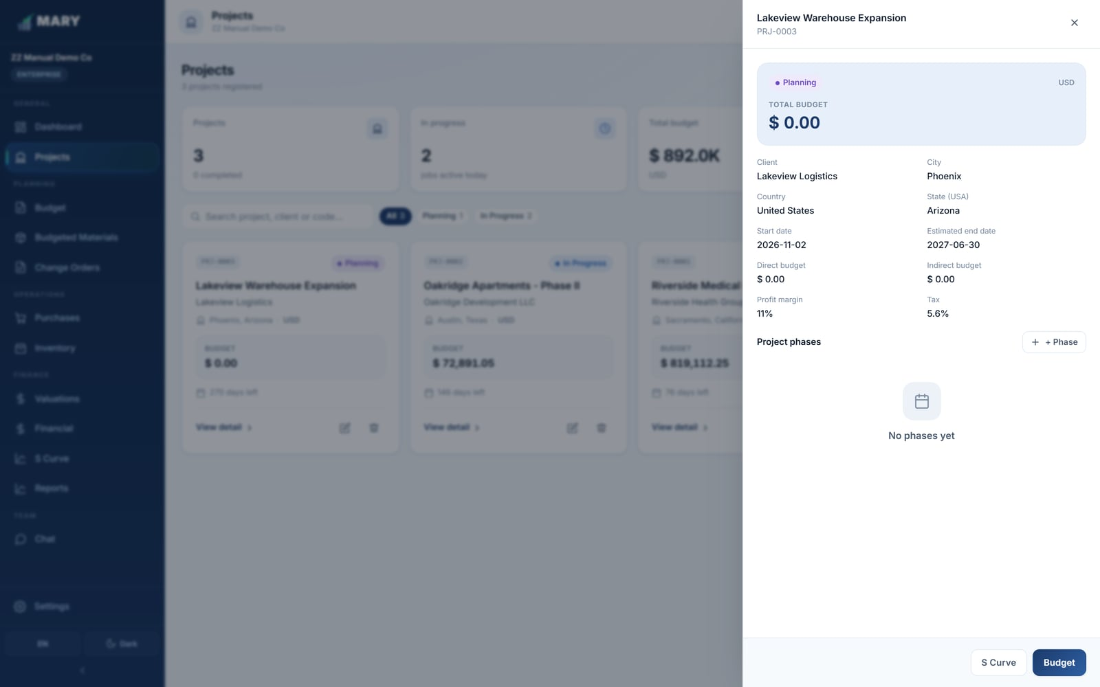
Figure 9. Project detail, with the summary panel and the phase list.

4.4 Deleting a project
MARY will not let you delete a project that has data attached to it. If you try, it tells you exactly which modules are holding records — budget lines, material entries, purchase orders, payroll, and so on.
INSTEAD OF DELETING
In almost every case the right move is to set the project status to Cancelled rather than delete it. That keeps the history and the audit trail intact while taking the project out of your active lists.

5. Budget
The budget is the backbone of the whole system. Every cost you record later, every material you issue and every dollar you bill the owner points back to a line in this screen.
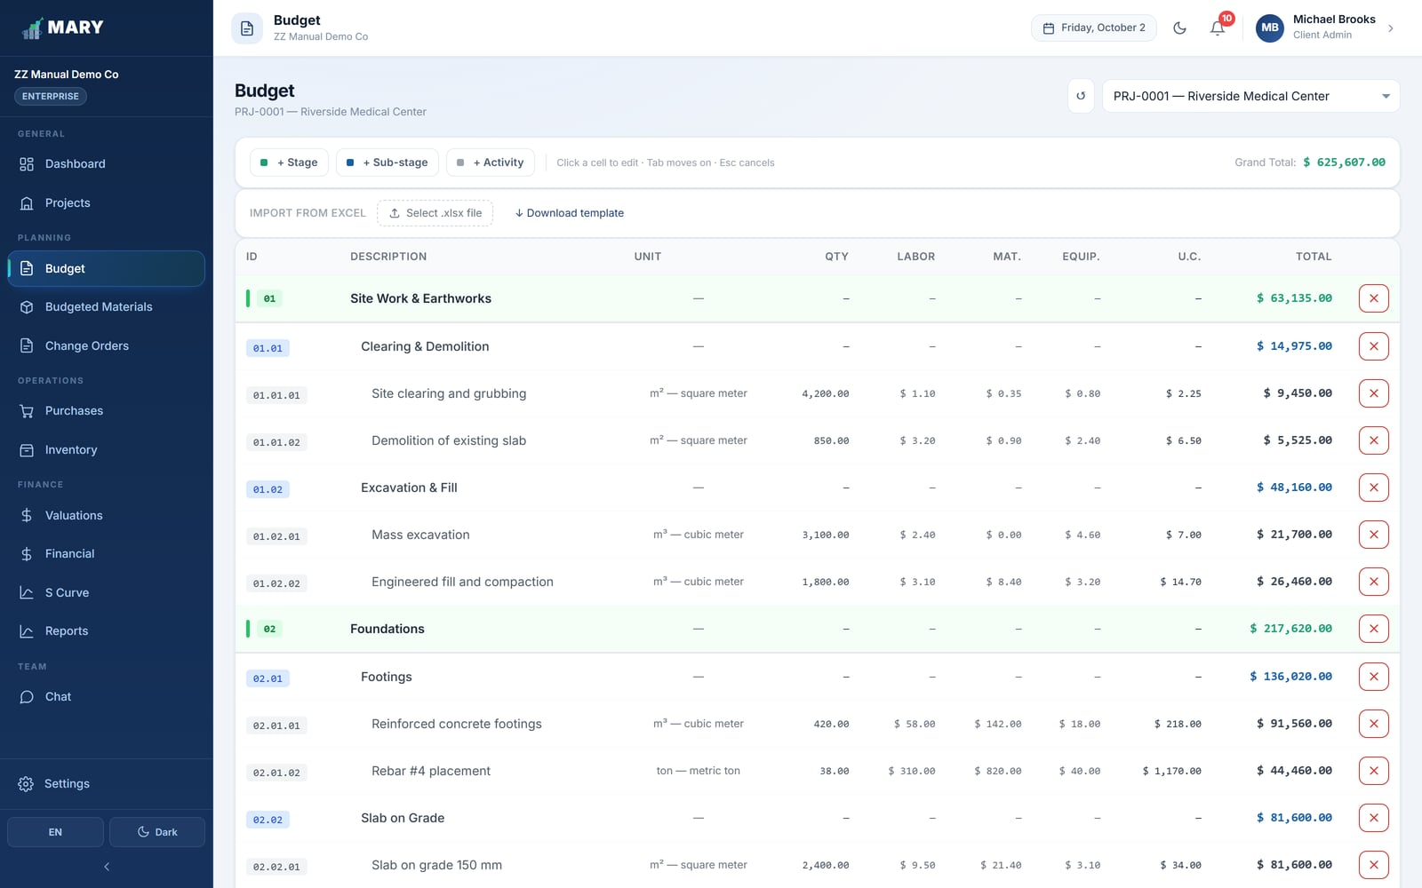
Figure 10. The Budget screen: a three-level tree of stages, sub-stages and activities.

5.1 How a budget is structured
MARY uses three levels. You can go straight from a stage to activities if you do not need the middle level.
Level | Example | Carries a price?
Stage | 01 — Site Work & Earthworks | No. It totals up what is under it.
Sub-stage | 01.02 — Excavation & Fill | No. It totals up its activities.
Activity | 01.02.01 — Mass excavation | Yes. This is where quantity and cost live.

Codes are generated for you as you add items, so the numbering always stays consistent.

5.2 Adding budget lines
- Choose the project at the top of the screen.
- Click + Stage and give it a name, e.g. "Foundations".
- With the stage selected, click + Sub-stage if you want a middle level.
- Click + Activity and fill in the unit, the quantity and the three cost components.

5.3 The three cost components
Each activity is priced per unit, split three ways. MARY adds them to get the unit cost, then multiplies by the quantity.
Component | What belongs here
Labor | The crew hours needed to produce one unit of the activity.
Materials | The material consumed to produce one unit.
Equipment | Machine time — excavators, pumps, cranes — per unit.

THE ARITHMETIC
Unit cost = Labor + Materials + Equipment. Line total = Unit cost × Quantity. The Grand Total at the bottom of the screen is the sum of every activity line — stages and sub-stages are only containers and never add a cost of their own.

You can edit any number directly in the grid, the way you would in a spreadsheet: click the cell, type, and press Enter or Tab to move on.

5.4 Indirect cost
Indirect cost — site offices, supervision salaries, insurance, permits, portable restrooms — is everything you spend to run the job that is not tied to one activity. MARY handles it in one of two ways:
- As a percentage. You enter an indirect cost percentage on the project and MARY keeps the pot at that percentage of the direct cost. If the direct cost changes, the pot recalculates itself.
- As a fixed amount. You leave the percentage empty and simply list what you expect to spend by category. The total is the sum of those lines.

Either way you can break the pot down by category — Project Administration, Facilities & General Services, Insurance Bonds & Guarantees, Professional & Legal Services, and Petty Cash. MARY shows you how much of the pot you have allocated and how much is still free, and warns you if the categories add up to more than the pot.
THE PETTY CASH CATEGORY IS SPECIAL
The amount you budget under Petty Cash is what limits the size of the petty cash fund you can open in Financial (section 11.6). Budget it before you try to open a fund, and note that you cannot reduce it below what has already been handed out.

5.5 The budget summary
At the bottom of the screen MARY totals everything up in the order an estimator would:
Line | How it is worked out
Direct cost | Sum of all activity lines.
Indirect cost | The overhead pot, either the percentage or the sum of the categories.
Subtotal | Direct + indirect.
Profit | Subtotal × the profit margin set on the project.
Grand total | Subtotal + profit. This is your contract value before tax.
Total with taxes | Grand total + tax.

5.6 Importing a budget from Excel
If your estimate already exists in a spreadsheet you do not have to retype it. Click Download template on the Budget screen, paste your lines into the template, and upload it. MARY shows you what it read before anything is saved, so you can correct the file and try again if the columns did not line up.

6. Budgeted Materials
The budget says how much money each activity should cost. Budgeted Materials says how much of each physical material that activity should consume — 2,100 bags of cement for the footings, 1,800 lengths of rebar for the cages. It is what turns "we are over budget" into "we are over budget because the slab ate 20% more cement than we allowed".
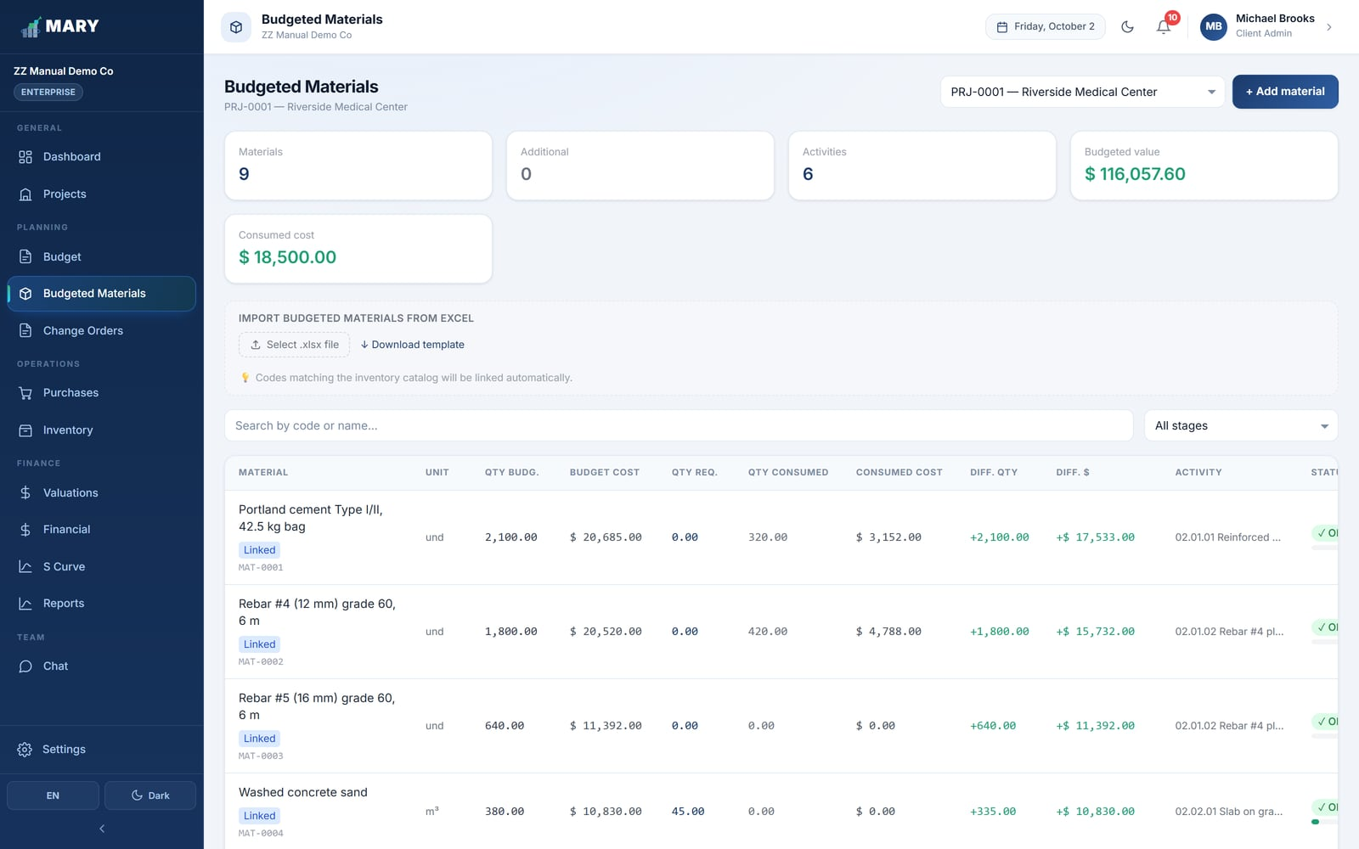
Figure 11. Budgeted Materials, comparing what was planned against what has actually been consumed.

6.1 Adding a budgeted material
- Pick the project.
- Click + Add material.
- Choose the activity the material belongs to.
- Either pick an item from the inventory catalog, or type a free name if it is not catalogued yet.
- Enter the budgeted quantity and the unit cost.

LINK TO THE CATALOG WHEN YOU CAN
If you link the line to a catalog item, MARY can track consumption automatically every time the warehouse issues that material. A free-text line has to be followed manually.

6.2 Reading the columns
Column | Meaning
Qty budg. | What you planned to consume.
Qty req. | What the field has asked for so far, through purchase requests.
Qty consumed | What has actually left the warehouse against this activity.
Diff. qty / Diff. $ | Budgeted minus consumed, in units and in money. Negative means you have overrun.
Status | OK while there is margin, Alert as you approach the budgeted quantity, Depleted once you pass it.

Lines added part-way through the job that were never in the original estimate can be flagged as Additional, so you can tell genuine scope growth apart from an estimating miss.

7. Purchases
This module covers the whole path from "the crew needs material" to "the purchase order is approved". It has two tabs: Requests and Purchase Orders.

7.1 How the flow works
This is the part of MARY that saves the most time, so it is worth understanding properly. When a request is submitted, MARY checks the warehouse stock for every line and sorts each one into one of three routes:
Route | When MARY picks it | What happens next
In Warehouse | The full quantity is already in stock. | No purchase order. The request goes to the Warehouse Manager to issue the material.
PO Required | None of it is in stock. | A purchase order is raised for the whole quantity.
Split | Part is in stock, part is not. | MARY splits the line: the warehouse issues what it has, and a purchase order covers the shortfall.

WHY THIS MATTERS
Nobody has to walk to the warehouse to check stock before raising a request, and nobody buys material the company already owns. The split case is handled automatically — the requester sees both halves on the same request.

7.2 Raising a purchase request
This is normally done by the Site Supervisor.
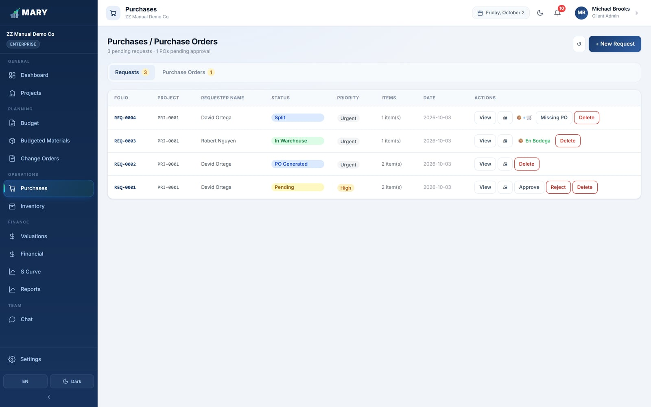
Figure 12. The Requests tab, showing each request with its folio, project and status.
- Open Purchases and make sure you are on the Requests tab.
- Click + New Request.
- Choose the project and the activity the material is for.
- Fill in your name, position and department — these print on the request form the warehouse signs.
- Set the required date and the priority (Normal, High or Urgent).
- Add each material with + Add item. Pick it from the catalog, or tick the box to add a brand-new material.
- Write a justification — one line explaining why it is needed.
- Click Submit request.

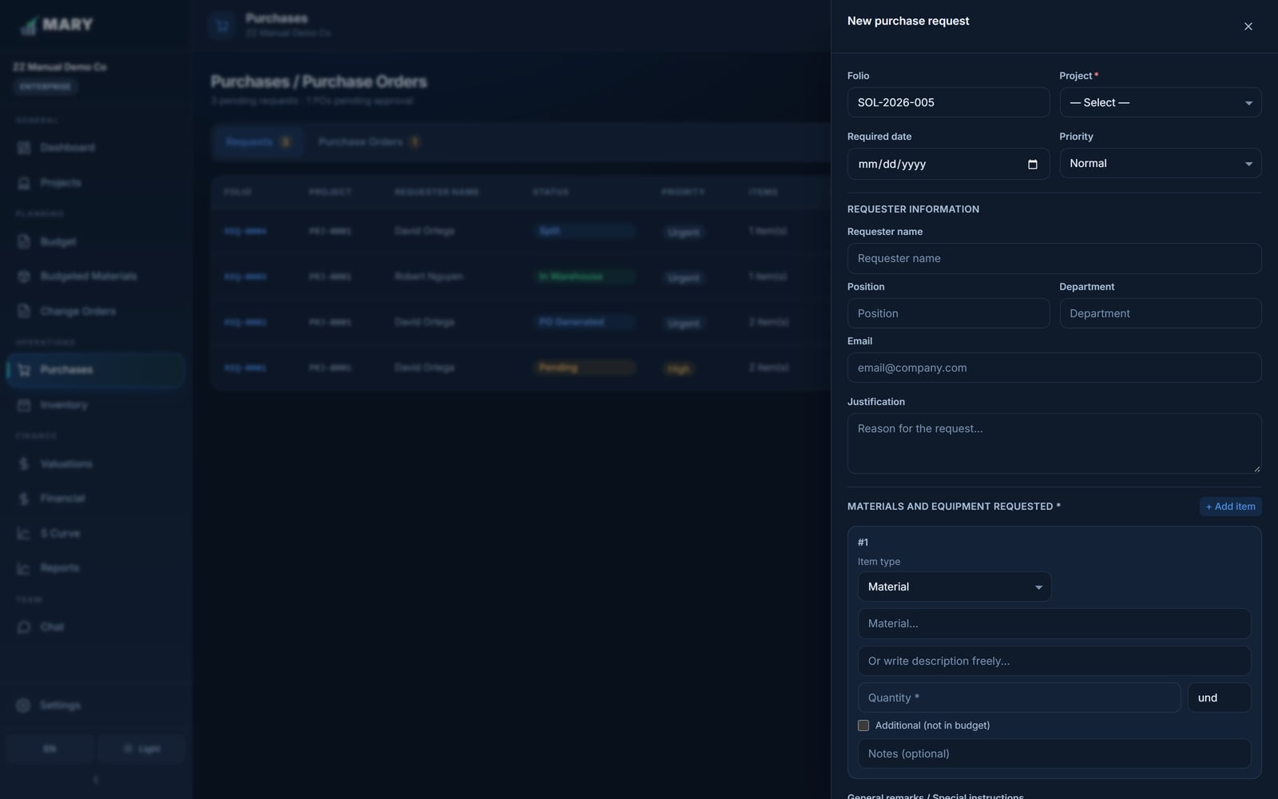
Figure 13. The new request form, with one line per material.
REQUESTING RENTED EQUIPMENT
Switch an item's type from Material to Rented equipment and you can enter the start date, end date and daily rate instead of a quantity. Equipment never passes through the warehouse — once the purchase order is approved, MARY posts it straight into Financial → Equipment.

7.3 Request statuses
Status | What it means
Pending | Submitted, waiting to be reviewed.
In Warehouse | Stock is available; waiting for the warehouse to issue it.
Pend. PO | Waiting for a purchase order to be raised.
Split | Part from the warehouse, part on a purchase order.
PO Generated | A purchase order exists for this request.
Partial | Some lines delivered, some still open.
Completed | Everything has been delivered or issued.
Rejected / Voided | Turned down, or cancelled before being fulfilled.

7.4 Creating and approving a purchase order
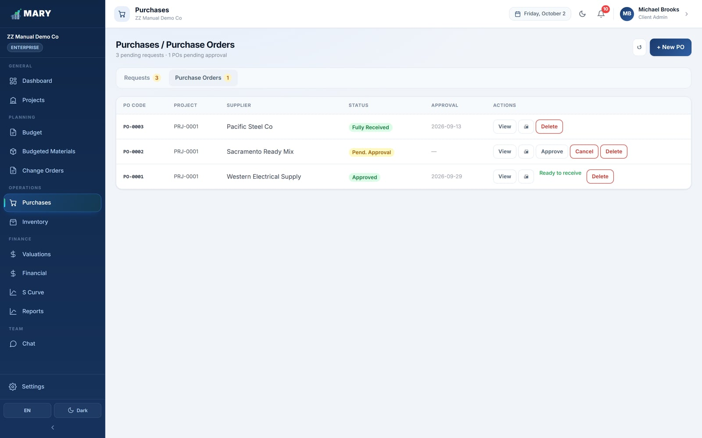
Figure 14. The Purchase Orders tab.
- Go to the Purchase Orders tab and click + New PO — or click Generate PO directly on a request, which copies the lines across.
- Enter the supplier.
- Choose the payment terms: Cash, 15 / 30 / 45 / 60 days credit, or Other.
- Check the unit prices and set the tax percentage.
- Click Save PO. It is created as Pending approval.
- An Administrator (or a Manager with the right permission) reviews it and approves or rejects it.

Once approved, the purchase order is ready for the warehouse to receive against. MARY notifies the people who need to know at each step.
PURCHASE ORDER STATUSES
Draft → Pending approval → Approved → Partial Receipt → Fully Received. A purchase order can also be Rejected or Cancelled. The warehouse can only receive material against an Approved purchase order.

7.5 Printing
Both requests and purchase orders have a Print button that produces a formal document on your company letterhead, with the folio number, the requester, the approver and signature blocks. This is the copy the warehouse and the supplier sign.

8. Inventory
Inventory is the warehouse: what you own, what came in, what went out, and what it is worth. It has four tabs.

8.1 Catalog
The catalog is the master list of every material your company handles. A material is created once and then used by every project.
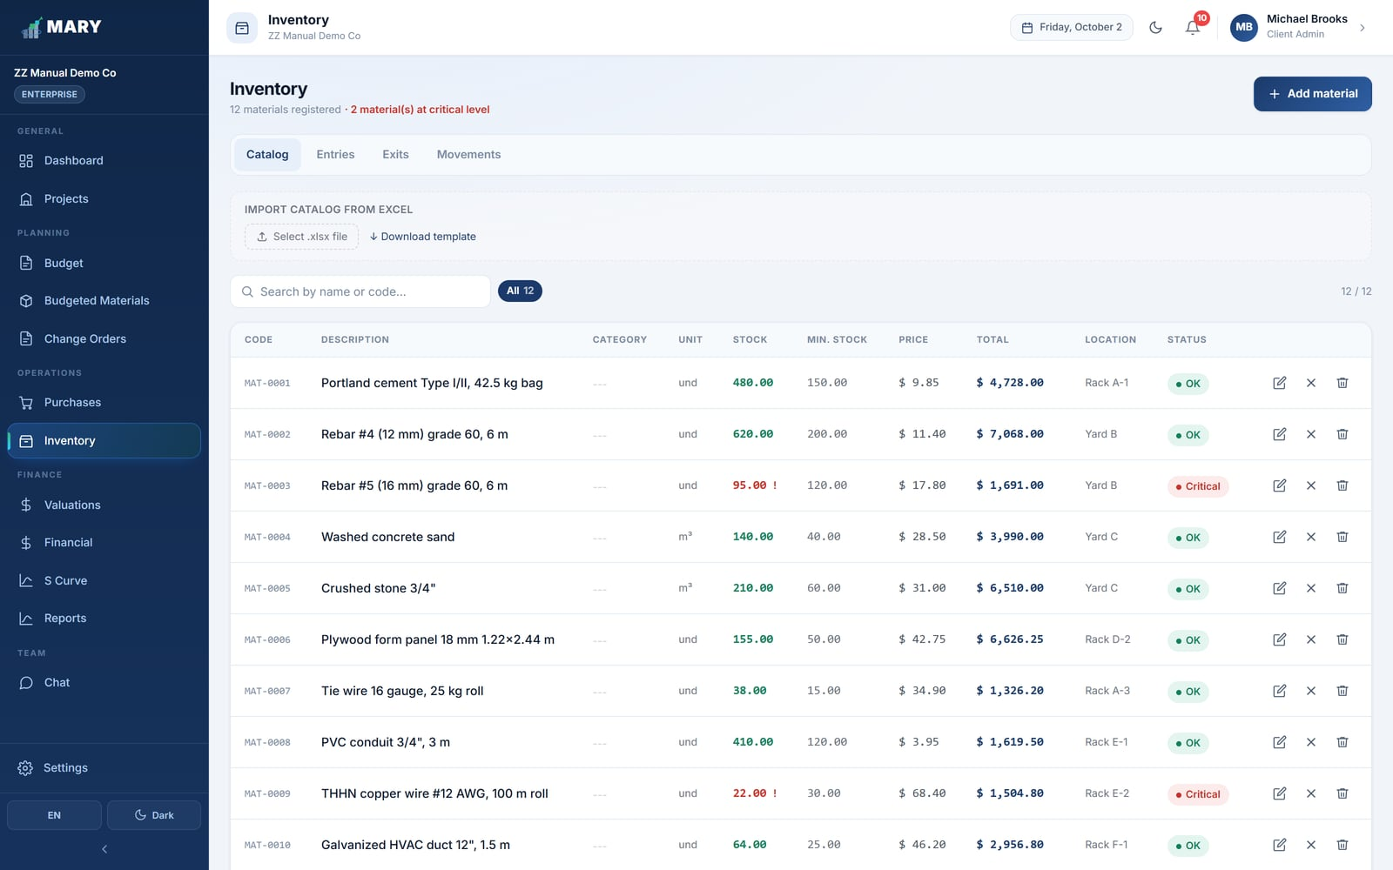
Figure 15. The material catalog. Items below their minimum stock are flagged Critical.
Field | What it is for
Code | Your internal reference, e.g. MAT-0001. Must be unique — MARY refuses duplicates.
Description | What the item actually is. Be specific: "Portland cement Type I/II, 42.5 kg bag" beats "cement".
Unit | How you count it. Pick from the standard list (m², m³, kg, und, gal, LF, ft³ and so on).
Category | Groups the catalog for reporting — Concrete, Steel, Electrical, and so on.
Warehouse location | Where to physically find it: "Rack A-1", "Yard B".
Minimum stock | The level at which MARY starts warning you. Set it to roughly your reorder point.

BULK LOADING THE CATALOG
The Catalog tab has an Import from Excel panel. Download the template, fill it in, and upload — far quicker than adding hundreds of materials one at a time.

8.2 Entries — receiving material
An entry records material arriving at the warehouse. Every entry raises the stock and feeds the FIFO valuation.
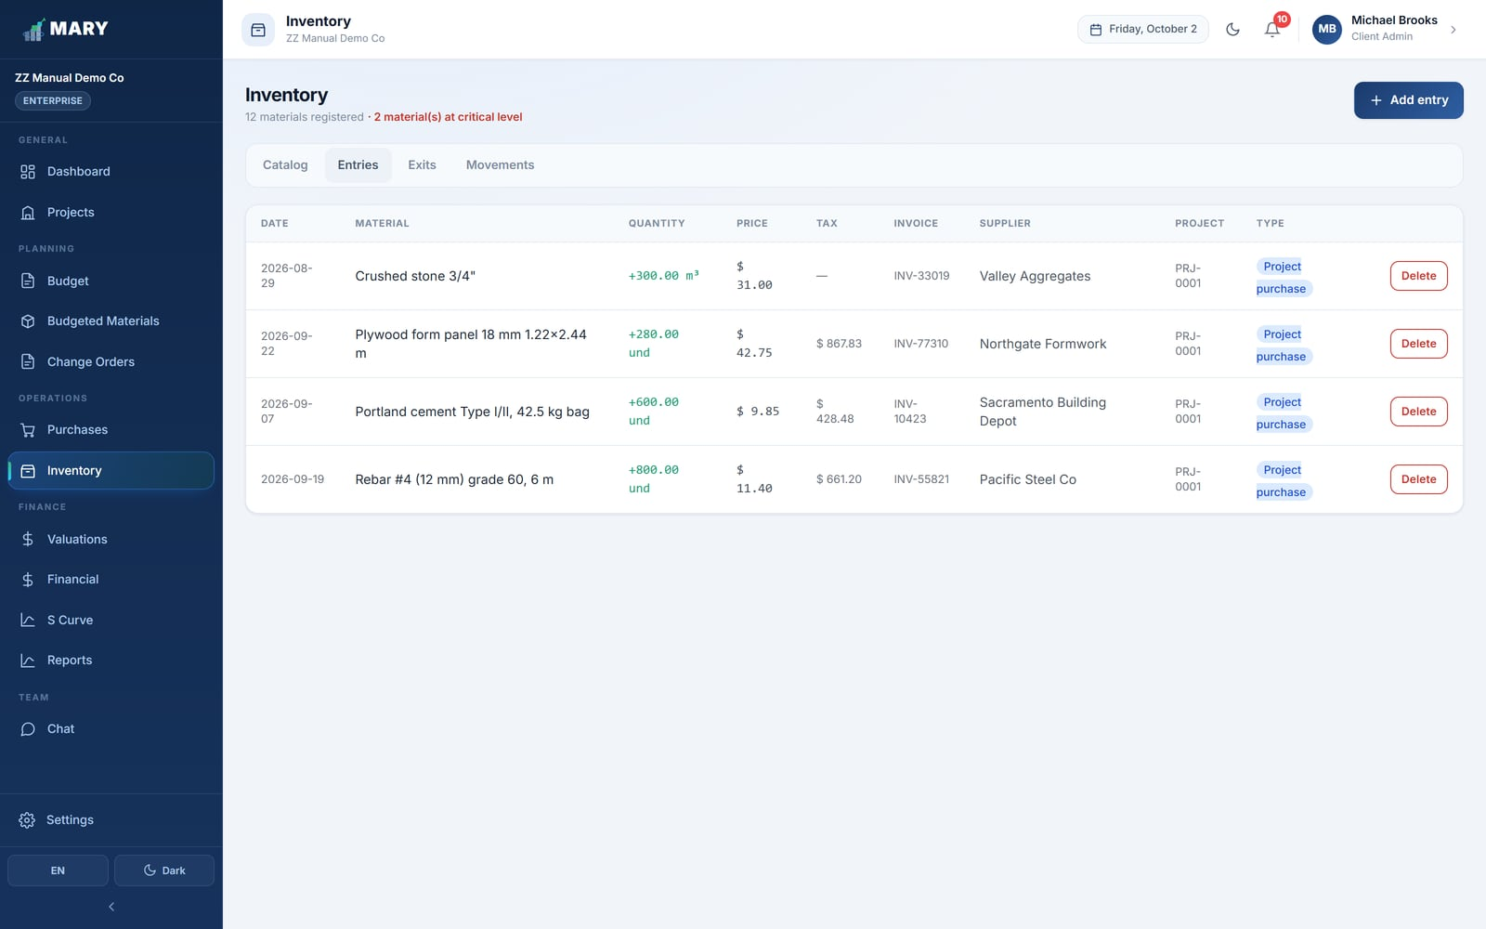
Figure 16. Material entries, each with its supplier, invoice and unit price.
- Open the Entries tab and click Add entry.
- Pick the material.
- Link the purchase order if the delivery came against one. This is what closes the loop back to Purchases.
- Enter the quantity, the unit price actually invoiced, the invoice number and the supplier.
- Set the reception date and save.

PRICE MATTERS
Always enter the real invoiced price, not the budgeted one. MARY values your stock FIFO — first in, first out — so the price on each entry determines what the material costs the project when it is later issued.

8.3 Exits — issuing material
An exit records material leaving the warehouse for the field. This is the moment a material becomes a project cost.
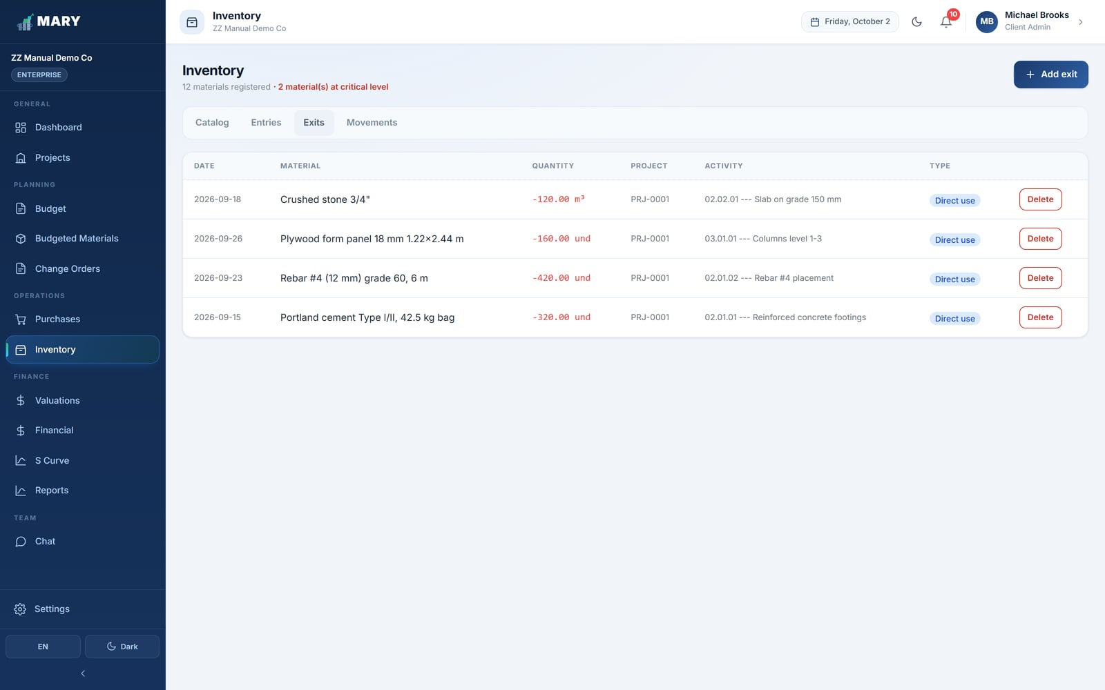
Figure 17. Material exits, each charged to a project and an activity.
- Open the Exits tab and click Add exit.
- Pick the material. MARY shows the stock available and will not let you issue more than you have.
- Choose the project and then the budget activity the material is being consumed by.
- Enter the quantity and the exit date, and save.

ALWAYS PICK THE RIGHT ACTIVITY
The activity you choose here is what makes Budgeted Materials, the S Curve and every cost report meaningful. Issuing material against the wrong activity quietly corrupts your cost tracking, and it is tedious to unpick later.

Two special cases are worth knowing:
- Surplus from another project. Material left over elsewhere can be moved in at no cost to the receiving project.
- General reserve. Stock bought centrally rather than for one job can be issued without charging a cost to the project.

8.4 Movements
The Movements tab is a single chronological ledger of every entry and exit together, which is the quickest way to answer "what happened to this material?".
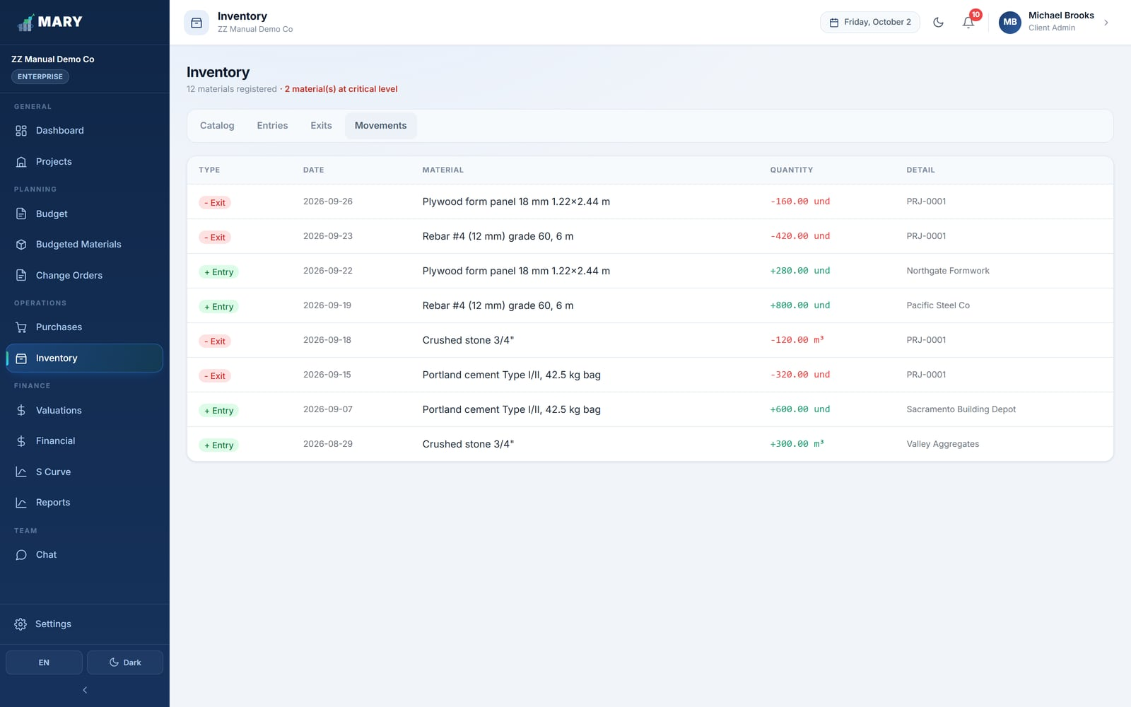
Figure 18. The combined movements ledger.

8.5 Correcting a mistake
Deleting warehouse records is deliberately restricted, because an entry that has already been issued against underpins real cost figures.
- If you delete an entry that later exits depend on, MARY warns you and offers either to delete the entry together with the affected exits, or the entry alone.
- A material that still has stock cannot be deleted from the catalog at all. Issue or write off the stock first, or simply deactivate the item.
- Warehouse Managers cannot delete records outright. They raise a deletion request with a justification, and an Administrator approves or rejects it — see section 15.2.

9. Change Orders
A change order records a formal change to the contract: the owner asks for something extra, the drawings were wrong, or a quantity turns out to be bigger than estimated. Rather than quietly editing the original budget — which would destroy your ability to measure your own estimating — MARY keeps the change as a separate, numbered, approved document.
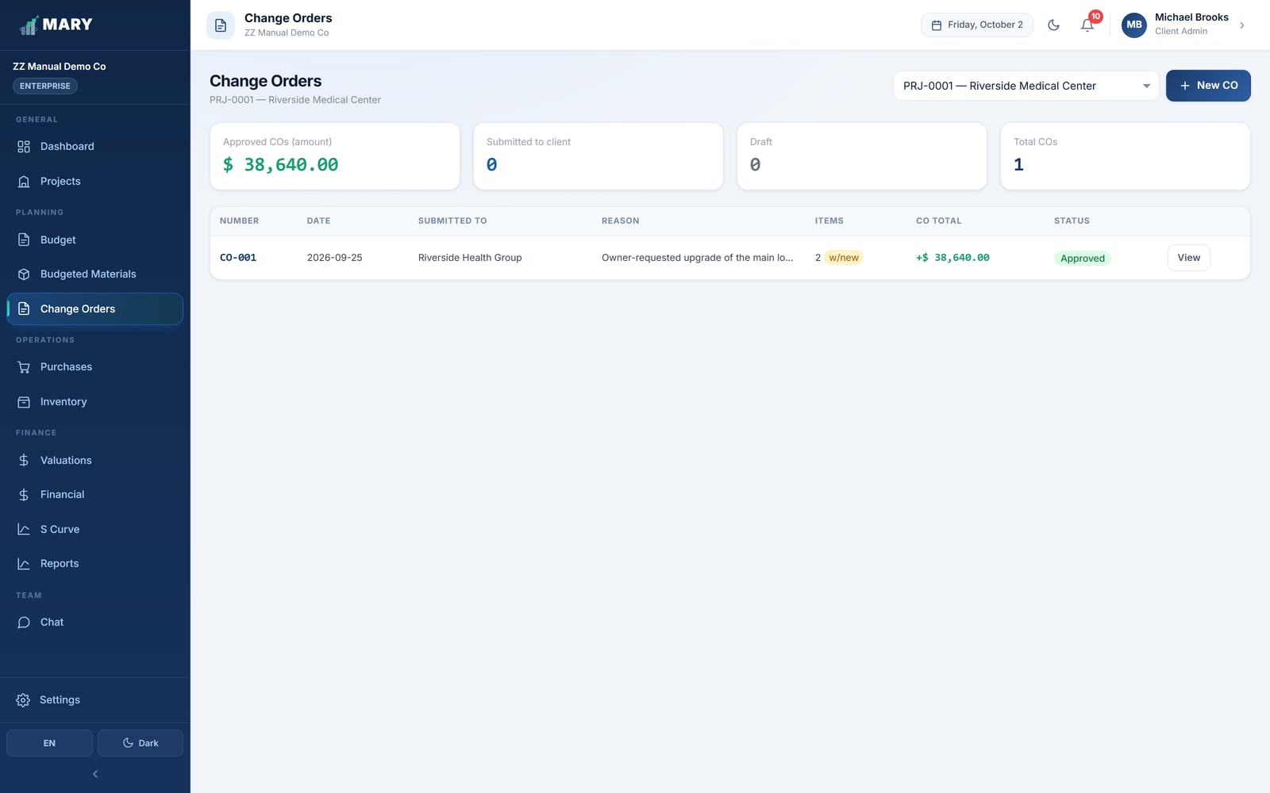
Figure 19. The Change Orders screen with totals by status.

9.1 Raising a change order
- Choose the project.
- Click + New CO.
- Give it a number (CO-001, CO-002…) and a date.
- Enter who it is submitted to — the owner's representative or the supervising engineer.
- Write the reason. Be specific; this is the text that justifies the claim.
- Add the changes, one line each.
- Add extra calendar days if the change extends the schedule.
- Click Save CO.

Two kinds of change line
Type | Use it when | What you enter
Existing activity | The quantity of work already in the budget changes. | Pick the activity; MARY shows the original quantity and you type the new one. It works out the difference.
New activity | The change introduces work that was never in the budget. | Describe it, set the unit, quantity and the three cost components, and choose where it sits in the budget tree.

9.2 The approval path
Status | Meaning
Draft | Being prepared internally. Nothing has been sent to the owner.
Submitted | Presented to the owner, awaiting their decision.
Approved | Accepted. The change is applied to the project budget.
Rejected | Turned down. The budget is untouched; the record is kept.

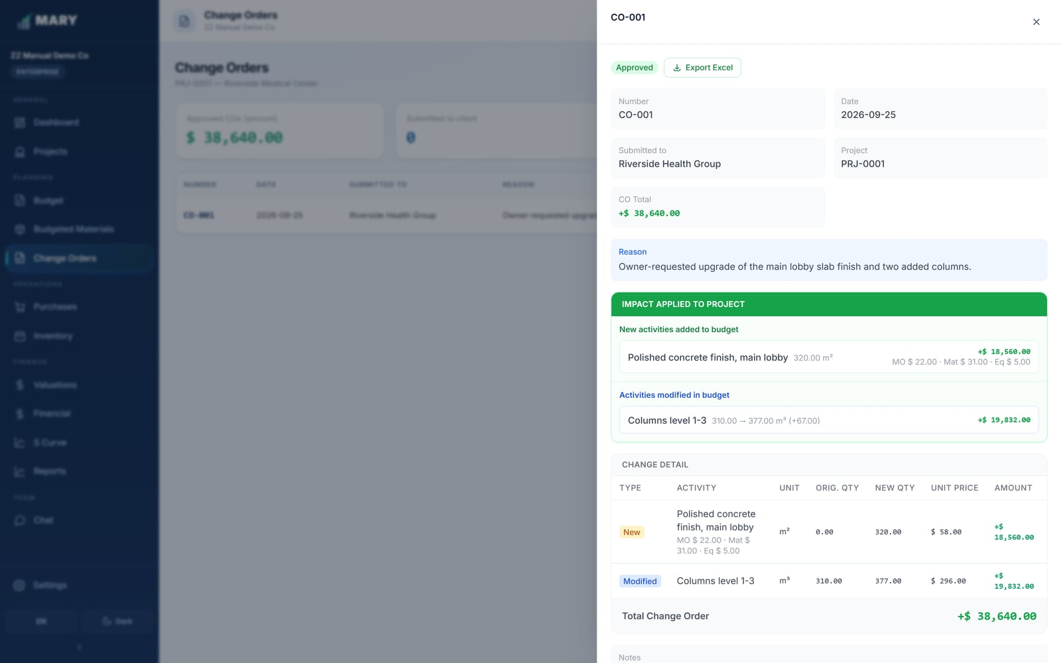
Figure 20. A change order in detail, line by line.
APPROVAL CHANGES THE BUDGET
The moment a change order is marked Approved, MARY applies it to the budget: quantities on existing activities are updated and new activities are inserted. Reports from then on compare against the revised budget, while the S Curve and the Reports module still let you see the original. Do not approve a change order until the owner really has approved it.

10. Valuations
A valuation is your progress billing to the owner: for this period, here is the work completed, here is what it comes to, here is what you owe us. MARY builds it from the same budget activities you have been tracking all along, so the amount you bill and the amount you have spent are always measured against the same lines.
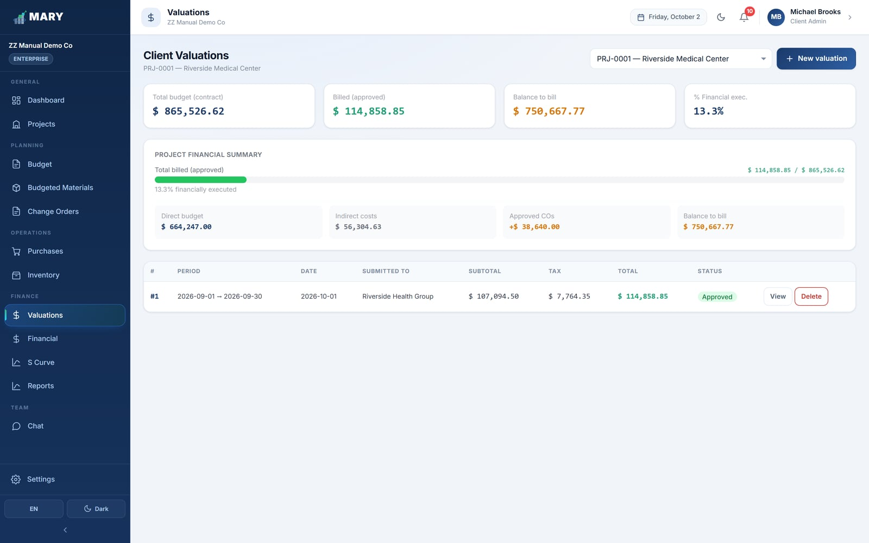
Figure 21. The Valuations screen, listing each billing period.

10.1 Creating a valuation
- Choose the project.
- Click New valuation.
- Set the period start and end dates, and the preparation date.
- Enter who it is presented to.
- For each activity, enter the quantity completed during this period.
- Review the totals and save it as a draft.

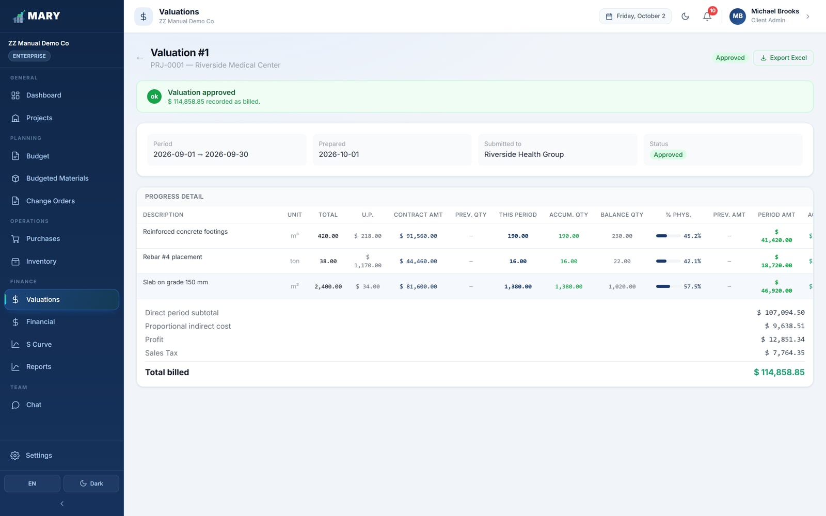
Figure 22. A valuation in detail, showing previous, current and accumulated quantities.

10.2 Reading a valuation
Column | Meaning
Contract qty | The total quantity for that activity in the contract.
Previous | What you had already billed in earlier valuations.
Current period | What you are billing now. This is the only column you type in.
Accumulated | Previous + current.
Balance | What is still left to bill on that activity.
% Progress | Accumulated as a percentage of the contract quantity.

MARY will not let the accumulated quantity exceed the contract quantity without flagging it, which stops you over-billing an activity by accident.

10.3 How the money is built up
Unlike your internal cost view, a valuation is what the owner pays, so it adds your overhead, your profit and the tax on top of the work done:
Line | How it is worked out
Subtotal | The work completed this period, at contract prices.
Indirect | The project indirect percentage applied to that subtotal.
Profit | The project profit margin applied.
Tax | The project tax percentage applied.
Valuation total | What you invoice for this period.

A valuation starts as a draft, which you can keep editing. Once it is approved it is locked and its quantities become the "previous" column of the next one. You can export any valuation to Excel to send to the owner.

11. Financial
Financial is where the real money spent on a project is recorded — everything that is not material coming out of the warehouse. It has six tabs, and every record you create here can be pointed at a budget activity, which is what makes the S Curve and the cost reports work.

11.1 Contingencies
Direct costs that did not go through the warehouse: ready-mix delivered straight to the pour, a specialist invoice, a pump hired for a day.
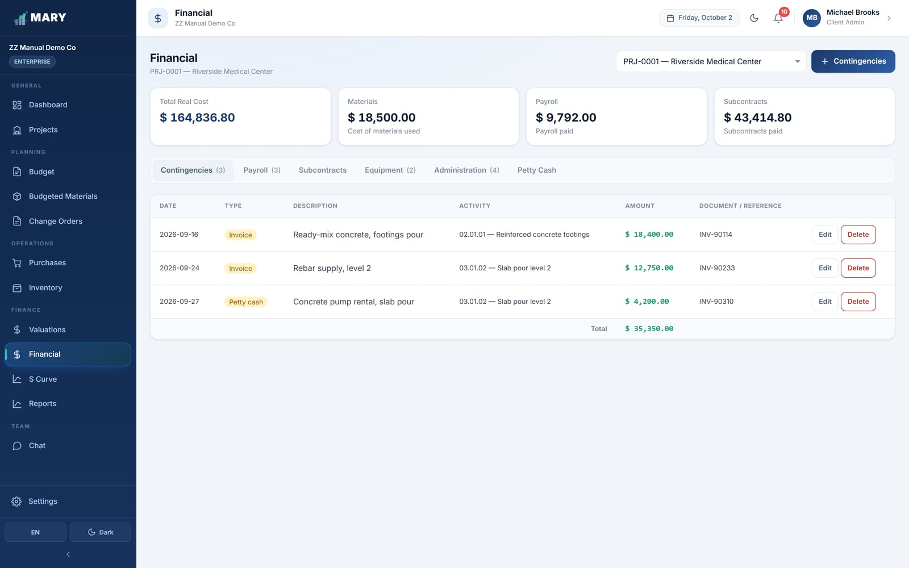
Figure 23. The Contingencies tab.
Each record takes a type, a description, an amount, a date, a document or invoice reference, and the activity it belongs to. Tax can be recorded separately from the net amount.

11.2 Payroll
What you pay your own crew, period by period.
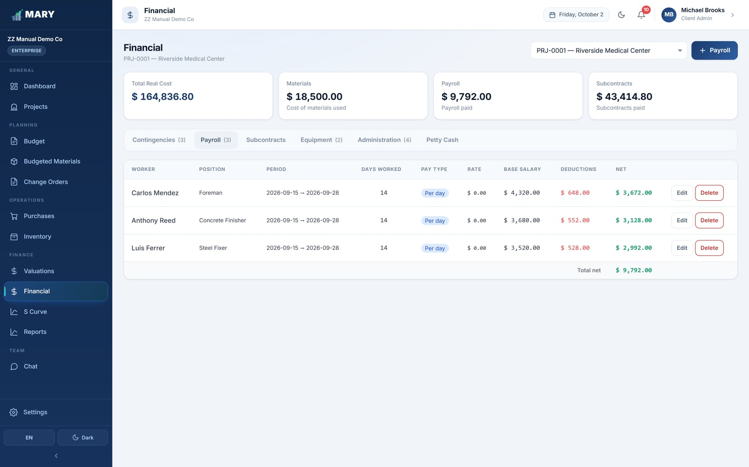
Figure 24. The Payroll tab.
Field | What to enter
Worker / Position | Who was paid and what they do.
Period start / end | The pay period this covers.
Base salary | Gross pay for the period.
Deductions | Taxes, benefits and anything else withheld.
Net | Calculated for you: base minus deductions.

11.3 Subcontracts
Work you have handed to someone else. This is the most involved tab, because a subcontract runs through its own small lifecycle: contract, progress valuations, retention and release.
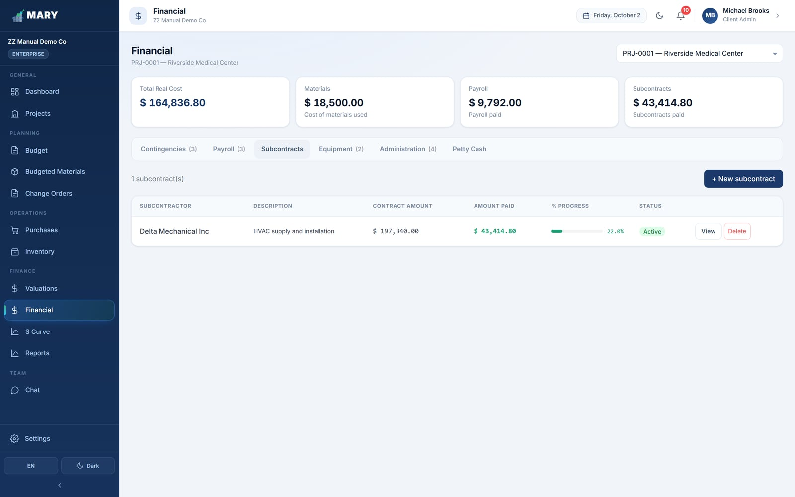
Figure 25. The Subcontracts tab, showing contract value, amount valued and balance.

Setting up a contract
- Click + New subcontract.
- Enter the subcontractor and a description of the work.
- Set the contract, start and estimated end dates.
- List the activities being subcontracted, each with a quantity and unit cost. These add up to the contract value.
- Set the tax percentage.
- Set the retention percentage — the slice you hold back from every payment as security.
- Set the warranty period in months — how long you hold the retention after the work is finished.

Subcontractor valuations
As the subcontractor progresses you create valuations against the contract, exactly as the owner does to you. Each one takes a period, the quantities completed, and MARY works out the subtotal, the tax, the retention withheld and the net amount to pay. A valuation is a draft until it is approved; approving it posts the cost to the project and books the retention.

Retention and payment orders
The Retention Bonds panel tracks, per subcontractor, how much you have retained in total, how much has been released, and how much is still being held. When the warranty period is up you release the retention, and MARY can then generate a formal Retention Payment Order — a numbered document you can print and pay against. The Retention Report (section 13) gives you the whole picture across every subcontractor.

11.4 Equipment
Machines on the job, whether rented or company-owned.
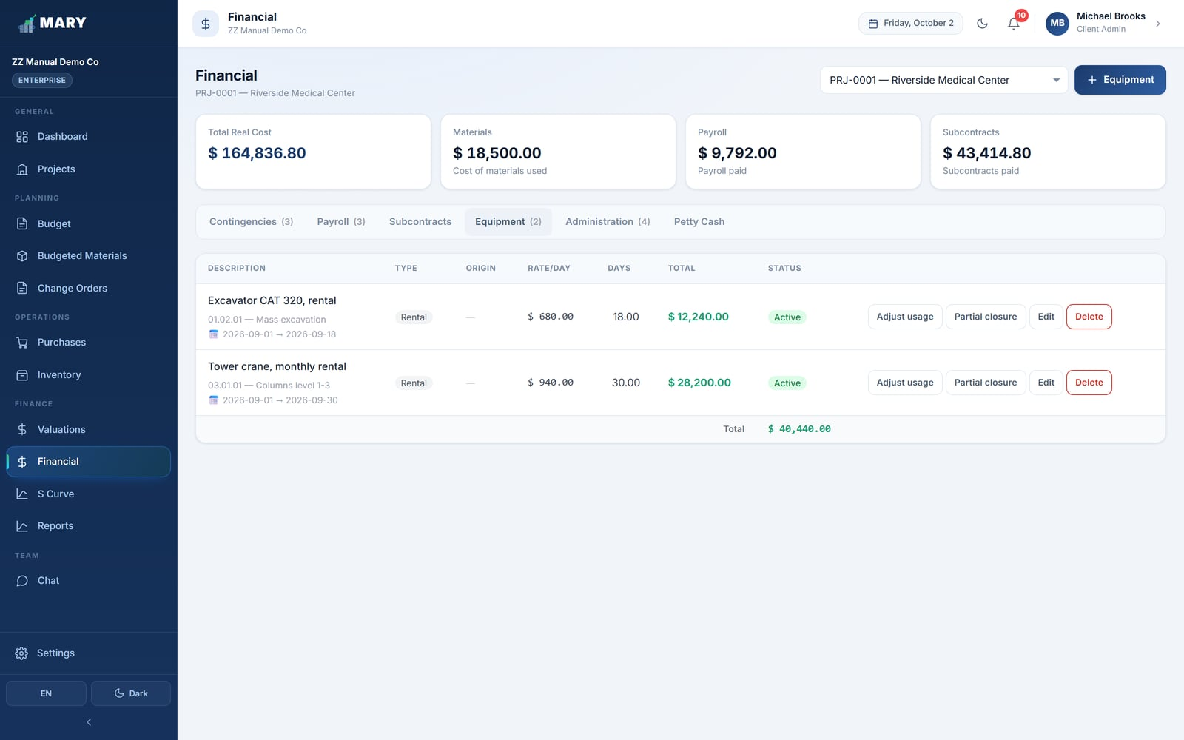
Figure 26. The Equipment tab.
A rented item is priced as a daily rate multiplied by days of use. Equipment that came in through an approved purchase order appears here automatically, tagged From PO, with the dates and rate already filled in.
Reality rarely matches the plan, so equipment records can be adjusted:
- Adjust usage. The machine worked more days than planned. You request an extension, give a reason, and it goes for approval.
- Partial closure. The machine went back early. You close it at the actual number of days, and the cost drops accordingly.

Each record carries a status — Active, Adjusted, Partial closure or Completed — and MARY shows the actual cost against what the purchase order said, so over-runs on plant are visible rather than buried.

11.5 Administration
The indirect costs you actually incurred, recorded against the same categories you budgeted in section 5.4.
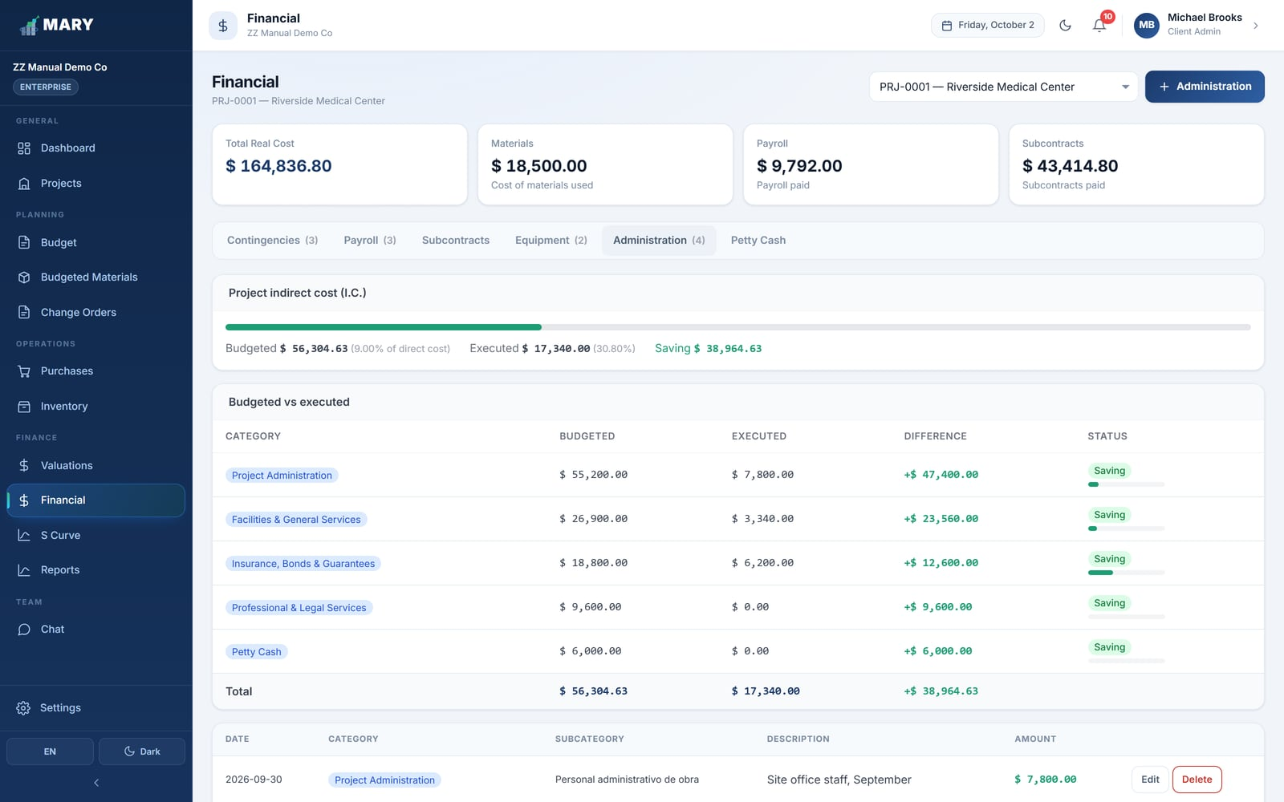
Figure 27. The Administration tab, comparing budgeted against executed overhead.
Each line is tagged Saving, On budget or Overrun against its budgeted category, so you can see at a glance whether your overhead is holding. Any part of the indirect pot you never broke down by category is shown as Unallocated, and expenses without a budgeted category are measured against that balance.

11.6 Petty Cash
A controlled cash float for the small things a site buys daily — a pound of nails, a taxi, a part from the hardware store — without raising a purchase order for each one.
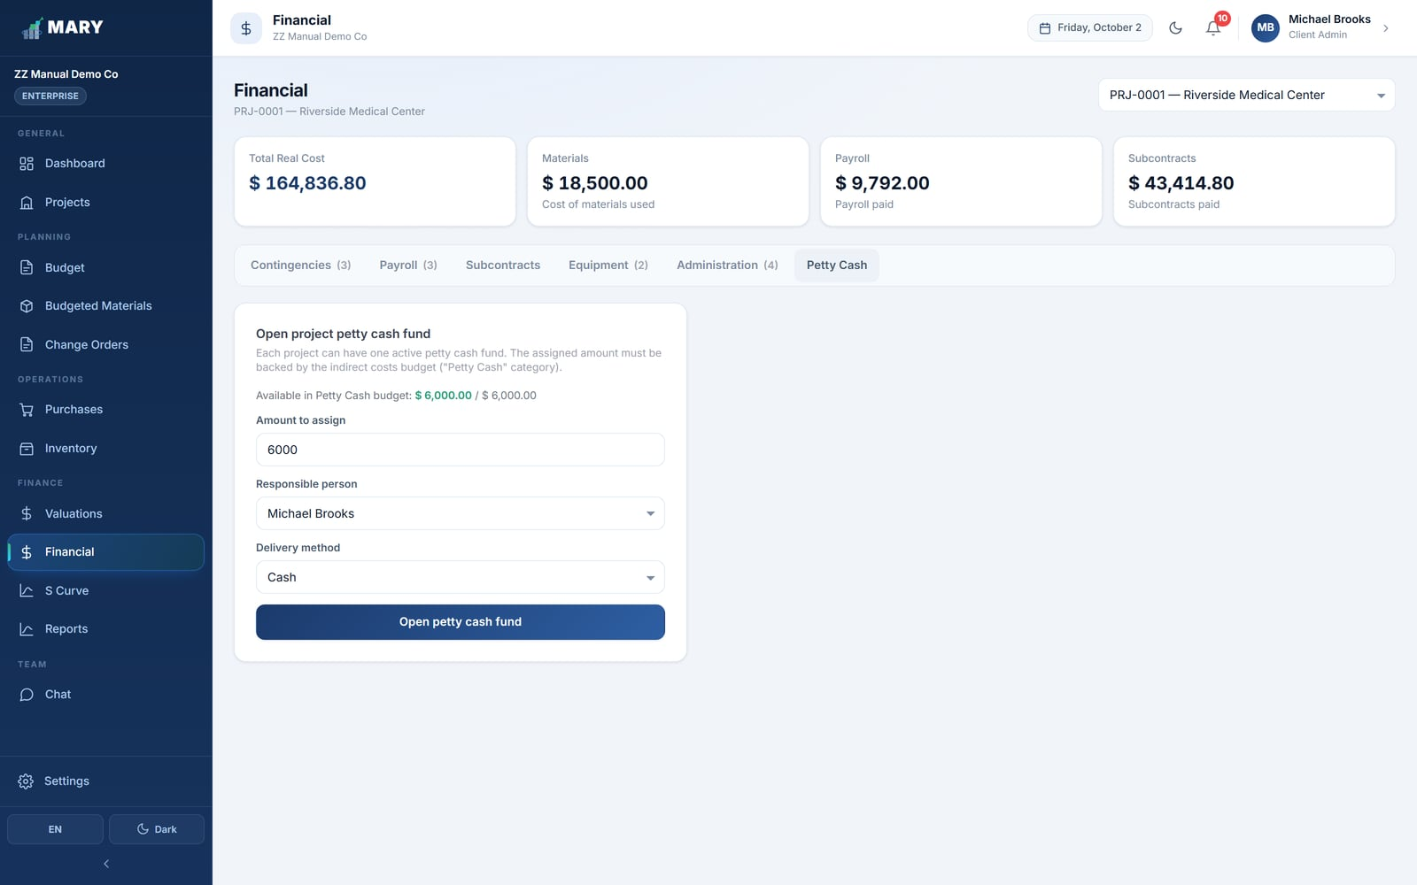
Figure 28. The Petty Cash tab.

Opening a fund
Each project can have one active fund at a time. The amount has to be backed by the Petty Cash category in the indirect cost budget.
- Enter the amount to assign and who is responsible for the cash.
- Choose how it was handed over: cash, check or bank transfer, with the check number or reference.
- Generate a delivery receipt for the responsible person to sign.

WHO CAN OPEN A FUND
An Administrator can open a fund directly. A Manager can request one, but it stays inactive until an Administrator approves it.

Recording expenses
Each expense takes a description, supplier, invoice number, amount and tax, plus how it should be posted — as Materials / Contingencies, as Administration (indirect), or as Equipment / Transport. The fund balance drops as you log expenses, and MARY warns you if an expense would push the fund negative.
If someone pays out of their own pocket, tick Paid out of my own pocket. That expense does not come off the fund balance; instead a personal reimbursement is created in their favour, tracked under Personnel reimbursements until it is marked as paid.

Settling and closing
When expenses pile up you generate a settlement — an expense report that groups them, goes for Manager or Administrator approval, and on approval replenishes the fund. To close a fund, MARY settles any outstanding expenses automatically and then locks it so nothing further can be charged.

12. S Curve
The S Curve answers the question every project meeting starts with: are we ahead or behind, and by how much? It plots the budget you planned to spend against what you have actually spent, cumulatively, over time.
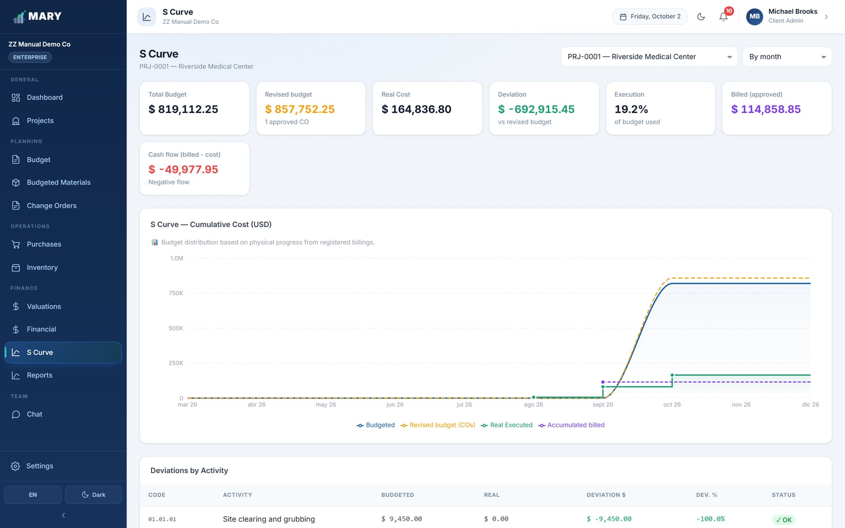
Figure 29. The S Curve, with budgeted and actual cost accumulating over the life of the job.

12.1 Reading the chart
- The Budgeted line is your plan, spread across the project dates.
- The Real Executed line is everything actually recorded — material issued, payroll, subcontracts, equipment and overhead.
- Where the real line sits above the budget line you are spending faster than planned; below, slower.

Switch between By month and By week depending on how closely you want to look. The four tiles above the chart give you the headline numbers: total budget, real cost, deviation in money, and percentage of budget used.

12.2 Deviations by activity
Below the chart is the part most people use most: a line-by-line comparison of every activity, showing budgeted, real, the deviation in money and in percent, and a status flag.
Status | When it appears | What to do
OK | Spending is at or under budget. | Nothing.
Alert | Slightly over budget. | Worth a look — is it a one-off or a trend?
Critical | Significantly over budget. | Investigate now, and consider whether it is a change order.

IF THE CURVE LOOKS EMPTY
The S Curve needs two things: a budget with priced activities, and real costs with dates. If one of them is missing MARY tells you there is not enough data rather than drawing a misleading chart.

13. Reports
Reports turns what is in MARY into formatted Excel workbooks you can email, print or hand to an auditor. Pick the report, pick the project, optionally narrow it to a date range, and either download the Excel file or open a print view.
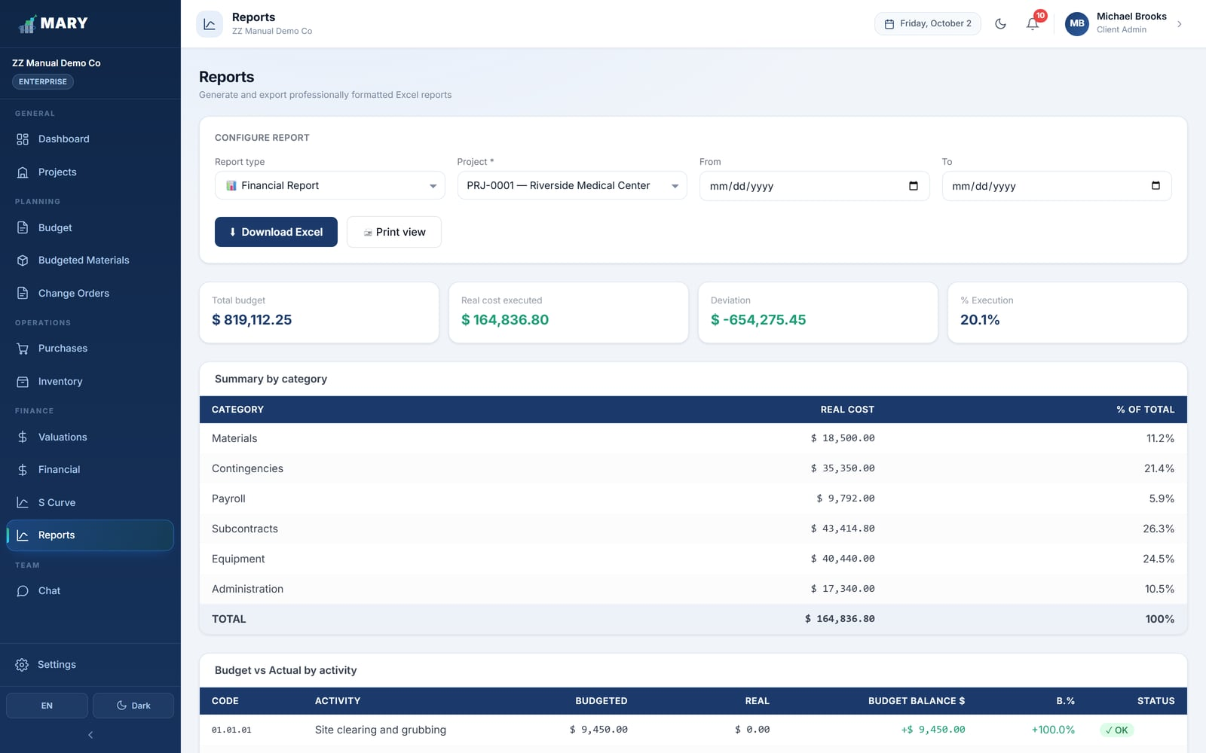
Figure 30. The Reports screen. The Financial Report is selected.

13.1 The four reports
Report | What it contains
Financial Report | The complete cost picture: executive summary, cost by category, budget versus actual for every activity, and a detail sheet per cost type. Includes sheets for change orders and subcontracts.
Inventory Report | Current stock with minimums and critical flags, plus every entry and every exit in the period.
General Project Summary | A one-page overview of the project — code, client, status, dates, budget, cost and progress.
Retention Report | Subcontract retention: amounts held, estimated release dates, what has been released, and the payment orders issued.

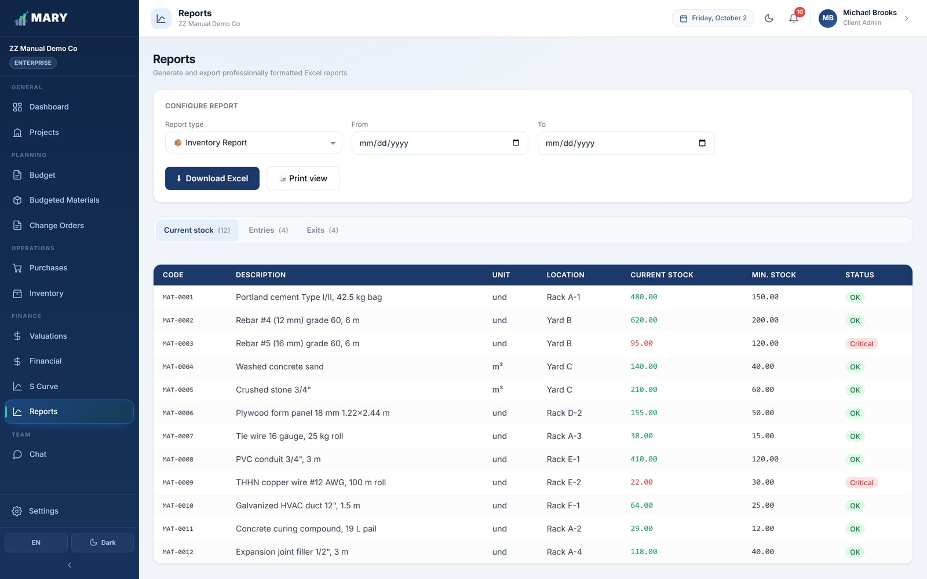
Figure 31. The Inventory Report on screen before export.
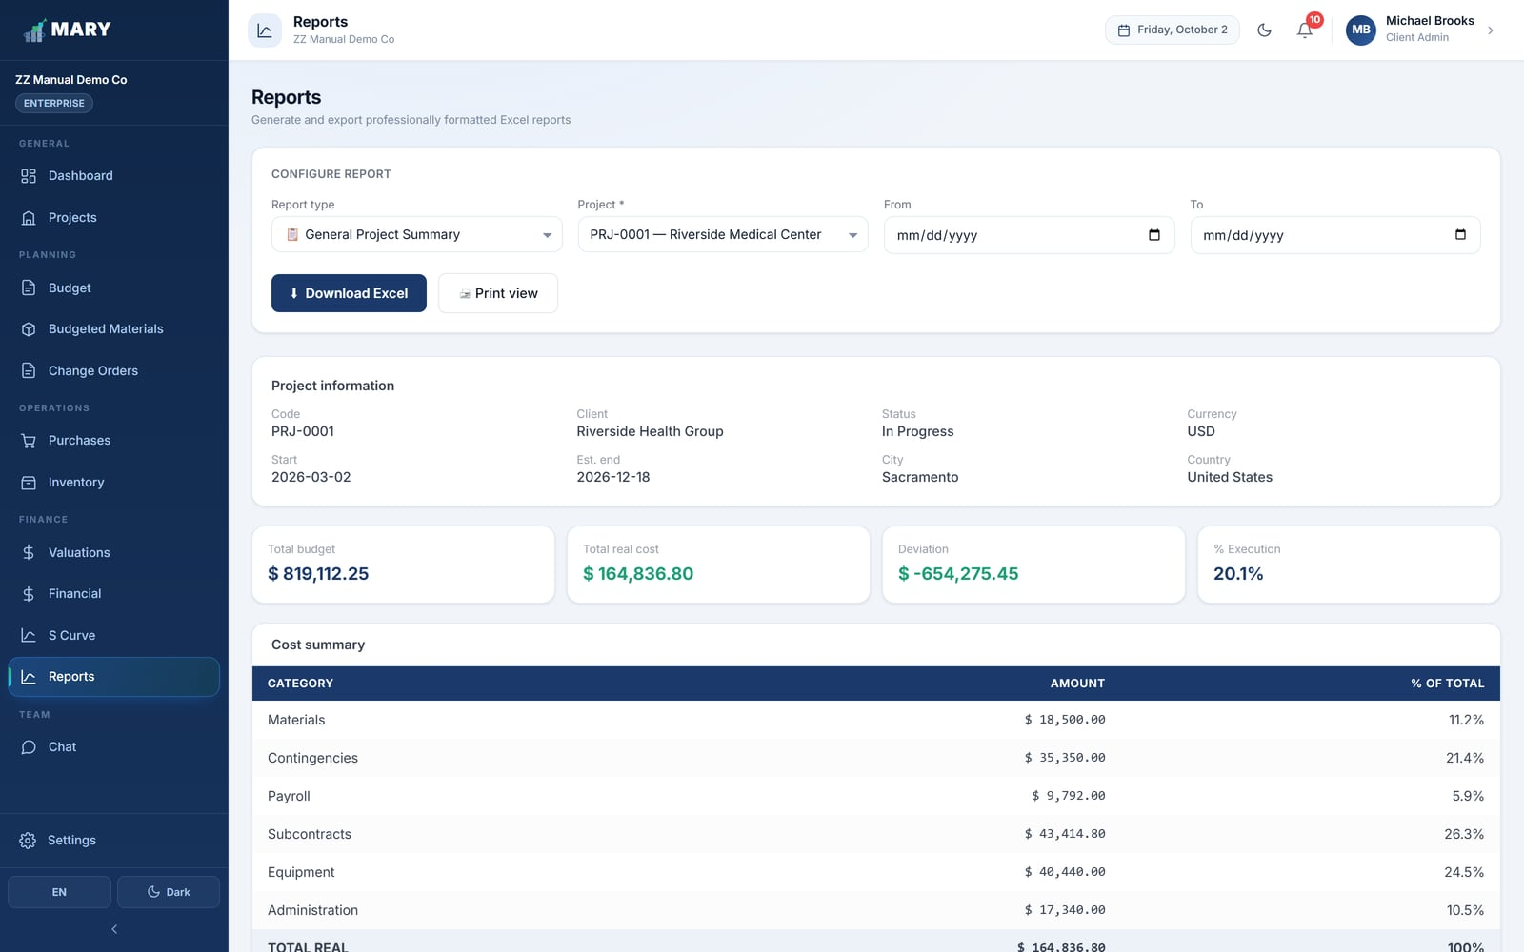
Figure 32. The General Project Summary.
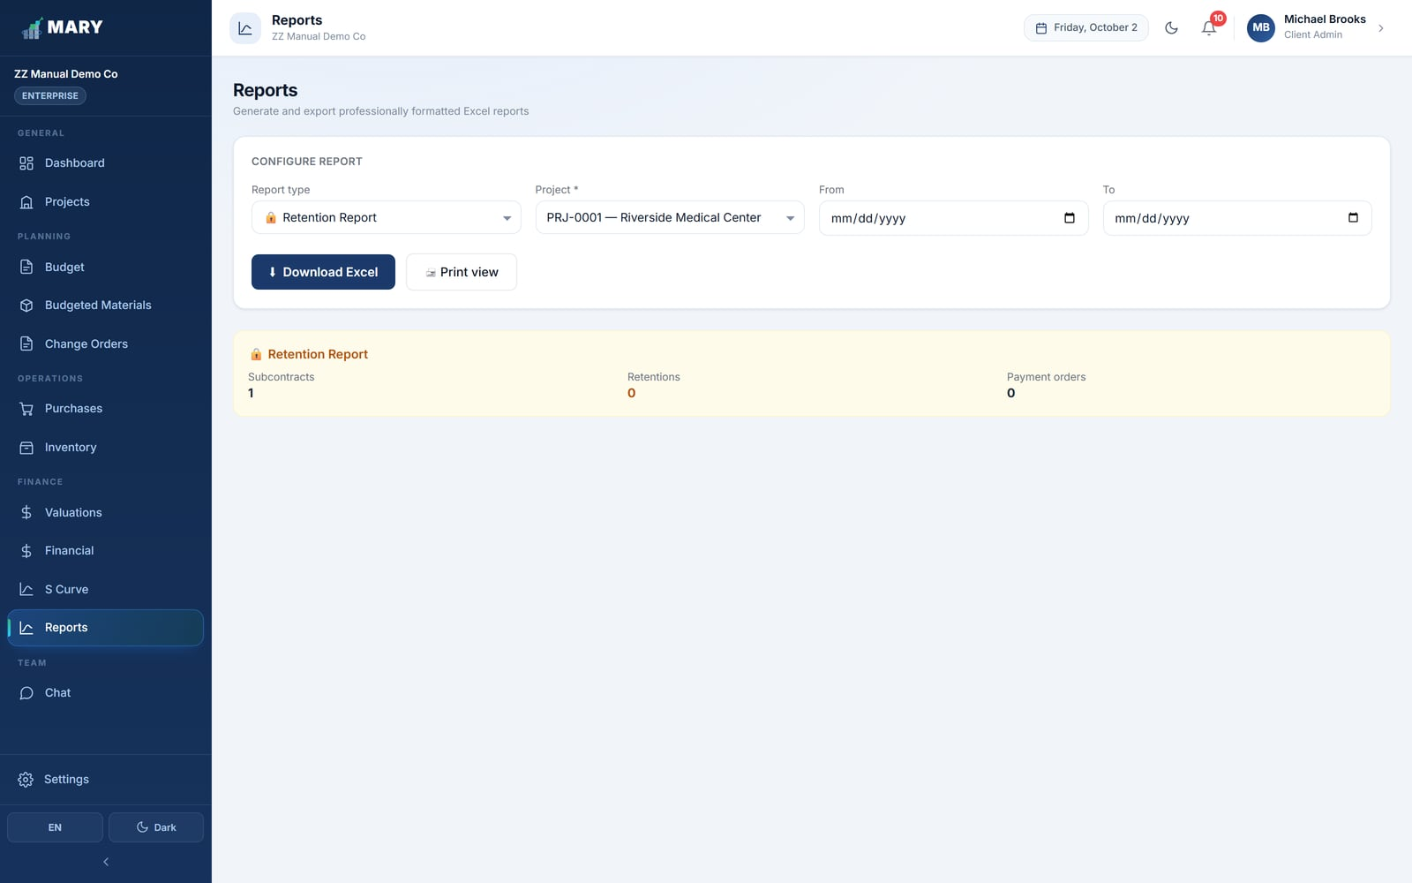
Figure 33. The Retention Report.

13.2 About the Excel files
The downloaded workbook is fully formatted — company name, report title, project, period and date in a header block, styled tables, number formats and multiple sheets. It is meant to be sent as-is, not reformatted.
REPORTS FOLLOW YOUR LANGUAGE
Export a report while MARY is in English and every sheet name, heading and label comes out in English. Switch to Spanish and the same report exports in Spanish. The data itself is not translated.

14. Chat
Chat is a simple internal messenger so questions about a job stay inside MARY, next to the records they refer to, instead of scattering across personal phones.
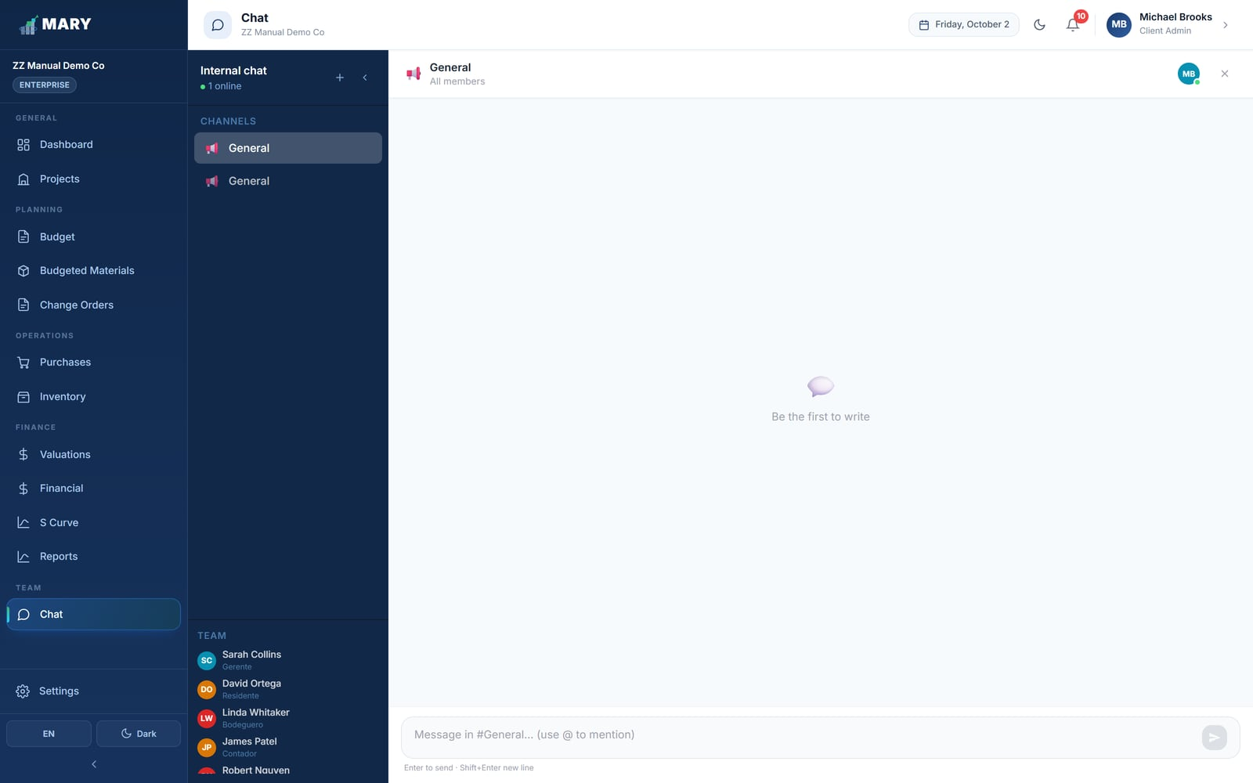
Figure 34. The Chat module.
Channels can be general or tied to a specific project. Everyone on your team has access to Chat regardless of role.

15. Settings
Settings is where an Administrator manages the team and the subscription, and where everyone manages their own account. It has four tabs, plus a link to the Audit Log.

15.1 Company users
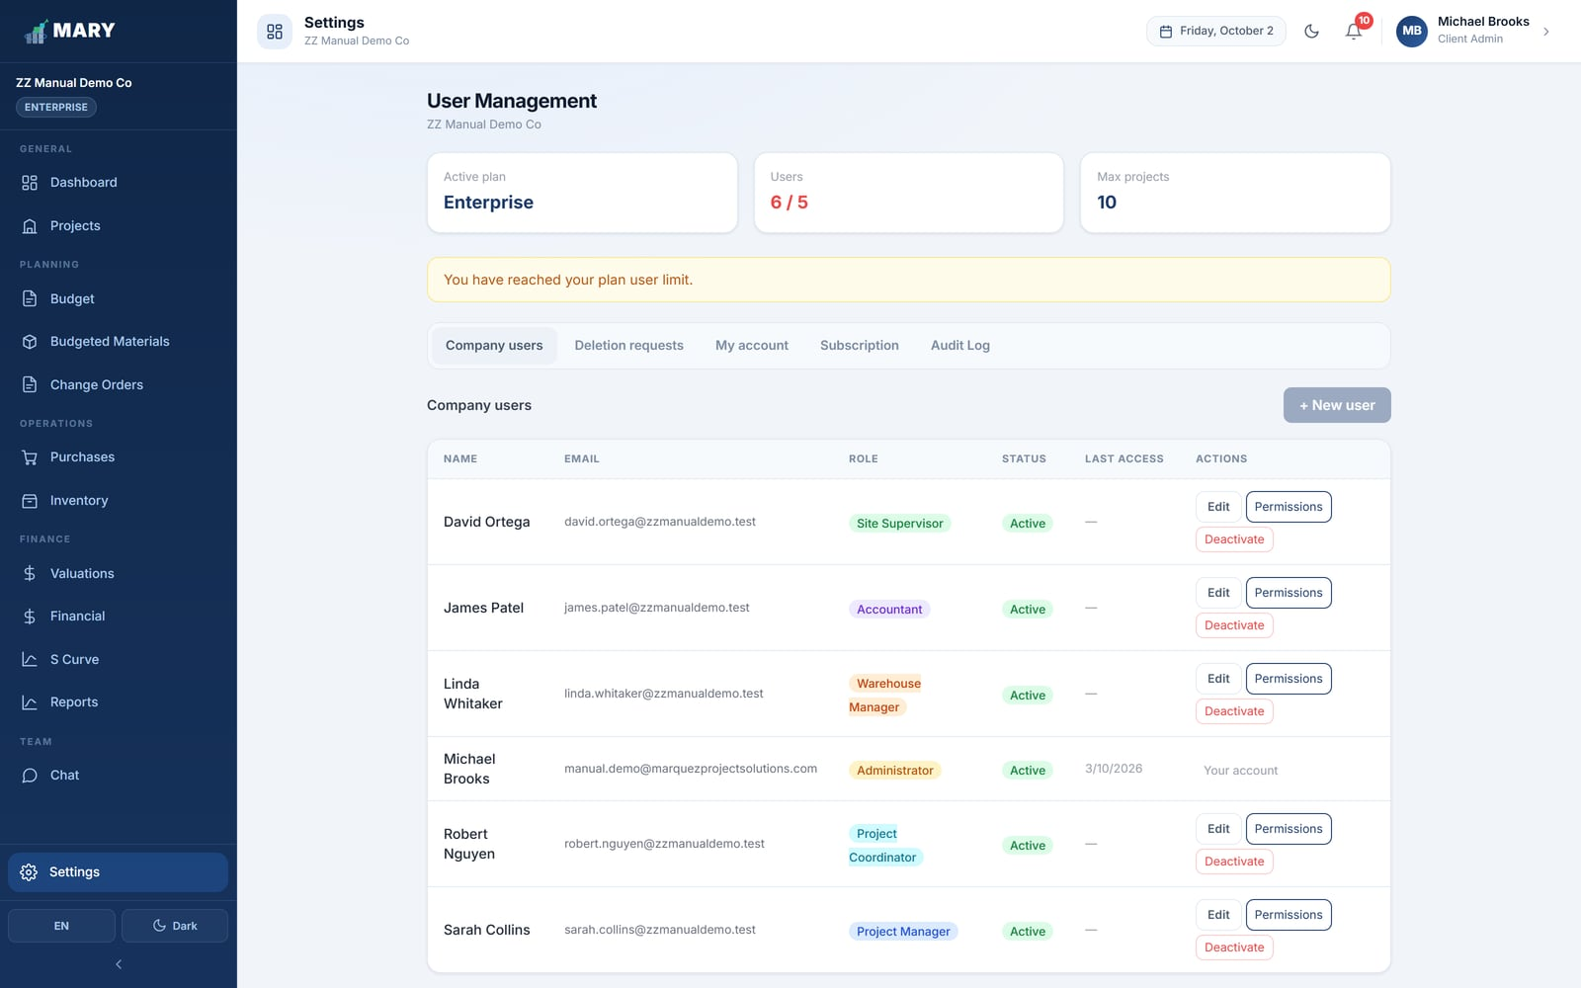
Figure 35. The user list, showing role, status and last access.

Adding someone
- Click + New user.
- Enter their full name and email address.
- Either set a temporary password, or leave it blank to have MARY email them an activation link.
- Choose their role.
- Click Save.

YOUR PLAN LIMITS HOW MANY USERS YOU CAN HAVE
Starter allows 1 user, Pro 3, and Enterprise 5. When you hit the limit MARY stops you adding more and tells you so. Deactivating someone frees their slot.

Editing, permissions and deactivating
- Edit changes the name or the role. Email addresses cannot be changed after the account exists.
- Permissions opens a per-module grid where you can grant or remove individual rights for that one person, on top of what their role already allows.
- Deactivate blocks sign-in without deleting anything. Their history and audit trail stay intact. You can reactivate them later.

DEACTIVATE RATHER THAN DELETE
When someone leaves, deactivate them. Deleting a user would orphan the records they created; deactivating keeps the history readable and frees the licence.

15.2 Deletion requests
Warehouse Managers cannot delete entries, exits or materials on their own, because those records underpin real cost figures. Instead they raise a deletion request with a justification, and it lands here for an Administrator to approve or reject.
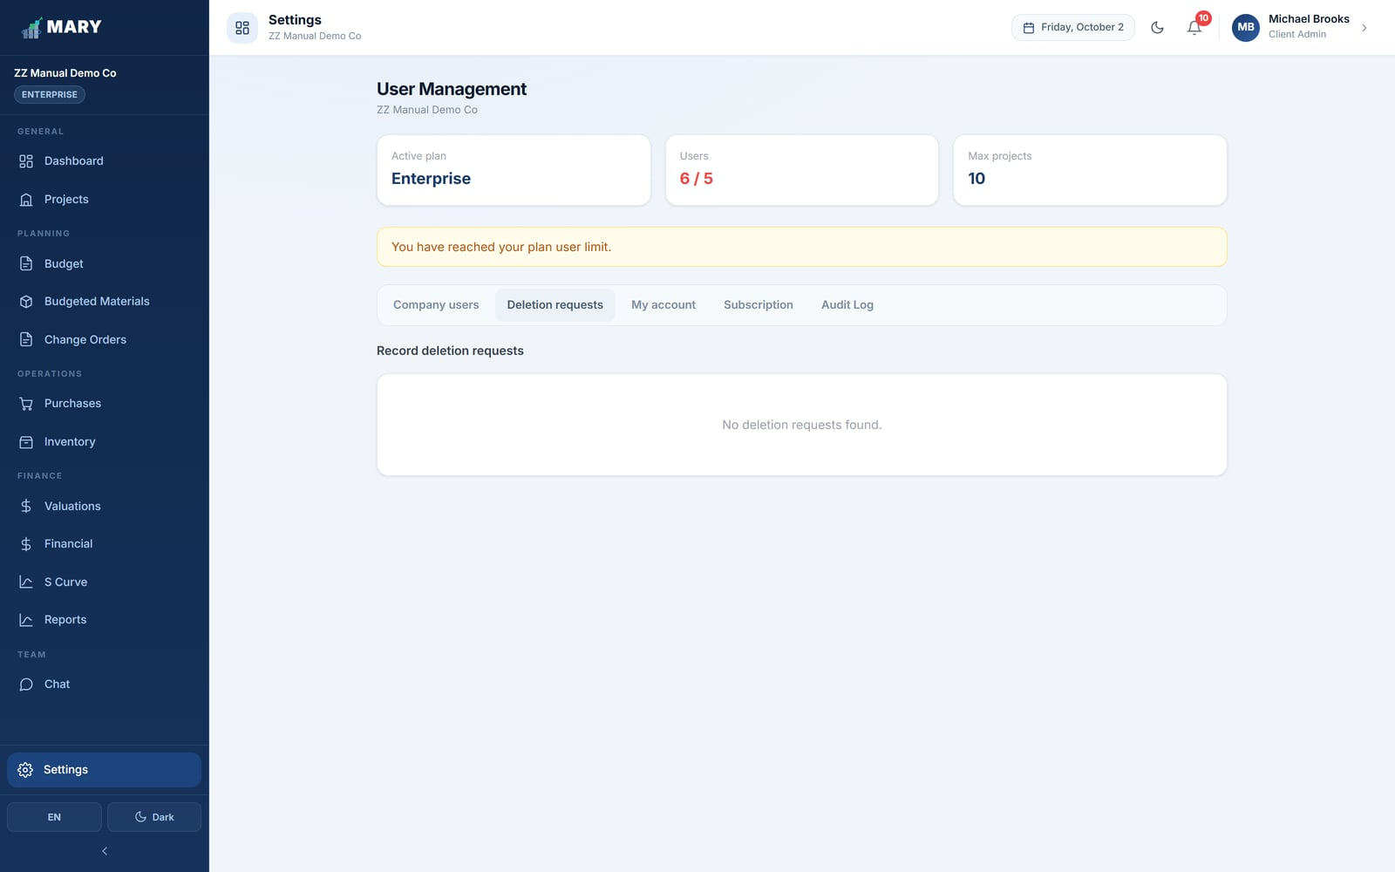
Figure 36. The deletion requests queue.
Approving the request performs the deletion and adjusts stock. Rejecting it leaves everything untouched; you can add a comment explaining why, which the requester sees in their notifications.

15.3 My account
Everyone, whatever their role, can open this tab to change their own interface language and password.
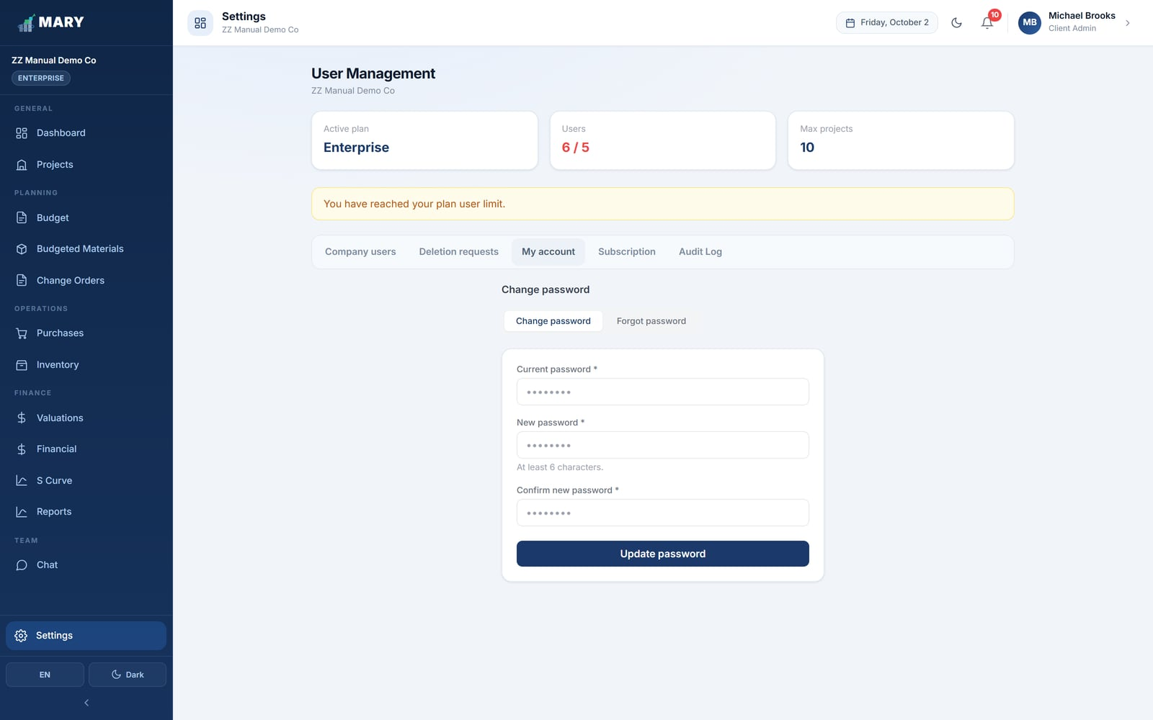
Figure 37. The My account tab.

15.4 Subscription
Shows your current plan, what it includes, how many users and projects you are allowed, and your billing status. From here an Administrator can change plan or update payment details.
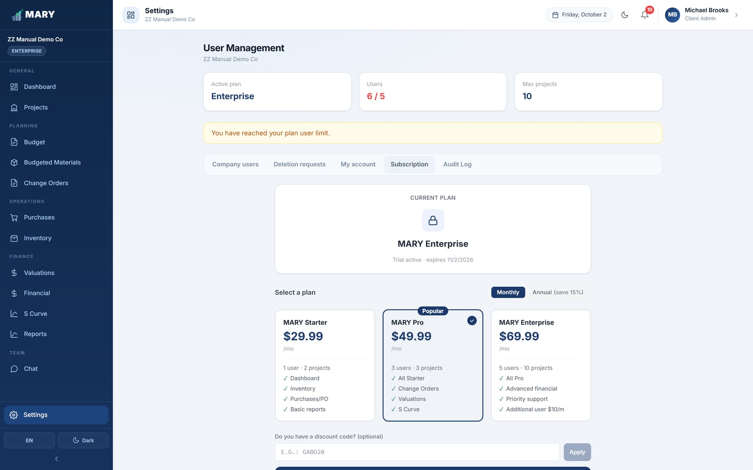
Figure 38. The Subscription tab.
Plan | Users | Projects | Includes
Starter | 1 | 2 | All base modules, email support.
Pro | 3 | 5 | Everything in Starter plus Change Orders, Valuations and priority support.
Enterprise | 5 | 10 | Everything in Pro plus the full Audit Log and additional users.

IF A SUBSCRIPTION LAPSES
MARY does not delete anything. It switches to read-only: you can still open every screen and export every report, but nothing new can be created or edited until the subscription is renewed. A banner across the top tells you when this is happening.

16. Audit Log
The Audit Log is the answer to "who changed this, and when?". Every meaningful action in MARY is recorded — who did it, what they did, which project it affected, and the detail of the record involved.
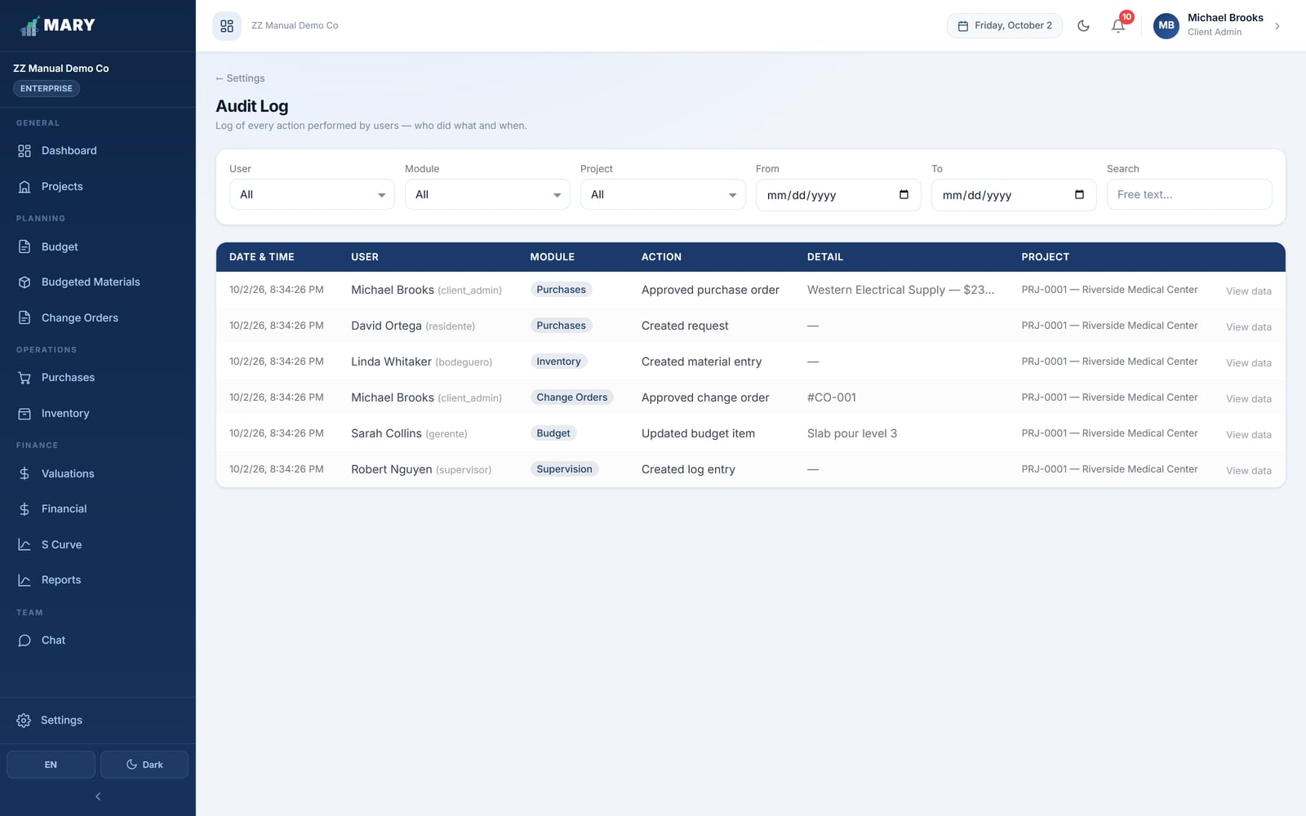
Figure 39. The Audit Log, filtered by user, module, project and date.
Filter by user, by module, by project, by date range, or search the free text. Click View data on any row to see the full detail of what was recorded.
AVAILABILITY
The Audit Log is part of the Enterprise plan and is visible only to Administrators. You reach it from Settings, where it appears as the last tab.

17. Everyday workflows
The chapters above describe each screen on its own. This chapter puts them together into the sequences your team will actually run, week in and week out.

17.1 Starting a new project (Administrator or Coordinator)
- Projects → + New Project. Set the currency, the dates, the profit margin, the tax and the indirect percentage.
- Budget → build the stages, sub-stages and activities, pricing each activity by labor, materials and equipment. Or import the estimate from Excel.
- Budget → break the indirect pot down by category, remembering to budget Petty Cash if the site will hold cash.
- Budgeted Materials → say how much of each material each activity should consume.
- Settings → Company users → make sure the people who will run the job have accounts and the right roles.
- Set the project status to In Progress.

17.2 Getting material to the crew (Site Supervisor → Warehouse Manager)
- Site Supervisor: Purchases → Requests → + New Request. Choose the project and activity, add the materials, set the priority and write the justification. Submit.
- MARY checks stock and routes each line: In Warehouse, PO Required, or Split.
- Warehouse Manager: for the In Warehouse part, go to Inventory → Exits → Add exit, charge it to the project and activity, and hand the material over.
- Administrator or Manager: for the PO Required part, Purchases → Purchase Orders → Generate PO, set supplier, prices, payment terms and tax, then approve it.
- Warehouse Manager: when the delivery arrives, Inventory → Entries → Add entry, linked to that purchase order, with the real invoiced price.
- Warehouse Manager: issue it to the field with an exit, against the same activity.

THE ONE HABIT THAT MATTERS
At every step, pick the correct activity. It takes two seconds and it is the single thing that determines whether your cost reports are worth reading.

17.3 Closing the month (Accountant)
- Financial → Payroll: enter the pay periods for the month.
- Financial → Contingencies: enter invoices that did not go through the warehouse.
- Financial → Subcontracts: create and approve the subcontractor valuations for the period.
- Financial → Equipment: adjust or close out any plant whose actual use differed from the purchase order.
- Financial → Administration: record the month's overhead against its budget categories.
- Financial → Petty Cash: generate and approve the settlement, and mark any personal reimbursements as paid.
- S Curve: check the deviations by activity and note anything flagged Critical.
- Reports → Financial Report: export and circulate.

17.4 Billing the owner (Manager or Administrator)
- Make sure the month's costs and progress are all recorded.
- Valuations → New valuation. Set the period.
- Enter the quantity completed this period for each activity.
- Check the subtotal, indirect, profit and tax build-up.
- Save as draft and review it with the team.
- Approve it, then export to Excel and send it to the owner.

17.5 Handling a scope change (Manager or Coordinator)
- Change Orders → + New CO. Number it, date it and say who it goes to.
- Write a precise reason — this is what justifies the claim.
- Add the changed and new activities, with quantities and prices.
- Add any extra calendar days.
- Save as draft, then mark it Submitted when it goes to the owner.
- Only once the owner has genuinely approved it, mark it Approved. MARY then applies it to the budget.

18. Troubleshooting

18.1 Common questions
What you see | Why, and what to do
A module is missing from my sidebar. | Your role does not include it, or it needs a higher plan. Check chapter 3, then ask your Administrator.
"This project cannot be deleted." | The project has records attached. MARY lists which modules. Either clear those records or set the project to Cancelled instead.
"Error: That material code already exists." | Catalog codes must be unique. Search the catalog for the code — the material is probably already there, possibly deactivated.
"Insufficient stock. Available: n" | You are trying to issue more than the warehouse holds. Record the incoming entry first, or reduce the quantity.
The S Curve says there is not enough data. | You need both a priced budget and real costs with dates. Check that costs have been entered and that they are dated inside the project period.
Budgeted Materials shows nothing consumed. | Exits were probably recorded without an activity, or against a free-text material that is not linked to the catalog. See sections 6.1 and 8.3.
"You have reached your plan user limit." | Deactivate someone who has left, or upgrade the plan in Settings → Subscription.
A banner says the subscription expired. | MARY is in read-only mode. Your data is safe and reports still export. Renew in Settings → Subscription.
Part of the screen is in the wrong language. | Switch language with the ES / EN button. Note that text your team typed in is never translated — only MARY's own labels.
I cannot delete a warehouse record. | Warehouse Managers raise a deletion request instead; an Administrator approves it in Settings → Deletion requests.

18.2 Good habits
- Always charge costs and material exits to the right budget activity. Everything else depends on it.
- Enter the real invoiced price on entries, not the budgeted price.
- Record costs as they happen rather than in a batch at month-end, so the S Curve stays honest.
- Use change orders for scope changes instead of editing the original budget.
- Deactivate people who leave; do not delete them.
- Agree one language for data entry even though each person reads the interface in their own.

19. Glossary
Term | Meaning in MARY
Activity | The lowest level of the budget, and the thing almost every cost is charged to.
Budgeted material | The quantity of a material an activity is expected to consume.
Change order (CO) | A formal, numbered change to the contract, approved separately from the original budget.
Direct cost | Cost that belongs to a specific activity: labor, materials, equipment, subcontracts.
Entry | Material arriving at the warehouse.
Exit | Material leaving the warehouse for the field. The moment it becomes a project cost.
FIFO | First in, first out — the method MARY uses to value stock.
Folio | The reference number on a purchase request, e.g. REQ-0001.
Indirect cost | Overhead needed to run the job but not attributable to one activity.
Petty cash fund | A controlled cash float held on site for small day-to-day purchases.
Purchase order (PO) | The approved commitment to buy from a supplier.
Purchase request | The field asking for material, before anything is bought or issued.
Retention | A percentage withheld from each subcontractor payment as security, released after the warranty period.
S Curve | Cumulative budgeted cost plotted against cumulative real cost over time.
Settlement | An expense report that groups petty cash expenses for approval and replenishment.
Stage / Sub-stage | The two grouping levels above activities in the budget.
Valuation | A progress billing — to the owner for your work, or to you from a subcontractor.

