Home Assignment 4
Submission deadline : April 15, 2016

Q1 [20 points]: write the following family tree in RDF and validate it,
Relationships using siblingOf, spouseOf, parentOf, and childOf from relationship ontology (http://vocab.org/relationship). Family members should be defined using URLs from a made-up namespace: http://family.

Namespaces: rdf=”http://www.w3.org/1999/02/22-rdf-syntax-ns#”,
…
adam + dotty
beth + chuck
edward
fan + greg
harriet
rel=http://purl.org/vocab/relationship/

<?xml version="1.0"?>
<rdf:RDF
xmlns:foaf="http://xmlns.com/foaf/spec/#"
xmlns:rel="http://vocab.org/relationship/#"
xmlns:rdf="http://www.w3.org/1999/02/22-rdf-syntax-ns#">
<foaf:Person rdf:about="http://family/harriet">
<rel:childOf><foaf:Person rdf:about="http://family/fan"/></rel:childOf>
<rel:childOf><foaf:Person rdf:about="http://family/greg"/></rel:childOf>
</foaf:Person>
<foaf:Person rdf:about="http://family/fan">
<rel:parentOf><foaf:Person rdf:about="http://family/harriet"/></rel:parentOf>
<rel:childOf><foaf:Person rdf:about="http://family/adam"/></rel:childOf>
<rel:childOf><foaf:Person rdf:about="http://family/dotty"/></rel:childOf>
<rel:siblingOf><foaf:Person rdf:about="http://family/edward" /></rel:siblingOf>
<rel:spouseOf><foaf:Person rdf:about="http://family/greg" /></rel:spouseOf>
</foaf:Person>
<foaf:Person rdf:about="http://family/greg">
<rel:parentOf><foaf:Person rdf:about="http://family/harriet"/></rel:parentOf>
<rel:spouseOf><foaf:Person rdf:about="http://family/fan" /></rel:spouseOf>
</foaf:Person>
<foaf:Person rdf:about="http://family/edward">
<rel:childOf><foaf:Person rdf:about="http://family/adam"/></rel:childOf>
<rel:childOf><foaf:Person rdf:about="http://family/dotty"/></rel:childOf>
<rel:siblingOf><foaf:Person rdf:about="http://family/fan" /></rel:siblingOf>
</foaf:Person>
<foaf:Person rdf:about="http://family/adam">
<rel:parentOf><foaf:Person rdf:about="http://family/edward"/></rel:parentOf>
<rel:parentOf><foaf:Person rdf:about="http://family/fan"/></rel:parentOf>
<rel:siblingOf><foaf:Person rdf:about="http://family/beth" /></rel:siblingOf>
<rel:spouseOf><foaf:Person rdf:about="http://family/dotty" /></rel:spouseOf>
</foaf:Person>
<foaf:Person rdf:about="http://family/dotty">
<rel:parentOf><foaf:Person rdf:about="http://family/edward"/></rel:parentOf>
<rel:parentOf><foaf:Person rdf:about="http://family/fan"/></rel:parentOf>
<rel:spouseOf><foaf:Person rdf:about="http://family/adam" /></rel:spouseOf>
</foaf:Person>
<foaf:Person rdf:about="http://family/beth">
<rel:siblingOf><foaf:Person rdf:about="http://family/adam" /></rel:siblingOf>
<rel:spouseOf><foaf:Person rdf:about="http://family/chuck" /></rel:spouseOf>
</foaf:Person>
<foaf:Person rdf:about="http://family/chuck">
<rel:spouseOf><foaf:Person rdf:about="http://family/beth" /></rel:spouseOf>
</foaf:Person>
</rdf:RDF>
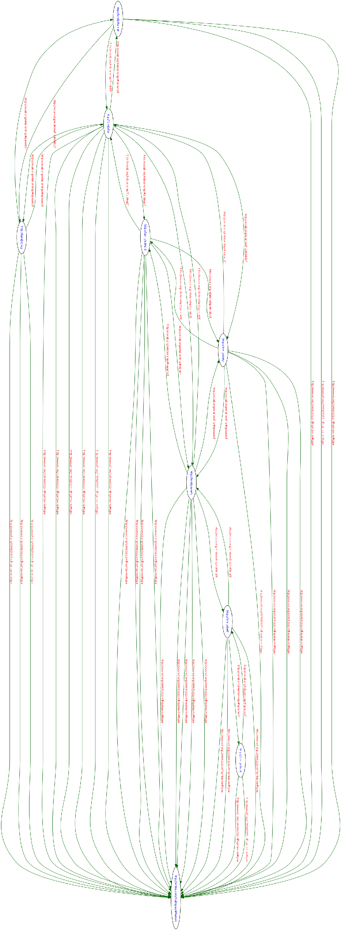
Q2 Use Protege to create this ontology. Write the RDF Schema for this ontology. Try to add some instances and use RDF to write these instances. ( 30 points)

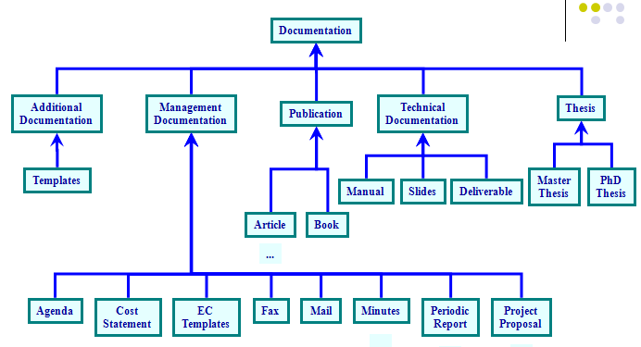

See attached files.

Q3 [50 points] : Make an internet radio web app for tourists. From website user will enter the city or state name. You need to display get 10 interesting facts from Dbpedia and display it.

- One can easily get simple facts from dbpedia by writing simple Sparql query. For example you can get all important fact about Michigan from dbpedia.
http://live.dbpedia.org/page/Michigan
you need to come up with query to display some interesting facts about that state, people living there, local Industry etc. Refer the example discussed in class.
Note that 20 points are only given to 10 interesting SPARQL queries while 30 points are for rest of tasks.
B[extra credit]- Use any Text to speech API to make it radio app by converting the text that you got in step A ( extra credit 20 points). It is enough to convert the text data to speech that you obtain from abstract relation of Dbpedia.

