1)

2)

To provide a means of indoor navigation to emergency personnel by utilizing already in place WiFi hotspots to determine current location. This can be accomplished by pre-mapping the building and its WiFi hotspots to determine WiFi signal strength at various locations. Then these locations can be mapped to latitude and longitude and paired with a floor of the building. The application can make a distinction on which floor the user is on by determining signal strength of known WiFi hotspots and display the desired map. Navigation is done by using a graph of nodes of locations connected by edges of viable paths. The nodes will likely occupy the same latitude and longitude in the building, however they will be connected between floors by using stairwell nodes. POIs can be a decoration on each location node to signify if the location has items of interest, such as chemicals, has someone currently on call with 911, or 911 has flagged the location as likely having individuals in need such as Alzheimer’s patients, disabled individuals, and small children.

* Rave Mobile Safety Smart911Connect API – Allows finding a caller within a corporate campus, might be able to expand to interior of building.
* MapBox – Rendering and interaction with map.
* Application MicroServices
  + Main Service
    - Holds and sends custom map data
  + Proxy Services
    - One for MapBox
    - One for 911 Services
  + Push Service
    - Able to send alerts and other immediate information to the user

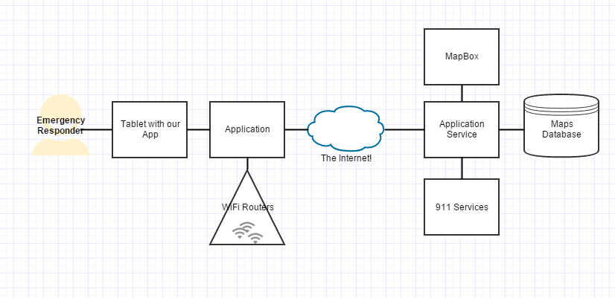

TODO: Sequence Diagram and Flow Diagram

3)

The twitter API is RESTFUL but lacks anything but HTTP GET and HTTP POST due to what appears to be a desire to support HTML4 and XHTML1 only clients.

<http://stackoverflow.com/questions/165779/are-the-put-delete-head-etc-methods-available-in-most-web-browsers>