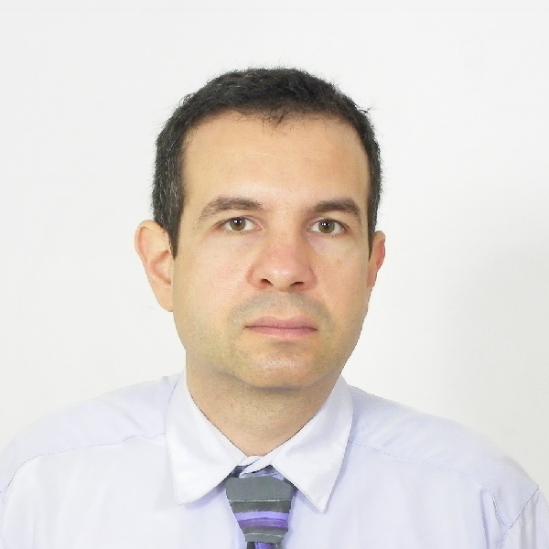  Darin  Masov  mobile: +359 877 344 388  mail: dmasov@gmail.com  Skype: darinmasov  Zoom: Darin Masov  Microsoft teams: Darin Masov  LinkedIn: https://www.linkedin.com/in/darin-masov-76b91231/  POSITION  Senior Java developer  PERSONAL DETAILS  Residence: Sofia/Rousse  EDUCATION  Diplom: Technical University of Rousse, Bulgaria, MSc in Computer Technologies  LANGUAGES  Bulgarian - native  English – fluent level  Russian - fluent level |  | More than 20 years professional experience in software architecture and development.  CAPABILITY  Deep knowledge and understanding in Java technologies and relational databases. Knowledge of Linux and network administration. Deep knowledge of hardware design. Experience of automotive communication protocols.  TECHNOLOGIES  - Java, JаvaEE, JSF, Servlets, Junit, REST, Hazelcast, micro-services  - Apache Tomcat, JBoss, Jetty, Glassfish, WebSphere  - Spring, Spring boot, Hibernate, JOOQ, Jboss seam  - Git, Bitbucket, SVN, PVCS, SourceSafe  - Jenkins, Maven, Ant  - Oracle DB (Development & administration), Postgres, MySQL  - hSQL, PL/SQL, Redis, Flyway, Lucene  - Jira, TestTrack, Canbanize  - Heroku PaaS, IaaS, SaaS  - Docker  - Nuxeo  - 3D modelling and printing  - Hardware design  - Linux administration  CERTIFICATIONS  - C developer  - C++ developer  - Java Developer (IPT intellectual)  - Java EE Developer (IPT intellectual)  - Marconi ICT, MTL language, (IFR Paris)  - Nuxeo fundamentals (Hyland university, Ohio, USA, 2022)  - Nuxeo backend basics (Hyland university, Ohio, USA, 2022)  - PORTFOLIO https://drive.google.com/file/d/1WmOyXHfmVVVTzWLMT2lOGAUqu7Rk_2dz/view?usp=sharing  The archive must be downloaded locally, is password protected, and the password is darinmasov9

PROJECTS
03/2023 – now
Non disclosure agreement
Senior software developer
12/2022 – 03/2023
Softbendr

Senior software developer
Online marketplace. Kotlin, Spring, Spring-boot, Flyway, REST services - JSON, Postgres, JOOQ, microservices

11/2017 – 11/2022
Senior software developer
Non disclosure agreement
10/2014 – 11/2017
Taller technologies
Senior software developer
1. Social network - GPS tracks and attached images, for mobile devices. Spring, REST services - JSON, Postgres, Hibernate, Redis, Cloudinary, Heroku PaaS
2. SaaS cloud system – ERP for the building industry.
Spring, Hibernate, Hazelcast, MySQL, several Ubuntu IaaS, Apache WEB server, Tomcat WEB container.
3. SmartHome IoT project, based on BeagleBone hardware, and OpenHAB.
Debian OS for BeagleBone.
4. PL/SQL integration scripts, mobile document management system. Oracle DB.

07/2012 – 02/2014
Trade Marketing Solutions
Software developer
WEB based ERP and forecast system for Coca-Cola, co-development with Coca-Cola Vienna
Several WEB modules, every of them upgrades current ERP system:
1. Demand forecast - according to old logged data - predicts the demands for every store.
2. Distribution management - module for distributing and redistributing of goods for exact store. Technical environment: Tapestry, MySQL, Maven (m2e), ShanilleKit

01/2011 – 07/2012
BulSi
Software developer
1. WEB based dictionary – neologisms (Jboss, Jboss Seam, EJB3, JPA/Hibernate, Postgres, facelets)
2. WEB based dictionary – phraseological (Jboss, Jboss Seam, EJB3, JPA/Hibernate, Postgres, facelets).
3. WEB based system for bibliography information. Technical environment: Jboss, Jboss Seam, EJB3, JPA/Hibernate, Postgres, facelets, Lucene, JavaScript
4. Server-side validation engine. Validates information, entering by the user http://www.banite.egov.bg etc. Technical environment: Xpath, XSLT, XML, DOM

07/2005 – 12/2010
Johnson Controls
Software test engineer

● Defect tracking. White and black box testing.
● Implemented installation and test scripts. C++ and JCI script (Basic based) for the target device - clusters for cars, BMW and VAG group. New and in production: automatic validation via MOST, CAN and K-BUS lines), KWP2000 diagnostics.

Technical requirements

JCI testing environment, Vector Informatik tools for CAN and LIN (CANoe, CANdela), Oscilloscope

11/2001 – 07/2005
EPIQ EA
Test engineer

● Development the software part and the hardware schematic of End Line Test (functional test) – automatic mechanical stress test for wipers. Standard wave analysis.
● Development the software part and the hardware schematic of End Line Test (functional test) - 9 different projects (15 test - fixtures) - hardware design ang software. Modules for viper cleaners.
● Software maintenance of End Line test (In-Circuit test) - 4 different projects - hardware design ang software
● Client side part of Automatic test-result analysis, SPC, e-mail and SMS notice alarm, link with SQL server, automatic weight analysis
● Development the software part and the hardware schematic of End Line Test (functional test) - module for opening the trunk, - CAN bus with rest-bus simulation (multi-threading), protocol TP2.0 under KWP2000, K-LINE, Real–time messages and diagnostic session, wave analysis, parsing of Vector Informatik traces.
● Development the software part and the hardware schematic of End Line Test (functional test) – Hall - effect based positioning sensor with 16 bit micro-controller. Mathematical wave digital analysis: - Fast Fourier transitions, Median filtering, RC circuit emulation, mathematical derivatives etc.
● Development the software part and the hardware schematic of End Line Test (functional test) - module for 2 K-LINE synchronized wipers.
● Modification of DLL middle level driver for Windows for K-Line Annecy communicator, developed with Visual Studio, program language C.
● Development the software part and the hardware schematic of End Line Test (functional test) - module for automotive wipers.
● Linking to LabVIEW - DLL middle level driver for LIN CanCard XL with LIN option
● Thermo - conductivity test
● Development the software part of mass production control based on Image recognizing. Software for counting and checking the electronic modules before packaging. Brightness, contrast and gamma control, match pattern etc.

Technical requirements

LabVIEW 6.1. for Windows 98, Visual Studio, National Instruments acquisition card, pneumatics, Vector Informatik CanCard XL with LIN option, National Instrument’s Imaq Vision and Vision builder. MTL programming language under Windows 98 OS, IFR (Marconi) IC testers. FESTO diagnostics protocol.

06/2000 – 03/2001
SIST Electronic
Electronics engineer

● Development the software part and the hardware schematic of Emulator that guarantees the normal functioning of ECU controlled petrol injector to LPG alternative fuel. User friendly command interface. Included reverse engineering.
● Development the software part of digital thermo regulator with clock for water-heater
● Hardware optimization of Electronic protecting of 3-phase motors in wide power range (up to 180 kW)
● Development the software part of 3D real time map generation, based on GPS and laser plane data acquisition.

Technical requirements

Programming language C, Protel PCB. SW tools for 8051 family micro-controllers (emulator and compiler), programming language Assembler.

06/1999 – 05/2000
DSM Ltd
Electronics engineer

● Development of microprocessor system for data recording and reading information by counters in a central automatic telephone exchange including hardware, software and PCB design. RS232 link to PC. User friendly command interface.
● Development the software part and the hardware schematic. Micro-controller for stepper motor.
●LAN and PC maintenance and repair

Technical requirements

Environment and tools: SW tools for 8051 family micro-controllers (IAR compiler), programming language assembly, C.

1994 – 1996
Electronics engineer

Radio and TV repair

Technical requirements

Oscilloscope, Multi-meter, Specialized tools etc.

