IoT -Based Fire Fighting Robo Car



**UNIVERSITY OF ENGINEERING**

**&**

**MANAGEMENT, JAIPUR**

IoT -Based Fire Fighting Robo Car

Submitted in the partial fulfillment of the degree of

**BACHELOR OF TECHNOLOGY**

In

**COMPUTER SCIENCE & ENGINEERING**

Under

**UNIVERSITY OF ENGINEERING & MANAGEMENT, JAIPUR**

BY

**DEEPAYAN SAHA**

**University Enrollment no: 12022002001083**

**University Registration no: 204202200200087**

UNDER THE GUIDANCE OF

**PROF. JYOTI ANAND**

COMPUTER SCIENCE & ENGINEERING



UNIVERSITY OF ENGINEERING & MANAGEMENT, JAIPUR

**Approval Certificate**

This is to certify that the project report entitled “IoT Based Fire Fighting Robo Car” submitted by Deepayan Saha **(Enrollment: 12022002001083)** in partial fulfillment of the requirements of the degree of **Bachelor of Technology** in **Computer Science & Engineering** from University **of Engineering and Management, Jaipur** was carried out in a systematic and procedural manner to the best of our knowledge. It is bona fide work of the candidate and was carried out under our supervision and guidance during the academic session of 2022-2026.

_______________________

**Prof. Jyoti Anand**

Project Guide, Assistant Professor (CSE)

UEM, JAIPUR

_______________________

**Prof. Dr. G Uma Devi**

Associate Dean of Engineering

Head of the Department (CSE)

UEM, JAIPUR

**ACKNOWLEDGEMENT**

The endless thanks go to Lord Almighty for all the blessings He has showered upon us, which has enabled us to write this final note for our research work. During the course of this project, as in the rest of our lives, we have been blessed by the Almighty with some extraordinary individuals who have woven a strong web of support around us. Words can never be enough to express how grateful we are to those incredible people in our lives who have made this project possible. We would like to take this opportunity to thank them sincerely for making our time during this research at the Institute a period we will always treasure .We are deeply indebted to our research supervisor, **Mrs. Jyoti Anand**, for introducing us to such an engaging and impactful topic. Each meeting with him added valuable insights to the implementation and helped broaden our perspective. He has guided us with his invaluable suggestions, illuminated our path during difficult times, and consistently encouraged us throughout our academic journey. This project has been a remarkable learning experience for both of us, and we are sincerely thankful to everyone who contributed, directly or indirectly, to its successful completion.

Deepayan Saha

**ABSTRACT**

This extend presents the improvement of a Fire Battling Robo Car, an autonomous/semi-autonomous automated vehicle outlined to identify and quench fires in controlled situations. The essential objective of the venture is to help in lessening fire-related risks by empowering early discovery and response in ranges which will be hazardous or blocked off to people. The robot is prepared with a fire sensor (or IR sensor), a microcontroller for handling inputs, engine drivers for development, and a water/spray-based quenching instrument. Upon recognizing a fire inside its operational run, the robot navigates toward the source and enacts its quencher to drench the fire. The framework is fueled by a rechargeable battery and controlled either independently or remotely through a remote module. This inventive arrangement illustrates the viable application of mechanical autonomy in catastrophe administration and fire security, with potential for advance improvement through integration with IoT, machine learning, and progressed route frameworks.

# Table of Contents

# CHAPTER

Introduction 3

1.1 Objective 3

1. CHAPTER

Literature Review 4

1. CHAPTER 9

Methodology

3.1. Proposed Model 9

3.2. Requirements

3.2.1. Hardware Components 10

3.2.2. Software Used 10

3.2.3. Language 14

3.2.4. Connections 15

3.3. Importance 16

1. Design and Implementation 17
2. Result and Discussion 19
3. Conclusion 20
4. Bibliography 21

# List of Figures

Figure 3.1: Arduino Circuit Model

Figure 3.2: IR 4 pin Flame sensors

Figure 3.3: Jumper Wires

Figure 3.4: BO motors

Figure 3.5: L298 Motor driver

Figure 5.1: Mini servo

Figure 5.2: 5-9 V Water pump + pipe

Figure 5.3: 3.7 V batteries (18650) series

# CHAPTER

**INTRODUCTION**

Fire scenes have been a decided around the world challenge, causing colossal incident of life, property hurt, and money related unsettling influence. Ordinary fire-fighting procedures, such as fire brigades, handheld quenchers, and sprinkler systems, frequently go up against basic imprisonments, tallying delayed response times, compelled accessibility in risky circumstances, and perils posed to human firefighters. The integration of mechanical innovation and made bits of knowledge in fire-fighting has created as a transformative course of action to progress fire concealment endeavors and soothe perils. The progression of fire-fighting robots (FFRs) has been driven by the need to make free systems competent of suitably recognizing, analyzing, and combating fires in enthusiastic circumstances. These adroitly robots utilize cutting-edge developments, such as multi-sensor fusion, computer vision, machine learning, and autonomous course, to operate in complex fire-prone zones with unimportant human mediations. The headway of FFRs has experienced a couple of stages, from crucial mechanical systems with confined fire disclosure capabilities to present day autonomous units arranged with advanced sensors, path-planning,calculations,andreal-time-decision-making-capabilities. A essential point of view of cleverly FFRs is their capacity to recognize fires accurately. Distinctive fire area procedures have been explored, checking unmistakable light image-based revelation, infrared warm imaging, and sensor-based fire checking. These techniques ensure fortunate area and response, diminishing the likelihood of fire spread and minimizing hurt. In extension to fire area, capable path-planning rebellious are crucial for enabling robots to investigate safely through fire-affected ranges. Routine path-planning procedures, such as innate calculations and the A* calculation, have been broadly utilized, though bionic cleverly calculations, such as creepy crawly colony optimization (ACO) and particle swarm optimization, have outlined overwhelming flexibility in enthusiastic circumstances.The execution of sagaciously FFRs has picked up balance in mechanical complexes, perilous circumstances, and urban firefighting scenarios, outlining their potential in improving fire security. By analyzing existing composing and headways in FFR development, this review focuses to supply a comprehensive understanding of fire revelation strategies, path-planning components, and autonomous fire-fighting techniques. Besides, test thinks approximately and real-world applications are assessed to highlight the reasonability of these robots in fire concealment.

**Objective of the study**

* To plan and create a mechanical vehicle competent of identifying and quenching fire.  
  The most objective is to form a portable robot that can sense fire and react successfully by moving towards it and enacting a fire concealment framework to put it out.
* To actualize a fire location framework utilizing reasonable sensors for precise fire recognizable proof.  
  Fire or IR sensors are utilized to distinguish the nearness of fire from a secure separate, guaranteeing the robot can recognize and find fire sources dependably.
* To empower independent or semi-autonomous route of the robot towards the fire source.  
  The robot ought to be able to move on its claim or with negligible control, utilizing sensor input to reach the fire without human intercession in hazardous regions.
* To improve security by giving a arrangement for firefighting in unsafe or hard-to-reach ranges.  
  The robot makes a difference decrease dangers to human firefighters by working in situations that are as well perilous or blocked off amid early-stage fires.
* To illustrate the potential of mechanical autonomy in crisis reaction and catastrophe administration.  
  The extend points to grandstand how mechanical technology innovation can be connected to back crisis administrations, especially in firefighting and protect missions.

**Scope of the Work** :-

The fire battling robo car venture is planned to address fire security challenges in situations where human get to may be unsafe or deferred. The scope of this venture incorporates the plan, advancement, and execution of a portable mechanical framework able of identifying and quenching small-scale fires. This model can be conveyed in indoor settings such as homes, workplaces, research facilities, or stockrooms for early fire discovery and reaction. The framework covers key regions such as sensor-based fire discovery, independent or remote-controlled route, and fire concealment utilizing water or quenching operators. It too investigates the integration of microcontrollers for framework coordination and remote communication modules for inaccessible operation. This venture serves as a foundational demonstrate for future improvements, such as real-time reconnaissance, integration with IoT for alarms, machine learning for cleverly decision.

# 2.CHAPTER

**LITERATURE REVIEW**

**1. Presentation :-**

Fire episodes posture a noteworthy risk to lives and property, driving to broad misfortunes each year. The progressions in mechanical autonomy have cleared the way for brilliantly fire-fighting robots (FFRs) that can independently distinguish and quench fires, decreasing human presentation to dangerous conditions. Conventional fire-fighting strategies such as fire brigades, handheld quenchers, and sprinkler frameworks have impediments, counting deferred reaction times and confined openness in perilous situations. The require for independent fire-fighting robots has picked up unmistakable quality due to their capacity to explore complex situations, distinguish fire sources with progressed sensors, and proficiently arrange ways to combat fires. This writing audit looks at the advancement, innovative headways, and adequacy of FFRs, centering on multi-sensor combination, path-planning calculations, and fire discovery methods.

**2. Fire-Fighting Robots :-**

Advancement and Patterns

The advancement of FFRs can be categorized into three eras:

• First-generation:

Fundamental robots adjusted for fire-fighting with restricted usefulness.

• Second-generation:

Robots modified offline, prepared with fire location sensors, helping in observation and fire evaluation.

• Third-generation:

Shrewdly robots competent of self-adaptability, independent decision-making, and real-time interaction with firefighters.

Cutting edge FFRs utilize multi-sensor combination, remote organizing, and machine learning to improve their proficiency. The integration of these advances empowers robots to explore powerfully changing fire situations and make educated choices with respect to fire source location and concealment.

**3. Fire Location Procedures in FFRs :-**

Fire discovery may be a vital angle of FFRs, guaranteeing precise and convenient reaction to fire occurrences. A few strategies have been investigated:

• Unmistakable Light Image-Based Location:

Video-based fire discovery procedures utilize brilliantly handling strategies to analyze fire behavior. These strategies depend on traits such as color, movement, and transient varieties. In any case, they are vulnerable to natural obstructions such as daylight and smoke.

• Infrared Warm Imaging:

Warm cameras identify fire sources based on temperature varieties, decreasing natural obstructions. Binocular vision-based fire source discovery advance upgrades precision by deciding the spatial area of the fire.

• Sensor-Based Discovery:

Sensor systems utilizing fire sensors, smoke sensors, and temperature sensors are broadly utilized for fire location. These frameworks give real-time checking and trigger alerts when fire conditions are recognized.

**4. Multi-Sensor Fusion in Fire-Fighting Robots :-**

Multi-sensor combination could be a key innovation in cutting edge FFRs, coordination data from diverse sensors to move forward fire discovery and decision-making capabilities. The combination of infrared warm cameras and RGB cameras upgrades fire distinguishing proof precision. By combining temperature information from warm cameras with visual examination from RGB cameras

**5. Path-Planning Instruments for Fire-Fighting Robots :-**

Path-planning is fundamental for FFRs to explore through fire-affected regions effectively. Different calculations have been created to optimize robot development:

• Conventional Strategies:

Hereditary calculations, A* calculation, Dijkstra calculation, and manufactured potential field strategies are commonly utilized. In any case, they confront challenges in complex and energetic situations.

• Bionic Cleverly Calculations: Insect colony optimization (ACO), molecule swarm optimization, firefly calculations, and safe calculations have developed as choices. These calculations imitate common forms to improve path-planning productivity.

• Made strides ACO:

Conventional ACO endures from moderate meeting and a propensity to induce caught in nearby optima. Changes such as worldwide initialization utilization, rollback procedures, way crossing components, and versatile pheromone overhauls improve ACO's execution.

**6. Independent Operation and Remote Control :-**

Independent operation could be a key include of advanced FFRs. Firefighters can remotely control the robots utilizing visual interfacing whereas the robots autonomously watch fire-prone regions. Real-time communication and energetic interaction empower FFRs to help in fire observation, protect operations, and fire concealment.

**7. Test Examination and Real-World Applications :-**

|  |  |  |  |  |
| --- | --- | --- | --- | --- |
| **S.No.** | **Author(s)** | **Year** | **Methodology** | **Key Findings** |
| 01. | Zhang et al. | 2020 | Dynamic weight allocation in ACO | Improved robot efficiency in complex environments |
| 02. | Bai et al. | 2020 | Negative feedback ACO | Enhanced path optimization and reduced local optima convergence |
| 03. | Wang et al. | 2021 | Adaptive pheromone updating | Increased flexibility and convergence speed in ACO |
| 04. | Lee et al. | 2019 | LSTM-based fire prediction | Accurate fire location and size estimation in tunnels |
| 05. | Chen et al. | 2019 | Video-based fire detection | Requires intelligent processing to minimize false detections |
| 06. | Patel et al. | 2020 | Infrared and binocular vision fusion | Combined color, motion, and temporal analysis for fire identification |
| 07. | Kim et al. | 2021 | Sensor fusion for obstacle avoidance | Enhanced fire source localization and reduced environmental interference |
| 08. | Singh et al. | 2021 | Multi-sensor path planning | Improved safe navigation in fire environments |
| 09. | Ali et al. | 2020 | Genetic algorithm path planning | Ensured obstacle avoidance and optimized navigation |
| 10. | Zhao et al. | 2018 | Multi-sensor path planning | Faced issues in complex and dynamic environments |

Exploratory investigation utilizing MATLAB and ROS recreations illustrates the adequacy of made strides ACO calculations in optimizing fire-fighting robot ways. Field tests approve the capacity of FFRs to identify fire sources precisely, explore independently, and execute fire concealment effectively. The usage of FFRs in real-world scenarios, such as mechanical complexes and unsafe situations, highlights their potential in upgrading fire security.

# 3. CHAPTER

# METHODOLOGY

**3.1 Proposed Model**

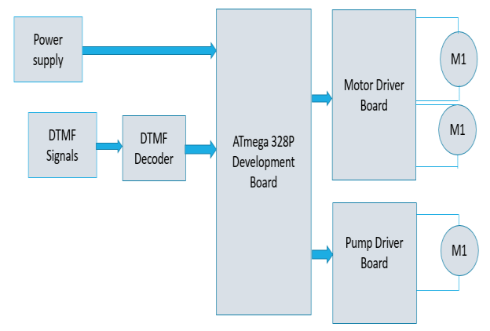

Fig 3.1.1: Proposed Model

The proposed show could be a compact, portable fire battling mechanical car outlined to identify and quench small-scale fires independently or by means of farther control. The robot is built on a wheeled chassis and is prepared with fire sensors for fire discovery, a microcontroller (such as Arduino) for control and decision-making, and a engine driver to function the drive engines.

Upon identifying a fire, the sensors send a flag to the microcontroller, which at that point commands the robot to move toward the fire source. Once the robot comes to the fire, it enacts its quenching mechanism—typically a little water pump or fan system—to stifle the fire. The framework works employing a rechargeable battery pack and can alternatively be controlled through remote modules such as Bluetooth for manual operation. .

**3.2 REQUIREMENTS**

**3.2.1 Hardware Components**

**i. Arduino:** It is an open-source electronics platform based on easy-to-use hardware and software. It consists of a microcontroller—a small computer on a single integrated circuit—that can be programmed to sense and control objects in the physical world. Arduino boards are equipped with sets of digital and analog input/output (I/O) pins that can interface with various sensors, motors, lights, and other electronic components. The platform is popular among hobbyists, students, and professionals due to its simplicity, flexibility, and strong community support. Arduino uses its own programming language, based on C/C++, and provides an integrated development environment (IDE) that makes it easy to write and upload code to the board. It is widely used in DIY projects, robotics, home automation, and interactive art installations.

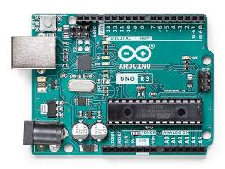

Fig 3.2.1: Arduino

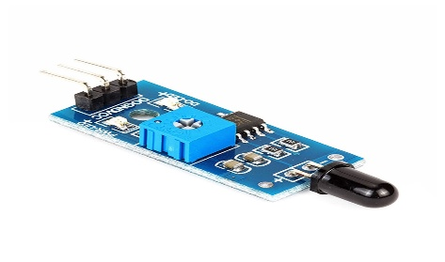**ii. IR 4 pin Flame sensors** **:** An IR (Infrared) 4-pin fire sensor is an electronic component outlined to identify the nearness of a fire or fire source by detecting infrared light radiated by flares. It ordinarily incorporates an IR recipient (like a photodiode or phototransistor) that's delicate to the particular wavelength of infrared radiation delivered by combustion (as a rule around 760 nm – 1100 nm).

Fig 3.2.2:IR Flame Sensor

**iii. BO Motors :** BO (Battery Worked) engines are little DC equipped engines commonly utilized in leisure activity mechanical technology and hardware ventures. These engines are lightweight, low-cost, and simple to interface with microcontrollers through engine drivers. They regularly work on 3V to 12V DC and offer direct torque, making them perfect for applications like little mechanical cars.

BO engines are accessible in numerous adapt proportions, permitting control over speed and torque. The yield shaft can be straightforwardly associated to wheels or gears, making them appropriate for driving automated stages. They are basic, solid, and idealize for essential development in DIY mechanical autonomy ventures, such as a fire battling robot.

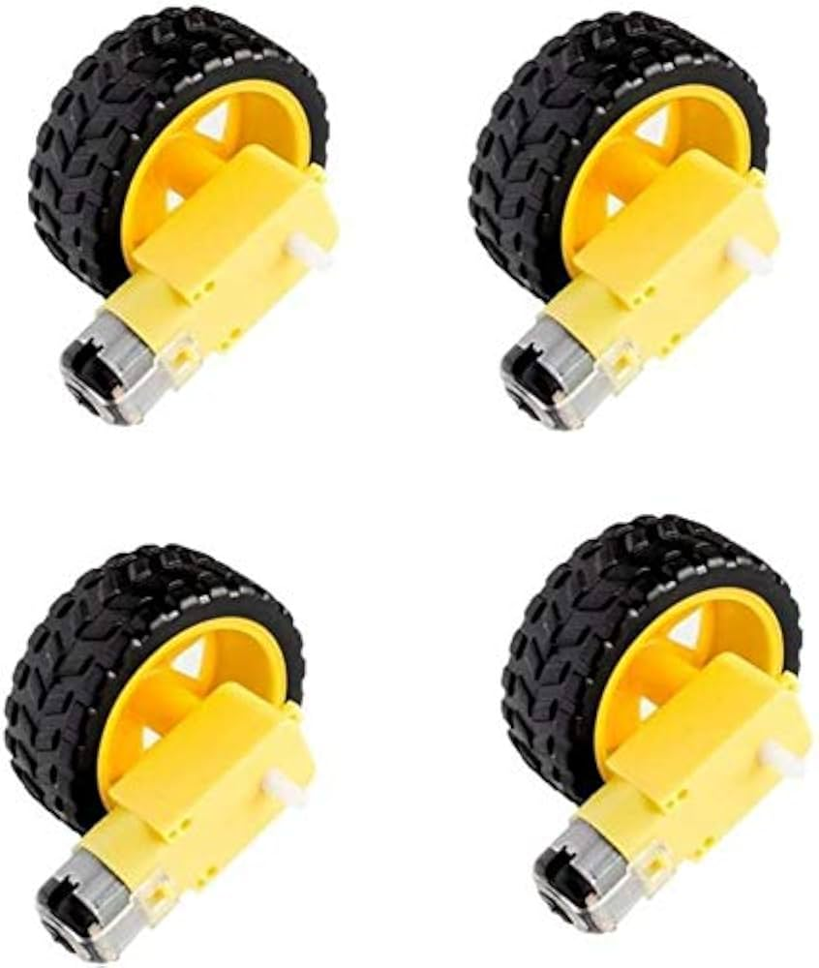

Fig 3.2.3: BO Motors

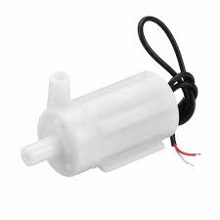**iv.Water Pump:**The Water Pump is a key actuator in the smart irrigation system. It is responsible for supplying water to the plants in the field or greenhouse whenever the soil moisture sensor detects a low moisture level. The pump operates using DC or AC electrical power to drive a motor that creates pressure and moves water through connected pipes or tubing.

Fig 3.2.4: Water Pump

**v. Jumper wires:** These are connecting wires. It is a very essential part of IOT application. It can be male to male, male to female, or female to female.

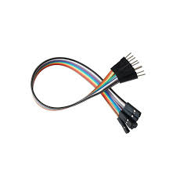

Fig 3.2.5: Jumper Wires

**vi. L298 Motor Driver :** The L298 motor driver may be a double H-Bridge engine driver IC that permits control of the course and speed of two DC engines at the same time. It is broadly utilized in mechanical autonomy and mechanization ventures due to its capacity to handle tall current (up to 2A per channel) and voltage (up to 46V). The driver can too be utilized to control stepper engines.

The module regularly incorporates input pins for control signals from a microcontroller (like Arduino), yield pins to put through DC engines, and a isolated control supply input for engine voltage. It moreover highlights empower pins for controlling engine speed by means of PWM signals and heading control pins for forward and invert revolution.

In a fire battling robot, the L298 engine driver plays a pivotal part in overseeing the robot's development by driving the BO engines based on commands from the microcontroller.

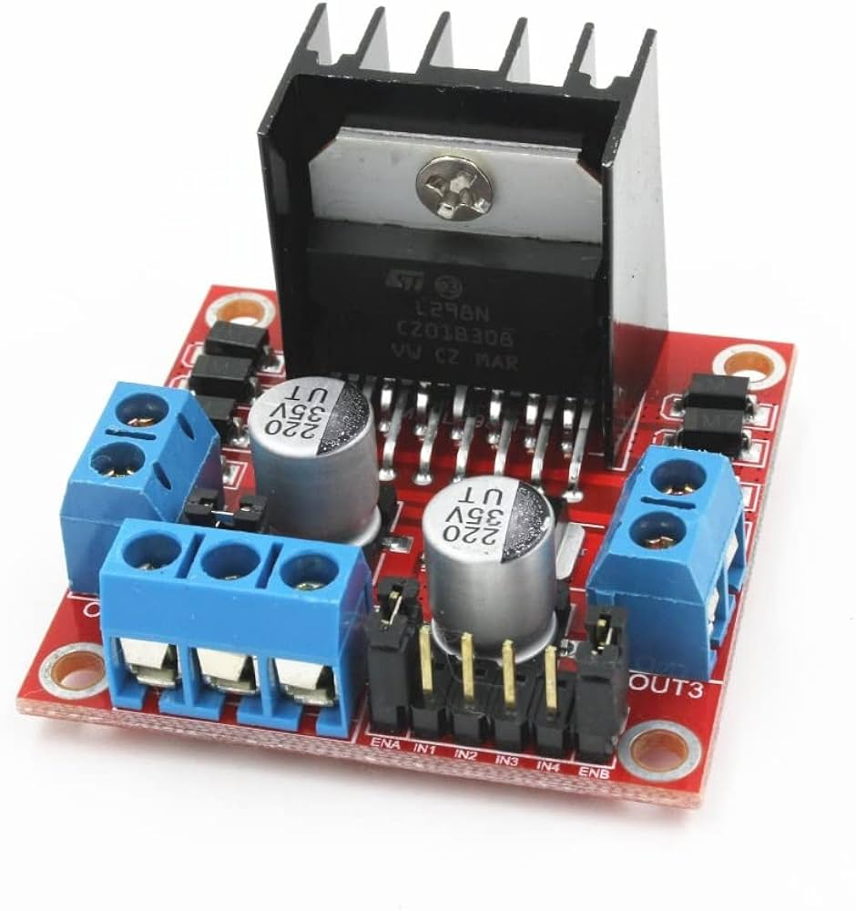

Fig 3.2.6 : L298 Motor Driver

**vii. Mini Servo**: A mini servo engine may be a little, lightweight actuator commonly utilized in mechanical technology for exact precise development. It ordinarily works on 4.8V to 6V and can pivot inside a run of 0° to 180°, controlled by means of PWM (Beat Width Tweak) signals from a microcontroller.  
Smaller than expected servos comprise of a little DC engine, a control circuit, and a set of gears, all encased in a compact case. They are perfect for applications requiring precise situating, such as controlling levers, arms, or components just like the fire quencher spout in a fire battling robot. Their moo control utilization, ease of control, and exact movement make them a well known choice.

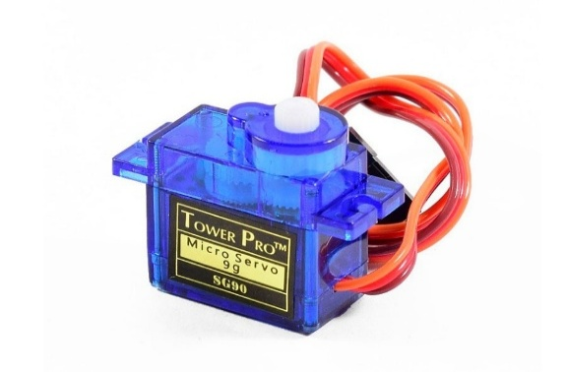

Fig 3.2.7: Servo Motor SG90

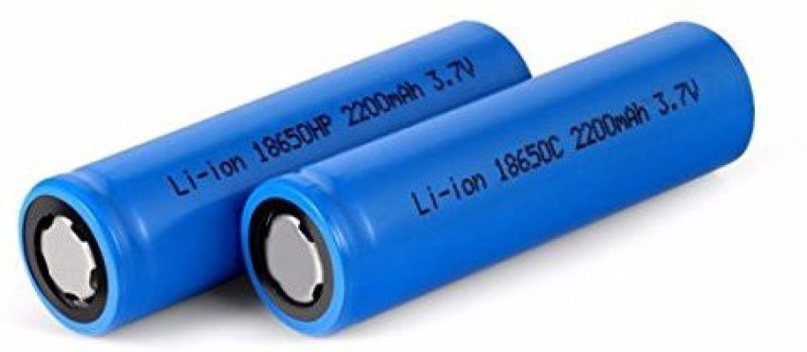**viii. 3.7V li-ion Battery :** The 18650 Li-ion battery may be a round and hollow rechargeable cell commonly utilized in gadgets and mechanical technology. Each cell typically provides 3.7 volts ostensible voltage and features a capacity extending from 2000 to 3500 mAh, depending on the demonstrate.

Fig 3.2.8: 3.7V Li-ion Battery

**3.2.2. Software used**

**i.** **Arduino IDE:** The Arduino IDE (Integrated Development Environment) is the official software platform used to write, compile, and upload programs to Arduino boards such as the Arduino Uno. It is simple, open-source, and widely used in educational and hobby electronics projects. The IDE provides a text editor where users can write code using a simplified version of C/C++, with two main functions: setup() for initialization and loop() for continuous execution. The built-in Verify button checks the code for errors, while the Upload button transfers the compiled code to the Arduino board via a USB cable. The Serial Monitor tool allows users to view real-time data from the board, which is especially useful for debugging sensor readings or output values.For practical lab sessions, students typically connect the Arduino Uno to their computer using a USB A-B cable. After launching the Arduino IDE, they select the correct board from Tools > Board > Arduino Uno, and the correct port from Tools > Port (e.g., COM3). Once configured, students write or load a sketch (e.g., a simple LED blink program), verify it to check for syntax errors, and upload it to

Fig 3.3.1: Arduino IDE

the board. Upon successful upload, the microcontroller executes the code, and students can observe outputs—such as LEDs blinking, sensors measuring temperature or distance, or values being printed to the Serial Monitor.

**3.2.3. Language Used**

**i. C/C++:** The Arduino programming language is based on C and C++, two of the most powerful and widely-used programming languages in the world. While it uses the syntax and structure of standard C++, the Arduino IDE simplifies the process by providing a set of predefined functions and hiding complex boilerplate code. For example, instead of writing a main() function, Arduino programs (called sketches) use two main functions: setup() and loop(). The setup() function runs once when the board is powered on or reset, while the loop() function runs continuously, making it ideal for controlling hardware behavior.

**3.3.** **Connections**

|  |  |  |  |  |
| --- | --- | --- | --- | --- |
| **Component** | **VCC** | **GND** | **Signal/Data pin** | **Connected to(Arduino Pin)** |
| Aurdino | VCC (3.3V or 5V) | GND | A0 | A0,A1,A2,A3,A4,A5,A6 |
| Flame Sensor (X3) | VCC (5V) | GND | Data | |  | | --- | |  |  |  | | --- | | D2,D3,D4,D5,D9,D0 | |
| BO motors(X4) | VCC (5V) | GND | IN | |  | | --- | |  |  |  | | --- | | D3 | |
| Water Pump | Powered via Relay | GND (via relay) | — | Controlled by L298 |
| L298 motor Driver | VCC (5V) | GND | SDA, SCL | A4 (SDA), A5 (SCL) |
| NPN transistor | VCC(5V) | GND(5V) |  | Water Pump (12V) |
| Battery | 9V or 12V (via barrel jack) | GND | |  | | --- | |  |  |  | | --- | | — | | Powers Arduino & Pump |

**3.3.1 system Architecture Fire Fighting Robo Car:-**

**3.3.2 Importance :-**

The fire-fighting robot car could be a completely independent fire location and concealment framework, built utilizing an Arduino-based stage. It coordinating three fire sensors associated to analog pins A0, A1, and A2 to persistently filter the environment and identify the heading of a fire. The robot employments four BO engines (100 RPM) for development, controlled by an L298N engine driver that gets directional and speed signals from the Arduino by means of computerized pins. Based on the flame's position, the robot navigates forward, in reverse, or turns left/right to approach the fire.

Mounted on best is an SG90 servo engine associated to stick A4, which turns a water spout to clear and point amid quenching. The scaled down water pump (6–9V) is driven by a TIP122 NPN transistor, with its base controlled by means of stick A5 through a 1kΩ resistor. The framework is fueled by three 3.7V 18650 lithium-ion cells in arrangement (totaling ~11.1V), and enacted through a fundamental switch. The plan emphasizes real-time fire following, portability, and centered quenching.

# 4. DESIGN & IMPLEMENTATION

* 1. **Detailed design & Coding:**

1. 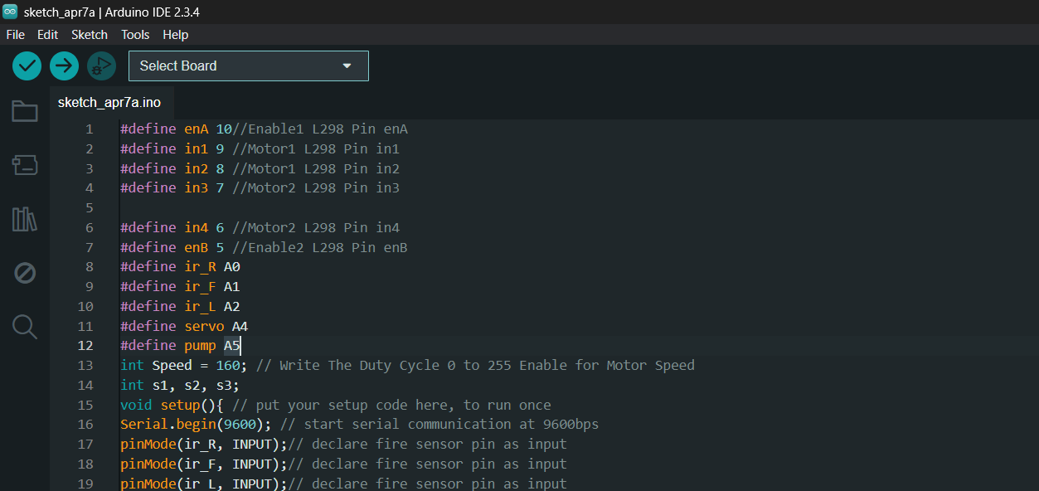**Fire Fighting Robo-Car Coding**

**Fig 4.1:** Arduino code for automatic irrigation using soil moisture sensor.

* 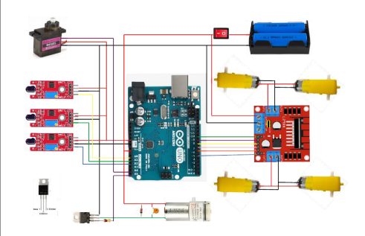Fire Fighting Robo Car Circuit Design :

**Fig 4.2:** Detailed Circuit Diagram

# 5. RESULTS & DISCUSSION

The fire-fighting robot car effectively recognized and quenched little blazes utilizing fire sensors and a water pump framework. The fire sensors (A0, A1, A2) viably recognized fire heading, permitting the robot to explore toward the source. The BO engines, controlled by means of the L298 driver, empowered smooth development, and the SG90 servo turned the water spout to splash water-precisely.  
The TIP122-controlled water pump worked well for small-scale fires like candles. Control was provided by a 7.4V (2S) 18650 Li-ion battery pack, giving steady execution for around 25 minutes.  
A few impediments were watched in shinning light conditions, which influenced fire sensor precision. By and large, the robot worked dependably in controlled situations and illustrated its capacity to independently find and quench fire. 5.1 Experimental Setup (Fire Fighting Robo Car)

The experimental setup for the smart water irrigation system was developed using an Arduino UNO microcontroller, a Mini Servo, a L298 Motor , and a mini water pump. The components were assembled on a breadboard and connected using jumper wires.

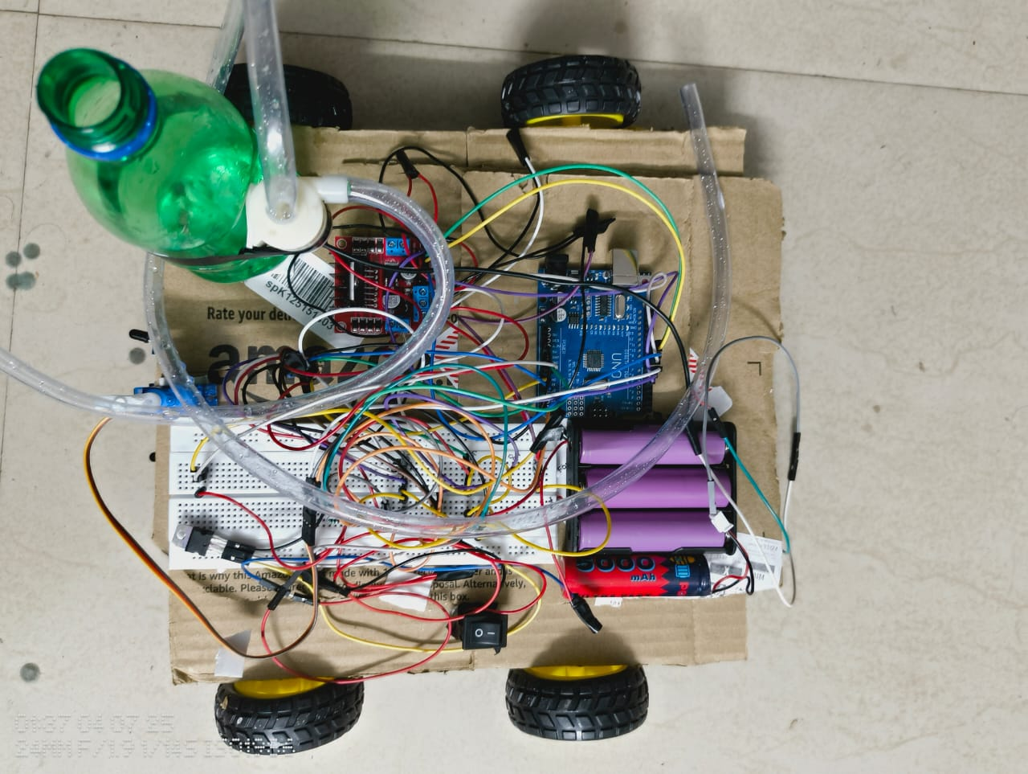

**Fig 5** : Fire Fighting Robo Car real time original base model

**5.2 Experimental Setup (Fire-Fighting Robo Car)**

The fire-fighting robot car was tried inside employing a little controlled fire (like a candle). It was prepared with 3 fire sensors (A0, A1, A2) to distinguish fire course, BO engines for development (by means of L298 engine driver), and a scaled down water pump controlled by a TIP122 transistor. An SG90 servo engine turned the spout to shower water. Control was provided by two 18650 Li-ion batteries (7.4V).

The robot independently found the fire, moved toward it, ceased at a secure remove, and enacted the water pump to quench the fire.

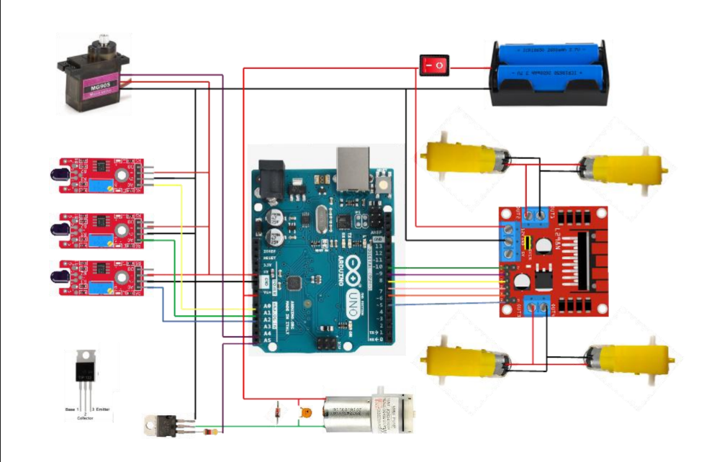

**Fig 5.2 :** Circuit Diagram

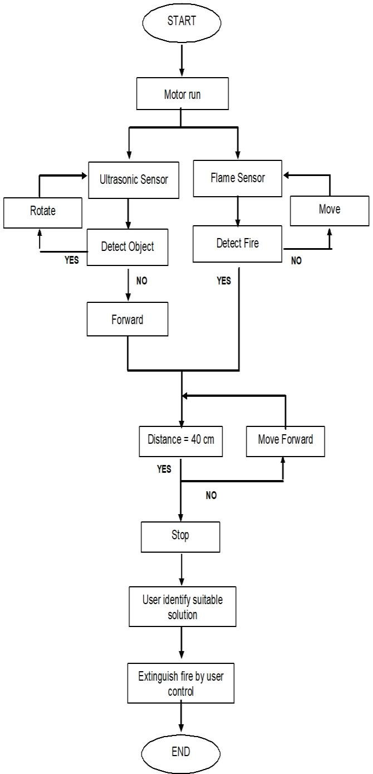

**Fig 5.3:** Working Algorithm

**CONCLUSION**

The IoT-based fire battling robot was effectively outlined and actualized to identify and quench little fires independently. By joining fire sensors, a water-spraying component, and engine control with real-time decision-making, the robot illustrated compelling fire location and concealment in controlled situations.

The utilize of IoT components (e.g., potential for inaccessible checking or cautions) includes esteem by empowering future upgrades such as real-time information logging, inaccessible control, or integration with shrewd security frameworks. This extend appears promising potential for utilize in situations where human mediation is unsafe, such as homes, stockrooms, or labs.

Generally, the framework demonstrated to be a cost-effective, adaptable, and utilitarian model for early fire reaction.

# BIBLIOGRAPHY

1. "Fire Fighting Robot" by Rasika Sohani, Shruti Somoshi, Vaishnavi Tayade, and Amruta Kapse. This paper talks about the plan of a fire-fighting robot controlled utilizing an Arduino Uno microcontroller, joining sensors for fire discovery and concealment.
2. **"**Independent Fire Battling with a UAV-UGV Group at MBZIRC 2020" by Jan Quenzel et al. This think about presents the improvement of independent airborne and ground robots planned to identify and quench fires, enumerating their support within the MBZIRC 2020 competition.
3. "Design and Deployment of an Independent Unmanned Ground Vehicle for Urban Firefighting Scenarios" by Kshitij Jindal et al. This inquire about addresses the plan and independent arrangement of a ground vehicle prepared with a automated arm for firefighting in urban situations, approved through tests and competition support.
4. "Independent Automated Fire Discovery and Quenching Framework" by creators on ResearchGate. This work proposes an independent robot framework that can identify fire utilizing fire sensors and quench it, joining components like Arduino UNO and Bluetooth modules.
5. "Plan of Shrewdly Fire-Fighting Robot Based on Multi-Sensor Combination" distributed in ScienceDirect. This paper examines the plan of an brilliantly fire-fighting robot utilizing multi-sensor combination, emphasizing its programmed review and fire-fighting capabilities.
6. "Fire Benefit Applications of Robots: A Writing Audit" by the National Fire Assurance Affiliation (NFPA). This writing survey summarizes the applications of robots in firefighting, counting real-world case thinks about.
7. "An Proficient Firefighting Strategy for Robotics: A Novel Convolution..." distributed in ScienceDirect. This investigate gives an inventive arrangement for independent firefighting strategies for robots, illustrating its adequacy and potential.
8. "Improvement of Fire Battling Robot (QRob)" by creators on ResearchGate. This paper presents the advancement of a compact firefighting robot planned to quench fires without uncovering firefighters to pointless threat.