**MuraMED**

Calibri 12 justified text

Harvard style bibliography like the ones below

**MuraMED Application Fields/Industries:**

* Medicine/Hospitals
* Sports Organizations & Schools
* Private Organizations for employees health/workplace

**MuraMed: AI-Assisted Musculoskeletal Radiograph Analysis (Hospitals/Mediine Field)**

MuraMed aims to redefine the realm of musculoskeletal radiography. By leveraging advanced deep learning techniques, this solution offers an unparalleled diagnostic tool for radiologists and orthopedic doctors, ensuring timely, accurate, and efficient detection of musculoskeletal abnormalities.

**Key Features:**

* Diagnostic Support: MuraMed offers an AI-backed second opinion for professionals, thereby enhancing diagnostic accuracy by spotlighting potential areas of concern in radiographs.
* Telemedicine Capabilities: In regions that lack specialized radiologists, MuraMed delivers a preliminary analysis, ensuring diagnostic services reach even the most remote corners.
* Seamless PACS Integration: MuraMed effortlessly integrates with existing hospital systems, offering instantaneous analysis upon radiograph upload, thereby optimizing the diagnostic process.
* Adaptive Learning: With each deployment, MuraMed evolves, drawing from diverse datasets to refine its diagnostic capabilities, ensuring heightened accuracy and reliability.

**Monetization Streams:**

* A diverse subscription model tailored to meet the needs of hospitals, clinics, and individual practitioners.
* A pay-per-use model, ideal for infrequent users or smaller healthcare establishments.
* Bespoke model training, tuning, and implementation services, ensuring the AI is tailored to specific demographics or equipment.

**Potential Challenges:**

Navigating the healthcare tech landscape demands a meticulous approach. Adhering to regulatory guidelines, ensuring robust data privacy measures, and fostering a close-knit collaboration with medical professionals are paramount. This ensures MuraMed is technologically robust while also catering to the pragmatic needs of its user base.

**Understanding PACS in the Context of MuraMed (subsection under PACS)**

Since MuraMed seeks to revolutionize the domain of musculoskeletal radiography. By harnessing the capabilities of cutting-edge deep learning methodologies, we present an unmatched diagnostic aid for radiologists and orthopedic specialists, ensuring prompt, precise, and efficient identification of musculoskeletal irregularities.

To be more precise, Picture Archiving and Communication System (PACS) is a medical imaging technology that provides economical storage and convenient access to images from various modalities. It's a synergy of hardware, software, and networking solutions that enables the capture, distribution, and display of medical images. PACS eradicates the need for tangible film, offering clinicians the advantage of remote access to view and diagnose from any location (*See the pictures below*).

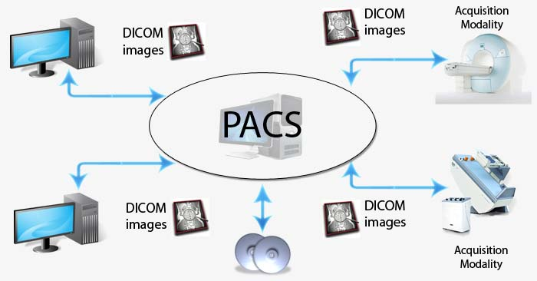

Figure X: The pathways of PACS: The foundational structure enabling MuraMed's seamless integration and rapid analysis within hospital systems.

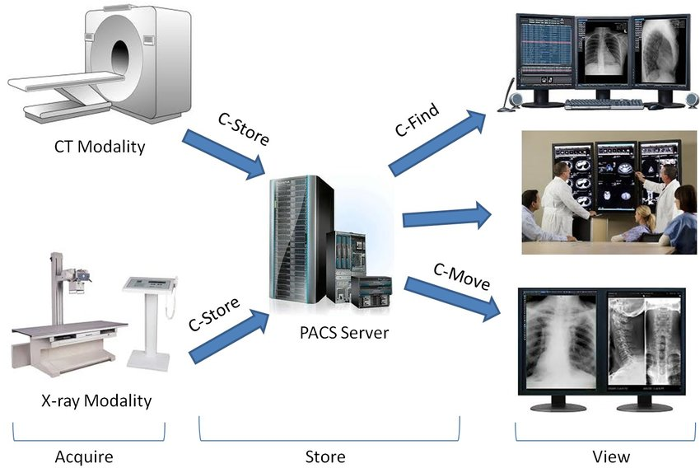

Figure X: Colorful streams of data flow: A visualization of the PACS network, channeling radiographic information to MuraMed for AI-assisted diagnostics.

**MuraMed: School & Sports Team Edition**

Extend MuraMed's capabilities to cater specifically to the needs of schools and sports teams, ensuring timely and accurate detection of musculoskeletal abnormalities in young athletes and students.

**Business Process & Reasons:**

1. **Early Injury Detection for Athletes:**

Process: Schools and sports teams can use MuraMed to scan their athletes at the beginning and end of every sports season. This aids in early detection of any musculoskeletal issues that might have arisen due to sports activities.

Reason: Early detection can help in prompt treatment, ensuring the athlete's long-term health and performance aren't compromised.

1. **Post-Injury Rehabilitation Monitoring:**

Process: For athletes recovering from injuries, regular scans can monitor the healing process and detect any complications.

Reason: Regular monitoring ensures that athletes are only allowed back in the game when fully recovered, reducing the risk of re-injury.

1. **Physical Education Class Health Check:**

Process: Schools can use MuraMed for students in physical education classes to ensure they are in optimal musculoskeletal health.

Reason: It can help detect early signs of conditions like scoliosis in students, allowing for early interventions.

1. **Integration with Sports Biomechanics:**

Process: MuraMed can be integrated with tools that analyze athletes' biomechanics, comparing their movement patterns with radiographic findings.

Reason: This helps in understanding if an athlete's movement patterns are contributing to musculoskeletal issues.

1. **Athlete's Health Passport:**

Process: Create a digital health passport where an athlete's radiographs, AI analyses, and doctor's notes are stored chronologically.

Reason: This provides a comprehensive view of an athlete's musculoskeletal health over time, useful for coaches, physiotherapists, and other medical professionals involved in the athlete's care.

1. **Educational Workshops:**

Process: Offer workshops to physical education teachers, coaches, and sports team medical staff on understanding radiographs, the importance of early detection, and how to use MuraMed effectively.

Reason: Educated stakeholders can make better decisions for the health of students and athletes.

1. **Collaboration with Sports Equipment Manufacturers:**

Process: Collaborate with sports equipment manufacturers to analyze if certain types of equipment (e.g., shoes, protective gear) contribute to musculoskeletal issues.

Reason: This can lead to the design of better equipment that reduces the risk of injury.

**Monetization Streams:**

* Package Deals: Offer package deals to schools and sports teams for scanning multiple students or athletes.
* Subscription Model: Schools and sports academies can subscribe on a yearly basis for continuous monitoring.
* Workshop Fees: Charge for the educational workshops offered.
* Data Analysis for Equipment Manufacturers: Charge sports equipment manufacturers for the analysis done to test their equipment.

**Reason to exist:**

With an increasing emphasis on sports and physical activities in schools, the health of young athletes and students is paramount. By introducing MuraMed to these institutions, we can ensure early detection, prompt treatment, and overall better musculoskeletal health for the younger generation.

**MuraMed: Workplace Edition**

To provide a specialized solution for workplaces, focusing on the early detection, monitoring, and management of work-related musculoskeletal disorders, particularly those affecting the neck and upper limbs.

**Applications & Reasons:**

1. **Routine Employee Screening:**

Application: Offer regular screenings for employees, especially those in jobs with high physical demands or repetitive tasks.

Reason: Early detection of musculoskeletal disorders can lead to timely interventions, reducing the severity and duration of the condition.

1. **Post-Injury Monitoring:**

Application: For employees recovering from work-related injuries, MuraMed can provide regular scans to monitor the healing process.

Reason: This ensures that employees return to work only when fully recovered, reducing the risk of re-injury and long-term complications.

1. **Ergonomic Assessment Integration:**

Application: Integrate MuraMed's findings with ergonomic assessments to tailor workplace setups for individual employees.

Reason: By understanding the specific musculoskeletal issues an employee faces, workplaces can adjust seating, computer setups, or workstations to reduce strain.

1. Employee Health Portal:

Application: Create a digital health portal where employees can track their screenings, AI analyses, and recommended interventions.

Reason: Empowering employees with knowledge about their musculoskeletal health can lead to proactive health decisions and better adherence to recommended interventions.

1. Collaboration with Occupational Health Providers:

Application: Partner with occupational health providers to offer a comprehensive health solution that includes MuraMed screenings, physical therapy, and ergonomic interventions (lots of big companies that we will target already have some related partners).

Reason: A holistic approach to employee health can lead to better outcomes and reduced costs in the long run.

**Monetization Streams:**

* Corporate Packages: Offer package deals to companies for scanning large numbers of employees.
* Subscription Model: Companies can subscribe on a yearly basis for continuous monitoring and access to the employee health portal.
* Workshop Fees: Charge for the educational workshops provided.

**Reason to exist:**

Given the significant impact of work-related musculoskeletal disorders on employee health, productivity, and associated costs, MuraMed's Workplace Edition aims to address this pressing issue. By providing timely detection, tailored interventions, and a holistic approach to musculoskeletal health, this solution has the potential to significantly benefit both employees and employers within the European Union and beyond.

**Future Thoughts**

Mobile Application: Develop a mobile application where doctors can upload radiographs directly and receive instant AI-generated feedback, making it a handy tool for on-the-go diagnosis.

Patient Portal: A portal where patients can track their radiographs, AI analysis, and doctor's notes. This fosters transparency and empowers patients with knowledge about their health.

Interactive 3D Visualization: Integrate a tool that converts 2D radiographs into interactive 3D models, using AI to highlight areas of concern. This aids doctors in understanding the issue better and can be a valuable tool for patient education.

AI-driven Recommendations: Post-diagnosis, the system can recommend potential treatments or rehabilitation exercises, based on the detected abnormalities.

Integration with Wearable Tech: Collaborate with wearable technology providers to predict potential musculoskeletal issues based on data like posture analysis, thereby offering preventive care.

Move and create a pets version MuraMed Pets.

**Bibliography**:

1. Buckle, P.W. & Devereux, J.J., 2002. The nature of work-related neck and upper limb musculoskeletal disorders. *Applied Ergonomics*, 33(3), pp.207-217. Available at: https://doi.org/10.1016/S0003-6870(02)00014-5 [Accessed Date: 23 August 2023].

2. Colombini, D. & Occhipinti, E., 2006. Preventing upper limb work-related musculoskeletal disorders (UL-WMSDS): New approaches in job (re)design and current trends in standardization. *Applied Ergonomics*, 37(4), pp.441-450. Available at: https://doi.org/10.1016/j.apergo.2006.04.008 [Accessed Date: 23 August 2023].

- **Dimitra**

**Business Case: MuraMED - Transforming Radiology with AI**

**MuraMED** is a healthcare technology company specializing in bone abnormality detection. Our primary solution is an AI-powered diagnostic system designed to aid radiologists and healthcare experts in spotting irregularities in bone X-ray images. The core objective of this technology is to enhance the precision, productivity, and speed of diagnosing musculoskeletal issues, ultimately resulting in improved patient well-being.

**Introduction**

In the rapidly evolving healthcare landscape, embracing advanced technologies has become crucial for improving patient care and healthcare operations. MuraMED, our innovative initiative, is leading this transformation. We're using Artificial Intelligence (AI) to change the way radiology and X-ray imaging work.

MuraMED addresses a significant challenge faced by healthcare facilities, radiologists, and orthopedic doctors - accurately and quickly spotting issues in X-ray images. While traditional methods work, they can be slow and prone to human errors. Our AI-driven solution not only speeds up the diagnosis process but also makes it more accurate. This allows healthcare providers make informed decisions faster.

**The Vision**

At MuraMED, we aim to make advanced radiological diagnostics available to healthcare facilities of all sizes, from large hospitals to small clinics. Our goal is to provide healthcare professionals with AI tools that enhance their skills, offering second opinions and ensuring even complicated cases get precise diagnoses.

**Mura Datasets**

MuraMED utilizes MURA datasets, which are extensive collections of musculoskeletal radiographs. These datasets are the foundation of our AI models, allowing us to provide top-notch diagnostic capabilities.

**Business Model Canvas: MuraMED**

**1. Key Partnerships:**

* **Radiologists & Orthopedic Doctors:** Collaborate with medical experts for feedback and continuous improvement of AI models.
* **Hospitals & Clinics:** Establish partnerships for deployment and integration of AI-assisted diagnostics.
* **Regulatory Bodies:** Engage with healthcare regulatory authorities for necessary approvals and compliance.
* **Medical Schools:** Partner with educational institutions for the deployment of AI tools in medical education.

**2. Key Activities:**

* **Model Training & Continuous Learning:** Develop and refine AI models for accurate diagnosis, ensuring continuous learning from medical data.
* **Integration with PACS:** Seamlessly integrate with Picture Archiving and Communication Systems (PACS) used in healthcare.
* **Data Augmentation & Pre-processing:** Enhance the quality and diversity of medical data through data augmentation and preprocessing.
* **Regulatory Compliance & Certifications:** Ensure compliance with healthcare regulations and attain necessary certifications.
* **Customer Support & Training:** Provide robust customer support and training to healthcare professionals and institutions.

**3. Key Resources:**

* **MURA Dataset and Additional Data:** Access to a diverse and extensive dataset is foundational to our AI model's training and continuous improvement.
* **Deep Learning Infrastructure:** Cutting-edge infrastructure, including GPUs and servers, is essential for model training and real-time diagnostics.
* **Medical Expertise:** Collaboration with radiologists and orthopedic doctors ensures the clinical relevance and accuracy of our AI models.
* **Development & Tech Team:** A skilled team of AI developers and engineers drives the development, deployment, and maintenance of our solutions.

**4. Value Propositions:**

* **AI-assisted accurate diagnosis:** Our AI models are trained on extensive datasets, enabling them to detect abnormalities in X-rays with remarkable precision, acting as a valuable aid to radiologists and orthopedic doctors.
* **Second opinion for radiologists:** MuraMED doesn't replace human expertise; it enhances it. Radiologists can now receive AI-generated second opinions, reinforcing diagnostic confidence.
* **Telemedicine support for remote areas:** MuraMED's cloud-based architecture facilitates telemedicine, extending diagnostic capabilities to underserved regions and remote clinics.
* **Continuous learning for improved accuracy:** Our AI models continuously learn from new data, ensuring that they stay updated with evolving medical knowledge.
* **PACS integration for seamless workflow:** MuraMED integrates seamlessly with Picture Archiving and Communication Systems (PACS), streamlining the diagnostic workflow within healthcare institutions.
* **Scalable and cost-effective AI infrastructure:** We've partnered with AI hardware providers to offer scalable and cost-effective infrastructure solutions, making AI adoption feasible for healthcare providers of all sizes.

**5. Customer Relationships:**

* **Subscription Support:** Provide responsive support for subscription-based customers.
* **Training Sessions for Medical Staff:** Offer training sessions to ensure the effective use of our AI tools.
* **Regular Updates & Feedback Sessions:** Keep customers informed with regular updates and gather feedback for improvements.
* **Online Portal for Account Management:** Facilitate easy account management and support through an online portal.

**6. Channels:**

* **Direct Sales to Hospitals & Clinics:** Engage in direct sales to healthcare institutions for seamless integration.
* **Online Portal for Subscription & Pay-per-Use:** Enable online subscription and pay-per-use services for individual users.
* **Partnerships with Medical Conferences & Workshops:** Collaborate with medical events for exposure and adoption.
* **Integration with Telemedicine Platforms:** Integrate our AI solutions with telemedicine providers' platforms.

**7. Customer Segments:**

* **Hospitals & Large Clinics:** Offer comprehensive AI solutions for healthcare facilities.
* **Individual Radiologists & Orthopedic Doctors:** Provide individual practitioners with AI tools for enhanced diagnostics.
* **Medical Schools & Training Institutes:** Support educational institutions with AI-based learning tools.
* **Telemedicine Service Providers:** Collaborate with telemedicine platforms to extend diagnostic capabilities.

**8. Cost Structure:**

* **Infrastructure & Hosting Costs:** Cover expenses related to AI infrastructure and
* **Research & Development:** Allocate resources for continuous model improvement and development.
* **Regulatory Compliance & Certification Costs:** Ensure adherence to healthcare regulations and certifications.
* **Marketing & Sales:** Invest in marketing and sales efforts to reach healthcare institutions and practitioners.
* **Employee Salaries & Benefits:** Compensate the skilled team of developers and medical experts.

**9. Revenue Streams:**

* **Subscription Fees from Hospitals & Clinics:** Generate recurring revenue from healthcare institutions.
* **Pay-per-Use Fees:** Offer flexible payment options for individual users.
* **Custom Model Training & Implementation Services:** Provide tailored AI model training and implementation for specific needs.
* **Educational Licensing for Medical Schools:** License AI-based learning tools to medical schools and training institutes.