mkelight server and usre guide

## SERVER GUIDE

1. AWS SERVER
   1. <https://aws.amazon.com/>

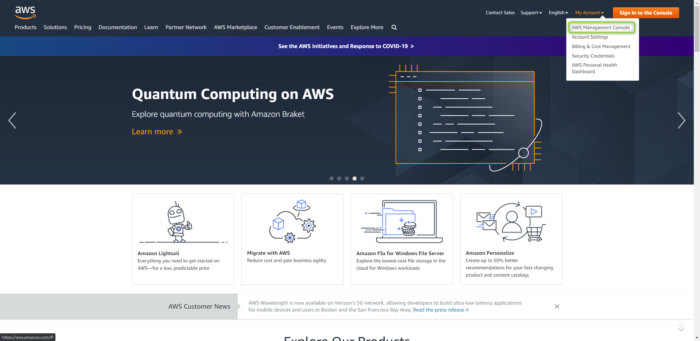

* 1. Login as IMA user

User name/Password: Dmitriy/dmitriy

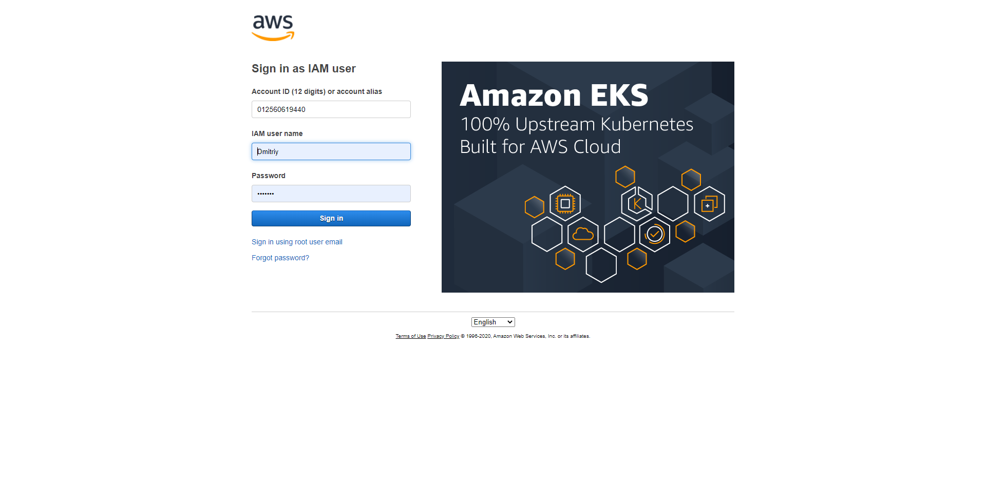

* 1. Server Instance(EC2)

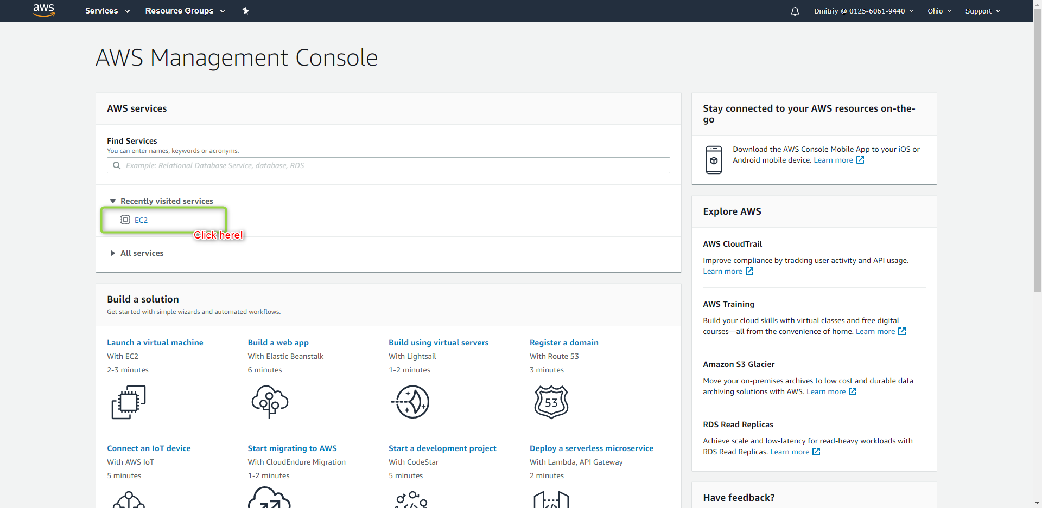

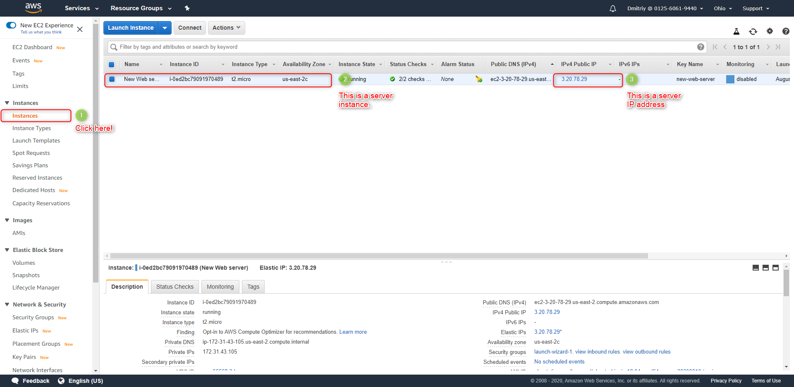

* 1. The server Information

User name: ubuntu

Ssh key: new-web-server.pem



* 1. Check the server

Open the browser(Chrome etc) and go to the following URL.

<http://3.20.78.29/>

If you can visit the following page, the server is running.

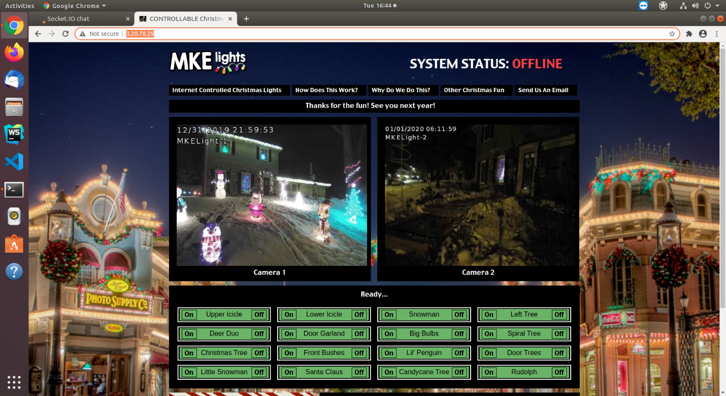

1. Connect to aws server with ssh(on Ubuntu)
   1. Open the terminal on ubuntu and copy the ssh key(new-web-server.pem) file to ubuntu.

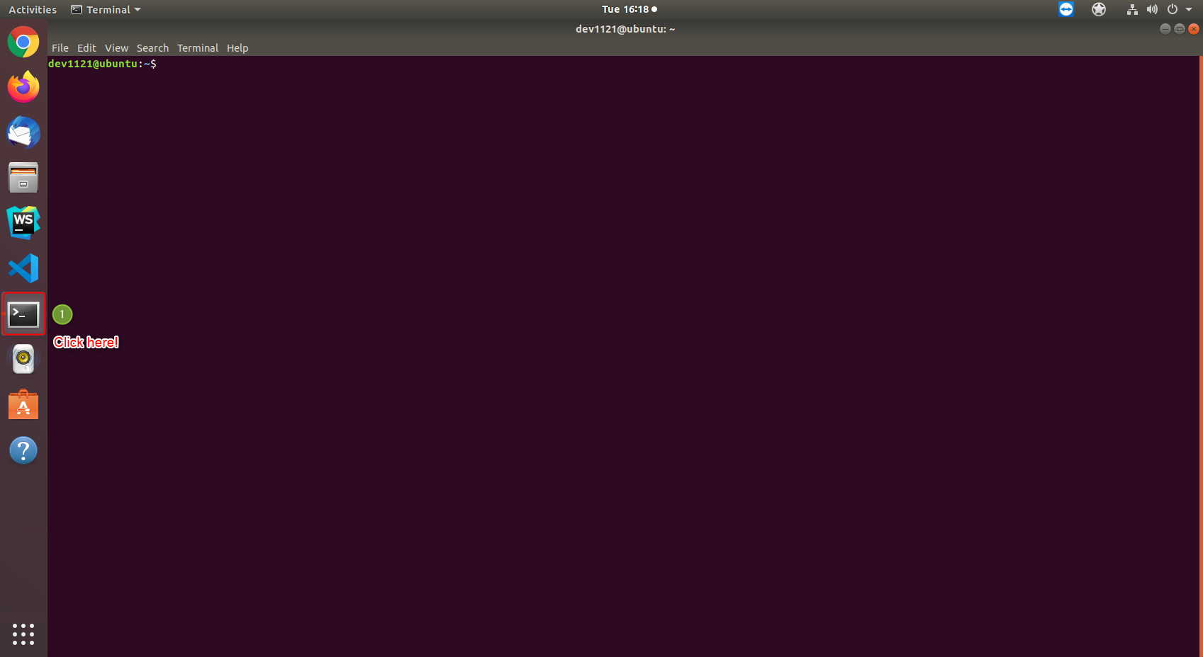

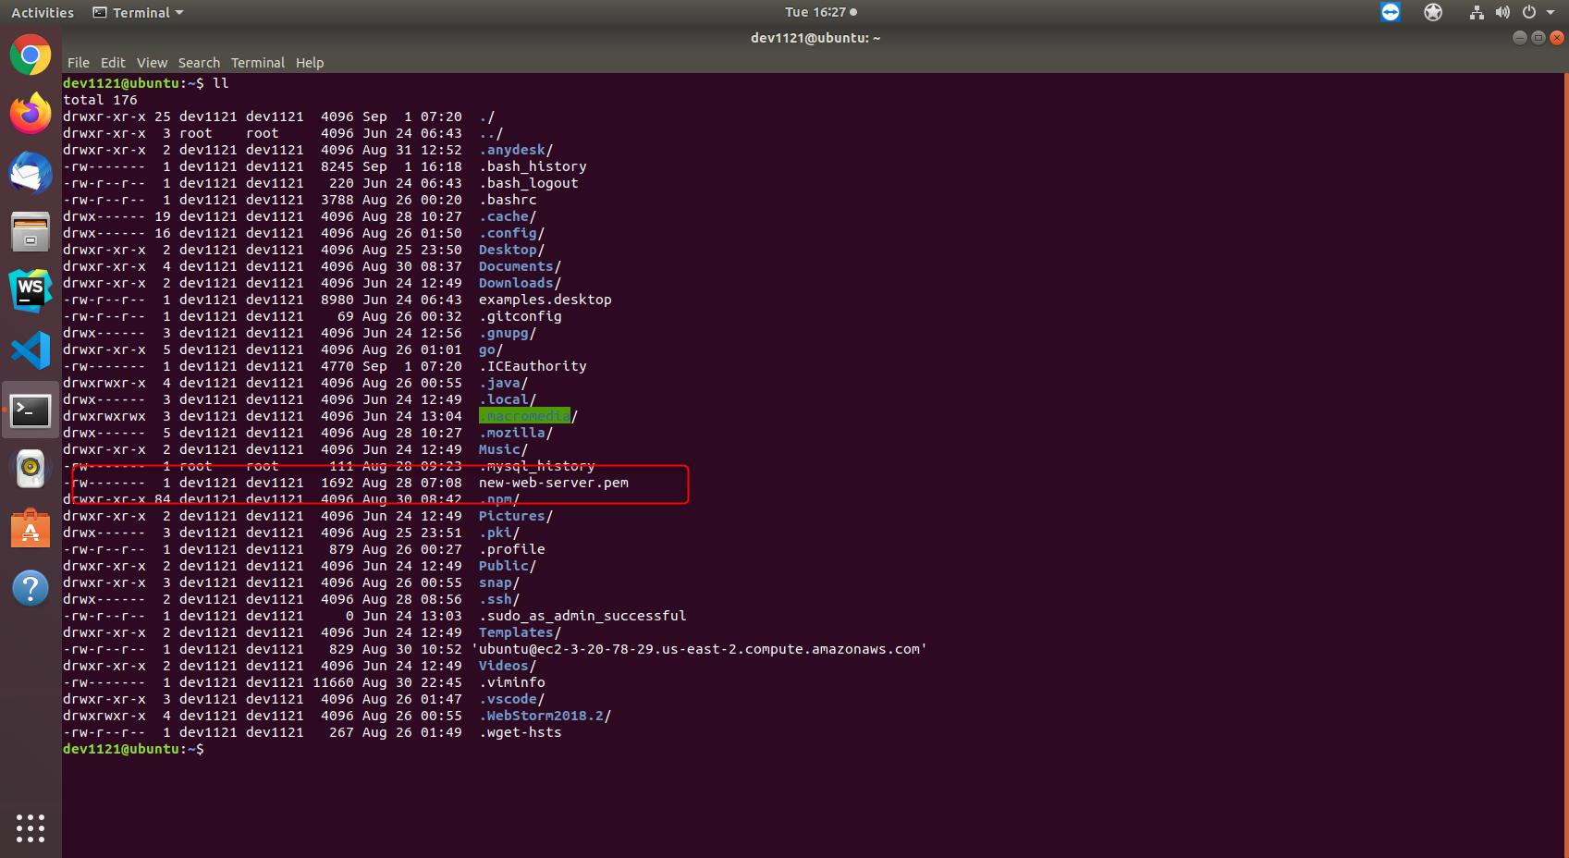

* 1. Copy the Public DNS on aws site page

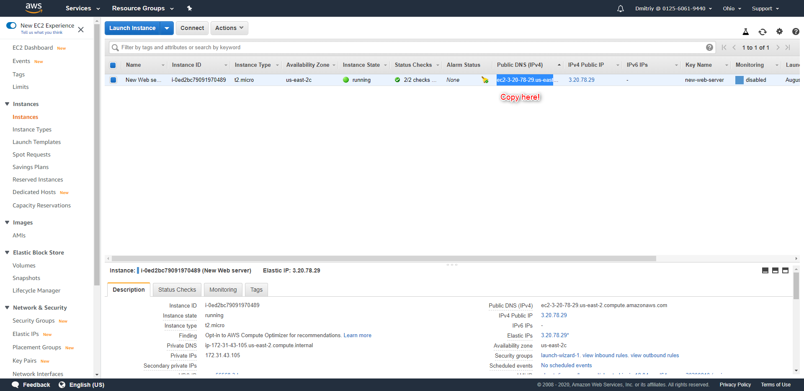

This is “ec2-3-20-78-29.us-east-2.compute.amazonaws.com”.

* 1. Connect to server

Write the following command on terminal

$ ssh -i new-web-server.pem ubuntu@ ec2-3-20-78-29.us-east-2.compute.amazonaws.com

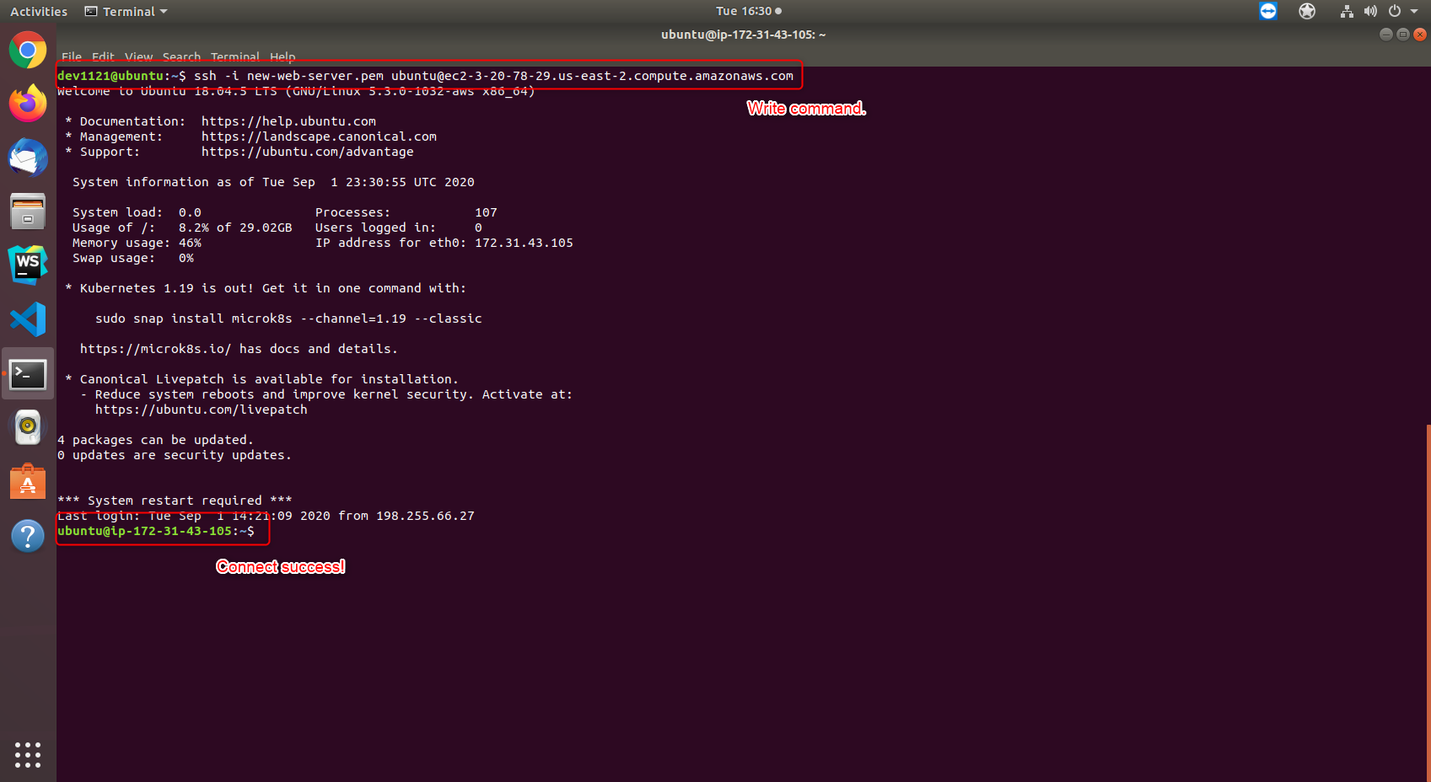

Here new-web-server.pem file is ssh key file and “ubuntu” is a user name of AWS server. And ec2-3-20-78-29.us-east-2.compute.amazonaws.com is a server public IP address.

1. Run socket server on AWS server
   1. Connect to AWS server(Refer 2.)
   2. Write and execute following command

$ cd socket_server

$ sudo nohup bash server.sh > server.out &

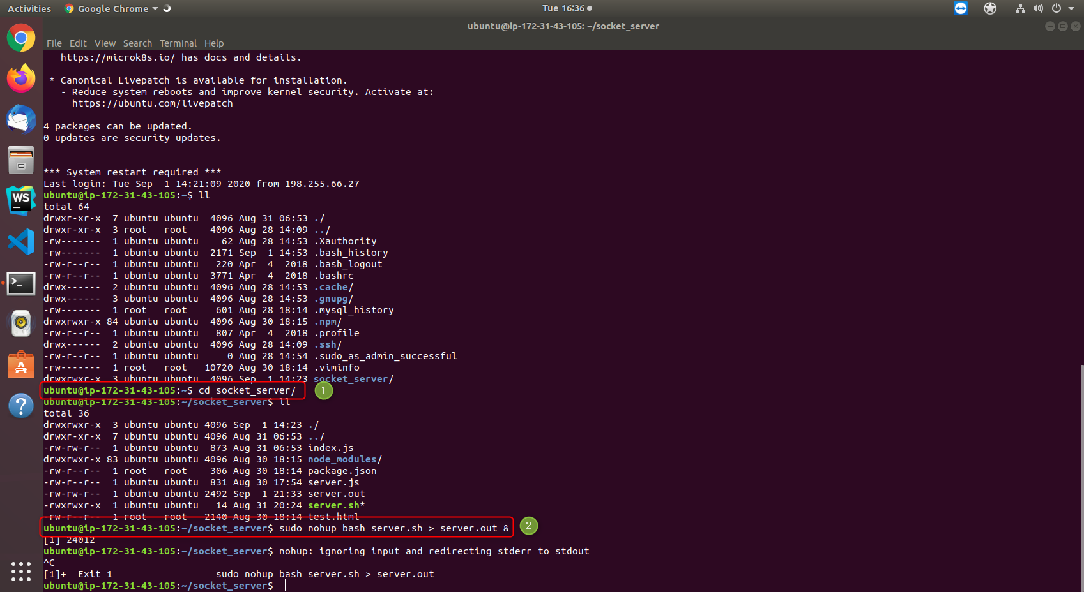

* 1. Check the socket server

Open the web browser(Chrome etc) and go to the following URL

<http://3.20.78.29:8080/>

If you can see following screen, the socket server is running.

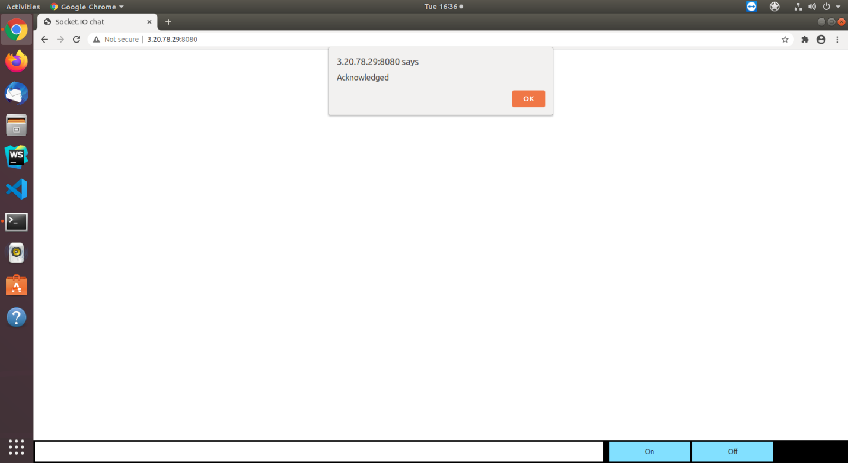

## CLIENT GUIDE

1. Install the socket server on pc that connect with controller device
2. Open the terminal on pc
3. Write and execute following command

$ cd socket_client

$ sudo nohup bash client.sh > client.out &

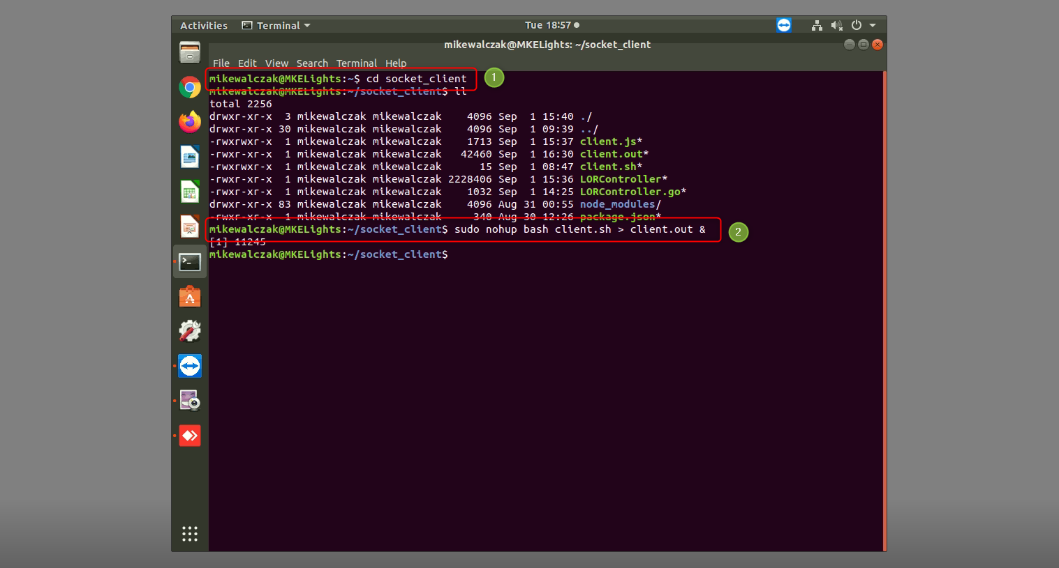

1. Test the client actions
   1. Open the browser (Chrome etc) and go to the following URL.

<http://3.20.78.29:8080/>

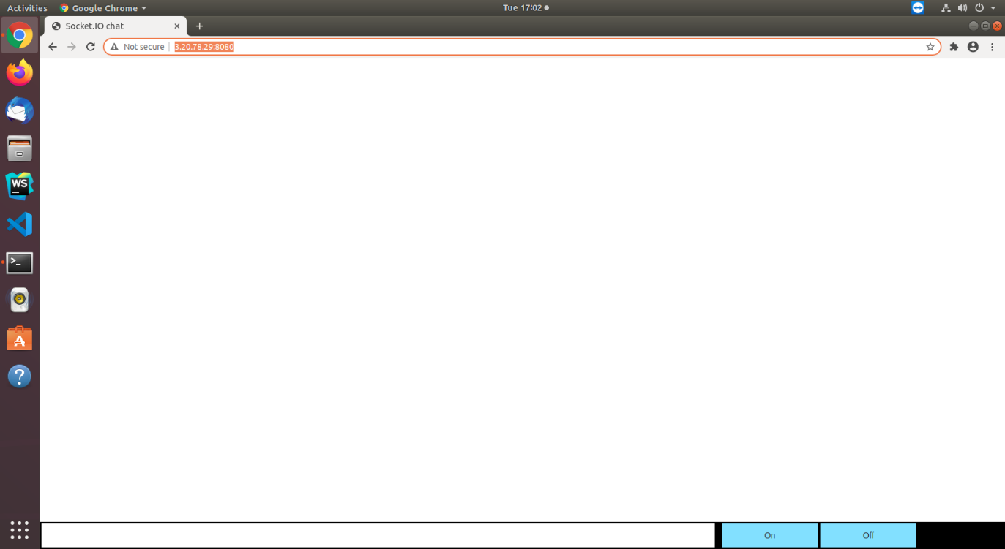

* 1. Input the channel id(01~16) and click On/Off buttons.

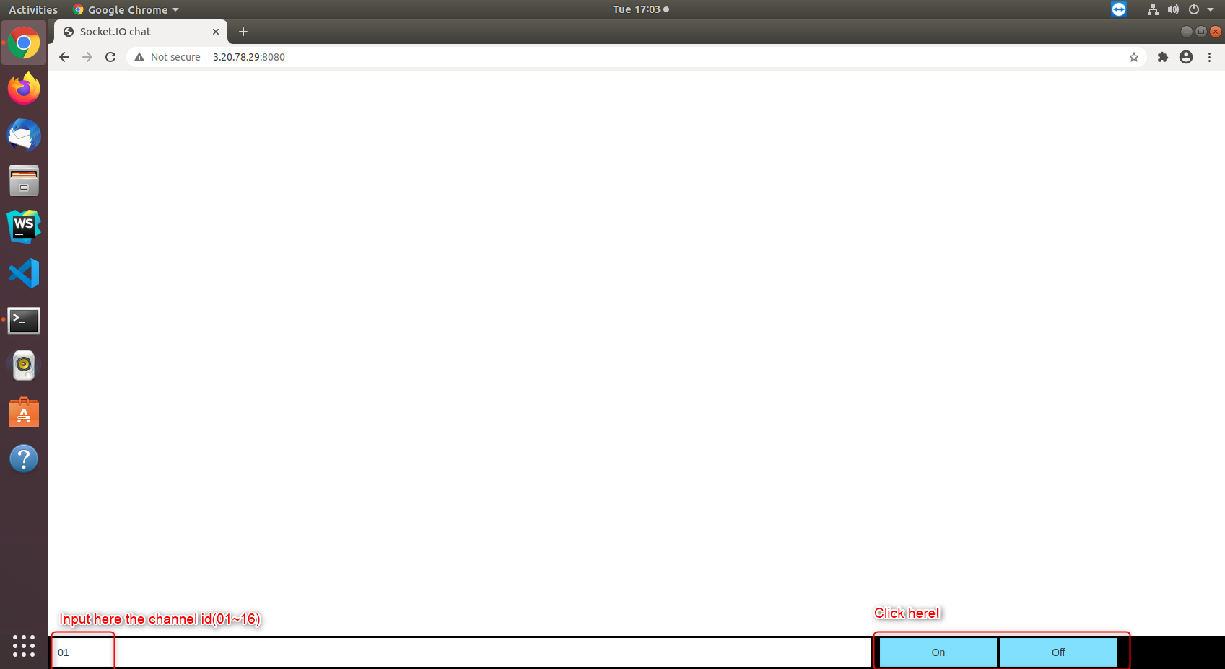

If you click On button, the light is turned on.

And also if you click Off button, the light is turned off.