Tasks:

1. ***isBranch does not write to Firestore***
2. ***These write to Firestore, but does not show the value in the panel***
   1. ***Be a 'Featured venue'***
   2. ***Activate Encore points: (field isActive_encore_points)***
   3. ***Bonus 'Kicker' discount***

***and***

1. ***Please add the PIN code field***

***And***

1. ***Please delete QR code or PIN code field***

Venue admin:



5. Can we add the venue name here?

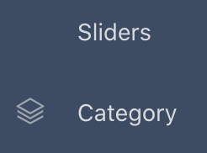

6. Can we hide these in the venue owner admin?



***7. Can we make this work?***

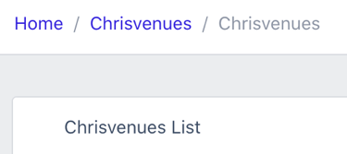

***8. Please remove the “Chris” part.***



***9. Please remove the “Chris” part.***

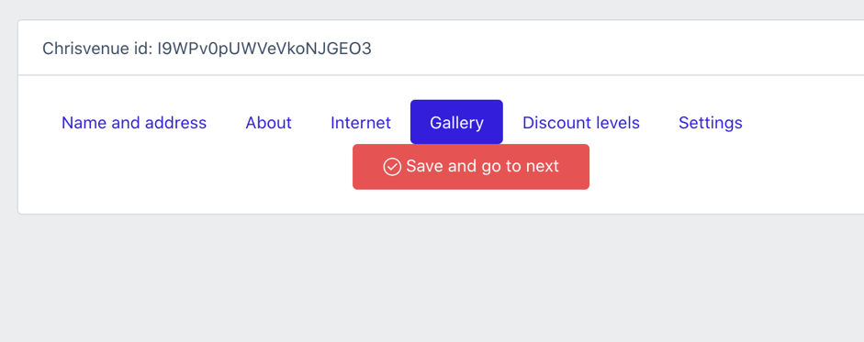 ***10. Seems gallery is not working for venue admin***



***11. Can this open a pop up with the terms & conditions from*** [***www.encoreapp.net***](http://www.encoreapp.net)***?***