Link Protocol: Attach Procedure

1 Scope
This clause specifies the attach procedure of the link protocol: the messages a terminal, an access point, the gateway and the directory exchange to admit the terminal, secure its link, open its session and register its route. Figure 1 gives the messages in order, each with the parameter it carries.

2 Procedure
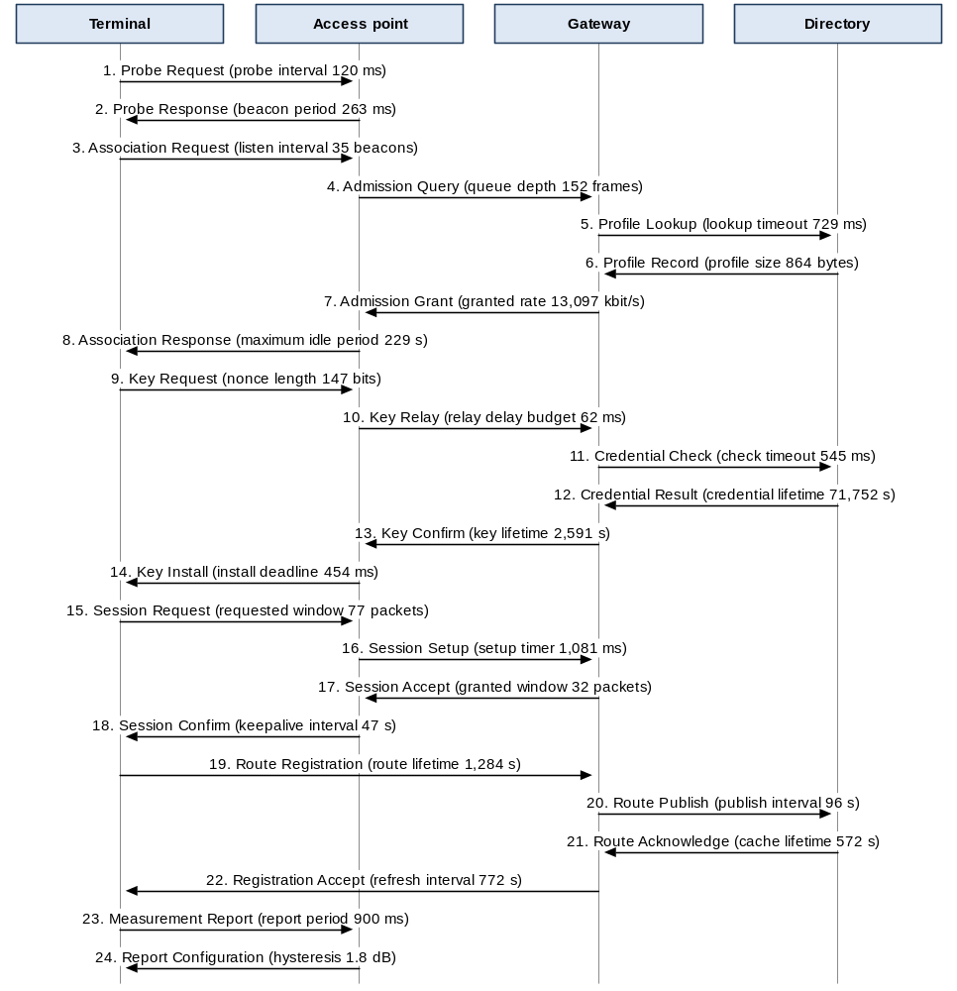
Figure 1. Attach procedure

3 Failure Handling
The terminal abandons the attach procedure if it is not complete within 38 s, and makes at most 36 attach attempts in any hour. A procedure abandoned at any step starts again from the probe.

