Lakeshore Convention Center: Metered Electricity

1 Electricity Use
Over the year the North substation delivered 7,275 MWh and the South substation 3,400 MWh. Figure 1 gives each substation's use month by month.
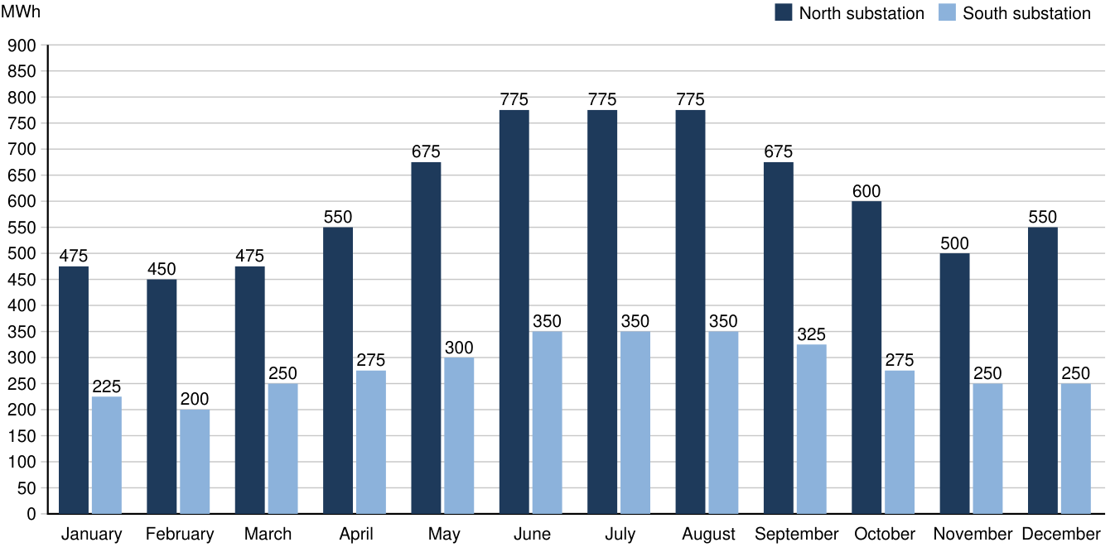
Figure 1. Monthly electricity use by substation

2 Peak Demand
The utility contract caps the center's demand at 3,519 kW. Figure 2 gives each substation's peak demand in each month; the two peaks seldom fall in the same hour, so their sum overstates the center's.
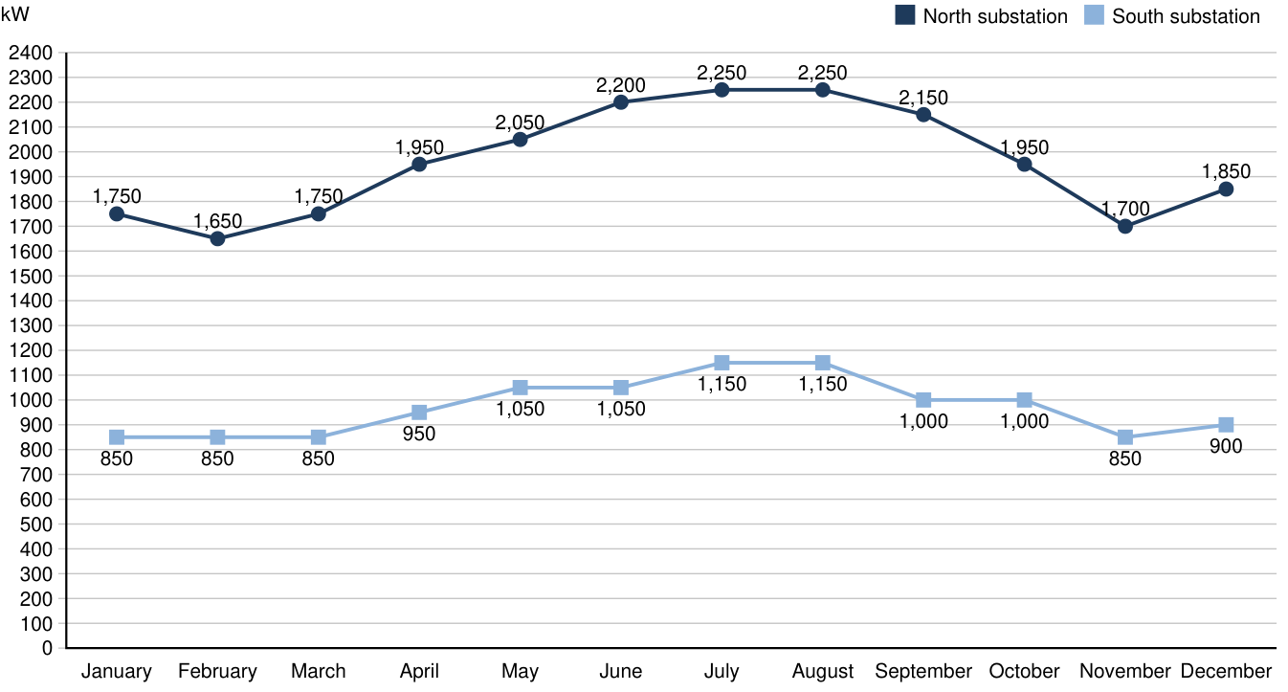
Figure 2. Monthly peak demand by substation

