Lakeshore Hall C: Energy by End Use

1 Energy by End Use
Over the cooling season, Hall C's cooling uses 1,375 MWh, its fans 350 MWh and its lighting 200 MWh, as Figure 1 shows month by month. Figure 2 compares the two cooling options' peak loads.
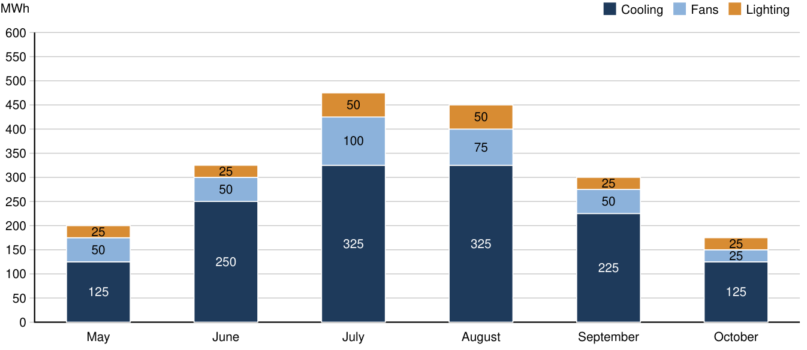
Figure 1. Hall C monthly energy by end use, May to October

2 Peak Loads
The two options' peak loads follow the season, rising to midsummer and falling after it.
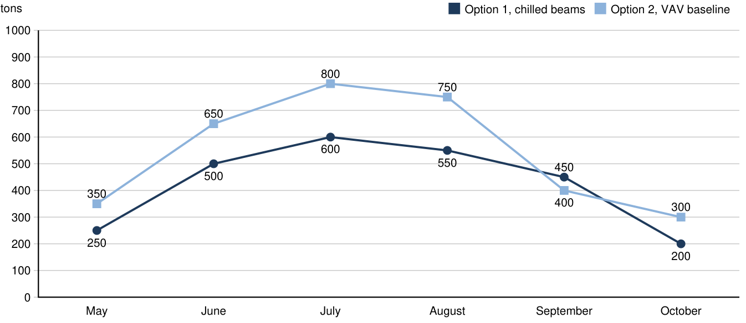
Figure 2. Monthly peak cooling load of the two options

