Lakeshore Hall C: Cooling Energy Study

1 Purpose
This study estimates the cooling energy of the two options compared in the design basis, to support the choice due at the end of schematic design. Both options were modelled with the same weather file, schedules and internal gains.

2 Monthly Cooling Energy
Figure 1 compares the two cooling options month by month over the cooling season, from May to October. Over the season, chilled beams use 1,600 MWh of cooling energy against 2,175 MWh for the VAV baseline.
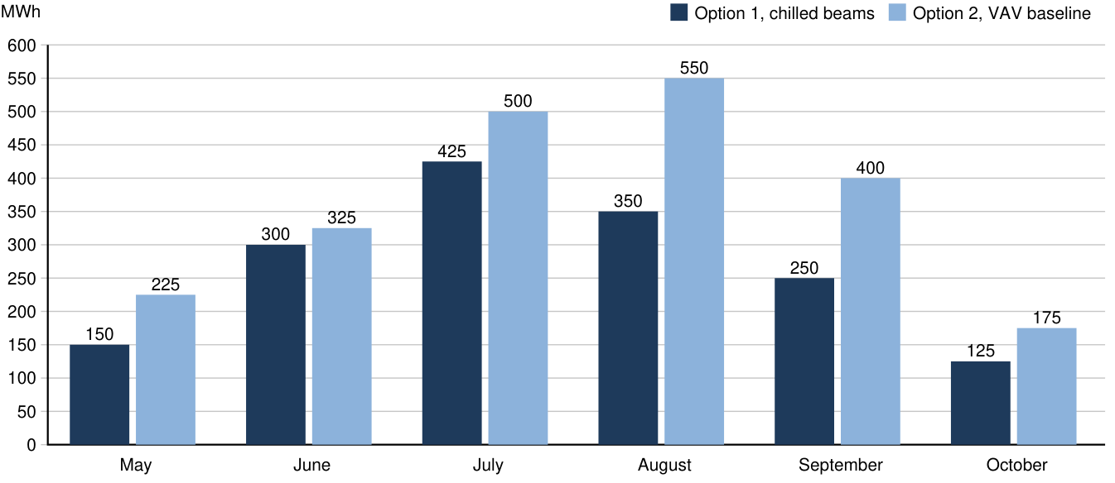
Figure 1. Monthly cooling energy, May to October
The difference is largest in the peak months, when the VAV baseline moves the most air to meet the hall's sensible load.

3 Peak Loads
Peak electrical demand for cooling is 978 kW with chilled beams and 1,395 kW with the VAV baseline. Figure 2 breaks the chilled beam design's peak cooling load down by zone.
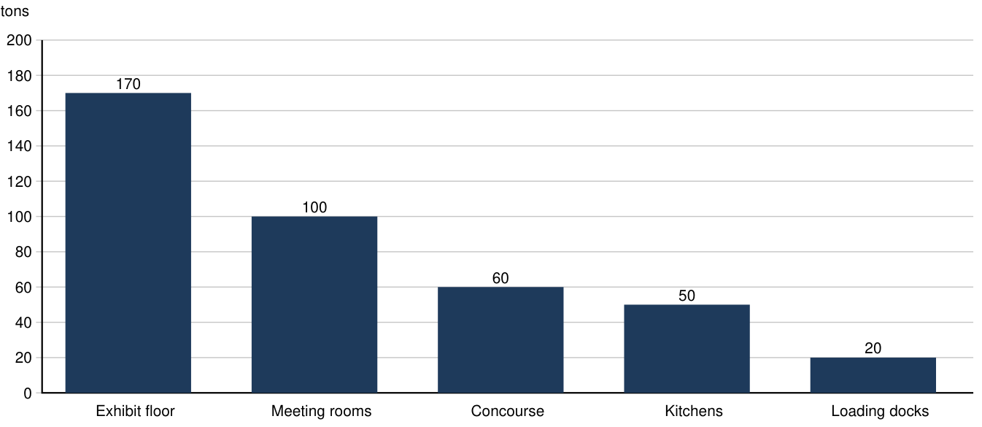
Figure 2. Peak cooling load by zone, chilled beam design

4 Conclusions
Chilled beams use less cooling energy in every month of the season. The saving should be weighed against their higher first cost, reported in the design basis.

