Experiment 6: Linking Jira with Confluence
AIM
To integrate Jira tasks with Confluence by creating a project overview page, displaying Jira work items and their statuses, and monitoring project progress.
PROCEDURE
- Open Jira and create a Scrum project with the required tasks.
- Open Confluence using the same Atlassian account.
- Create a new page titled Online Shopping System Project Overview.
- Add a project description explaining the purpose of the Online Shopping System.
- Use the Insert Jira work items option to search for and embed the five Jira issues: BAS-2, BAS-3, BAS-4, BAS-5 and BAS-6.
- Display the issue keys, task descriptions, priorities and statuses on the Confluence page.
- Add a Project Progress section to show completed, in-progress and pending tasks.
- Calculate the project completion percentage using:
$$\text{Progress}=\frac{\text{Completed tasks}}{\text{Total tasks}}×100$$
- Publish the Confluence page and verify that the Jira issues and project progress information are displayed correctly.
- Capture a screenshot of the published page for submission.


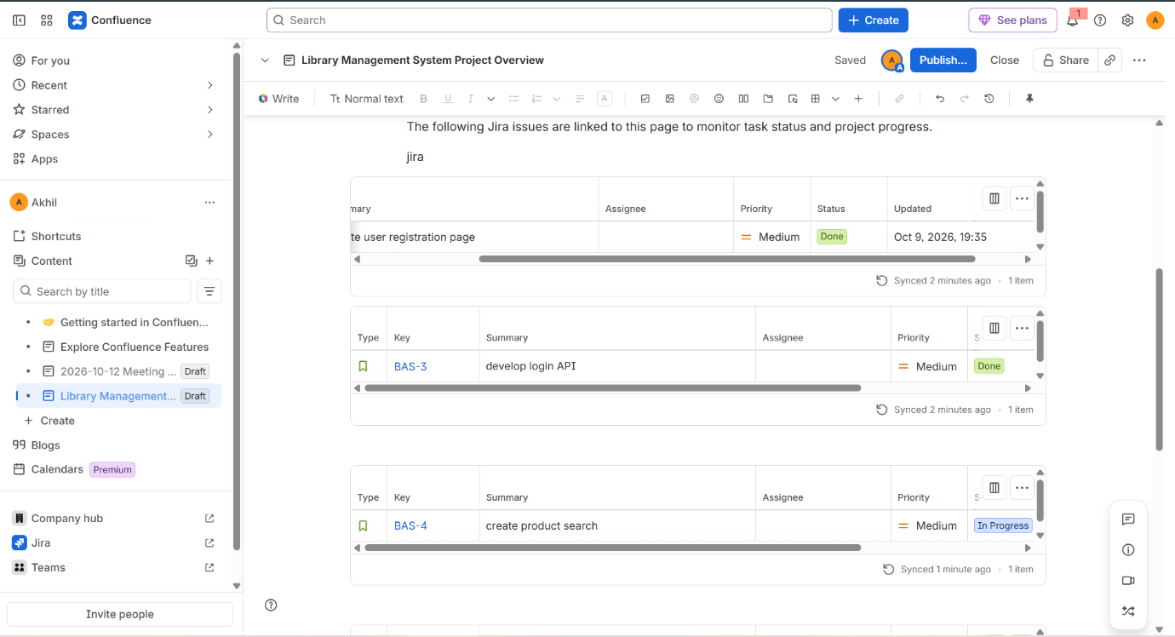

Result:
Jira work items were successfully linked with Confluence. A project overview page was created to display five Jira tasks, their priorities and statuses, and project progress information for the Online Shopping System.

