Experiment 7: Prioritization Using MoSCoW and Kano Models in Jira
Aim
To prioritize the requirements of a Task Management System using the MoSCoW and Kano models in Jira.
Procedure
- Open Jira and create a project named Task Management System.
- Create four work items representing the following requirements:
  - User Login and Role Assignment
  - Task Creation and Assignment
  - Task Prioritization and Deadlines
  - Progress Tracking and Reporting
- Apply the MoSCoW model using Jira labels to classify the requirements as Must-Have or Should-Have.
- Apply the Kano model using Jira labels to classify the requirements as Basic Needs, Performance Needs, or Excitement Needs.
- Assign both MoSCoW and Kano labels to each work item.
6. Verify that the following labels are assigned correctly:
Requirement | MoSCoW label | Kano label
User Login and Role Assignment | moscow-must | kano-basic
Task Creation and Assignment | moscow-must | kano-performance
Task Prioritization and Deadlines | moscow-should | kano-performance
Progress Tracking and Reporting | moscow-should | kano-excitement

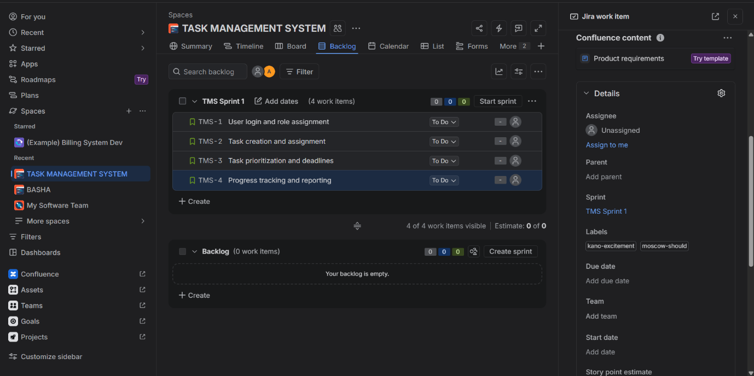
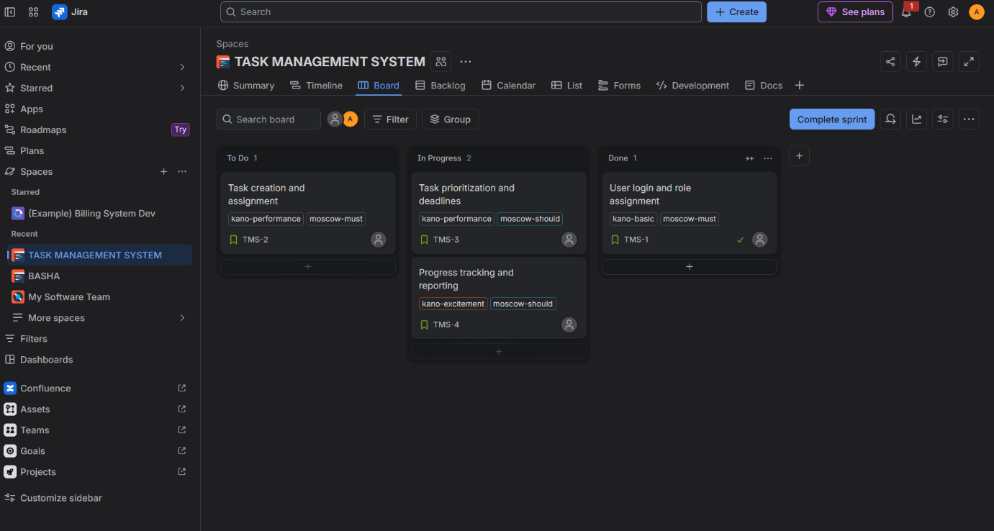

Result
The requirements of the Task Management System were successfully prioritized using the MoSCoW and Kano models in Jira. Both models were recorded using labels, making it easier to identify essential requirements, performance-related features, and features that can improve user satisfaction.

