Experiment 8: Requirement Prioritization Using MoSCoW and Kano Techniques in Jira
1. Aim
To categorize and prioritize the requirements of an Online Learning Platform using the MoSCoW and Kano techniques in Jira.
2. Procedure
- Open Jira and create a project named Online Learning Platform.
- Create the following six requirements as issues in Jira:
  - Course Enrollment and Registration
  - Video Lecture Streaming
  - Interactive Quizzes and Assignments
  - Progress Tracking Dashboard
  - Peer-to-Peer Discussion Forums
  - Certificate Generation
- Apply the MoSCoW prioritization technique by assigning labels according to the importance of each requirement:
  - Must-Have: Course Enrollment and Registration, Video Lecture Streaming.
  - Should-Have: Interactive Quizzes and Assignments, Progress Tracking Dashboard.
  - Could-Have: Peer-to-Peer Discussion Forums.
  - Won't-Have for now: Certificate Generation.
- Apply the Kano technique by assigning labels according to user satisfaction:
  - Basic Needs: Course Enrollment and Registration, Video Lecture Streaming.
  - Performance Needs: Interactive Quizzes and Assignments, Progress Tracking Dashboard.
  - Excitement Needs: Peer-to-Peer Discussion Forums, Certificate Generation.
- Save the labels in Jira. Verify that each requirement contains one MoSCoW label and one Kano label.
- Review the categorized requirements to understand their relative importance and contribution to user satisfaction.

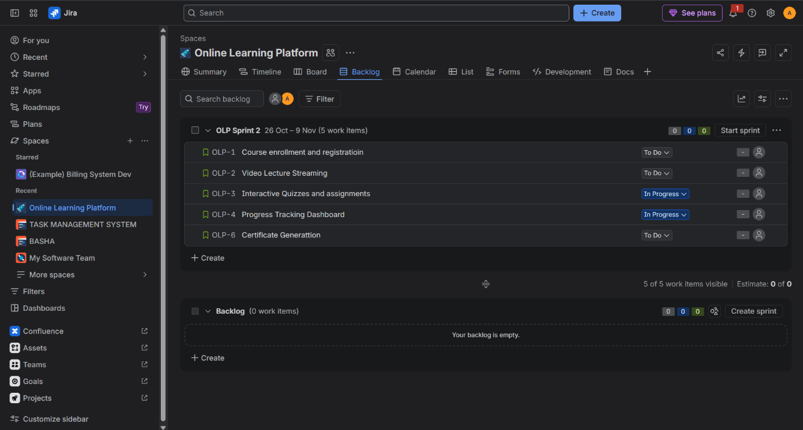
3. Result
The six requirements of the Online Learning Platform were successfully categorized and prioritized in Jira using the MoSCoW and Kano techniques. This helped identify essential features, prioritize development tasks, and understand how different features contribute to user satisfaction.

