Experiment 4:
Aim
To develop a flowchart using RAPTOR to find the length of a given string without using a built-in string-length function.
Procedure
- Start the RAPTOR software and create a new flowchart.
- Use an Input symbol to read a string from the user.
- Initialize the variable i to 1 and the variable count to 0.
- Use a loop to examine each character of the string.
- Increment count by 1 for every character and increment i to move to the next character.
- Repeat the process until all characters have been counted.
- Use an Output symbol to display the total number of characters.
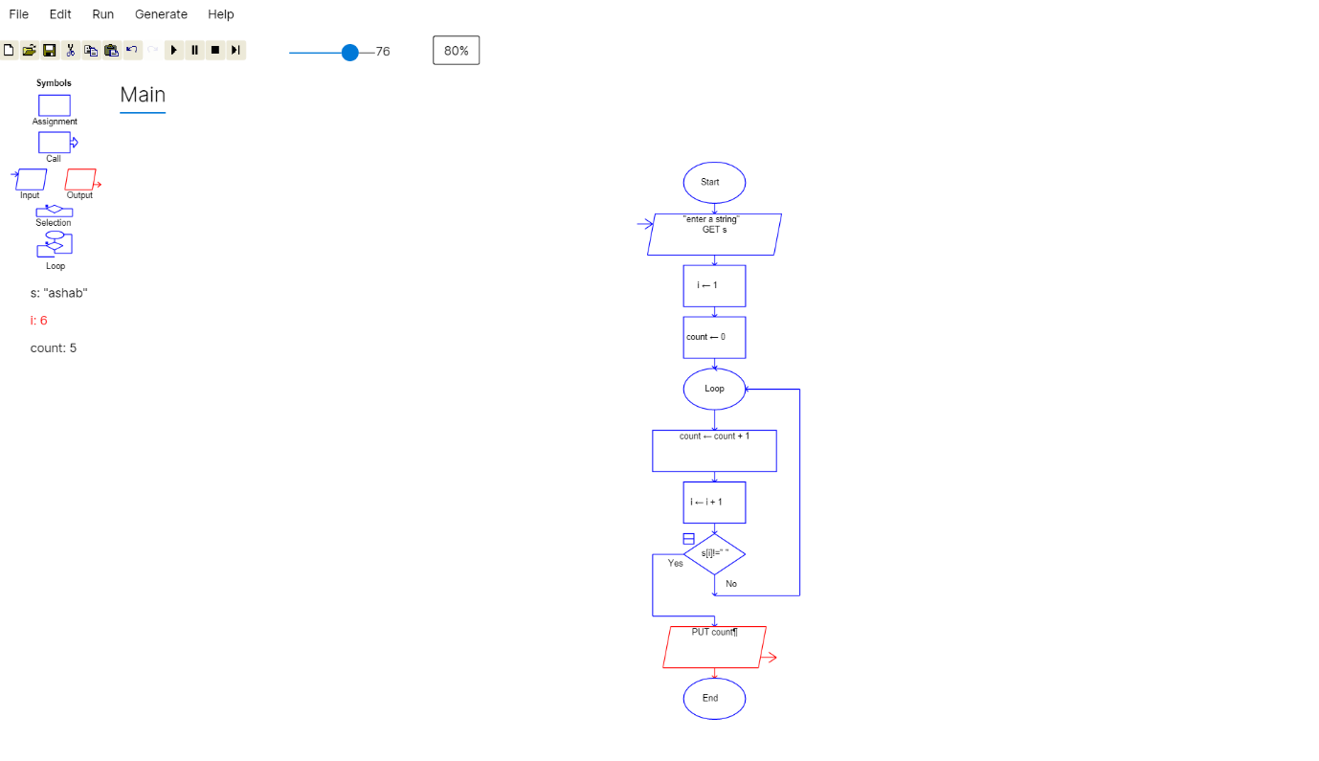
- Stop the flowchart.

Result
A RAPTOR flowchart was designed to find the length of a given string by counting its characters without using a built-in string-length function.

