Aim:
To create a Kanban Board in Jira to visualize tasks and simulate a workflow.
Procedure
- Open Jira and log in to your Atlassian account.
- Create/open the My Software Team project using the Kanban template.
- Open the Board option from the project menu.
- Configure the board with the following columns:
  - To Do
  - In Progress
  - Done
- Click Create and add at least five sample tasks, such as:
  - Design Homepage
  - Create Database
  - Develop Login Page
  - Test Application
  - Prepare Documentation
- Initially, keep the tasks in the To Do column.
- Drag a task from To Do to In Progress when work begins.
- After completing the task, drag it from In Progress to Done.
- Repeat the process for the other tasks to simulate the workflow.
- Take a screenshot of the completed Kanban board showing the tasks in the different columns.
OUTPUT: 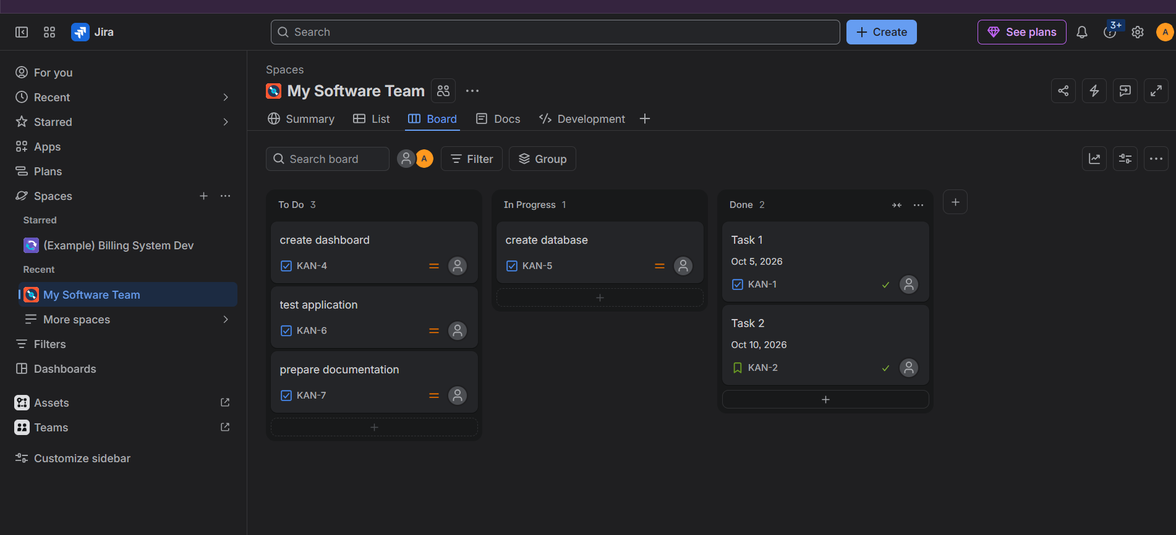

Result
A Kanban Board was successfully created in Jira with To Do, In Progress, and Done columns. Sample tasks were added and moved across the columns to simulate the workflow.

