AIM
To create an E-Commerce mobile application prototype using Figma for discussing the user interface design with stakeholders and obtaining their feedback and approval.
PROCEDURE
- Open Figma and create a new design file.
- Create a mobile frame for the E-Commerce application.
- Design the Home Screen with:
  - App name
  - Search bar
  - Product categories
  - Product images
  - Product prices
- Create a Product Details screen containing:
  - Product name
  - Product image
  - Price
  - Description
  - Add to Cart button
- Create a Shopping Cart screen showing:
  - Selected products
  - Quantity
  - Price
  - Total amount
- Create a Checkout screen with:
  - Customer details
  - Delivery address
  - Payment option
  - Place Order button
- Create an Order Confirmation screen.
- Use the Prototype option in Figma to connect the screens.
- Run the prototype using the Present/Play option.
- Demonstrate the prototype to stakeholders, collect their feedback on the UI design, and make necessary changes for approval.
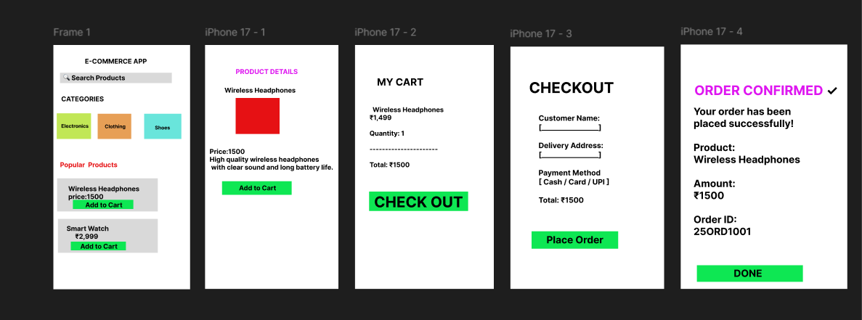
RESULT
An E-Commerce mobile application prototype was successfully created using Figma. The screens were connected using the Prototype feature to demonstrate the user flow and facilitate stakeholder feedback and approval.

