Experiment 5: MoSCoW Prioritization for Library Management System
AIM
To categorize the requirements of a Library Management System using the MoSCoW prioritization method in Google Sheets or Microsoft Excel, based on user impact and feasibility.
SOFTWARE REQUIRED
- Google Sheets or Microsoft Excel
THEORY
The MoSCoW method is a software requirement prioritization technique used to classify requirements according to their importance. It helps the development team decide which features should be implemented first, considering user needs, time, budget and available resources.
MoSCoW stands for:
- Must-Have: Essential requirements necessary for the system to function properly.
- Should-Have: Important requirements that can be implemented after essential features.
- Could-Have: Optional requirements that improve the system but are not essential.
- Won't-Have (for now): Requirements that are excluded from the current development phase and may be considered in the future.
PROCEDURE
- Open Google Sheets or Microsoft Excel.
- Create a new spreadsheet named Library Management System – MoSCoW Prioritization.
- Create columns for S.No, Requirement, MoSCoW Category, User Impact, Feasibility and Justification.
- Enter the ten requirements of the Library Management System.
- Categorize each requirement as Must-Have, Should-Have, Could-Have or Won't-Have (for now).
- Evaluate the user impact and feasibility of implementing each requirement.
- Provide a justification for each assigned category based on user needs, development time, budget and available resources.
- Format the spreadsheet using suitable headings, borders and text wrapping.
- Save the completed spreadsheet and capture a screenshot for submission.

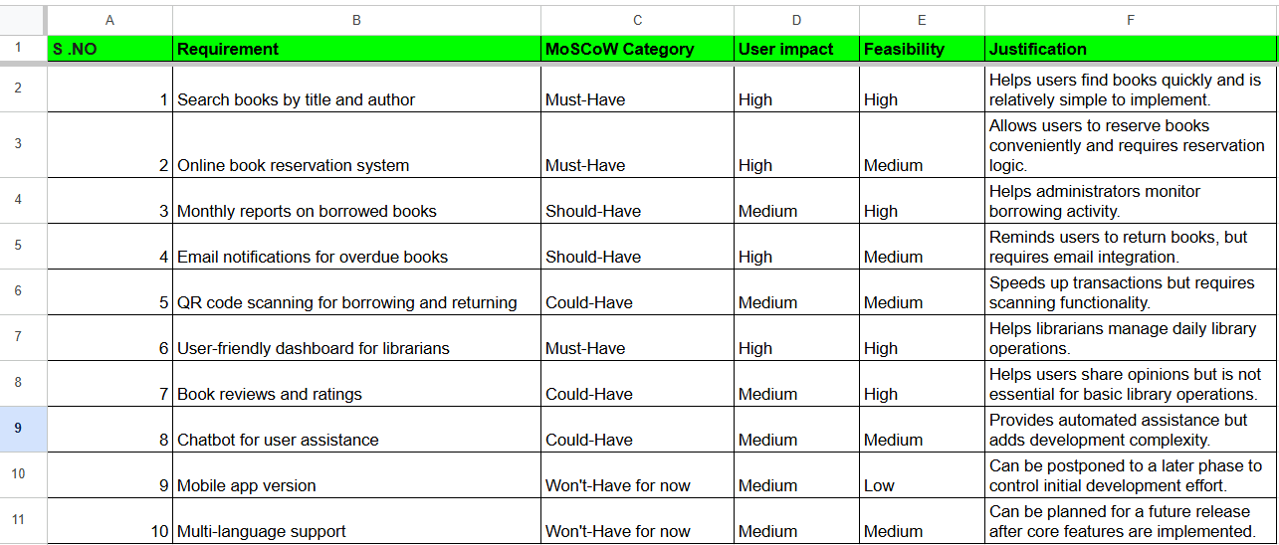

RESULT
The requirements of the Library Management System were successfully categorized using the MoSCoW prioritization method in Google Sheets or Microsoft Excel. Each requirement was evaluated based on user impact and implementation feasibility, with suitable justifications provided.

