SIMATS ENGINEERING (SAVEETHA SCHOOL OF ENGINEERING)

Department of Computer Science and Engineering
CO2 ASSESSMENT TOOL 2 – Architecture Design Assignment

Course Code: | CSA1023 | Course Title: | Software Engineering
CO Assessed: | CO2 | Assessment: | Assessment Tool 2 – Architecture Design Assignment
Weightage: | 20% | Total Marks: | 25
CO2 Statement: | Perform detailed requirements analysis, design scalable architectures, and prioritize features with a focus on cross-disciplinary skills
Student Name: | D Mahaboob Basha | Reg. No.: | 192525369
Date: | 26/10/2026 | Duration: | 60 minutes
Code of Conduct
I D Mahaboob Basha(192525369) (Name / Reg No) certify that this submission is my original work and that I have adhered to the guidelines specified for this assessment. I understand that any violation of academic integrity rules will result in disciplinary action.
Signature of the Student: D.Basha
Annexure A – Architecture Design Assignment

Instructions to Students:

Each student will be assigned an individual software project problem statement. Based on the assigned problem, analyze the system requirements and design an appropriate software architecture by applying software engineering principles. Your submission should demonstrate your ability to select, justify, and evaluate a suitable architectural style.
Question
Based on your assigned problem statement, perform an Architecture Design Analysis and prepare an architecture design report by answering the following questions:

Analyze System Requirements

  - Study the given problem statement and identify the system objectives.
  - Analyze the functional and non-functional requirements that influence the software architecture.
  - Identify key quality attributes such as scalability, maintainability, reliability, availability, performance, and security.

Select a Suitable Software Architecture

  - Select an appropriate architectural style for the proposed system (e.g., Layered Architecture, Client-Server, MVC, Microservices, Event-Driven, Service-Oriented Architecture, Serverless, or Hybrid Architecture).
  - Justify why the selected architecture is the most suitable for the given problem.

Draw the Software Architecture Diagram

  - Design a clear architecture diagram illustrating the overall structure of the proposed system.
  - Include all major layers/components, databases, external systems, APIs, and communication mechanisms.
  - Use appropriate software architecture notations and labels.

Explain Components and Their Interactions

  - Describe the purpose and responsibilities of each architectural component.

  - Explain how the components communicate and exchange data.
  - Illustrate the overall workflow of the system.

Discuss Quality Attributes
Evaluate how the proposed architecture addresses the following aspects:

  - Scalability
  - Security
  - Performance
  - Reliability
  - Maintainability
  - Availability

Justify Architectural Decisions

  - Explain the rationale behind your architectural choices.
  - Discuss the trade-offs considered while selecting the architecture.
  - Explain how the chosen architecture supports future enhancements, system integration, and long-term maintainability.

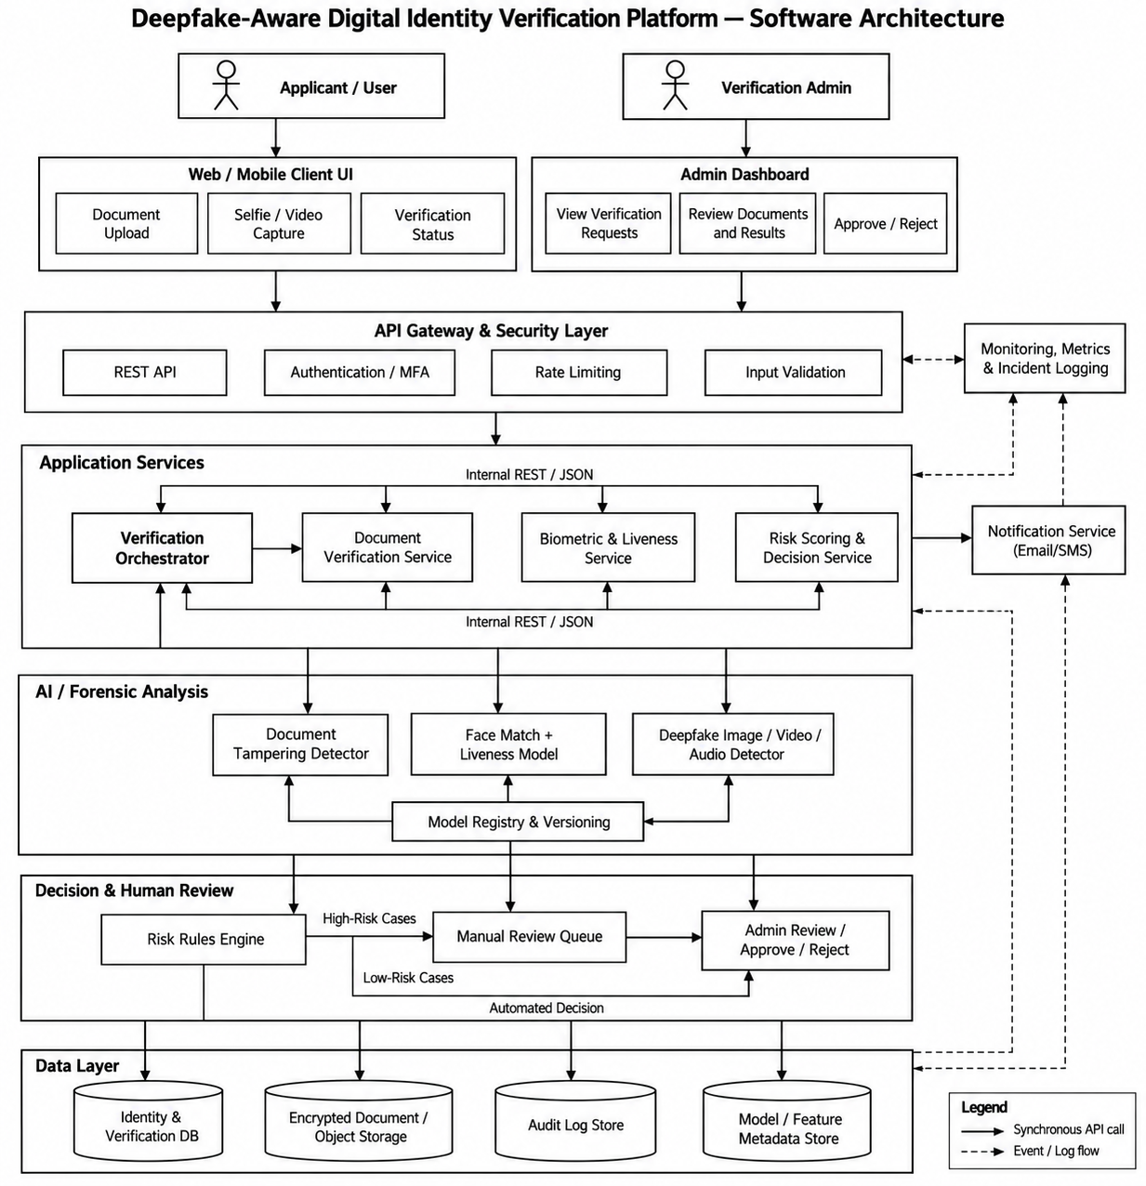

Rubrics for Calculation
Evaluation Criteria | Excellent (4 Marks) | Good (3 Marks) | Satisfactory (2 Marks) | Needs  Improvement (1 Mark)
System  Requirement Analysis (30%) | Thoroughly analyzes the problem statement, accurately identifies functional and non-functional requirements, and clearly explains quality attributes influencing the architecture. | Analyzes most  requirements with minor omissions or limited explanation. | Identifies only basic  requirements with partial analysis. | Requirement analysis is incomplete, inaccurate, or lacks clarity.
Selection of Software  Architecture (25%) | Selects the most appropriate architectural style  with strong technical justification aligned to system requirements. | Selects a suitable architecture with reasonable justification. | Architecture is partially  suitable with limited justification. | Inappropriate architecture selected or justification is missing.
Architecture Diagram and Component Design (20%) | Produces a clear, complete, and well-structured  architecture diagram with all major components, interfaces, and  interactions accurately represented. | Diagram is mostly complete with minor omissions or notation issues. | Diagram  includes only essential  components and lacks sufficient detail. | Diagram is incomplete, unclear, or technically incorrect.

Component Interaction and Quality  Attribute  Analysis (15%) | Clearly explains component responsibilities, interactions, and thoroughly discusses scalability, security, performance, reliability, maintainability, and availability. | Explains most  components and quality attributes with minor gaps. | Provides limited explanation of  interactions and addresses only some quality attributes. | Component  interactions and quality  attributes are poorly explained or missing.
Architectural Justification and Technical Presentation (10%) | Provides strong justification for architectural decisions, discusses trade-offs and future enhancements, and presents a  well-organized, professional report. | Provides adequate justification with minor gaps; report is well organized. | Limited justification with minimal discussion of trade-offs or future scope; report needs  improvement. | Justification is weak or absent; report lacks organization and technical clarity.

Criteria | Mark
System Requirement Analysis (30%) | /5
Selection of Software Architecture (25%) | /5
Architecture Diagram and Component Design (20%) | /5
Component Interaction and Quality Attribute Analysis (15%) | /5
Architectural Justification and Technical Presentation (10%) | /5
TOTAL | /25

