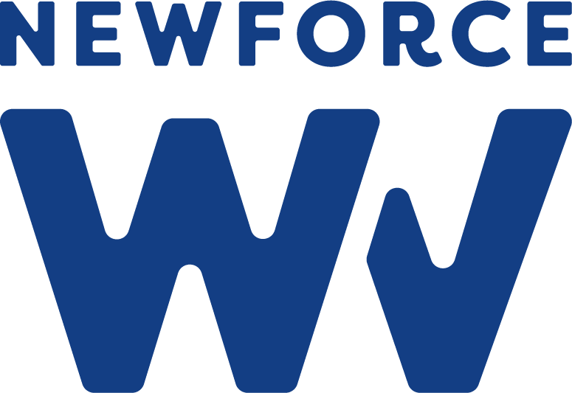

Executive Summary
This project investigates the impact of school consolidation in West Virginia over the past decade, focusing on where closures have taken place, which communities have been most affected, and whether consolidation is linked to changes in student outcomes, such as graduation rates and attendance. Using publicly available data from the West Virginia Department of Education and the National Center for Education Statistics (NCES), this analysis explores patterns of school closure across WV counties and the measurable effects on students in those communities. A key challenge will be connecting closure data to outcome data at the county level, as individual student records are not publicly accessible.

Motivation
West Virginia has experienced many school closures and consolidations in recent years, driven by declining enrollment, budget issues, and changing population patterns. This is more than just a statistic — it’s a lived experience. In my own town, three schools have shut down in just the last three to four years. In my senior year, my high school was closed and consolidated. These closures impact more than just buildings; they disrupt communities, increase travel burdens for families, and can have long-term effects on students’ academic experience and sense of belonging. As a data analytics student with a personal connection to this issue, I want to use data to tell the full story of school consolidation across West Virginia and what it means for students navigating a changing educational landscape.

Data Question
This project will examine the following data questions: How many schools have been closed or consolidated in West Virginia over the past decade, and where have these closures been geographically concentrated? Do patterns of school closure relate to county-level demographic factors such as population decline or poverty rates? What measurable changes, if any, are observed in student outcomes (graduation rates, attendance) in counties that have experienced school consolidation? These questions aim to provide a comprehensive understanding of the consolidation trend in WV and its effects on students and communities.

Minimum Viable Product (MVP)
The MVP for this project will be an interactive dashboard (probably built in Tableau or Power BI) displaying findings across three main views: a county-level map of WV showing school closures over time, charts illustrating correlations between closures and demographic data, and visualizations of student outcome trends before and after consolidation. The target audience includes educators, policymakers, and community members interested in understanding the scope and impact of school consolidation in West Virginia. At a minimum, the final deliverable will feature at least one map visualization, two to three supporting charts, and a clear narrative connecting the data to real community impact.

I will use SQL/Python and Excel to clean the data. (Still deciding on SQL or Python. Will need to actually review the data sources before making decisions.)

Data Sources
The following data sources will be used for this project: West Virginia Department of Education (WVDE) — school enrollment, closure, and consolidation records, as well as graduation rates and attendance data by county; National Center for Education Statistics (NCES) — federal school-level and district-level data, including enrollment trends and school status over time; U.S. Census Bureau / American Community Survey (ACS) — county-level demographic data, including population trends and poverty rates. Additional sources may be identified and added as the project develops.

Known Issues and Challenges
The project is expected to face challenges such as limited data availability at the individual student level. Since individual student records are not publicly accessible, the analysis will rely on county-level aggregates, resulting in findings that show correlations rather than direct causation.

Different counties within West Virginia vary in how they report and organize their data, often using distinct formats, frameworks, or levels of detail. As a result, data cleaning and standardization are necessary to facilitate smooth integration before merging datasets. When linking closure records with outcome data, careful matching of school closure timelines with changes in student outcomes is essential to ensure datasets align correctly across different time periods and formats. Fortunately, this process does not require API keys, since the main data sources are publicly accessible and easy to download. The data cleaning steps will include standardizing county names, reconciling date formats, imputing any missing outcome data, and merging datasets based on shared county identifiers, ultimately ensuring a coherent and consistent integration of all data.

