**Title:** Treatment effectiveness in patients with multimorbidity: sharing information and shared trial data

**Author list:** L. J. Hannigan, S. Dias, N. J. Welton, < Neil, Claudia, others? > D. A. McAllister

Target journal(s): Trials; Medical Decision-Making; epidemiology journals?

## Background

### Multimorbidity and the challenge of estimating interactions in clinical trials

Multimorbidity (where two or more conditions occur together) is common and increasing {REF}. Patients with multimorbidity are less likely to receive recommended drug treatments than those with a single disease {REF}. However, individual clinical trials usually have insufficient data to adequately estimate treatment-comorbidity interactions, and so it is unclear if these patients would benefit differentially from treatment. Meta-analytic approaches, including individual patient data (IPD) meta-analyses, can be used to pool observations across trials and thus estimate interactions with greater power {REF}. However, even in meta-analyses, data on an informative range of combinations of specific drug treatments and comorbidities are likely to remain sparse.

*Outline alternative approaches (Bonferroni, body systems etc)*

One potential solution to this issue that has not previously been explored involves the estimation of interactions not just at the level of individual drugs, but also for *classes* of related drugs. This can be achieved with the application of Bayesian hierarchical models in the context of an IPD meta-analysis. A major advantage of Bayesian methods is that they allow sharing of information across related groups. Furthermore, there is an inherent tiered structure to any meaningfully grouped set of clinical trials that lends itself to hierarchical modelling. For example, a researcher interested in comorbidity-treatment interactions among drugs used to lower blood pressure could collate a set of clinical trials of these drugs and would find they could be organised in the hierarchical structure illustrated in **Figure 1**, panel (a) – with individual trials nested within drugs, and drugs nested within a wider grouping that could be termed ‘drugs of interest’. However, in many cases, informative additional levels can be added to the hierarchy. This is illustrated in **Figure 1**, panel (b), where related drugs have been grouped into a class (e.g., drugs A and B into class AB) nested within the wider grouping. Modelling the same data with these additional levels specified allows for the specific sharing of information between related drugs within a wider grouping and, as a result, for the estimation of interaction effects at different levels of the hierarchy.

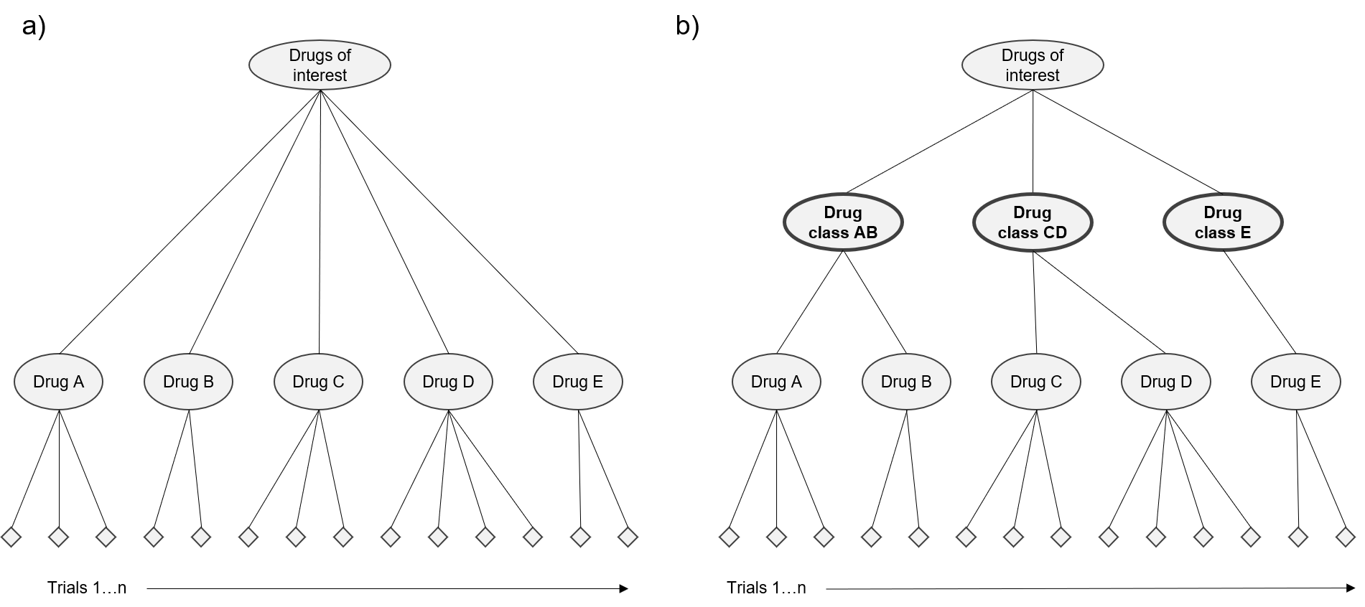

Figure . Schematic diagram of inherent and augmented hierarchical structure of a hypothetical set of clinical trials investigating drugs for a condition of interest

The addition of new levels (or ‘nodes’) in a hierarchical network, such as the drug classes added to the network shown in Figure 1, must be based on similarities among the existing groupings (e.g., in **Figure 1**, between drugs). For example, drugs could be meaningfully grouped together into a class if they share a similar mechanism of action or route of administration. While ultimately at the researcher’s discretion, there are established systems for the classification of drugs upon which these groupings could be based. One such model is the World Health Organisation’s Anatomic and Therapeutic Classification (WHO-ATC) system {REF}. The WHO-ATC system classifies drugs, based on their active ingredients, in a five-level hierarchy (with the 5th level uniquely identifying a specific drug), and as such is ideally suited for adaptation and use in a hierarchical modelling framework. In the example provided previously, the researcher’s ‘drugs of interest’ were drugs to lower blood pressure, or antihypertensives. In the WHO-ATC system, these take the level 3 code *C02*. If drug A and B in **Figure 1** were, respectively, the antihypertensives tolonidine and clonidine, then class AB in the WHO-ATC system could be the level-5 grouping *C02AC*, corresponding to a class of drugs called ‘Imidazoline receptor agonists’ – to which both tolonidine and clonidine belong. The structure of the WHO-ATC system means that further groupings, corresponding to the intermediate levels between the drug class *C02AC* and the wider grouping of antihypertensive drugs *C02* could also be added to the hierarchy in **Figure 1**. For example, if drugs C and D were, respectively, reserpine and rescinnamine, and accordingly class CD in the figure was *C02AA* (‘Rauwolfia alkaloids’), then an additional node could be added to correspond to the level-4 code *C02A* (‘Antiadrenergic agents, centrally acting’), in which both classes AB and CD would be nested.

Drugs used therapeutically for related conditions are often, themselves, intrinsically related. Typically, although not exclusively, they are related in ways that reflect their classification under the WHO-ATC system. Incorporating this hierarchical structure of drugs nested within classes and other related groupings into IPD meta-analyses, and using Bayesian methods to share information at all levels of the network, has the potential to help address the challenge of characterising treatment-comorbidity interactions that, in turn, is central to tackling the high-dimensional problem of multimorbidity.

*Set up/contextualise applications of interaction effect estimates (as priors for new drugs, to modify estimates of treatment effectiveness in routine data)*

### The current study

In the current study, we present the results of a set of simulations demonstrating the benefits of exploiting the hierarchical structure of data generated by clinical trials of related drugs to estimate treatment-comorbidity interactions using Bayesian hierarchical models. These models allow information from individual trials to be shared at the level of drugs, drug classes, and wider groupings of related classes. Our aims in this simulation study are twofold. First, we aim to describe the conditions under which an interaction effect can be precisely estimated when modelling trial IPD in a Bayesian hierarchical framework incorporating drug class information. Second, we aim to demonstrate the value of this approach using specific examples of applications of the class-level interaction effect estimates produced using these models. Overall, the results of this study will be useful in guiding decisions around seeking individual patient-level data for meta-analyses of specific interaction effects, and in illustrating the utility of existing drug-class level priors for a range of applications.

## Methods

Sampleselection – metadata from existing trials

Using the US clinical trials register (clinicaltrials.gov) we identified two distinct sets of phase 3 placebo-controlled trials with >= 300 participants, metadata from which was used to define the structure of the simulated data. We used metadata from real trials in order to ensure our simulated data would reflect, as closely as possible, the characteristics of real IPD that is (theoretically) available from trial sponsors. The specific example sets (described below) were selected to enable us to test our approach in relation to two structurally diverse networks of drugs/trials from which comorbidity-treatment interactions identified via meta-analyses of real IPD could have important implications for treatment in the context of multimorbidity. The first, comprising 161 trials including 210,046 participants, was a set of trials of non-insulin glucose lowering drugs for diabetes. This set, referred to henceforth as the *diabetes trial-set*, included 24 separate drugs from 7 different WHO-ATC-5 level classes (e.g., DPP-4 inhibitors, SGLT-2 inhibitors). The second (162 trials including 75,266 participants) was a set of trials of drugs for inflammatory conditions such as rheumatoid arthritis, psoriasis, and Crohn’s disease. This set, referred to henceforth for convenience as the *rheumatoid* *trial-set* included 32 separate drugs from 17 different drug classes (e.g., CD80-directed Antibody Interactions, Tumor necrosis factor alpha (TNF-a) inhibitors) across two broader pathways (full details below).

#### Simulated data structure: diabetes trial-set

Each set of trials was organised into a hierarchy based on the biological mechanism of action of the drugs under study. For the diabetes trial-set, the WHO-ATC-5 level grouping of included drugs was closely reflective of the mechanism of action, so this was used as a node in the hierarchy. As a result, diabetes trials were nested within drugs, drugs were nested within WHO-ATC-5 drug classes, and drug classes were nested within the wider drug grouping (the WHO-ATC-4 level code A10B). A single branch of the hierarchy, for 8 trials of the drug empagliflozin, is shown graphically in the upper-left section of **Figure 2**. The full network diagram for the diabetes trials can be viewed online here {link to specific diabetes network diagram if possible}, and the same application can be used to draw network diagrams based on the WHO-ATC classification system for any combination of eligible trials from the clinicaltrials.gov database with relevant metadata available {LINK to shiny app homepage}. The R code for the network diagram is available from <https://github.com/dmcalli2/ctg_network_diagram> <<UPDATE AS REQD.

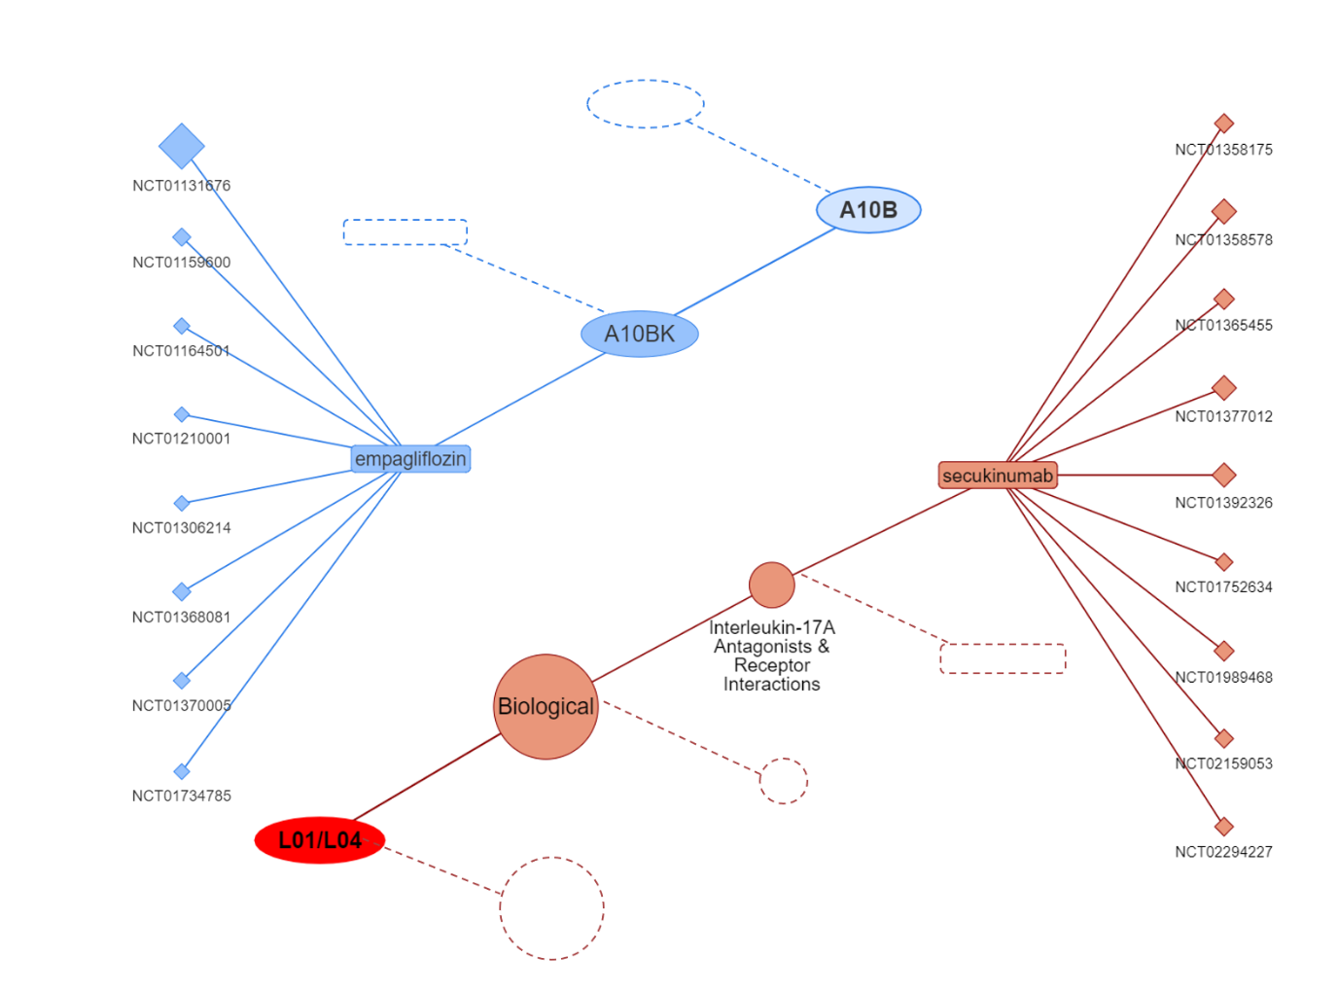

Figure 2. Extracts from the hierarchical network diagrams of the included sets of trials (upper left: trials of A10B drugs for diabetes; lower right: trials of L01/L04 drugs for inflammatory conditions)

#### Simulated data structure: rheumatoid trial-set

For the rheumatoid trial-set (of drugs for inflammatory conditions), we determined that the WHO-ATC system did not map onto mechanism of action sufficiently closely to be used as a proxy as for the diabetes trials. Thus, trials in this set were nested within drugs, which were explicitly nested within mechanism of action as the drug class level of the hierarchy. The hierarchy for this set of trials also differed from the one for the diabetes trials in that an additional grouping level was identified, wherein different mechanisms of action could be classified as belonging to either a biological or conventional broader drug pathway within the wider drug grouping (the WHO-ATC-3 codes L01/L04). Classifications for the drugs in the rheumatoid trial-set, in terms of mechanisms of action, broader pathways, and (for reference) the un-used WHO-ATC-5 codes are presented in **Table 1**. A single branch of the hierarchy, for 9 trials of the drug secukinumab, is shown in the lower-right section of **Figure 2**.

Table . Classification of drugs from the rheumatoid trial-set into classes based on mechanisms of action and broader pathways (with WHO-ATC-5 class information provided for reference)

|  |  |  |  |
| --- | --- | --- | --- |
| **Drug** | **WHO-ATC level 5 code** | **Broader pathway classification** | **Mechanism of action classification** |
| sirukumab | L04AC | Biological | Anti-IL-6 |
| tocilizumab | L04AC | Biological |
| atacicept | L04AX | Biological | B-lymphocyte stimulator (BLyS) with/without A proliferation-inducing ligand (APRIL) |
| belimumab | L04AA | Biological |
| ocrelizumab | L04AA | Biological | CD20-directed Antibody Interactions |
| rituximab | L01XC | Biological |
| abatacept | L04AA | Biological | CD80-directed Antibody Interactions |
| natalizumab | L04AA | Biological | Integrin Receptor Antagonists |
| vedolizumab | L04AA | Biological |
| anifrolumab | L04AX | Biological | Interferon-a receptor 1 antagonist |
| brodalumab | L04AC | Biological | Interleukin-17A Antagonists & Receptor Interactions |
| ixekizumab | L04AC | Biological |
| secukinumab | L04AC | Biological |
| risankizumab | L04AC | Biological | Interleukin-23 Antagonist with/without Interleukin-12 Antagonist activity |
| tildrakizumab | L04AC | Biological |
| ustekinumab | L04AC | Biological |
| baricitinib | L04AA | Biological | Janus Kinase Inhibitors |
| peficitinib | L04AA | Biological |
| tofacitinib | L04AA | Biological |
| upadacitinib tartrate | L04AA | Biological |
| iguratimod | L04AX | Biological | Nuclear factor-kappa B (NF-KB) inhibitor |
| blisibimod | L04AA | Biological | selective antagonist of B-cell activating factor |
| fostamatinib | L01XX | Biological | spleen tyrosine kinase inhibitor |
| adalimumab | L04AB | Biological | Tumor necrosis factor alpha (TNF-a) inhibitors |
| certolizumab pegol | L04AB | Biological |
| etanercept | L04AB | Biological |
| golimumab | L04AB | Biological |
| infliximab | L04AB | Biological |
| voclosporin | L04AD | Conventional | Calcineurin inhibitors |
| methotrexate | L01BA | Conventional | Folic acid analogues |
| azathioprine | L04AX | Conventional | Nucleic Acid Synthesis Inhibitors |
| apremilast | L04AA | Conventional | Phosphodiesterase 4 Inhibitors |

Key among the differences between the two example trial-sets (and the network hierarchies into which they were organised) is the fact that the structure of the hierarchy for the diabetes trial-set was entirely in line with the corresponding WHO-ATC hierarchy, whereas the rheumatoid trial-set was organised into a hierarchy differing from the WHO-ATC model, based on clinical expertise. This distinction illustrates the flexibility of the approach and the breadth of its applicability. A hierarchical structure is valid insofar as the groupings used are interpretable in biological or practical terms, and statistically meaningful – such that they account for a portion of the overall variability between trials.

### Simulation of data

We simulated data for each trial-set based, borrowing both the structure of the hierarchies (number of trials per drug, number of drugs per class etc) and the characteristics of each trial within each of the hierarchies (using information about enrolment and the trial structure) from the real-world metadata on clinicaltrials.gov. For both trial-sets, data were simulated based on an overall covariate-treatment interaction of -0.1 standard deviations at the level of the wider drug grouping and differing degrees of variation around this effect (further details on this below) at the intermediate levels of the hierarchy. For simplicity, data was simulated at a trial rather than individual-patient level. In reality, IPD would be almost certainly be required to calculate interactions between a specific covariate (or, more likely, multiple specific covariates) of interest and the treatment consistently across trials. For example, in the context of multimorbidity and the possibility of specific comorbidity-treatment interactions, the set-up of our simulation effectively mimics a scenario in which an effect estimate for the same comorbidity-treatment interaction is available for every trial. This is unlikely to be the case when using only published results, but is far more feasible in the context of IPD (which also offers other well-documented benefits {REF}).

We manipulated the amount of variation around the overall simulated effect at different levels of the hierarchies in order to examine a range of scenarios reflecting different assumptions about the between-trial, between-drug, and between-class (and, for the rheumatoid trial-set, between-pathway) heterogeneity of effect. The resulting simulation for each trial-set was a combination of all possibilities of the different values listed in **Table 2**, with each combination being considered a single scenario. For example, for the simulation based on the diabetes trial-set, the single scenario with the minimum amount of total variation across the network involved a fixed effect of -0.1 at the wider drug grouping level, and random effects with a mean of 0 and standard deviation of 0.05 at the drug class, drug and trial level. Similarly, for the rheumatoid trial-set simulation, the single scenario with the maximum amount of total variation across the network involved a fixed effect of -0.1 at the wider drug grouping level, and random effects with a mean of 0 and standard deviation of 0.25 at the pathway, drug class (i.e., mechanism of action), drug and trial level.

|  |  |  |  |  |  |  |  |  |
| --- | --- | --- | --- | --- | --- | --- | --- | --- |
|  |  | **Simulation example** | | | | | | |
|  |  | Diabetes trial-set | | |  | Rheumatoid trial-set | | |
|  |  | Simulated effect |  | Simulated variation |  | Simulated effect |  | Simulated variation |
| **Level of hierarchy** | Wider drug grouping | -0.1 |  | 0 |  | -0.1 |  | 0 |
| Pathway | 0 |  | NA |  | 0 |  | 0.05, 0.15, 0.25 |
| Drug class | 0 |  | 0.05, 0.15, 0.25 |  | 0 |  | 0.05, 0.15, 0.25 |
| Drug | 0 |  | 0.05, 0.15, 0.25 |  | 0 |  | 0.05, 0.15, 0.25 |
| Trial | 0 |  | 0.05, 0.15, 0.25 |  | 0 |  | 0.05, 0.15, 0.25 |

Table 2. Values used to simulate data across a range of scenarios

The prevalence of the comorbidity for which the interaction effect was simulated was set at 20% for all scenarios. This value is a conservative (due to potential eligibility restrictions associated with clinical trials) approximation of the prevalence of cardiovascular disease in patients with diabetes [1] and depression/anxiety in inflammatory conditions such as rheumatoid arthritis [2] and inflammatory bowel disease [3]. As a sensitivity analysis, for the highest and lowest variation scenarios, we also manipulated the prevalence of the comorbidity to examine its influence on the models’ ability to recover interaction effect estimates.

For each scenario we simulated 1000 datasets over which to iterate during the modelling process, by sampling values from a normal distribution at each level of the hierarchy. The R code for the simulation is available at <https://github.com/dmcalli2/simlt_interactions>.

### Modelling strategy

We fitted hierarchical generalized linear models using the R-INLA package {REF} to each iteration of each scenario, for both examples (diabetes and inflammatory conditions). The effect at the level of the wider drug grouping was modelled as a fixed effect (with the pre-specified value of -0.1), and other levels of the hierarchy were modelled as random effects, with priors as truncated Gaussian distributions with a mean of 0 and precision of 1. The basic model is specified below:

R code for running the models on the simulated data is available online from <https://github.com/dmcalli2/simlt_interactions>.

## Results

An abbreviated version of a simulated dataset (a single iteration of a single scenario) from the simulation based on the diabetes trial-set, a, is shown in Table 3. This dataset and an equivalent from the simulation based on the rheumatoid trial-set are provided in full in the supplementary materials. For each simulation, only the simulated interaction effect changed across iterations and scenarios; all other values in the dataset remained consistent across iterations.

Table . Example dataset from simulation based on diabetes trial-set (abbreviated to 20 rows)

|  |  |  |  |  |  |
| --- | --- | --- | --- | --- | --- |
| **Trial ID** | **WHO-ATC level 5 code** | **Drug** | **Number of participants per experimental group in trial** | **Simulated covariate-treatment interaction effect estimate** | **SD of effect estimate (derived1)** |
| NCT00819741 | A10BA | metformin | 216 | 0.08 | 0.19 |
| NCT01512979 | A10BA | metformin | 158 | 0.07 | 0.23 |
| NCT01545388 | A10BA | metformin | 112 | 0.07 | 0.27 |
| NCT02068443 | A10BA | metformin | 124 | 0.13 | 0.25 |
| NCT00131664 | A10BB | glimepiride | 130 | -0.14 | 0.25 |
| NCT01459809 | A10BB | glimepiride | 179 | -0.11 | 0.21 |
| NCT00086515 | A10BB | glipizide | 350 | -0.19 | 0.15 |
| NCT00094757 | A10BG | pioglitazone | 173 | -0.26 | 0.22 |
| NCT00220961 | A10BG | pioglitazone | 301 | -0.23 | 0.16 |
| NCT00484198 | A10BG | rivoglitazone | 455 | -0.10 | 0.13 |
| NCT00241605 | A10BG | rosiglitazone | 300 | 0.05 | 0.16 |
| NCT00359112 | A10BG | rosiglitazone | 272 | 0.03 | 0.17 |
| NCT00386100 | A10BG | rosiglitazone | 344 | -0.03 | 0.15 |
| NCT00499707 | A10BG | rosiglitazone | 151 | -0.05 | 0.23 |
| NCT00286494 | A10BH | alogliptin | 164 | -0.19 | 0.22 |
| NCT00432276 | A10BH | alogliptin | 401 | -0.34 | 0.14 |
| NCT00968708 | A10BH | alogliptin | 2690 | -0.20 | 0.05 |
| NCT01318070 | A10BH | alogliptin | 113 | -0.24 | 0.27 |
| NCT01318083 | A10BH | alogliptin | 104 | -0.26 | 0.28 |
| NCT01787396 | A10BH | gemigliptin | 144 | -0.10 | 0.24 |
| … |  |  |  |  |  |

*Notes: 1 The standard deviation for each trial was derived by assuming a SD of 1 for the main effect in a trial, and using the number of participants per group in each trial to calculate standard errors for subgroups with and without a hypothetical comorbidity (prevalence set at 0.2, which were combined to give the overall variance of the interaction estimate (presented here as standard deviation)*

### Recovery of the simulated interaction using hierarchical models

Our first aim was to explore the conditions under which recovery of a ‘true’ comorbidity-treatment interaction effect with an informative degree of precision is possible using hierarchical models that share information at the drug class level. The results of the models as applied to all simulated datasets across all scenarios are summarised in Figure 3. The figure shows the model-derived estimates of the interaction effect at the level of the wider drug grouping, with 95% credible intervals from the posterior distributions, for each scenario (with scenarios arranged, along the x-axis, in order of increasing total variation in the network hierarchy). In addition, the within-scenario (across-iteration) variation for the scenario-level means and credible intervals is indicated by the error bars.



Figure . Average values, across all iterations of each individual scenario, for the means, 2.5th percentiles, and 97.5th percentiles of the posterior distribution of interaction effect estimates from the models

*Note- Error bars show 95% credible intervals for values within scenarios, across iterations*

The simulated wider drug grouping interaction effect of -0.1 standard deviations was successfully recovered by the models in all cases, even as the overall amount of variation in the network increased. Differences, between the two simulations, in the precision with which the wider drug grouping effect was recovered, in part illustrate the influence of the specific characteristics of a network hierarchy (the size of trials, number of trials per drug, number of drugs per class, etc) – though the simulation based on the rheumatoid trial-set also had an additional level of the hierarchy (pathway) at which variation was simulated.

### Evaluating the impact of comorbidity prevalence

The main simulation analyses were conducted using a fixed prevalence for the hypothetical comorbidity of 20%. Mindful that comorbidities of interest may exist at lower levels of prevalence, we performed sensitivity analyses to evaluate the performance of the model with comorbidity prevalence values as low as 1%. The results for the highest and lowest variation scenarios for each simulation are summarised in Figure 4. Prevalence values lower than 5%, appear to reduce the precision with which interaction effects can be recovered, particularly in low variation networks. Nonetheless, recovery of the simulated wider drug grouping level interact effect still appears consistent and unbiased.

Figure . Results of sensitivity analyses in which the prevalence of the hypothetical comorbidity in the simulations was increased incrementally between 0.01 and 0.20 - aaverage values, across all iterations of selected scenarios, for the means, 2.5th percentiles, and 97.5th percentiles of the posterior distribution of interaction effect estimates from the models

Estimates of drug and drug-class level effects

Consistent and unbiased recovery of the simulated interaction effect at the wider drug grouping level for both simulations indicates that the models are appropriate for use in a wide range of scenarios. Our second aim was to illustrate the advantages of this hierarchical modelling approach – and specifically, of incorporating drug class information into the hierarchies – over conventional meta-analytic approaches to estimating comorbidity-treatment interactions. So far, such approaches would be largely equivalent in terms of their ability to estimate an overall estimate of the comorbidity-treatment interaction for a set of trials of related drugs. However, as variation in a network increases (between trials, between drugs) the applicability of these estimates - as the basis priors for new drugs in the wider grouping, or as values with which to modify estimates of relative treatment efficacy for use alongside health registry data to more accurately predict the effectiveness of treatments in specific populations – is reduced. This is where models incorporating information about drug class groupings, or other intermediate nodes in the network hierarchy, provide a substantial improvement.

For this and subsequent sections, we move from discussing the results of all iterations of all scenarios of the simulations (which were used in totality to approximate all possible realities), to discussing the results of *specific* iterations of selected scenarios, which can be thought of as representing specific, alternative realities. That is, real IPD for the one of the trial-sets would allow for the generation of a single set of trial-level interaction effect estimates for a given covariate-treatment interaction. A single iteration represents one possible version of this set of estimates. For consistency with the results presented so far, single iterations are selected at random from those low variation, medium variation, and high variation scenarios for each scenario where the wider drug grouping effect was estimated at -0.1 (+/- 0.01) standard deviations.

Figure 5, which presents data from the modelling results for 3 specific iterations in the diabetes trial-set-based simulation, illustrates the additional information available when information is shared at the level of drug class within the network hierarchy. In the figure, the posterior distributions of the interaction effects for a specific drug from each class are plotted from a single iteration in each of the high, medium, and low variation scenarios. In each case, while the estimate at the wider drug level is centered on -0.1, effects at the level of the drug and the classes in which they are nested can vary considerably. This is most evident in the highest variation scenario, but important differences exist in the low and medium variation scenarios too. For example, in the low variation scenario, the drug lixisenatide, in the class A10BJ, has a comorbidity-treatment interaction effect centered around 0, despite the overall effect of -0.1 in the wider grouping. Differences between the effects for specific drugs in the network and the overall effect at the wider drug grouping level are even more pronounced (and, potentially, clinically meaningful), in the higher variation scenarios.



Figure . Posterior marginals for model-derived estimates of interaction effects at the wider drug grouping and for selected drug-classes from three specific iterations of the simulation based on the diabetes trial-set

The main advantage of this approach – of explicitly modelling drug class groupings and allowing information to be shared specifically between drugs in a class – is its ability to produce drug and class level estimates of interaction effects. As shown in Figure 5, this is increasingly advantageous as there is more variation in the network around the overall effect – and particularly as more of this variation is able to be accounted for by modelled classes and other groupings.

### Demonstration of applications: model-derived priors

Bayesian data analysis is based around the principle that existing evidence can (and should) be updated with new information. The same principle can also be articulated from a different perspective: new information should be considered not in isolation, but in the context of pre-existing evidence. To further illustrate the advantages of using a meta-analytic model in which information is shared at the level of drug class to investigate comorbidity-treatment interactions, we will describe and simulate two related applications in which estimates from the model are used as priors to improve the estimation of interaction effects in new drugs. Specifically: a) new drugs in a new drug class within the wider drug grouping; and b) a new drug in an existing class within the wider drug grouping.

#### Application 1: priors for new drugs in a new drug class

To simulate this situation, we created three new trials in the diabetes-trial set. The precision (based on the number of participants enrolled) of these trials was set to the average of the precision of the existing trials in the network. The new trials all tested a different new drug, which all belonged to the same new class (labelled A10B*N*) within the wider drug grouping of A10B drugs. We simulated a distribution of possible effects for this new drug class, drawing 1000 values at random from a normal distribution with a mean of 0 and standard deviation of 0.15. Between-trial and between-drug variation of 0.15 SDs was also added to this effect. We selected the mean, 5th, and 95th percentile values of the resulting distribution to take forward for modelling. Respectively, these effects represented three possible scenarios that could be indicated from the data in the new trials, namely: i) that the comorbidity-treatment interaction in the new drug class was ~0; ii) that the new drugs were substantially *less* effective in patients with the comorbidity; or iii) that the new drugs were substantially *more* effective in patients with the comorbidity.

For each of these 3 scenarios, we meta-analysed the simulated effects from the new trials with different priors on the class level effect. The priors used were those generated from running the full model on the selected iterations of the original simulated data, as well as priors generated from running a hierarchical model *without* drug class information on these same iterations, and a vague prior (representing a situation where no prior evidential context is applied with the investigation of interactions for the new drugs). The results are summarised in Figure 6.



Figure . Application of model-derived priors to the estimation of treatment-covariate interaction effects in a new drug class within the wider drug grouping of drugs in the diabetes trial-set

Non-informative (/vague) prior

The uppermost row of panels in Figure 6 shows the results of running the model in the 3 scenarios (where the simulated new trial data shows the new drugs to perform worse in the presence of the comorbidity, where the treatment-comorbidity interaction is neutral, and where the new drugs appear to be more effective in the patients with the comorbidity) with a non-informative prior. In each case, the mean of the posterior distribution of the interaction effect estimate shifts exactly to the drug class-level effect simulated in the new trials, because there is no prior evidence to update. However, given that we know that the new class of drugs belongs in the wider drug grouping of *A10B* drugs for diabetes, information about the comorbidity-treatment interactions for the other drugs in the network can be used to contextualise the data from the new trials.

##### Strong priors (from low variation network)

The second row of panels in Figure 6 shows the results of re-running the model in the 3 scenarios using priors from two models applied to the selected low variation iteration of the original simulated diabetes dataset. The first of these priors comes from a standard model – that is, one which does not include drug class level information in the hierarchy. As such, it is a strong prior distributed around the wider drug grouping effect of -0.1 (top line, panel 1 in this row). Because the amount of data in the original dataset (161 trials) vastly outweighs the amount of data generated by the 3 new trials, the posterior after updating this prior with the new data is virtually unchanged (top line; panels 2, 3, and 4 in this row). Similarly, the wider drug grouping level prior for from the full model including drug class information (second line, panel 1 in this row), is also hardly influenced by the new data (top line; panels 2, 3, and 4 in this row). This contrasts with the drug class and drug level priors from the full model (remaining lines, panel 1 in this row). The posterior distribution of the treatment-covariate interaction effect in the new drug class for these priors is pulled towards the simulated effect. This is because full model allows for the possibility that drug and drug-class level effects vary around the overall drug grouping level effect – meaning that new information indicating that a class of drugs within the hierarchy has an interaction effect either higher or lower than -0.1 is not entirely overridden by the existing evidence.

##### Medium strength and weak priors (from medium and high variation networks)

The remaining two rows of panels in Figure 6 further illustrate the advantages of drug class and drug level priors. As the amount of between class, between drug, and between trial variation in the wider drug grouping network increases, the plausibility of a new class of drugs in the network having a covariate-treatment interaction effect that differs from the overall effect of -0.1 also increases. The wider drug grouping level priors from both the standard and (to a lesser extent) full model including drug class information are still resistant to the effects of the new data, although they do begin to shift towards the effect estimate in the new trials in the high variation scenario in particular (e.g, lines 1 and 2, panel 4 of the bottom row of Figure 6). Posteriors from the models of the new trial data using the drug class and drug level priors are substantially updated by the new data – reflecting the plausibility of different class or drug level effect for new drugs in a hierarchy that contains substantial variation at each of its levels.

#### Application 2: priors for new drugs in an existing drug class

A distinct, but related application for priors derived from these models is one in which there are new trials of a new drug in an *existing* class. To simulate this situation, we created three new trials in the rheumatoid-trial set. The precision (based on the number of participants enrolled) of these trials was set to the average of the precision of the existing trials in the network. The new trials all tested the same new drug, which belonged to the existing class ‘Folic acid analogues’, within the ‘Conventional’ broader pathway, nested within the wider drug grouping of L01/L04 drugs. We simulated distributions of possible effects for this new drug class in low, medium and high variation scenarios, drawing (for each scenario) 1000 values at random from a normal distribution with a standard deviation of either 0.05, 0.15, or 0.25. For each draw, the mean of the distribution was set at the estimated effect in the drug class from the selected iteration of the corresponding scenario in the original dataset. This allowed for within scenario consistency. Between trial variation of 0.15 SDs was also added to this effect. We selected the mean, 5th, and 95th percentile values of the resulting distributions to take forward for modelling. Respectively, these effects represented the same three possible scenarios as in the previous application, namely: i) that the comorbidity-treatment interaction in the new drug class was ~0; ii) that the new drugs were substantially *less* effective in patients with the comorbidity; or iii) that the new drugs were substantially *more* effective in patients with the comorbidity. Each scenario was examined at each level of variation.

The results of the models of the ‘new trial’ data, again using priors from the relevant original simulations, are shown in Figure 7. This figure is interpreted similarly to the previous figure, but with one important difference. Because the new drugs are in an existing class, an effect for this class was estimated – bases on the other drugs in the class – in each of the original datasets. This effect differs (by chance) in each of the selected iterations for the low, medium, and high variation. It is indicated by a blue dashed line in the ‘Prior only’ column of panels.

*Add detailed walkthrough of results*



Figure . Application of model-derived priors to the estimation of treatment-covariate interaction effects in an existing drug class within the wider drug grouping of drugs in the rheumatoid trial-set

1. Iglay K, Hannachi H, Joseph Howie P, Xu J, Li X, Engel SS, et al. Prevalence and co-prevalence of comorbidities among patients with type 2 diabetes mellitus. Curr Med Res Opin [Internet]. 2016;32:1243–52. Available from: http://www.tandfonline.com/doi/full/10.1185/03007995.2016.1168291

2. Matcham F, Rayner L, Steer S, Hotopf M. The prevalence of depression in rheumatoid arthritis: a systematic review and meta-analysis. Rheumatology [Internet]. 2013;52:2136–48. Available from: https://academic.oup.com/rheumatology/article-lookup/doi/10.1093/rheumatology/ket169

3. Mikocka-Walus AA, Turnbull DA, Moulding NT, Wilson IG, Andrews JM, Holtmann GJ. Controversies surrounding the comorbidity of depression and anxiety in inflammatory bowel disease patients: A literature review. Inflamm Bowel Dis. 2007;13:225–34.