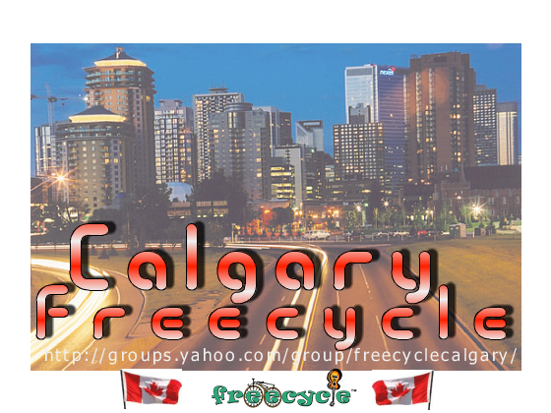
FreecycleCalgary
One person's trash is another person's treasure!
WAIT ----- DON'T THROW IT AWAY!
Get rid of stuff you don't need.
Toys
Plants
Clothes
Bicycles
Furniture
Appliances
Gardening Tools
Construction Materials
Keep our landfills from overflowing
Join the Freecyclecalgary Freecycle™ Network
FREE & OPEN TO ALL
24 HOURS A DAY, 365 DAYS A YEAR
ON-LINE @ www.groups.yahoo.com/group/freecyclecalgary
WWW.FREECYCLE.ORG

