TECHNICAL EVIDENCE

Client Performance Analysis
This analysis covers 2,537 BigFix Clients from 10-01-2026 to 10-06-2026. It was generated on 10-21-2026 11:02:26. The Client Performance Excel holds every row behind the tables in this analysis.
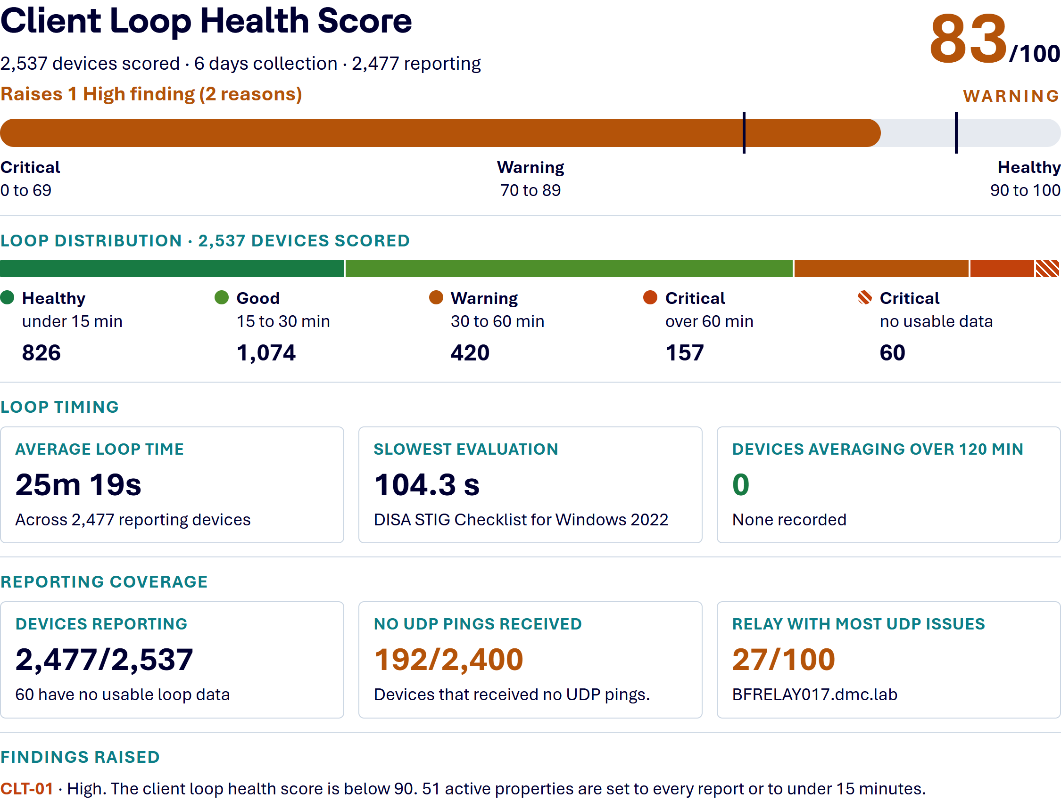

How the Score Is Calculated
Each device earns points for its group. Healthy earns 100, Good 85, Warning 67 and Critical 34. The score is the average across all devices.
A score of 90 to 100 is Healthy, 70 to 89 is Warning, and 0 to 69 is Critical.

Why Client Loop Speed Matters
The BigFix client loop speed (evaluation cycle) is critical because it determines how quickly an endpoint detects changes, evaluates policy relevance, and acts on instructions. A fast, optimized loop ensures near real-time responsiveness, while a slow loop can lead to delays in patch application, slower software deployment, and less responsive reporting.

Action Latency
The speed of the evaluation loop directly dictates how quickly a “Take Action” command is initiated. When a policy or patch becomes relevant, the client must complete its current loop before detecting and acting on it.

Operational Efficiency
The client continuously evaluates Fixlets, Tasks, and Analyses to determine applicability. A slow loop can make the client appear unresponsive and delay critical security updates.

Optimal Performance Targets
- A 15-minute average evaluation cycle is considered excellent.
- A 30-minute average evaluation cycle is the benchmark threshold used in health checks before deeper investigation begins.
- Cycles consistently exceeding 30 to 60 minutes typically indicate that the agent is overloaded, often due to the abuse of the Master Actionsite, too many activated Analyses, excessive site subscriptions, excessive amounts of custom analyses/properties, and/or poorly written relevance amongst any custom content.

Loop Health
Each device is placed in a group by its average loop time across the collection period.
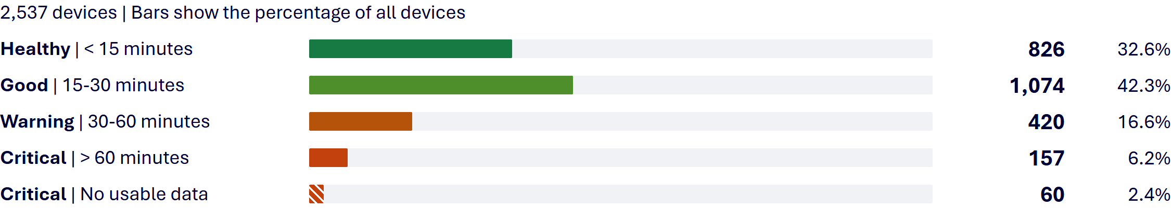
The slowest device averages 1.8 hours per loop. The longest single loop any device reported is 2.6 hours.
60 devices (2.4%) reported no usable loop data. They count as Critical in the distribution and in the score. When more than 5% of devices have no usable data, CLT-01 gives it as a reason.

Loop Cost
These sections show what the Client evaluates in each loop. They do not change the score.
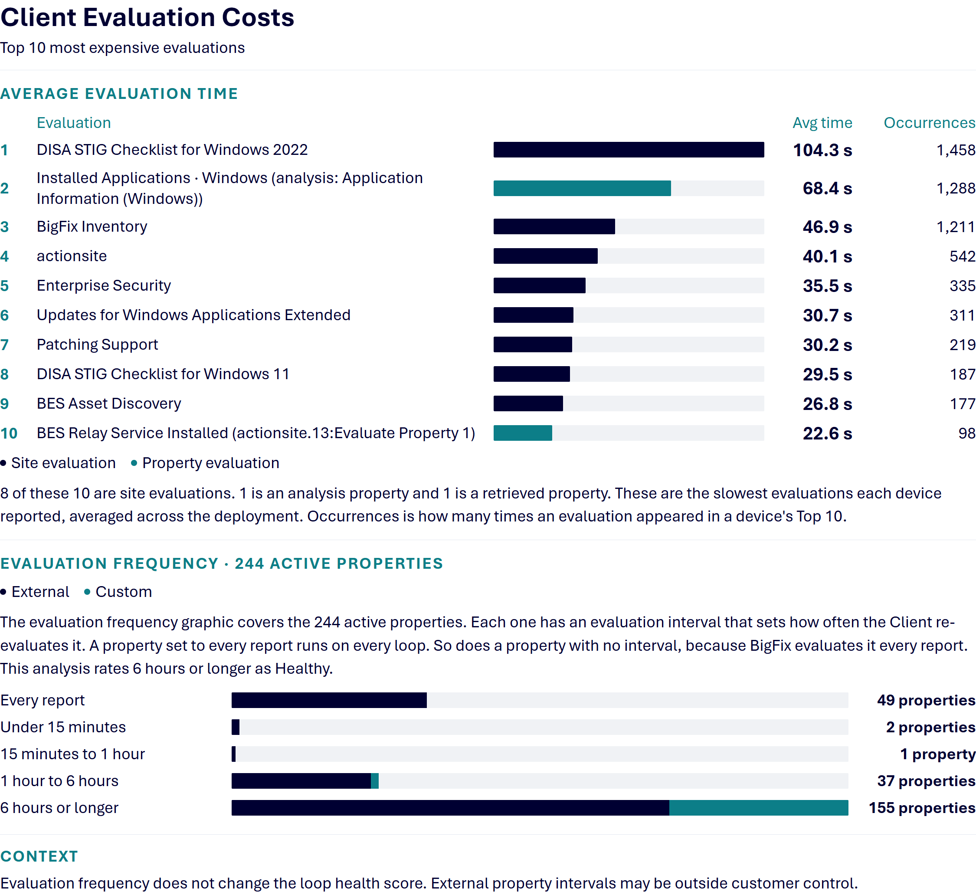
Supporting workbook: S7_20261021_110224_Client_Loop.xlsx. Sheets: Evaluation Offenders; Evaluation Frequency.

Content and Refresh Settings
Evaluation Frequency labels analysis properties from custom, operator and master sites as Custom, and those from external sites as External. External property intervals may be outside customer control. Review changes with the content owner.
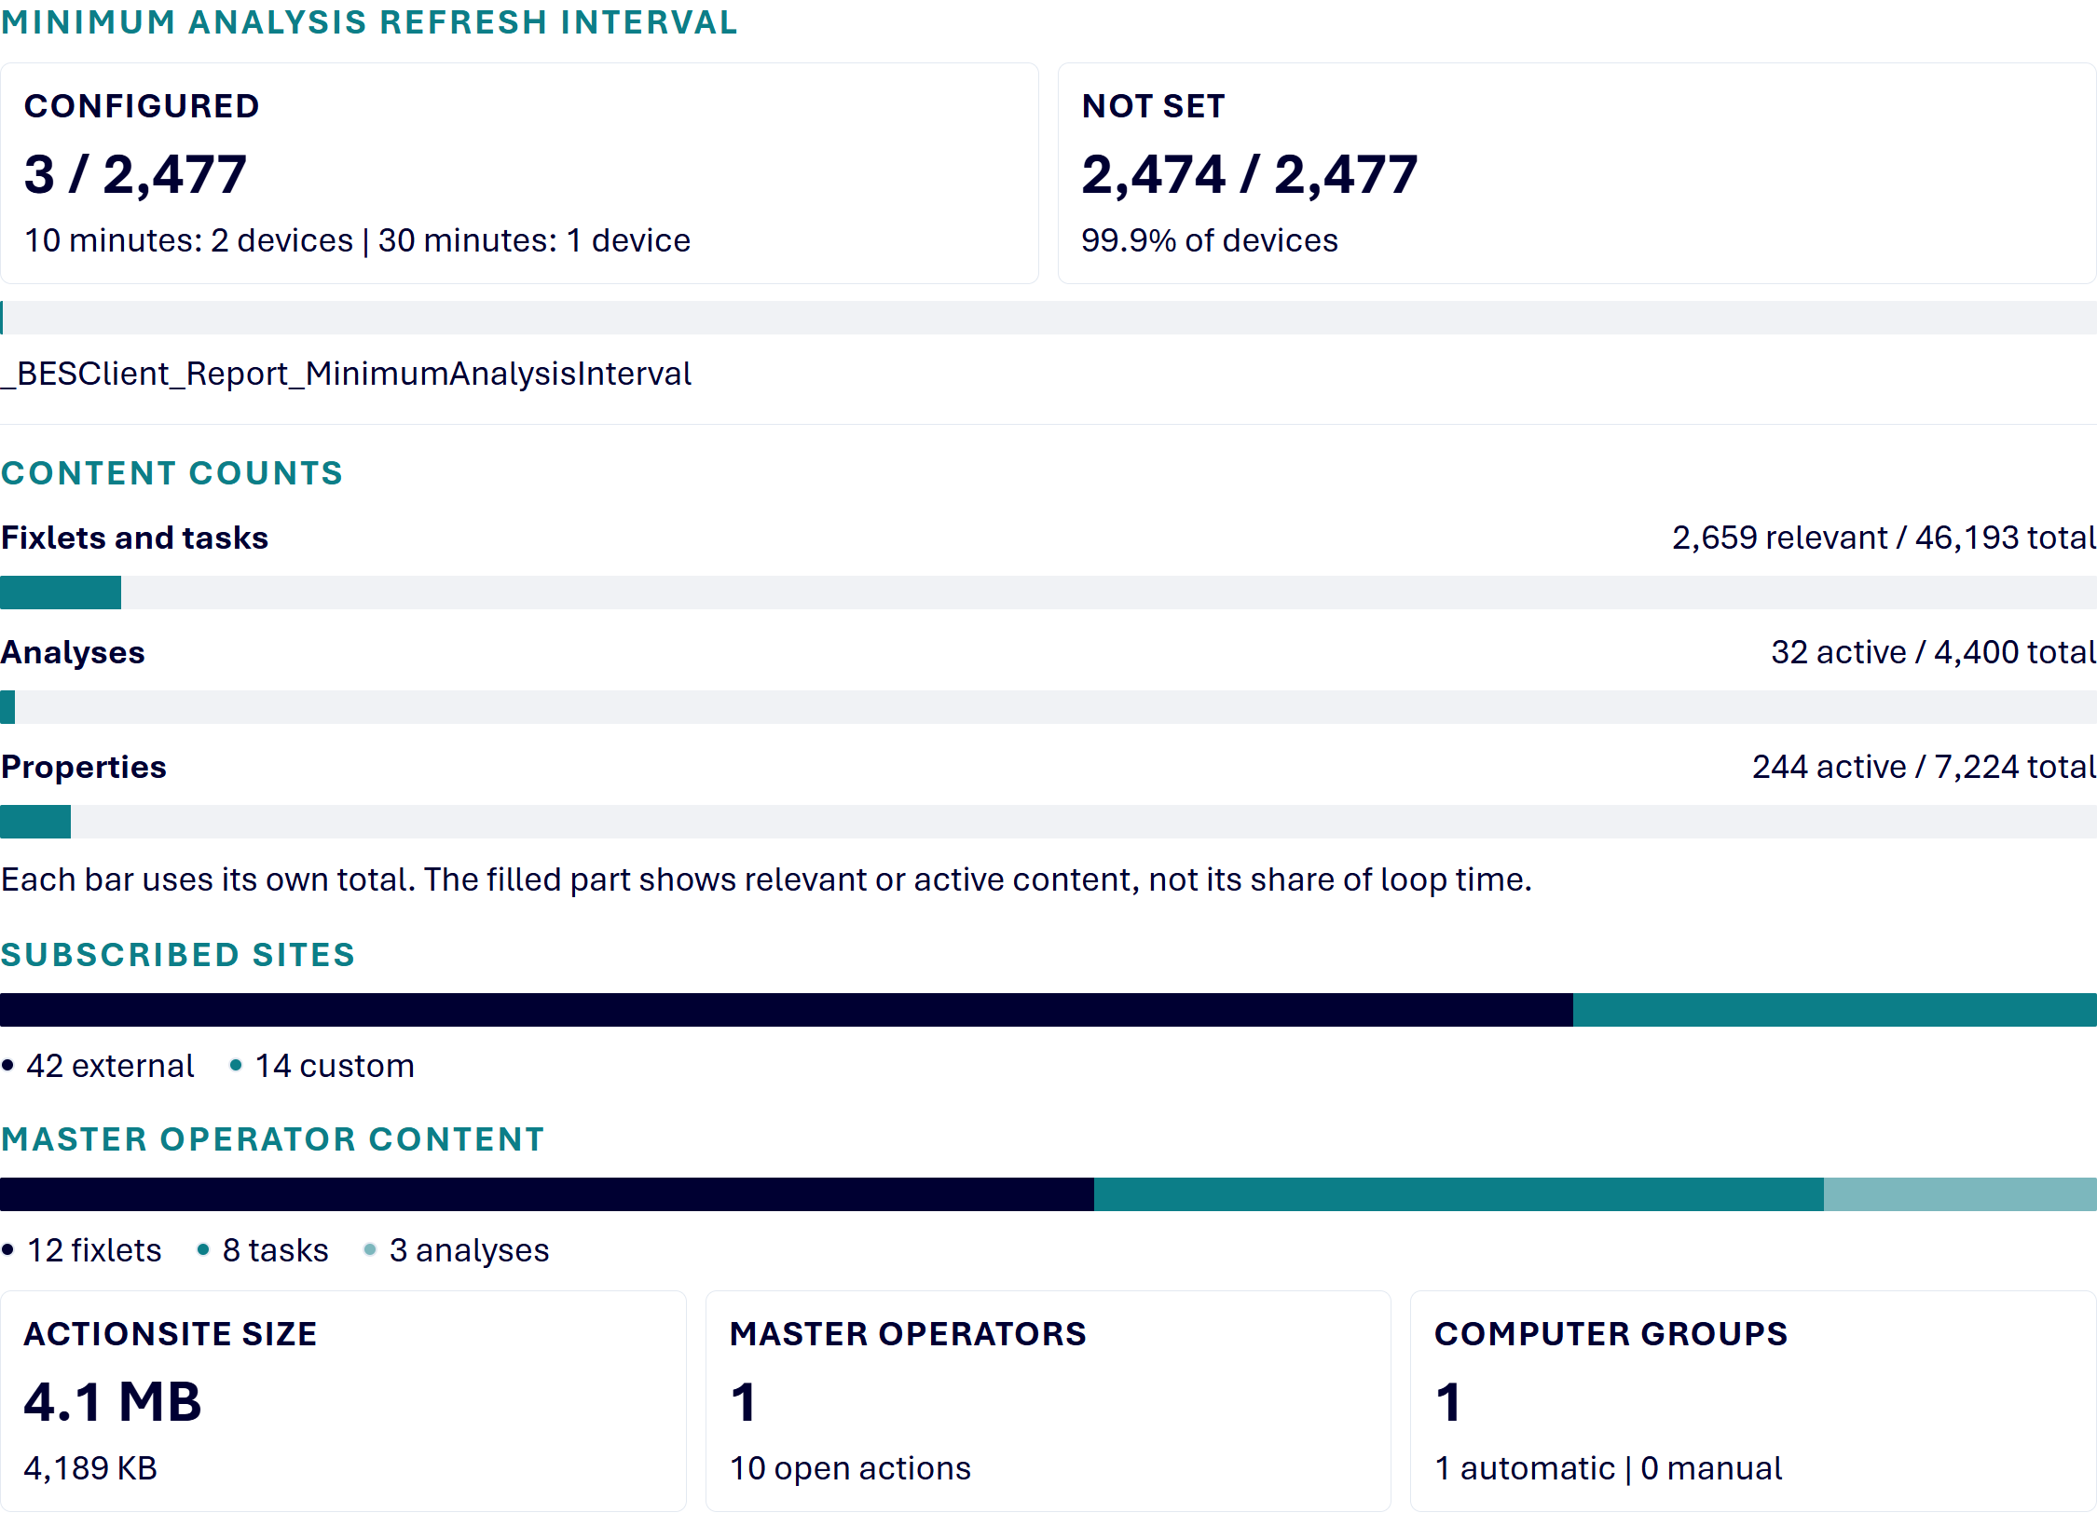

Minimum Analysis Refresh Interval
Setting | Value | Devices | % of 2,477
_BESClient_Report_MinimumAnalysisInterval | 10 minutes | 2 | 0.1%
_BESClient_Report_MinimumAnalysisInterval | 30 minutes | 1 | <0.1%
Not set | - | 2,474 | 99.9%
A device with this setting runs its analyses at most once per that interval.

Contributing Factors
Deployment-wide counts that add work to every Client loop.
Metric | Value | Status | Basis
ActionSite size | 4.1 MB (4,189 KB) | Healthy | Healthy at 10 MB or below. Soft warning over 10 MB. Hard ceiling at 25 MB.
Subscribed sites | 56 total (42 external, 14 custom) | Healthy | Healthy at 100 or fewer. Review when over 100.
Computer groups | 1 total (1 automatic, 0 manual) | Healthy | Healthy at 100 or fewer. Review when over 100.
Fixlets and tasks | 2,659 relevant of 46,193 total, as of the 09-30-2026 08:34 capture. Fixlets: 2,161 relevant of 44,297. Tasks: 498 relevant of 1,896. | Healthy | Healthy at 80,000 total or fewer. Review when over 80,000.
Analyses | 32 relevant of 4,400 total, as of the 09-30-2026 08:34 capture. 32 active. | Healthy | Healthy at 10,000 total or fewer and 500 active or fewer. Review if either is over threshold.
Properties | 7,224 total (244 active, 0 custom-flagged) | Healthy | Healthy at 10,000 total or fewer and 500 active or fewer. Review if either is over threshold.
Master operators | 1 | Healthy | Healthy at 5 or fewer. Review when over 5.
Open actions issued by master operators | 10 | Healthy | Healthy at 25 or fewer. Review when over 25.
Master-operator fixlets/tasks/analyses | 23 total (12 fixlets, 8 tasks, 3 analyses) | Healthy | Healthy below 50 combined. Review at 50 or more.

📝 NOTE The custom-flagged count uses the BigFix property custom flag. Evaluation Frequency groups active analysis properties by source site. These are different classifications.
Content counts come from a separate deployment capture. Its timestamp is shown with the counts and may differ from the client loop collection period.

Supporting workbook: S7_20261021_110224_Client_Loop.xlsx. Sheets: Evaluation Frequency; Min Analysis Interval.

CPU Settings
These settings control how much CPU the Client uses. They are reported for context and are not scored. Duty cycle is the work interval divided by the work and sleep intervals together. It is the configured share of time, not measured CPU use. Not Set means the collection returned no value.

CPU Idle Settings
Work Idle and Sleep Idle set how long the Client works and rests during normal evaluation.

Multicore CPU Scaling
Available on BigFix 11.0.7 and later Clients. Not Applicable means the Client is older than 11.0.7.
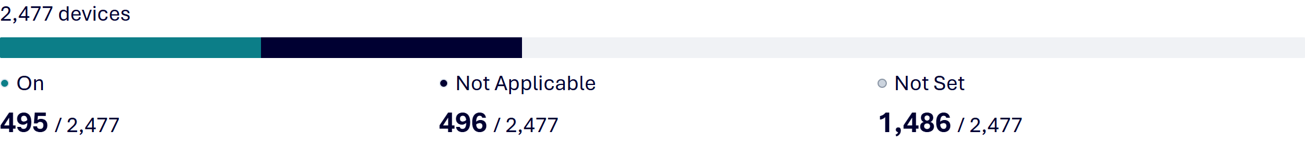

FastHashVerify
FastHashVerify lets the Client use more CPU while it checks the hash of a downloaded file, which shortens verification for large patches. It is off by default. When it is on, 20 ms work and 60 ms sleep is a configured duty cycle of 25% while hashing.
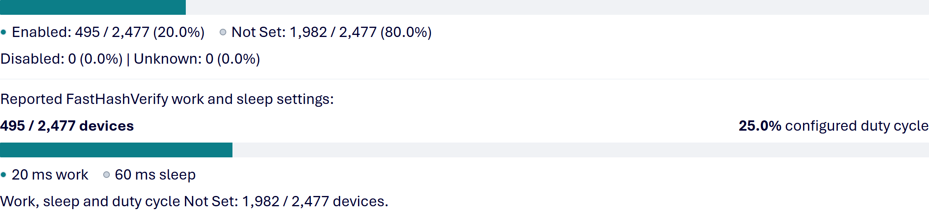

Notification and Polling
Relays send UDP notifications so Clients act on new content right away. Command polling is the fallback when those notifications do not arrive.
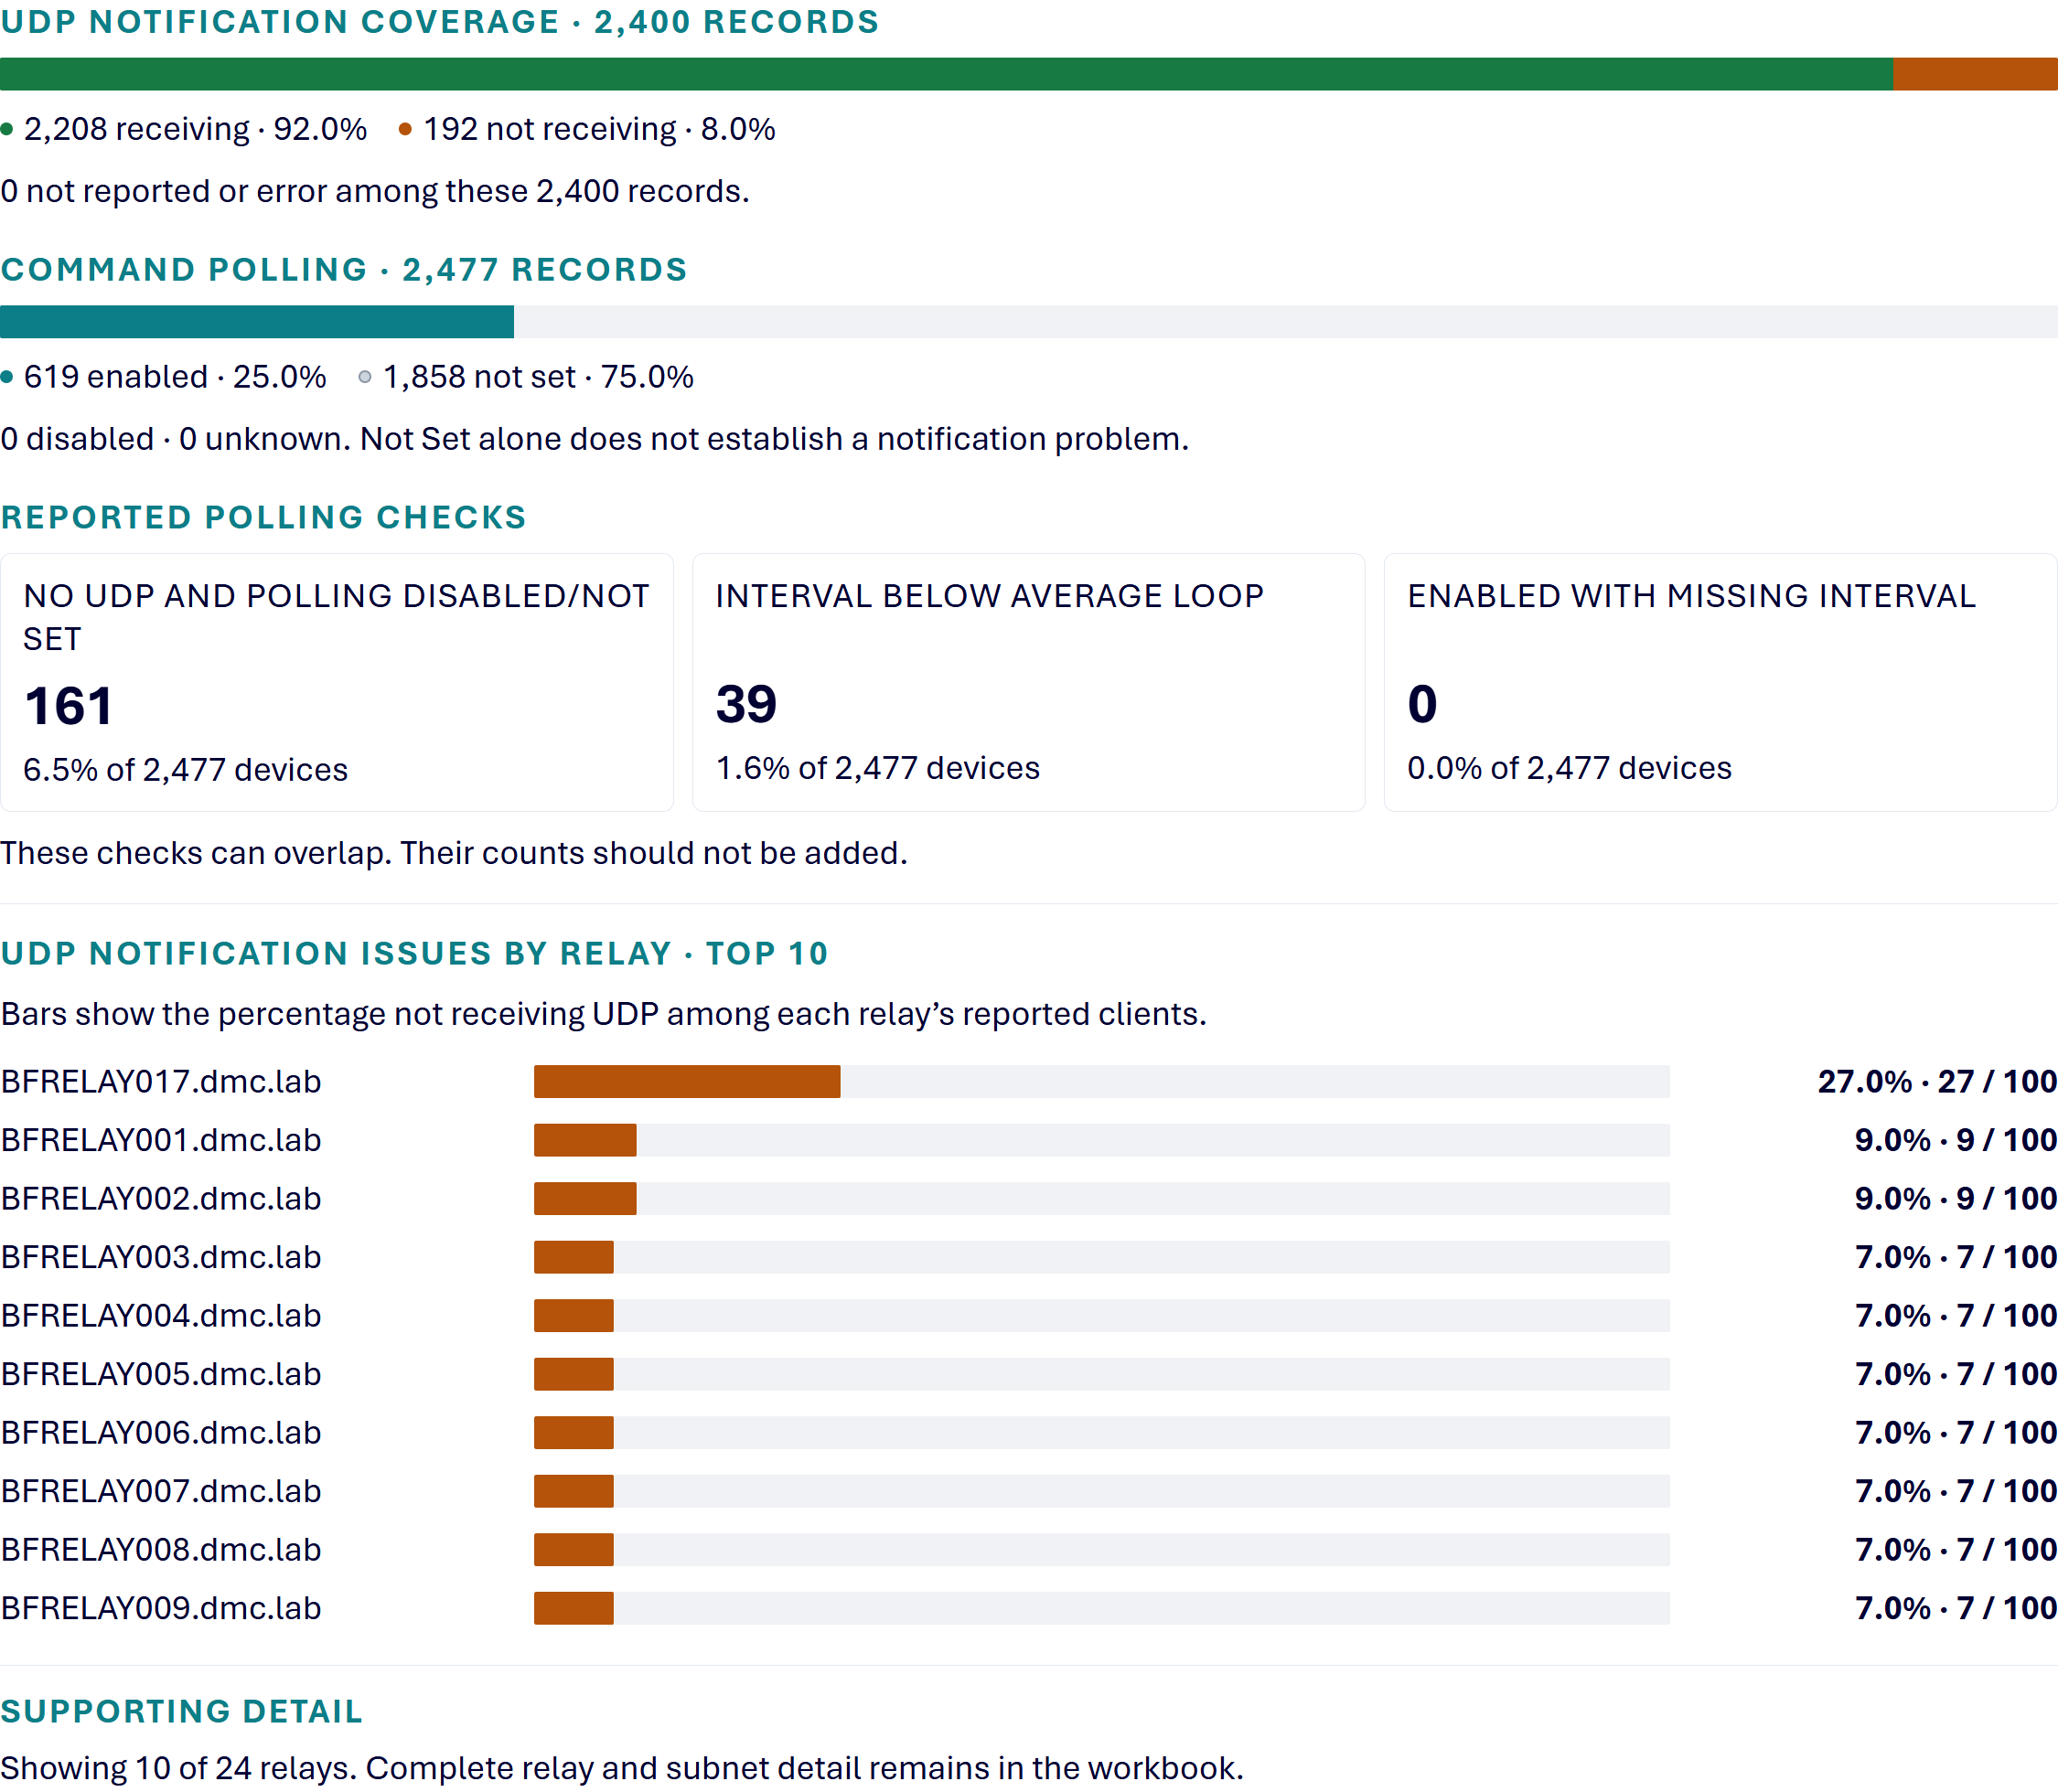
Supporting workbook: S7_20261021_110224_Client_Loop.xlsx. Sheets: UDP Coverage; UDP Issues by Relay; UDP Issues by Subnet; Polling Summary; Polling by Relay; Polling by Subnet.

Four Starting Points for Reviewing Loop Speed
These four areas are starting points for reviewing slow client loops. Change one thing, run the analysis again and compare the Average Loop Time tile with your Day 0 baseline.
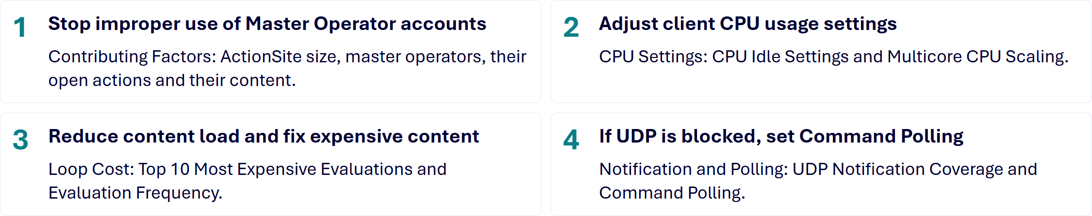

1. Stop improper use of Master Operator (MO) accounts
In this report: Contributing Factors shows ActionSite size, master operators, their open actions and their content.
This can lead to two major problems.
- Excessive actionsite folder growth that leads to increased client processing time. This folder (.\BigFix Enterprise\BES Client\__BESData\actionsite) contains the endpoint’s local copy of the Master Action Site, which all clients process as part of their normal evaluation cycle. If this folder exceeds 10 MB, the client may spend excessive time processing it, delaying evaluation of other content. Suggested action: Clean up actions and content associated with MO accounts and the Master Action/Operator Site. Restrict the use of MO accounts to only be used for the actual configuration of BigFix itself.
- Interrupted client loops that can also lead to increased client processing time. The BigFix client gives newly received actionsite (also mailbox site and operator-site) versions special evaluation handling so that action-related changes can be processed and reported quickly. Suggested action: Restrict the use of MO accounts to only be used for the actual configuration of BigFix itself.

2. Adjust client CPU usage settings
In this report: CPU Settings: CPU Idle Settings and Multicore CPU Scaling show which Clients have each setting.
The default work and sleep settings are 10 ms and 480 ms, about a 2% configured duty cycle on one core. Review the reported settings before considering changes. Refer to the task “BES Client Setting: CPU Usage” in the BES Support site.
For BigFix 11.0.7 and later, there is also Multicore CPU Scaling. The client scales its work to the number of cores at startup, so an 8-core system no longer gives the client only 0.25% of the available clock time. It right-sizes the client’s CPU use and does not raise it. It is off by default, so deploy it carefully and avoid virtual machines and critical or sensitive servers. The setting is _BESClient_Resource_ScaleWorkTimeWithCPUCores. Deploy it with the task “Enable Client CPU Multicore Scaling”.

3. Reduce content load and fix expensive content
In this report: Loop Cost: Top 10 Most Expensive Evaluations and Evaluation Frequency.
- Verify the proper implementation of Anti-Virus exclusions.
- Reduce overall content load. Limit the number of Fixlets/Tasks, sites, computer groups, operators, and Analyses.
- Identify expensive content. Determine which Fixlets, Tasks, or Analyses consume the most evaluation time and optimize or disable them as needed. There are two ways to investigate this. (1) The Client Usage Profiler tool can be used to help identify these items. This tool does a very deep dive and uploads a “package” of data to troubleshoot various issues. (2) This collection uses the “Client Performance Counters - Basic” analysis. That analysis contains a Top 10 most expensive evaluations per client property. Investigate to see if they are needed (including duplicate properties), are they reporting too often, can they be made more efficient?

📝 NOTE It's easier to view this data in Web reports vs. the Console since the console shows <multiple results>. If you try to view that data using the Summary view instead of the List view just be aware the console sorts low to high. So, the results are not in a good order. Web Reports provides another view. Explore Data > Content > choose the analysis > View Computers.

- Identify and adjust properties with frequent reporting intervals. This issue is tied closely to expensive content but has a subtle difference. Properties have settings that control how often they evaluate. Some properties might need to be evaluated often like an important security setting, but many others are either not that important or just don’t change that often. So, evaluating those properties every client reporting period, each minute, etc. is wasteful and can increase loop times. The Evaluation Frequency table counts the properties set to every report or to under 15 minutes.

💡 TIP The session relevance below identifies custom properties and properties from active custom analyses set to evaluate in under 15 minutes. It does not list external analysis properties. Change the evaluation period on the last line to adjust the query.
(/* Property Name */ names of it, /* Analysis Name */ name of source analyses of it as string | (it) of "Single Property", /* Evaluation
Time */ (it) of ("Every " & ( if (0=it) then (" Report") else (it as string & " Minutes"))) of (it / minute) of evaluation period of it, /*
Source Analysis Name */ name of source analysis of it | "None", /* Source Site Name */ name of site of source analysis of it| "None"
) of bes properties whose( (custom flag of it OR (analysis flag of it AND custom flag of source analysis of it AND exists active flags whose (it) of activations
of source analysis of it) ) AND evaluation period of it < 15 * minute)

4. If UDP is blocked, set Command Polling
In this report: Notification and Polling: UDP Notification Coverage and Command Polling.
When clients do not receive UDP notifications and the firewall is out of your hands, Command Polling is the workaround. Deploy the task “Set Command Polling to 10 Minutes over Average Evaluation Time”.

