TECHNICAL EVIDENCE

FillDB Performance Analysis
This analysis covers a FillDB capture from 11-16-2025 02:56 to 11-17-2025 15:57. The analyzer processed 4,237,218 lines. FillDB writes no Excel. The source CSV is saved beside this Mini Report.
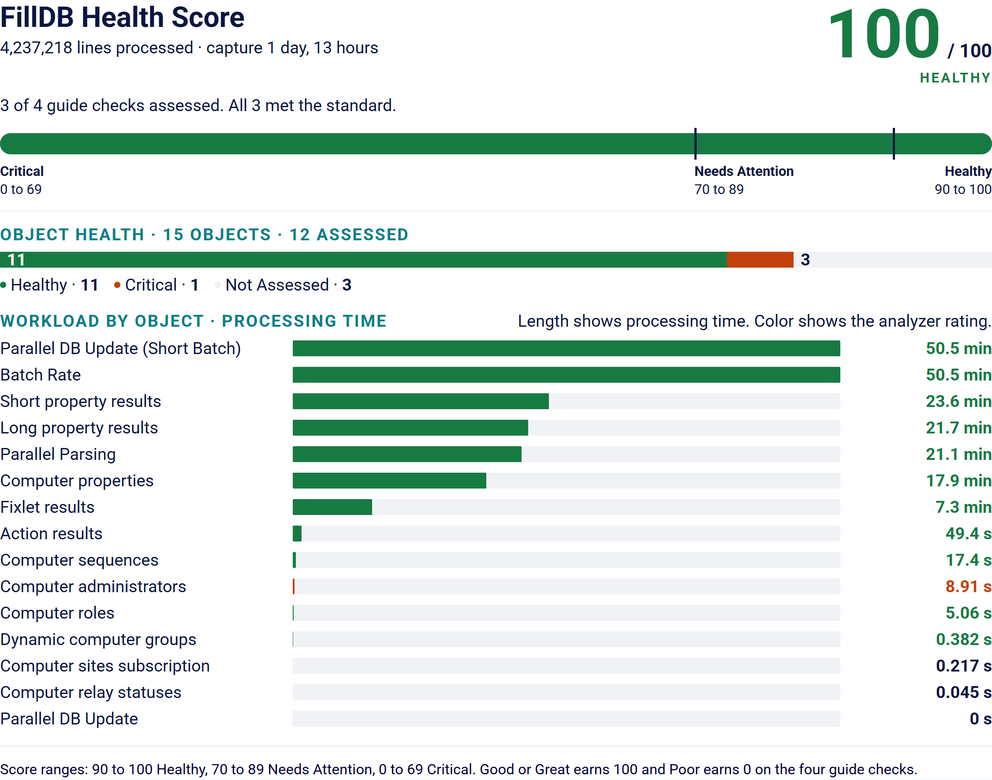

How This Score Is Calculated
The FillDB Health Score is based on the share of the guide's FillDB checks that meet the standard:
- Great or Good: 100 points
- Poor: 0 points
The score covers the four checks named in PRF-BIG-30 FillDB Health Check (BigFix Non-Functional Requirements: A Checklist Approach, version 11.x.4, page 25): Parallel DB Update (Short Batch), Parallel DB Update, Batch Rate and Parallel Parsing. The guide says each should have a health check of Good or Great.
Formula: (Great + Good) / assessed checks x 100
This score covers the FillDB capture only.
Other objects and checks without a recognized Health Check result are shown for context but are not included in the score.
Score ranges: 90 to 100 is Healthy, 70 to 89 is Needs Attention and 0 to 69 is Critical.
The analyzer rates 10 objects Great, 1 Good and 1 Poor. 3 objects had too little data to rate. Parallel DB Update (Short Batch) takes the most time at 50.5 minutes. The score covers 3 of the 4 checks named in the NFR guide. The other 1 had too little data. The Workload by Object chart in the Infographic shows the time for every object.

FillDB Objects
Health Check is the analyzer's own rating, shown as the analyzer writes it. Rows marked Not enough data are left out of the score.
FillDB Object | Count | Time (ms) | Rate/s | Health Check
Fixlet Results | 1,021,932 | 439,062 | 2,328 | 093%: Good
Action Results | 88,953 | 49,436 | 1,799 | 360%: Great
Short Property Results | 15,491,643 | 1,417,112 | 10,932 | 2186%: Great
Long Property Results | 1,822,795 | 1,304,706 | 1,397 | 140%: Great
Computer Administrators | 601 | 8,906 | 67 | 004%: Poor
Computer Roles | 19,879 | 5,062 | 3,927 | 393%: Great
Computer Sequences | 1,496,322 | 17,405 | 85,971 | 8597%: Great
Computer Properties | 1,496,271 | 1,071,013 | 1,397 | 140%: Great
Computer Sites Subscription | 1,243 | 217 | 5,728 | ----: Not enough data.
Computer Relay Statuses | 77 | 45 | 1,711 | ----: Not enough data.
Dynamic Computer Groups | 1,982 | 382 | 5,188 | 519%: Great
Parallel DB Update (Short Batch) | 1,496,466 | 3,031,912 | 494 | 988%: Great
Parallel DB Update | 0 | 0 | 0 | ----: Not enough data.
Batch Rate | 1,496,466 | 3,031,912 | 494 | 988%: Great
Parallel Parsing | 1,496,466 | 1,267,825 | 1,180 | 236%: Great

Capture Summary
Duration (s) and Throughput (lines/s) are the analyzer's own run time and speed. They are not FillDB times.
Statistic | Value
Report Generated | 10-21-2026 11:02
Collection Start | 11-16-2025 02:56
Collection End | 11-17-2025 15:57
Capture Duration | 1 day, 13 hours
Lines Processed | 4,237,218
Duration (s) | 68.54
Throughput (lines/s) | 61,821.1
FillDB Duration (hh:mm:ss) | 1 day, 13:00:56
FillDB Parsing Threads | 3
FillDB Database Threads | 3

