TECHNICAL EVIDENCE

PerfMon Infrastructure Analysis

PerfMon Capture 1
BFROOT1
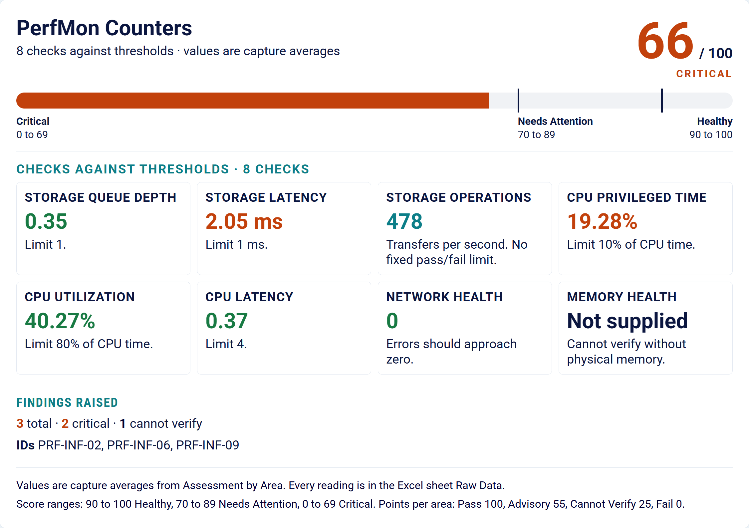

How This Score Is Calculated
The PerfMon Infrastructure Score is based on how each monitored counter area compares to its applicable threshold during the capture window:
Pass: 100 points | Advisory: 55 points | Cannot Verify: 25 points | Fail: 0 points
Formula: Pass% x 100 + Advisory% x 55 + Cannot Verify% x 25 + Fail% x 0
Each area takes the status of its worst counter, judged on that counter's average. A few high readings can raise an average over the limit. Each area section gives the peak and the number of readings over the limit.
Score ranges: 90 to 100 is Healthy, 70 to 89 is Needs Attention and 0 to 69 is Critical.

Capture Summary
Of the 14 counters reviewed, 3 did not meet the standard, 10 met it and 1 could not be verified. The 14 counters roll up into the 8 areas in the Infographic. Each area takes the status of its worst counter.
Analyzed system: BFROOT1. Capture window: 06-14-2026 20:17 to 06-14-2026 21:16 across 60 readings.
Hardware / Context | Value / Source
Logical Processors | 4 (Detected from BLG)
Physical Memory | Not supplied
Physical Disks | 1 (Detected from BLG)
Virtual Machine | No
Supporting workbook: S7_20261021_110224_Perfmon.xlsx

Automated Findings
Finding ID | Area | Review Context
PRF-INF-02 | Storage Latency | Fail. Average 2.05 ms against a limit of 1 ms. Peak 40.7 ms. 4 of 59 readings were over the limit. See Storage Latency.
PRF-INF-06 | CPU Privileged Time | Fail. Average 19.28% against a limit of 10%. Peak 32.95%. 54 of 59 readings were over the limit. See CPU Privileged Time.
PRF-INF-09 | Memory Health | Cannot Verify. Page file in use should be 5% of physical memory or less. Physical memory was not supplied, so this area cannot be verified. Cannot Verify earns 25 points in the score. See Memory Health.

Storage Queue Depth
✓ Observation: The standard was met for this capture window. The worst counter averaged 0.35 against a limit of 1 across 60 readings, with a peak of 4.00. 4 readings were briefly over the limit, but the average stayed within it. 2 related counters were reviewed and all met the standard.
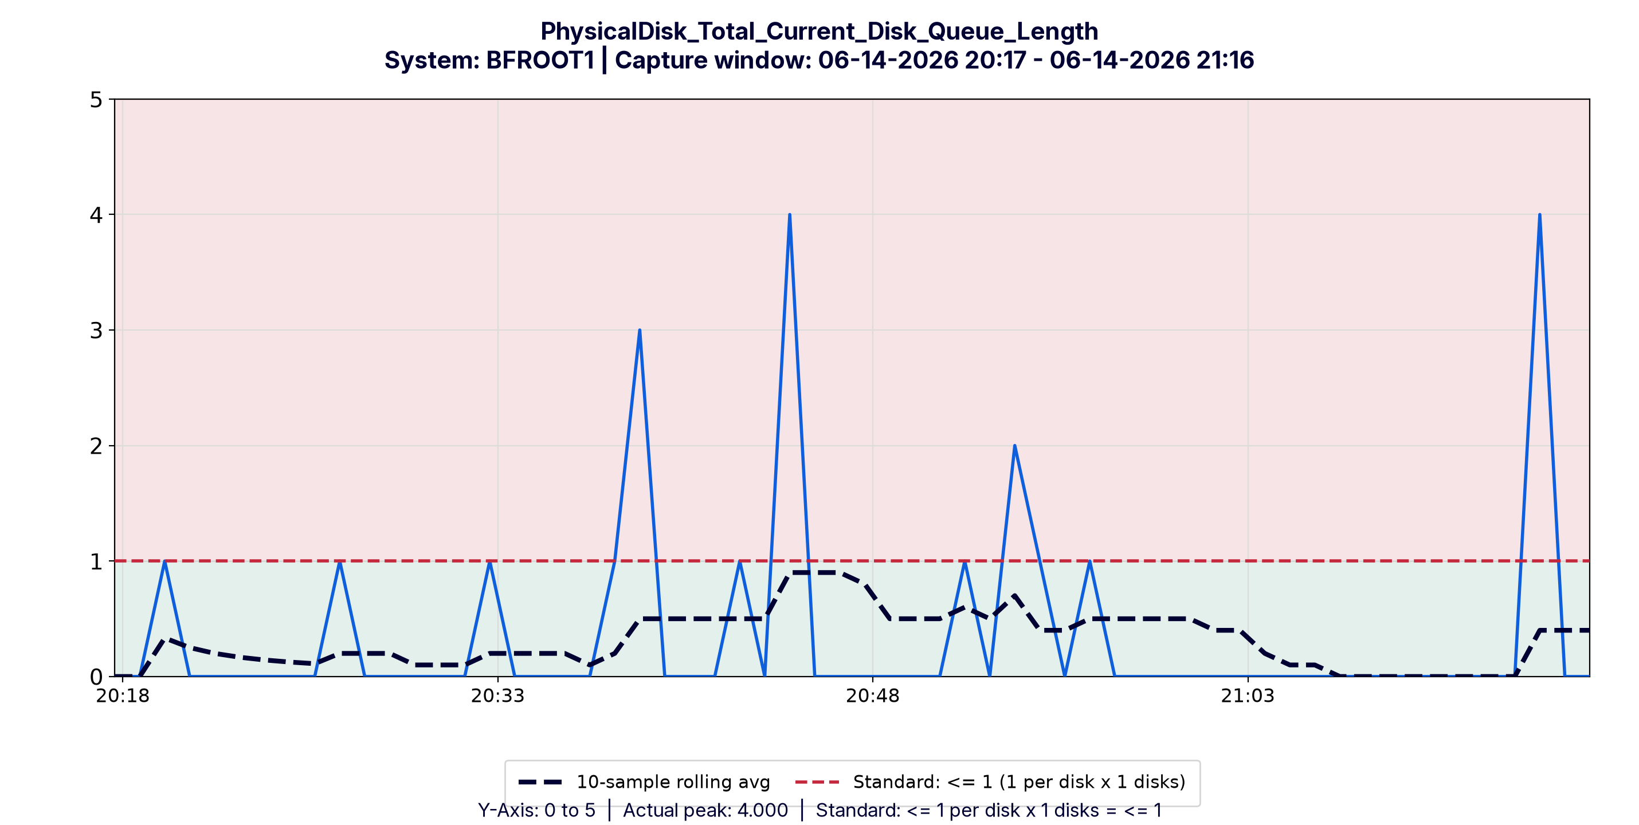
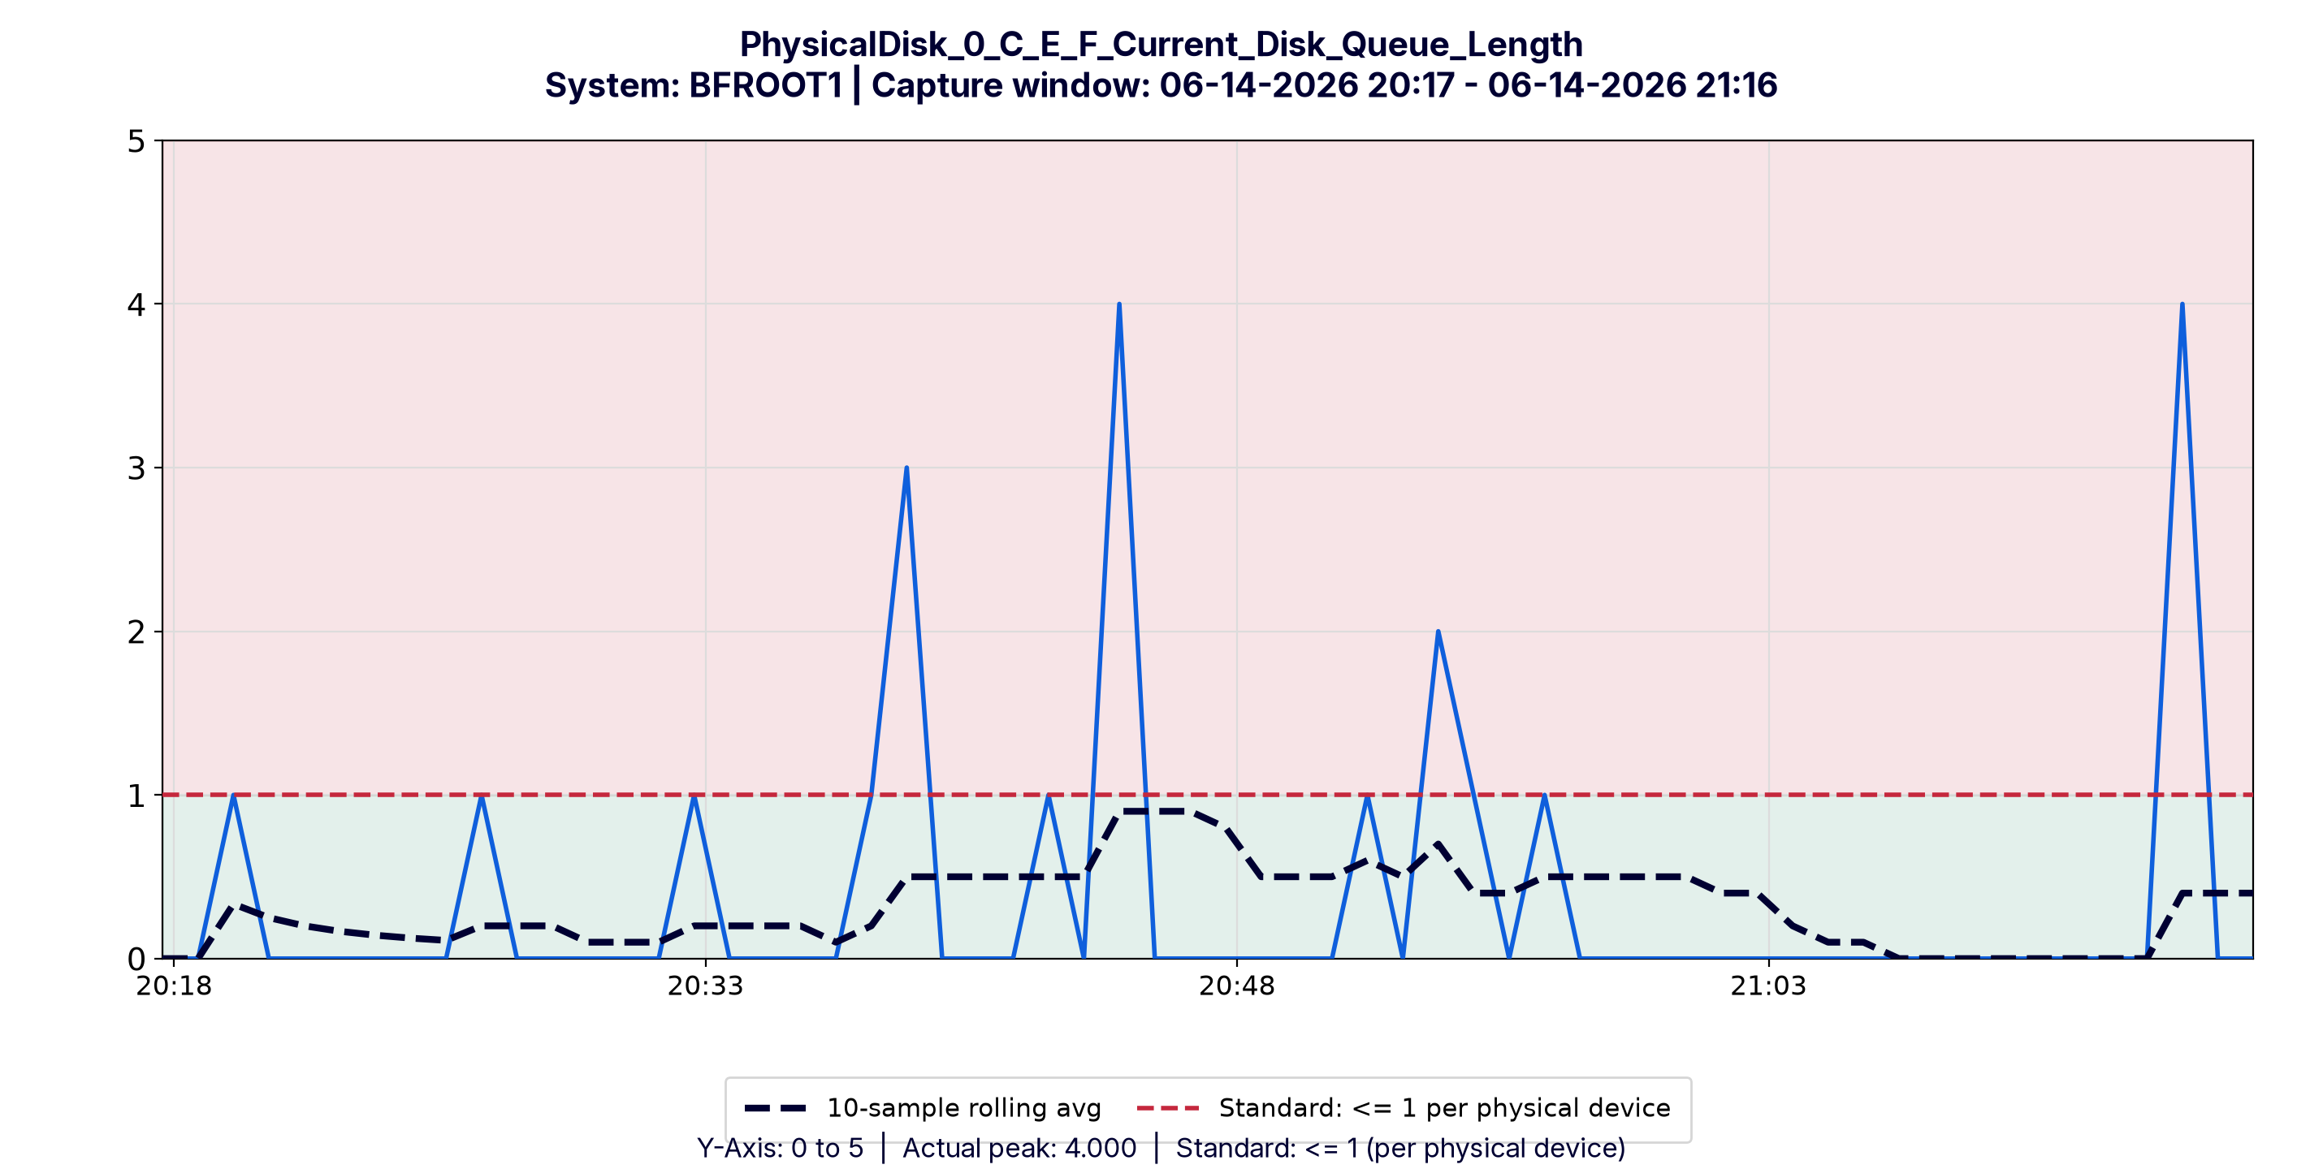

Storage Latency
✗ Observation: The standard was not met for this capture window. The worst counter averaged 2.05 ms against a limit of 1 ms. 4 of 59 readings (6.78%) were over the limit, in the breach window 06-14-2026 20:34:40 to 06-14-2026 20:40:40. They raised the average over the limit. The other 55 readings met the standard. It peaked at 40.7 ms. 2 related counters need review in this section.

Affected Counters Requiring Review
✗ Counter: PhysicalDisk_Total_Avg_Disk_ms_Transfer: average 2.05 ms, peak 40.7 ms, 4 readings (6.78%) over the limit.
✗ Counter: PhysicalDisk_0_C_E_F_Avg_Disk_ms_Transfer: average 2.05 ms, peak 40.7 ms, 4 readings (6.78%) over the limit.
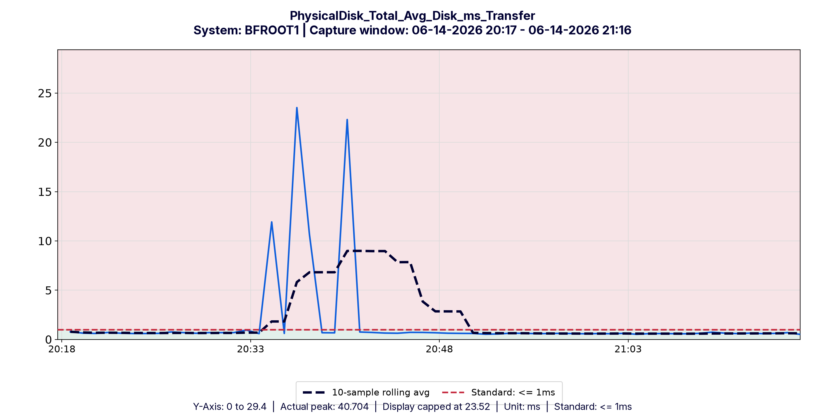
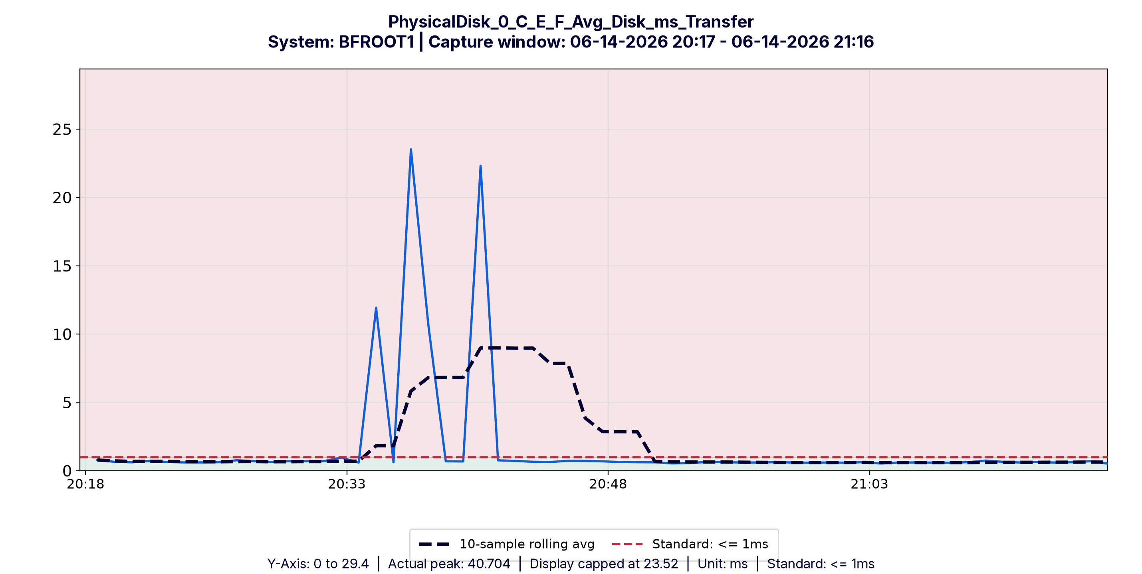

Storage Operations
✓ Observation: This counter has no limit. It is reviewed for saturation or flat-lining. The highest reading was 1,924 and the average was 478 across 59 readings. Both counters are shown for workload review. No fixed pass/fail limit is applied.
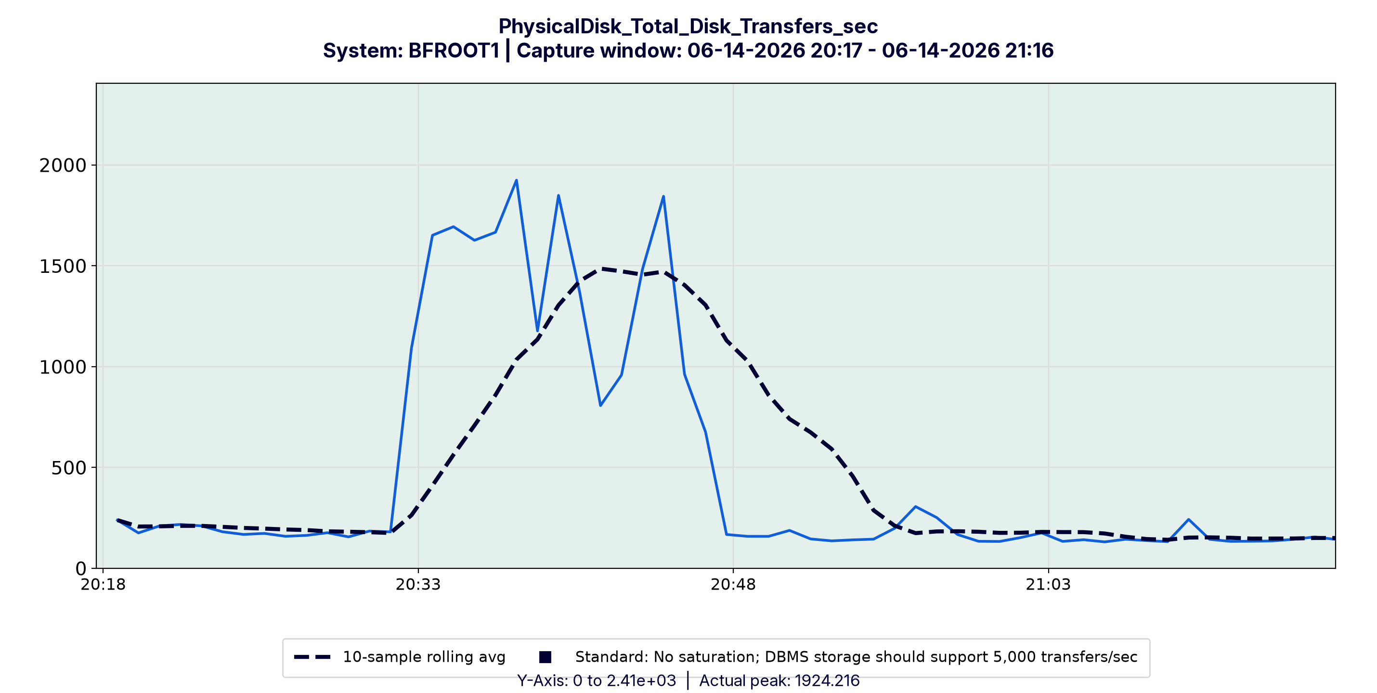
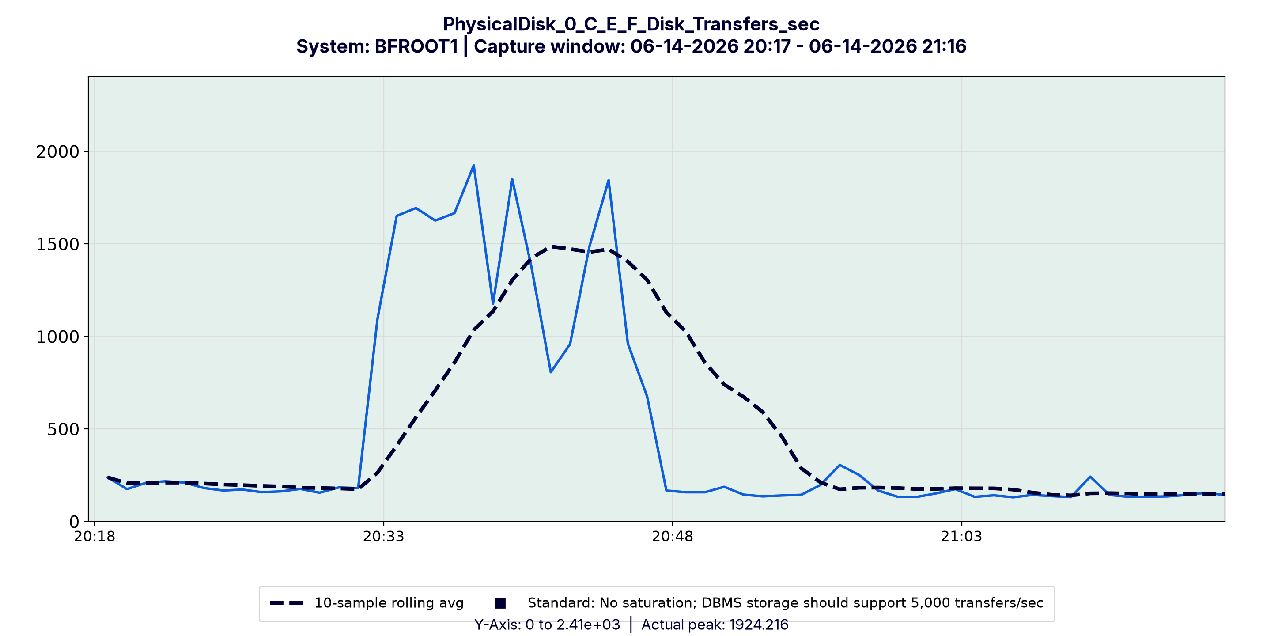

CPU Privileged Time
✗ Observation: The standard was not met for this capture window. The worst counter averaged 19.3% against a limit of 10%. The average stayed over the limit for most of the capture. It peaked at 33.0%, with 54 of 59 readings (91.5%) over the limit. Breach window: 06-14-2026 20:18:40 to 06-14-2026 21:15:40.

Affected Counters Requiring Review
✗ Counter: Processor_Total_Privileged_Time: average 19.28%, peak 32.95%, 54 readings (91.53%) over the limit.
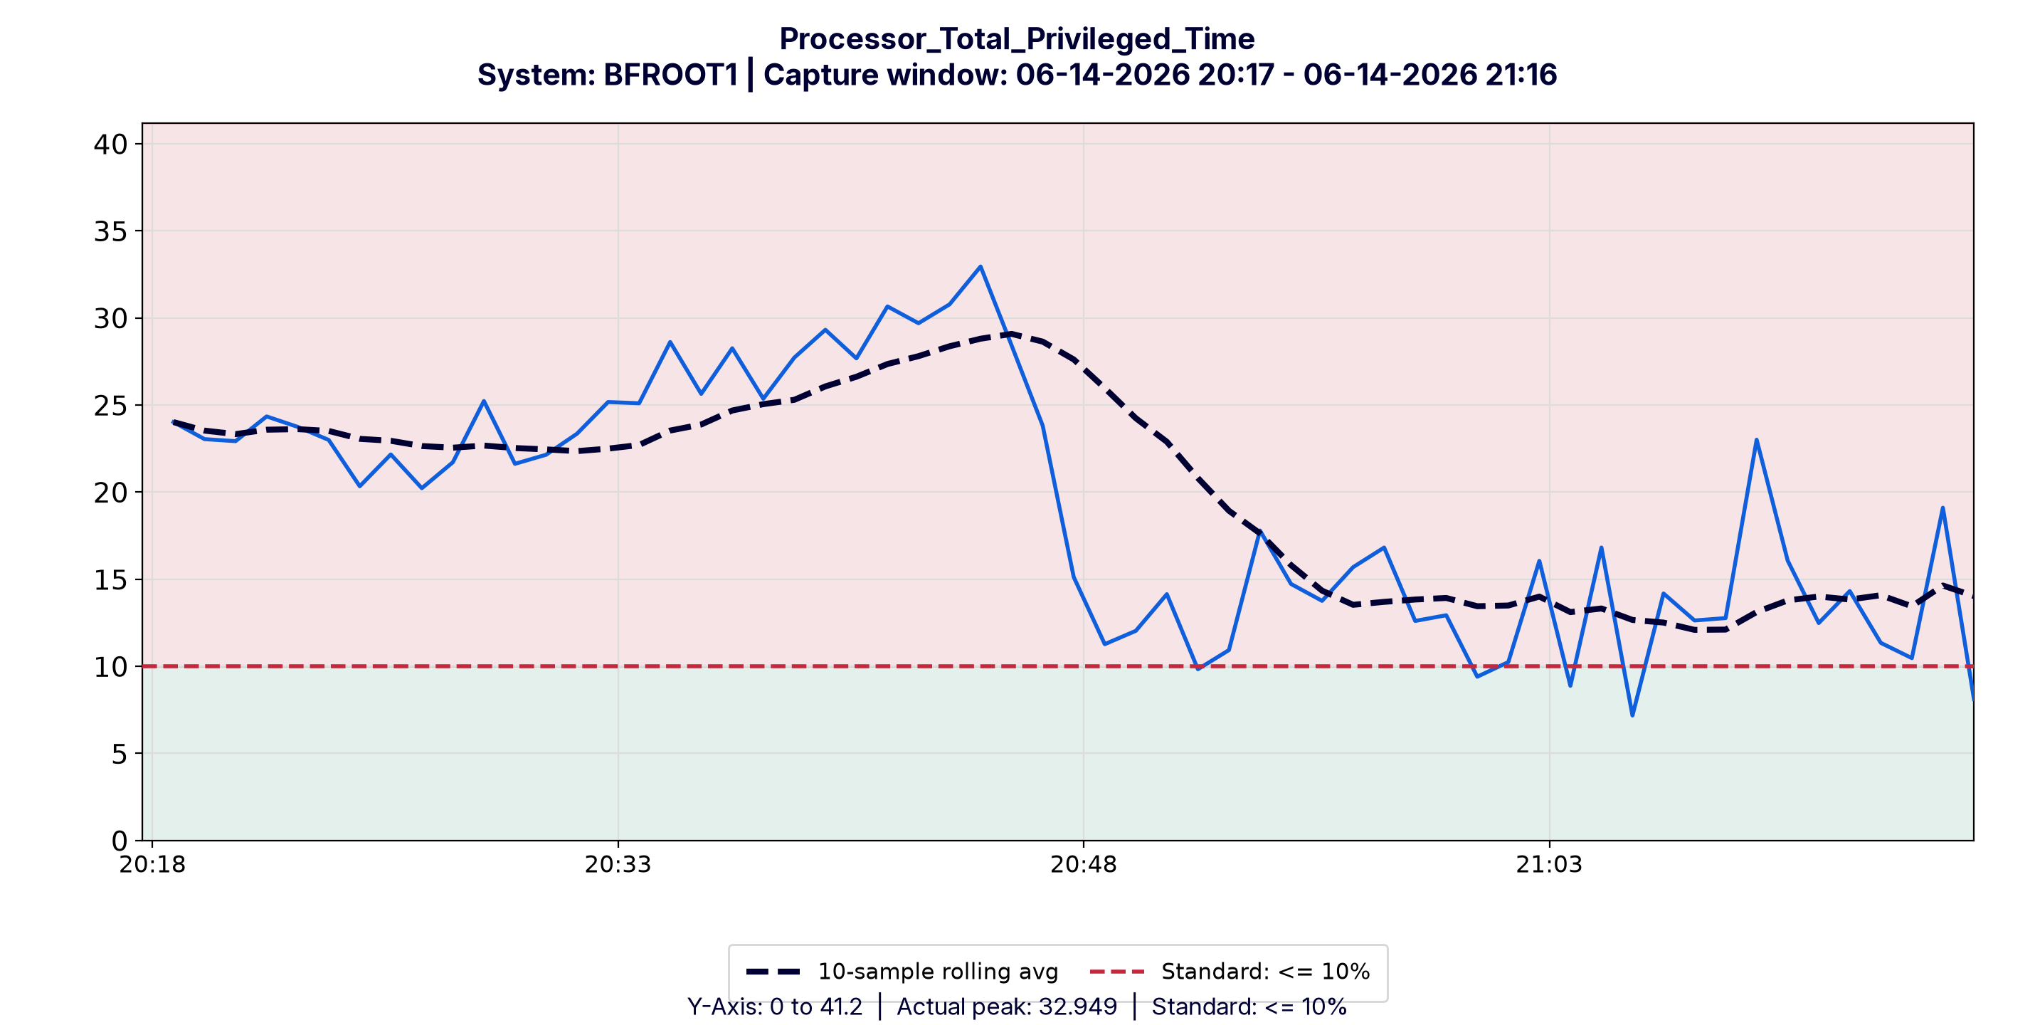

CPU Utilization
✓ Observation: The standard was met for this capture window. The worst counter averaged 40.3% against a limit of 80% across 59 readings, with a peak of 65.9%.
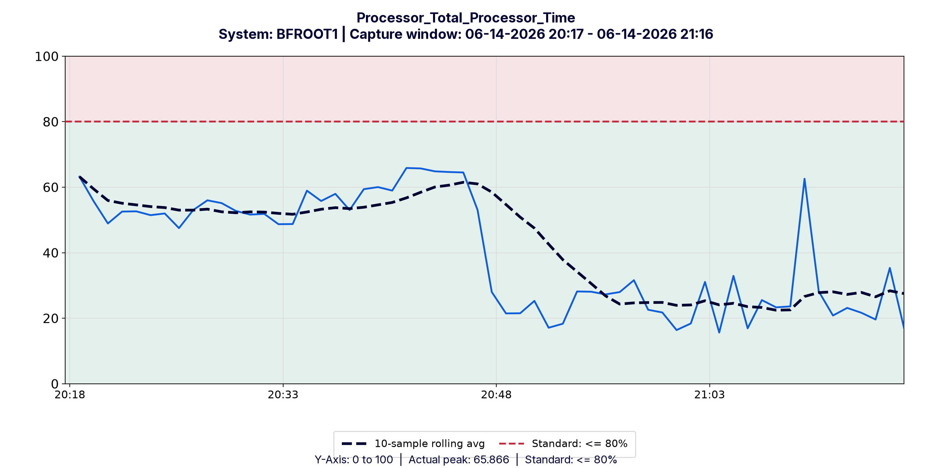

CPU Latency
✓ Observation: The standard was met for this capture window. The worst counter averaged 0.37 against a limit of 4 across 60 readings, with a peak of 15.0. 2 readings were briefly over the limit, but the average stayed within it.
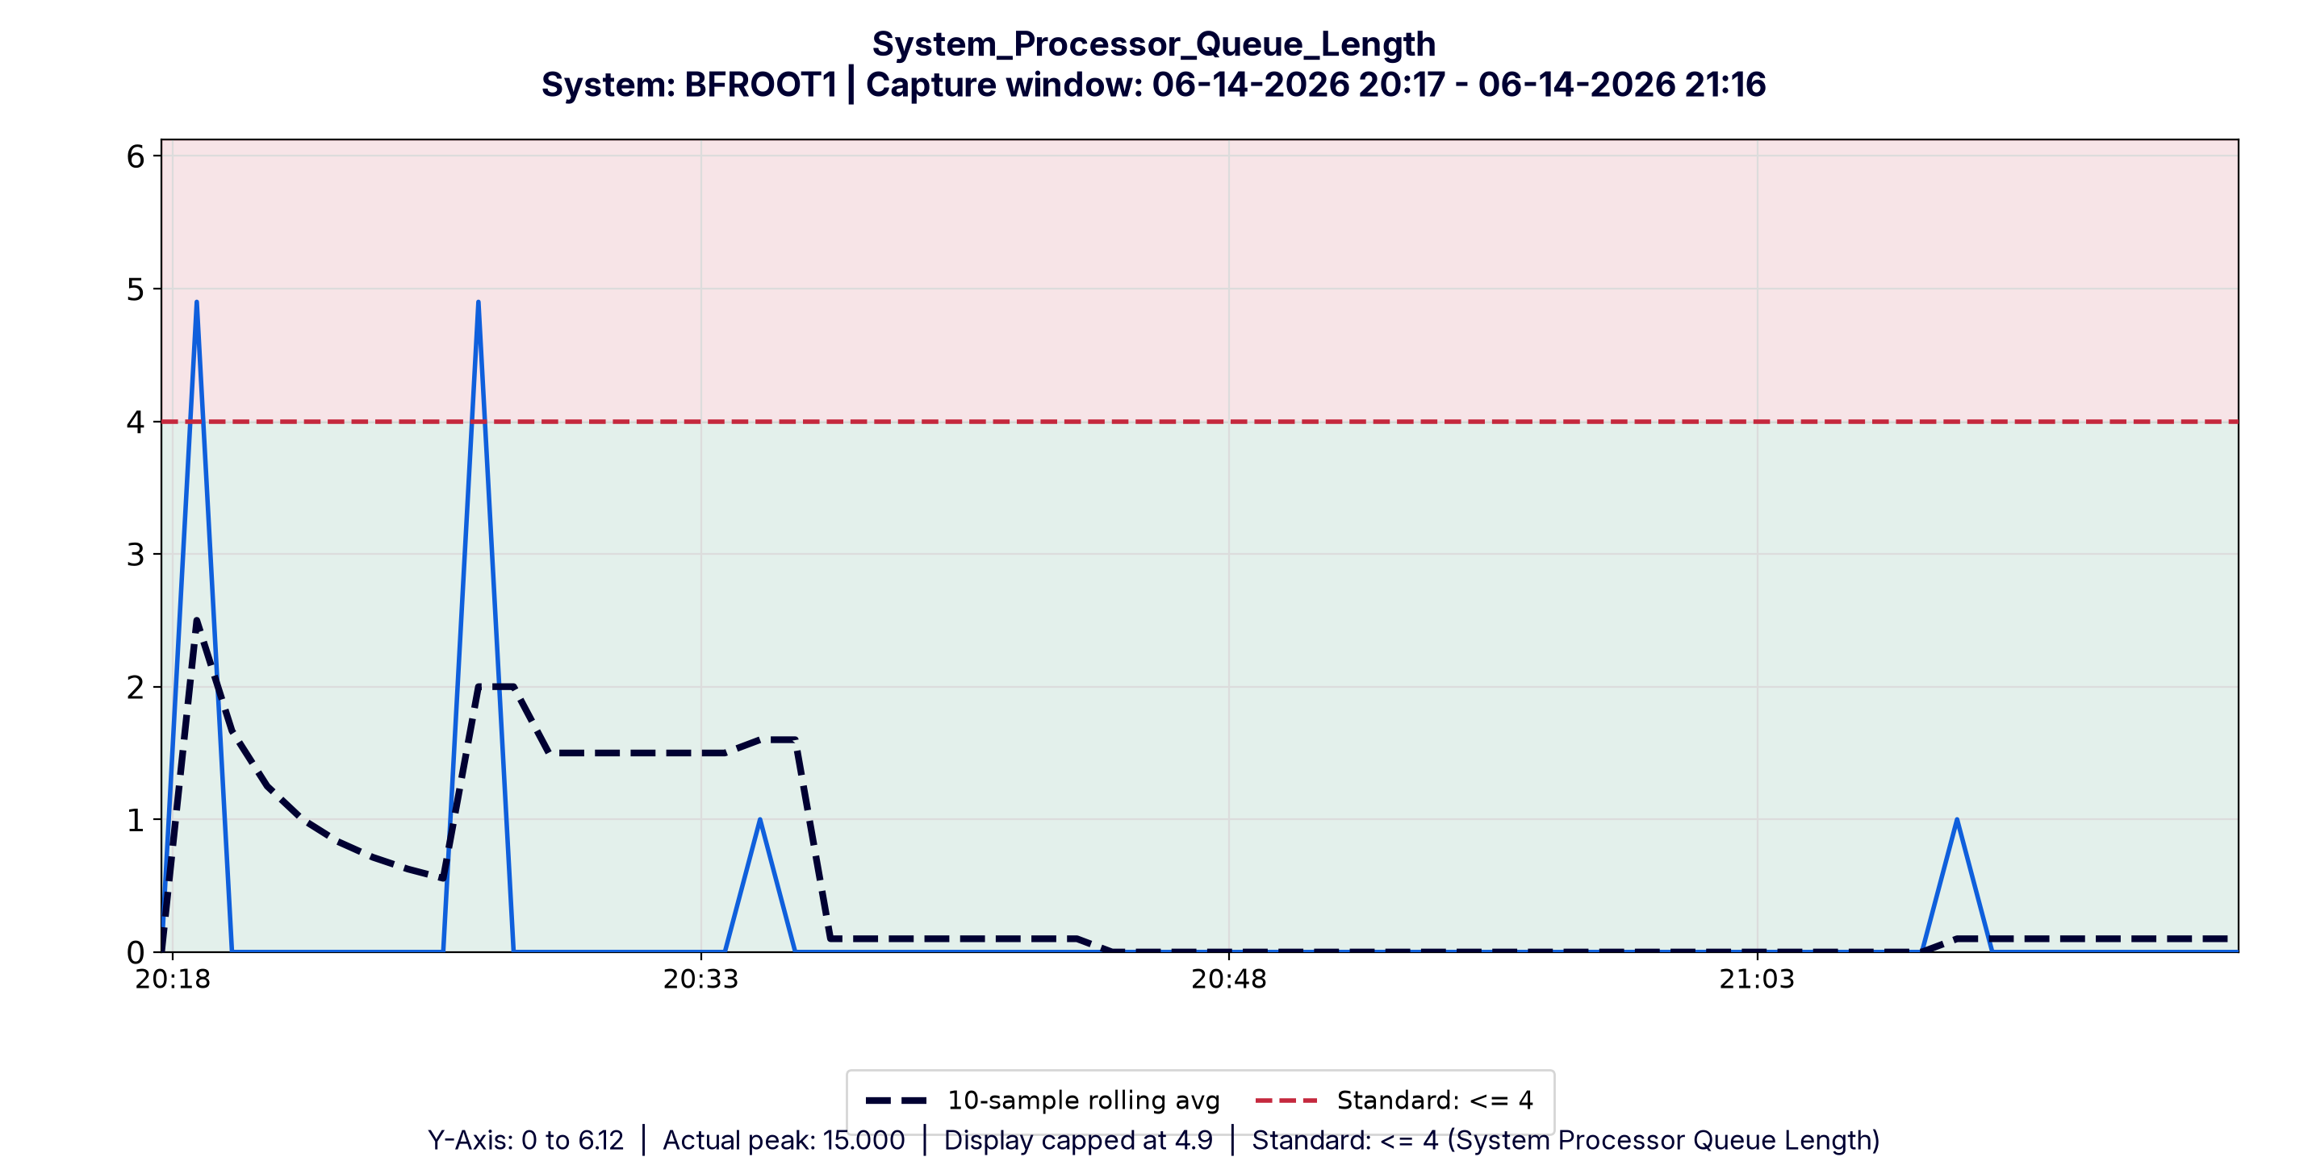

Network Health
✓ Observation: No packet errors or discards were added between samples across 59 readings. 4 related counters were reviewed and all met the standard.

Memory Health
? Observation: Physical memory was not supplied, so this area cannot be verified. Cannot Verify earns 25 points in the score. PRF-INF-09 measures page file use against physical memory.

Affected Counters Requiring Review
? Counter: Paging_File_Total_Usage_Peak. It was not compared with the limit because physical memory was not supplied.

Assessment by Area
Area | Status | Standard / Basis | Observed
Storage Queue Depth | ✓ Pass | <= 1 per disk x 1 disks = <= 1 | avg 0.35, peak 4.0, 4 readings over
Storage Latency | ✗ Fail | <= 1ms | avg 2.05 ms, peak 40.7 ms, 4 readings over
Storage Operations | ✓ Pass | No limit. Reviewed for flat-lining against 5,000 transfers per second. | avg 477.57, peak 1924.22
CPU Privileged Time | ✗ Fail | <= 10% | avg 19.28%, peak 32.95%, 54 readings over
CPU Utilization | ✓ Pass | <= 80% | avg 40.27%, peak 65.87%
CPU Latency | ✓ Pass | <= 4 (System Processor Queue Length) | avg 0.37, peak 15.0, 2 readings over
Network Health | ✓ Pass | Packet errors and discards should approach zero per interface. Evaluated as the non-negative increase between samples | avg 0.0, peak 0.0
Memory Health | ? Cannot Verify | Page file in use should be <= 5% of physical memory. Physical memory was not supplied, so this area cannot be verified. Cannot Verify earns 25 points in the score. | Paging_File_Total_Usage_Peak

