BigFix Master Class 2026
Automated Performance and Configuration Analysis
Student Lab Guide

September 29, 2026

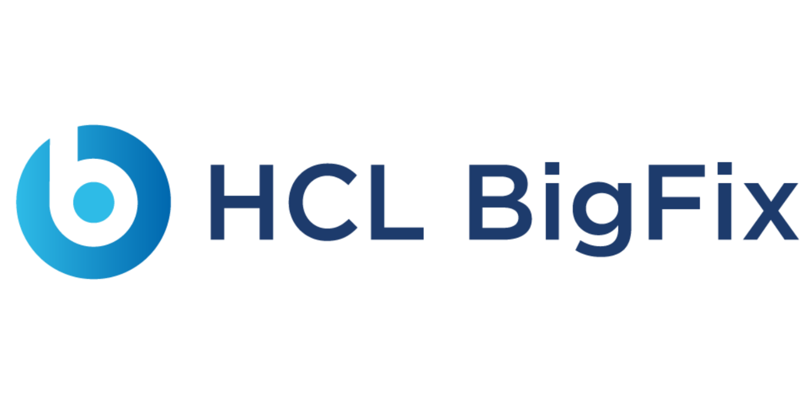
For more information
To learn more about BigFix, contact your HCLSoftware representative, HCL Business Partner, or visit www.BigFix.com.

About HCLSoftware
HCLSoftware, a division of HCLTech, develops, markets, sells, and supports software for digital transformation, data, analytics and insights, AI and automation, and enterprise security. HCLSoftware is the cloud-native solution factory for enterprise software and powers millions of apps at more than 20,000 organizations, including more than half of the Fortune 1000 and Global 2000 companies. HCLSoftware's mission is to drive ultimate customer success through relentless product innovation.
https://www.hcltechsw.com

© Copyright 2026 HCL

Produced in the United States of America.

All product names, trademarks and registered trademarks are property of their respective owners.

Contents
BigFix Master Class 5
Student exercises 5
Overview 5
Before you begin 5
Shared collection workflow 5
Exercise 1: Client Performance Loop Analysis 6
Exercise 2: Perfmon Infrastructure Analysis 13
Exercise 3: FillDB Performance Analysis (optional) 16
Reading the Mini Report 19
Completion checklist 21
Troubleshooting 21

Release Date | Version | Authors | Comments
September 28, 2026 | 0.1 | Master Class team | Initial lab guide draft.
September 29, 2026 | 0.2 | Master Class team | Screenshots and the current Workbench workflow.

BigFix Master Class

Student exercises

Overview
This lab introduces the BigFix Master Class Diagnostics Workbench. You collect operational data from a BigFix deployment with a collection task, run the matching Workbench module, and read the Mini Report it produces.
In this lab you will learn how to:
- Connect a BigFix collection task to the data a Workbench module needs.
- Run the Agent Performance and Perfmon exercises on their own.
- Run the optional FillDB exercise when the session schedule allows.
- Recognize the main evidence and measurements in a Mini Report.
The three modules run one at a time. The core path is Agent Performance followed by Perfmon. FillDB is an optional third exercise. Each module writes a Mini Report, an Infographic, and for two of the modules an Excel workbook.
NOTE: The Mini Report is the primary artifact of this class. The Workbench has no full report mode and no scoring workbook.

Before you begin
You need the following:
- Access to the lab BigFix console and the custom site Performance and Config Analysis.
- An instructor-provided BigFix account for actions that need operator permissions.
- The Diagnostics Workbench project folder and a writable output folder.
- A Windows 10 or 11 workstation with Python 3.12 or newer, Microsoft Edge or Google Chrome, and Microsoft Word and Excel.
- A folder for collected data. Use the instructor-provided sanitized capture when live collection takes longer than the class session.
NOTE: Microsoft Word and Excel are the preferred and tested applications for the Mini Reports and workbooks. LibreOffice and other compatible applications may work, but they have not been fully vetted.

Shared collection workflow
The collection tasks are in the Performance and Config Analysis site. Each exercise follows the same pattern. Prepare the required analysis or service, run the collection task, retrieve the files, and place them in the Workbench data folder.
Module | BigFix content | Data to retrieve
Agent Performance | BigFix Master Class -- Agent Performance Counters - Basic (2.0) analysis and BigFix Master Class -- Collect Agent Performance Counter Analysis Data (2.0) task | Client_Loop XML or CSV. Optional Top 10, UDP, and Deployment_Information captures.
Perfmon | BigFix Master Class -- Setup and Run Perfmon Counters (2.0) | The Perfmon .blg file from every targeted server.
FillDB | BigFix Master Class -- Enable FillDB Performance Logging (2.0) | FillDBPerf.log and its rollover files after logging is disabled.

Put the files for one deployment under one data folder:
<Data Folder>\
Client_Loop\ Agent Performance export and optional captures
Deployment_Information\ Optional root server information captures
Perfmon\ One or two Perfmon .blg captures
FillDB_Performance\ FillDB performance logs or the analyzer CSV

Important: Perfmon logs are large and are retrieved directly from the target machines. They are not uploaded by the collection task.

Exercise 1: Client Performance Loop Analysis
In this exercise, you collect client evaluation loop data and use the Workbench to review evaluation time, expensive evaluations, command polling, UDP coverage, and FastHashVerify settings.
BigFix collection
- In the BigFix console, open the Performance and Config Analysis site.
- Activate BigFix Master Class -- Agent Performance Counters - Basic (2.0). If it is already active and reporting, continue. Allow 24 to 48 hours of reporting before you collect.
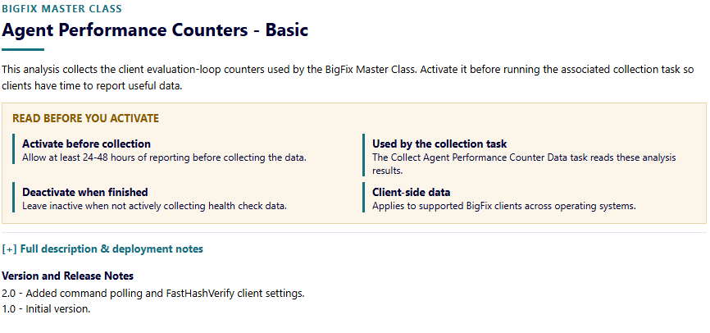
- Run BigFix Master Class -- Collect Agent Performance Counter Analysis Data (2.0) against the root server. Use the instructor-provided account when the task asks for API credentials. Do not place credentials in this guide or in the collected files.
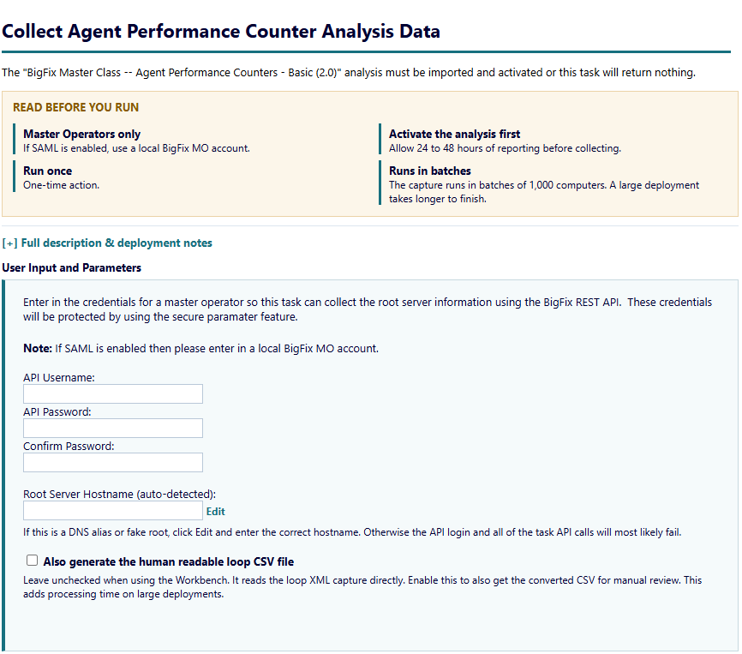
- Wait for the action to complete and retrieve the Client_Loop XML or CSV. Retrieve the optional Top 10, UDP, and Deployment_Information captures when they are present.
- Place the files under Client_Loop and Deployment_Information in your data folder.
NOTE: The primary file is named Client_Loop_<date>_<time>.xml or .csv. The task can also produce top10-query-results.csv and udp-notification-results.csv.
Run the Workbench
- Open Launchers and run Run Diagnostics Workbench.cmd. The first run creates the private Python environment, which takes about a minute.
- On Folders, set Data Folder to your data folder. The Workbench scans it and reports how many modules found their input.
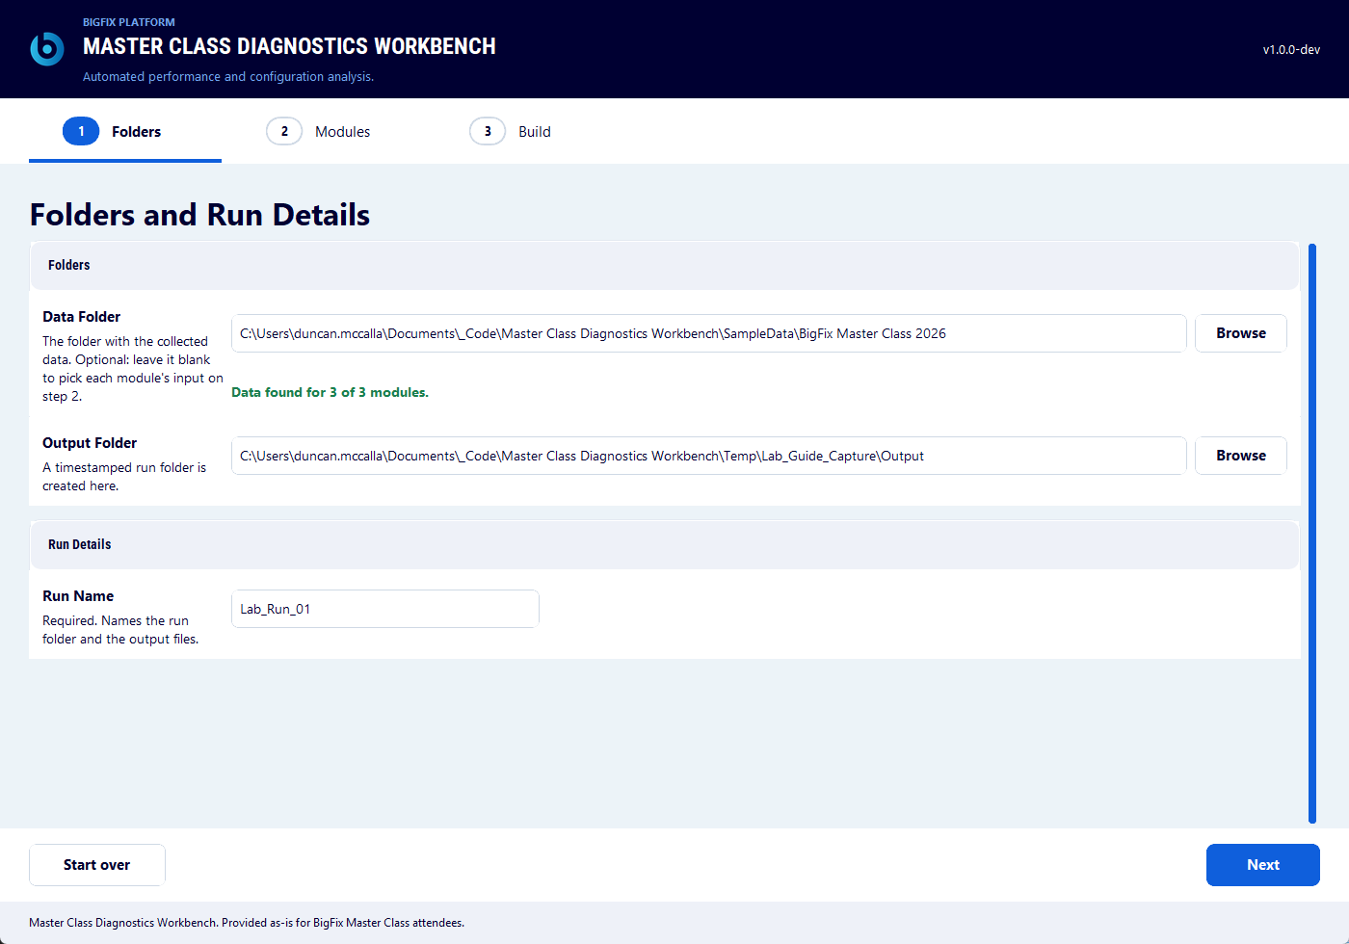
- Set Output Folder and enter a Run Name that identifies your lab run. The run name prefixes every output file.
- Click Next. On Modules, click Clear and then tick Client Performance Loop Analysis only.
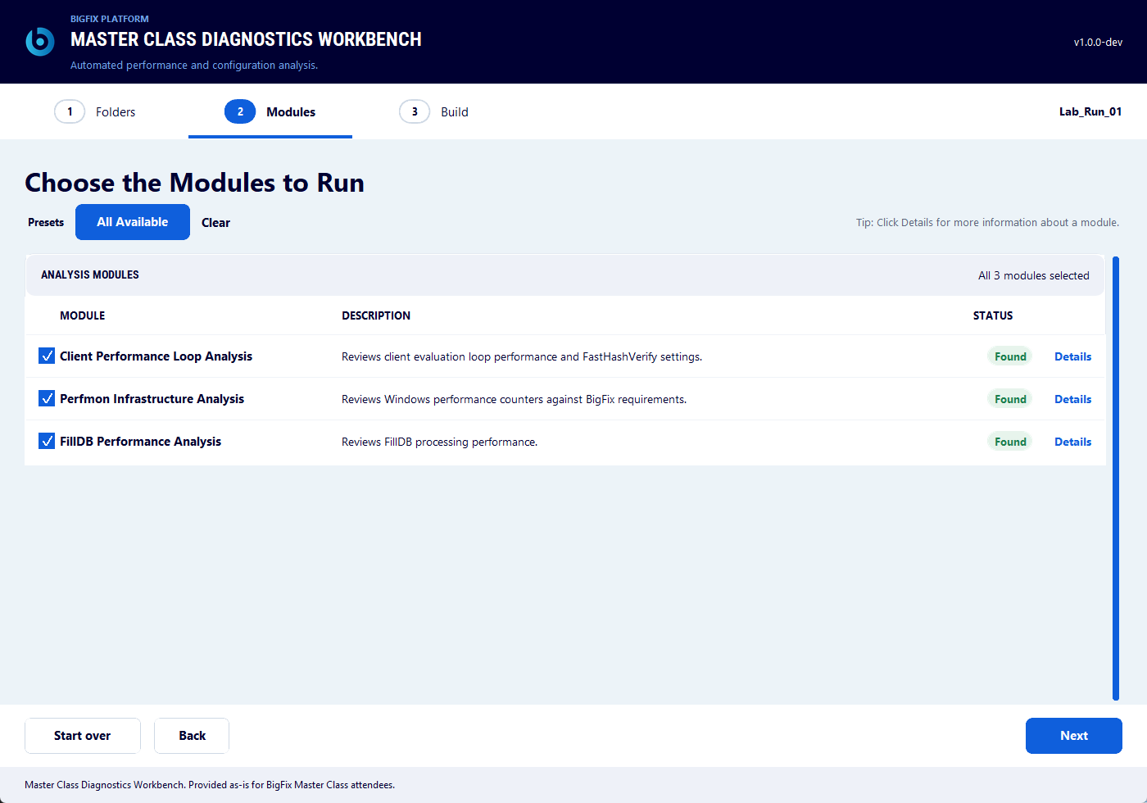
- Click Details. Confirm the loop export and the optional captures. Enter the Report Start Date and Report End Date for the collection period.
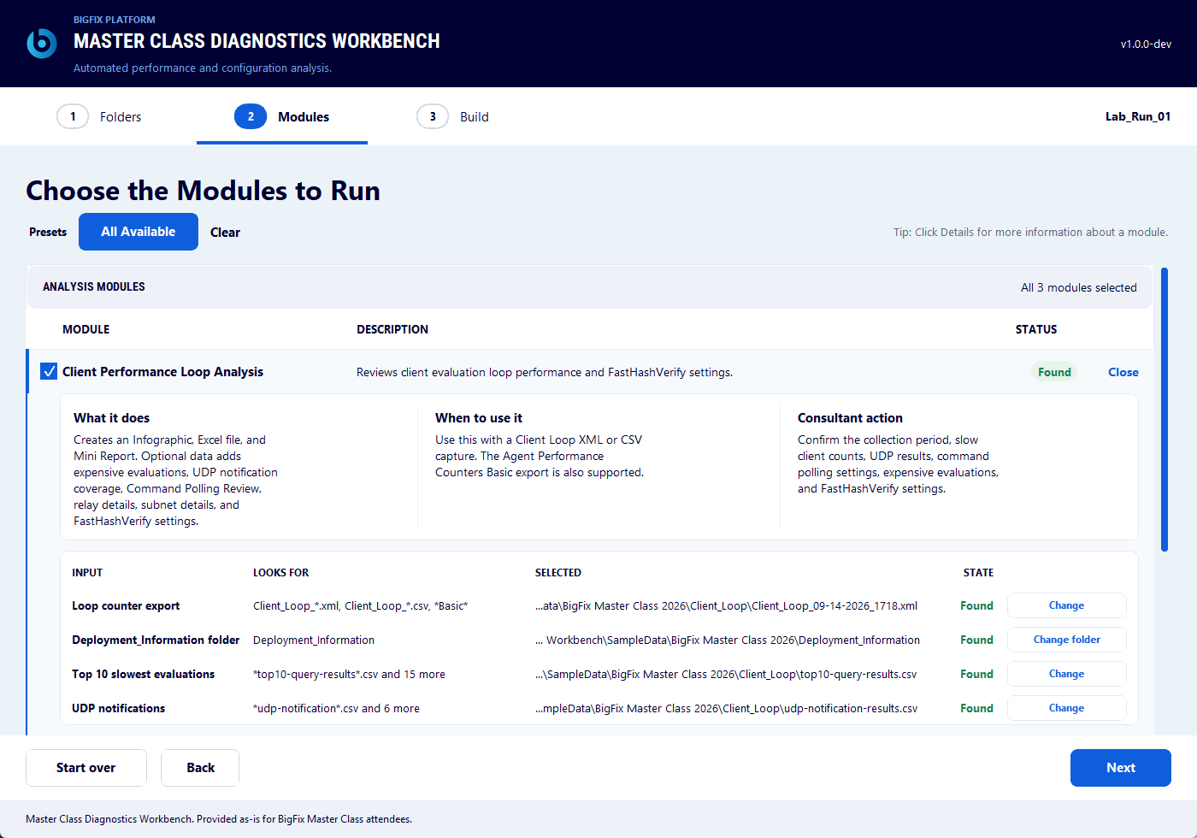
- Click Next. Check the Run Details strip and click Build. The module status moves from Queued to Running to Done.
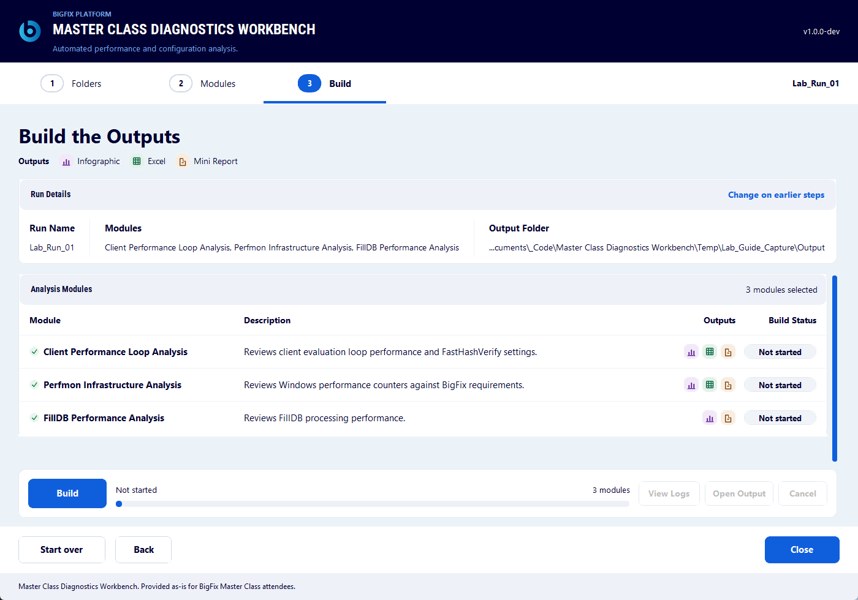
- When the status is Done, click Open Output and open the Mini Report in the Client_Loop folder.
Review the result
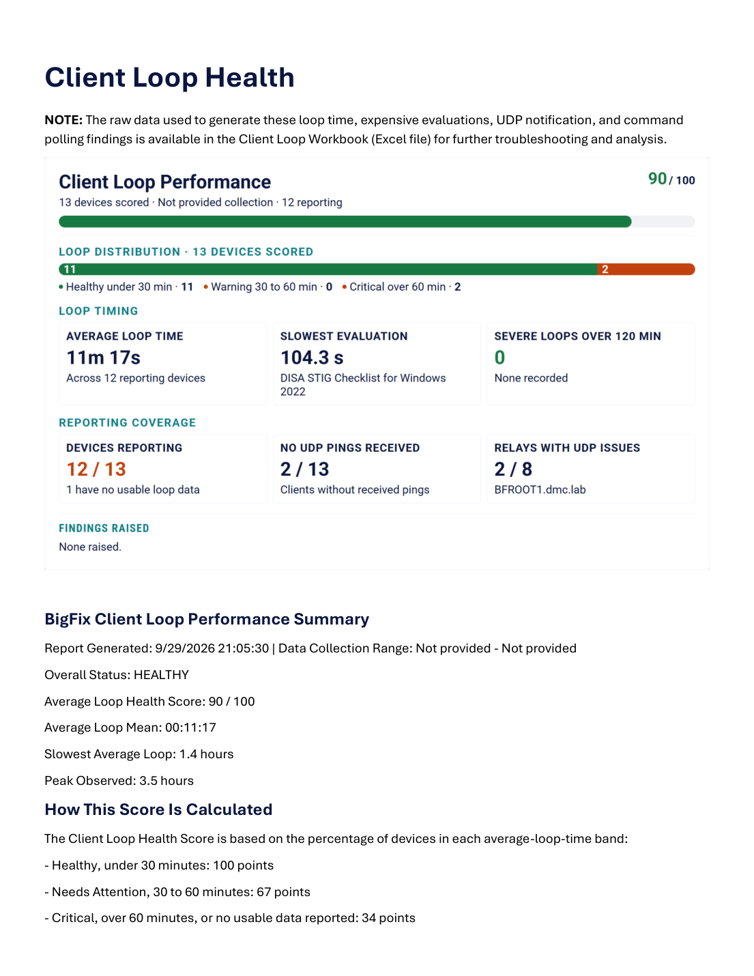
- Compare the maximum and average evaluation cycle times.
- Review the Top 10 evaluation table when the optional capture was collected.
- Review command polling and UDP coverage when the optional UDP capture was collected.
- Review the FastHashVerify enabled, work, and sleep values. These settings matter when large patch or software update files are common.
- Record one observation from the Mini Report that you would investigate next.
The Performance and Config Analysis site also holds four client setting tasks that act on what this Mini Report shows. They are not part of this exercise. Use them only when the review points to a setting change:
- BigFix Master Class -- Enable Client FastHashVerify Setting (Default - 25% Single Core) (1.0)
- BigFix Master Class -- Set CPU Utilization to 2% on Multi-Core Systems (1.0)
- BigFix Master Class -- Set CPU Utilization to 20% (Single Core) (1.0)
- BigFix Master Class -- Set Command Polling to 10 Minutes over Average Evaluation Time (1.0)
You have now successfully completed Exercise 1.

Exercise 2: Perfmon Infrastructure Analysis
In this exercise, you capture Windows performance counters from the BigFix role servers in scope and use the Workbench to review processor, memory, disk, and network behavior against the platform requirements.
BigFix collection
- In the BigFix console, open the Performance and Config Analysis site.
- Run BigFix Master Class -- Setup and Run Perfmon Counters (2.0) separately against each Windows role server in scope. Include the SQL Server host when the instructor has selected it.
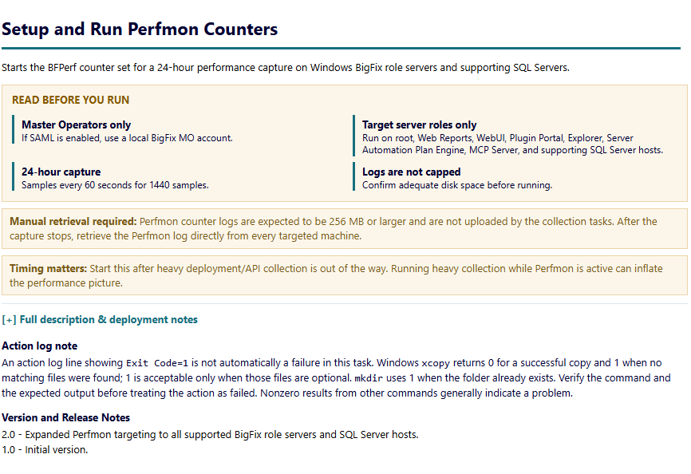
- Allow the counter set to run for the collection window. The task starts the BFPerf counter set and writes a README beside the results.
- When the capture is complete, stop BFPerf with the command in the generated README, or use the approved disable procedure for the lab environment.
- Retrieve the .blg file directly from every targeted machine. Keep the files separate and identify each server clearly.
- Place one or two .blg files under Perfmon in your data folder.
NOTE: Perfmon logs are expected to be 256 MB or larger. The task does not upload them. Copy them by hand.
Run the Workbench
- Open the Workbench and set Data Folder, Output Folder, and Run Name as in Exercise 1.
- On Modules, click Clear and then tick Perfmon Infrastructure Analysis only.
- Click Details. Confirm Capture 1. The CPUs and Disks values are detected from the capture. Enter RAM in GB and tick Virtual machine when the server is a VM. Add Capture 2 when a comparison is part of the exercise.
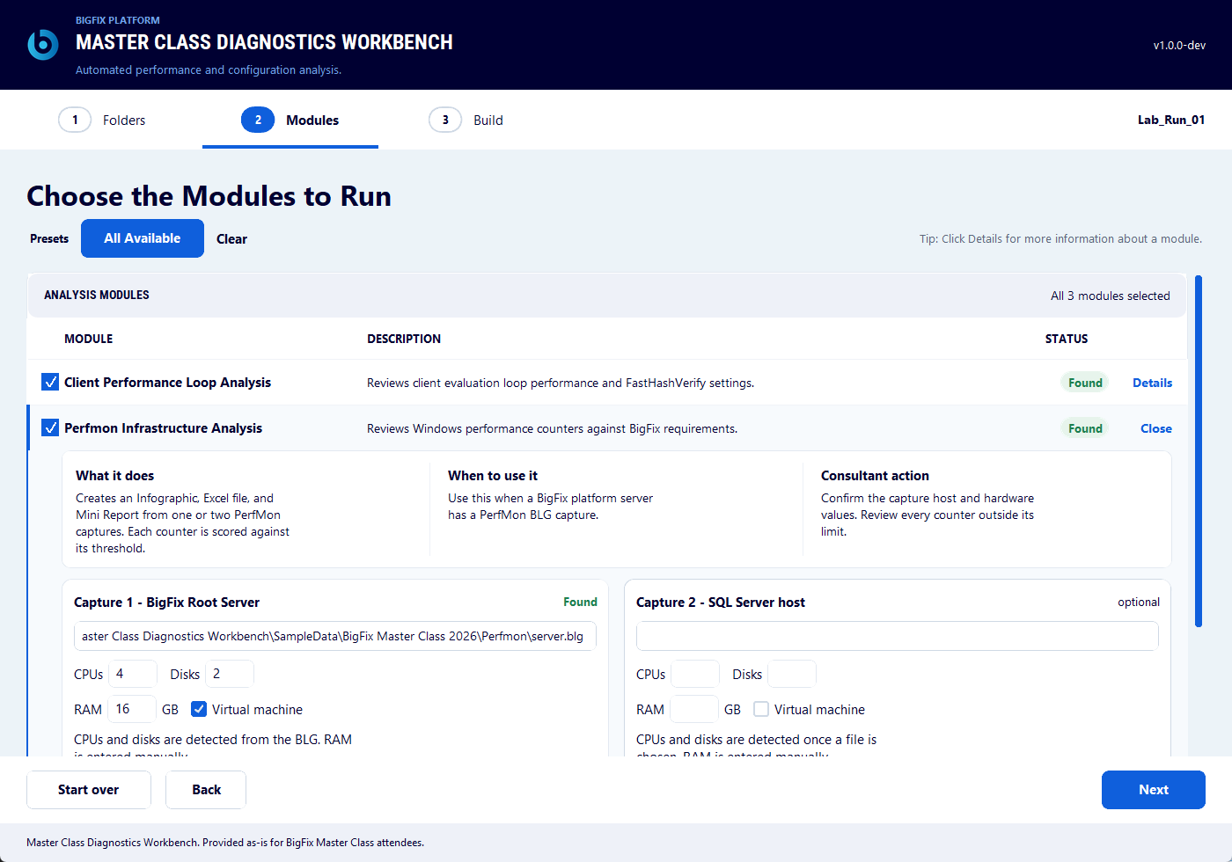
- Click Next and click Build. Parsing a large capture can take several minutes.
- When the status is Done, click Open Output. The Perfmon folder holds the Mini Report, the Excel workbook, and a _Perfmon_Charts folder with the scorecard Infographic and one chart per counter.
Review the result
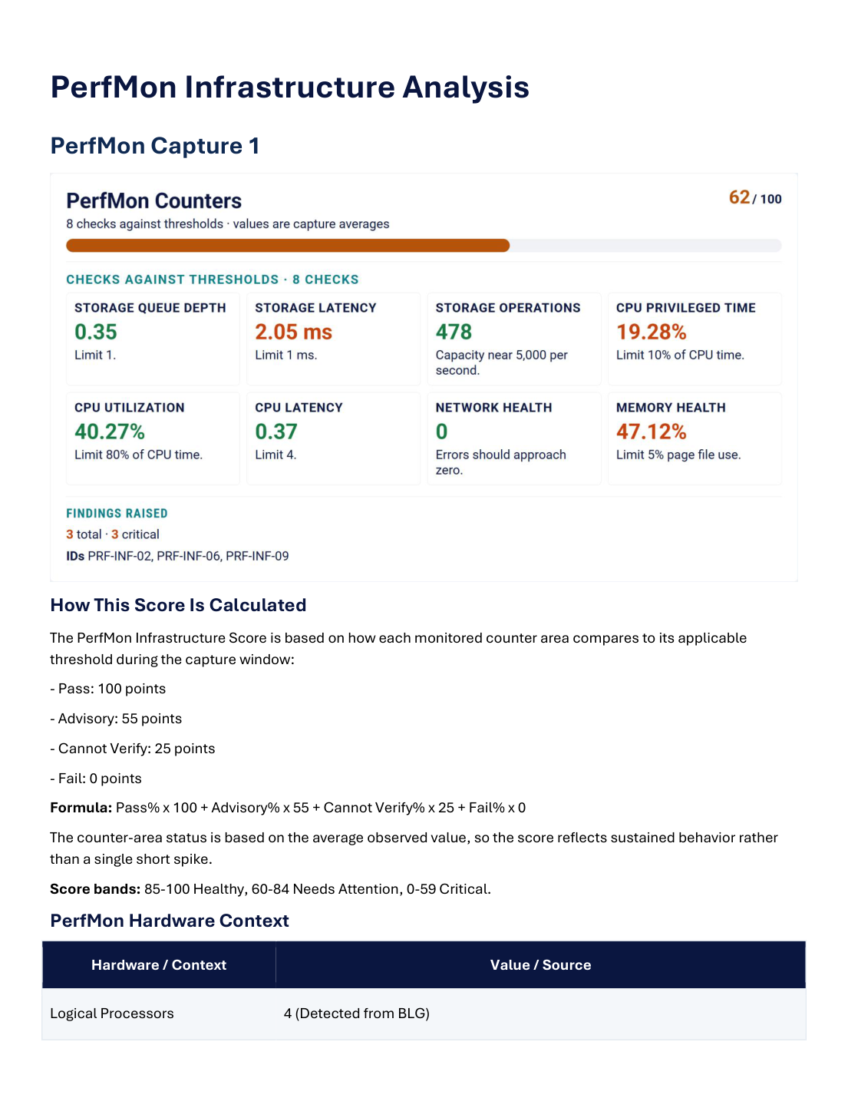
- Review the overall infrastructure result and the supporting counter observations.
- Identify one resource pattern that deserves a closer look.
- Compare two captures when a second server or a before and after capture is available.
You have now successfully completed Exercise 2.

Exercise 3: FillDB Performance Analysis (optional)
In this exercise, you collect FillDB performance logging from the root server and use the Workbench to review how quickly client reports are processed.
BigFix collection
- In the BigFix console, open the Performance and Config Analysis site.
- Run BigFix Master Class -- Enable FillDB Performance Logging (2.0) against the root server. Use the default automatic disable window unless the instructor specifies another duration.
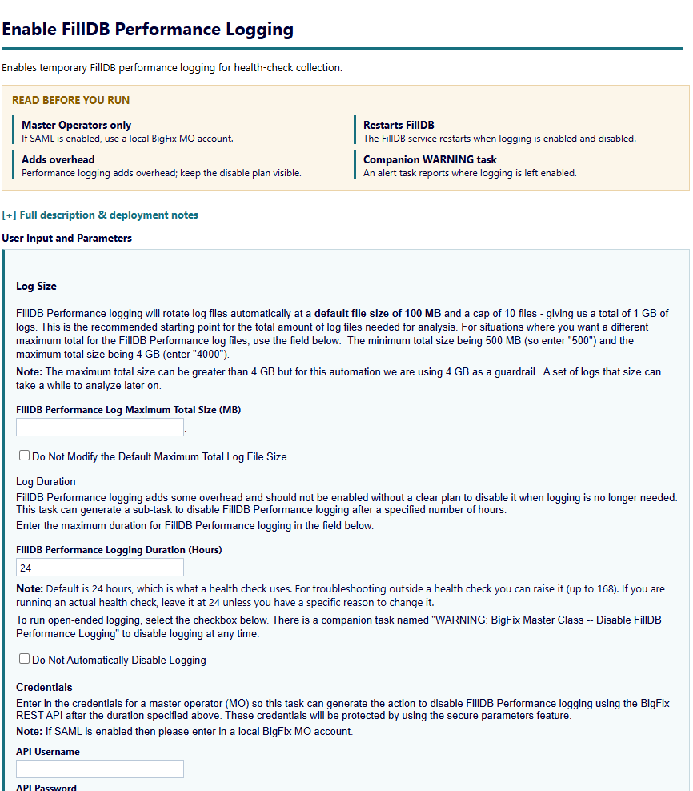
- After the collection window, wait for logging to be disabled and retrieve FillDBPerf.log plus any rollover files from the root server.
- If automatic disabling was not selected, run the companion warning task or the approved disable procedure before you retrieve the log set.
- Place the logs, or the instructor-provided analyzer CSV, under FillDB_Performance in your data folder.
Important: The log set must be complete and no longer active before analysis. Keep the rollover files together with FillDBPerf.log.
Run the Workbench
- Open the Workbench and set Data Folder, Output Folder, and Run Name as in Exercise 1.
- On Modules, click Clear and then tick FillDB Performance Analysis only.
- Click Details and confirm the log. The collection dates are optional. The log span is used when they are left blank.
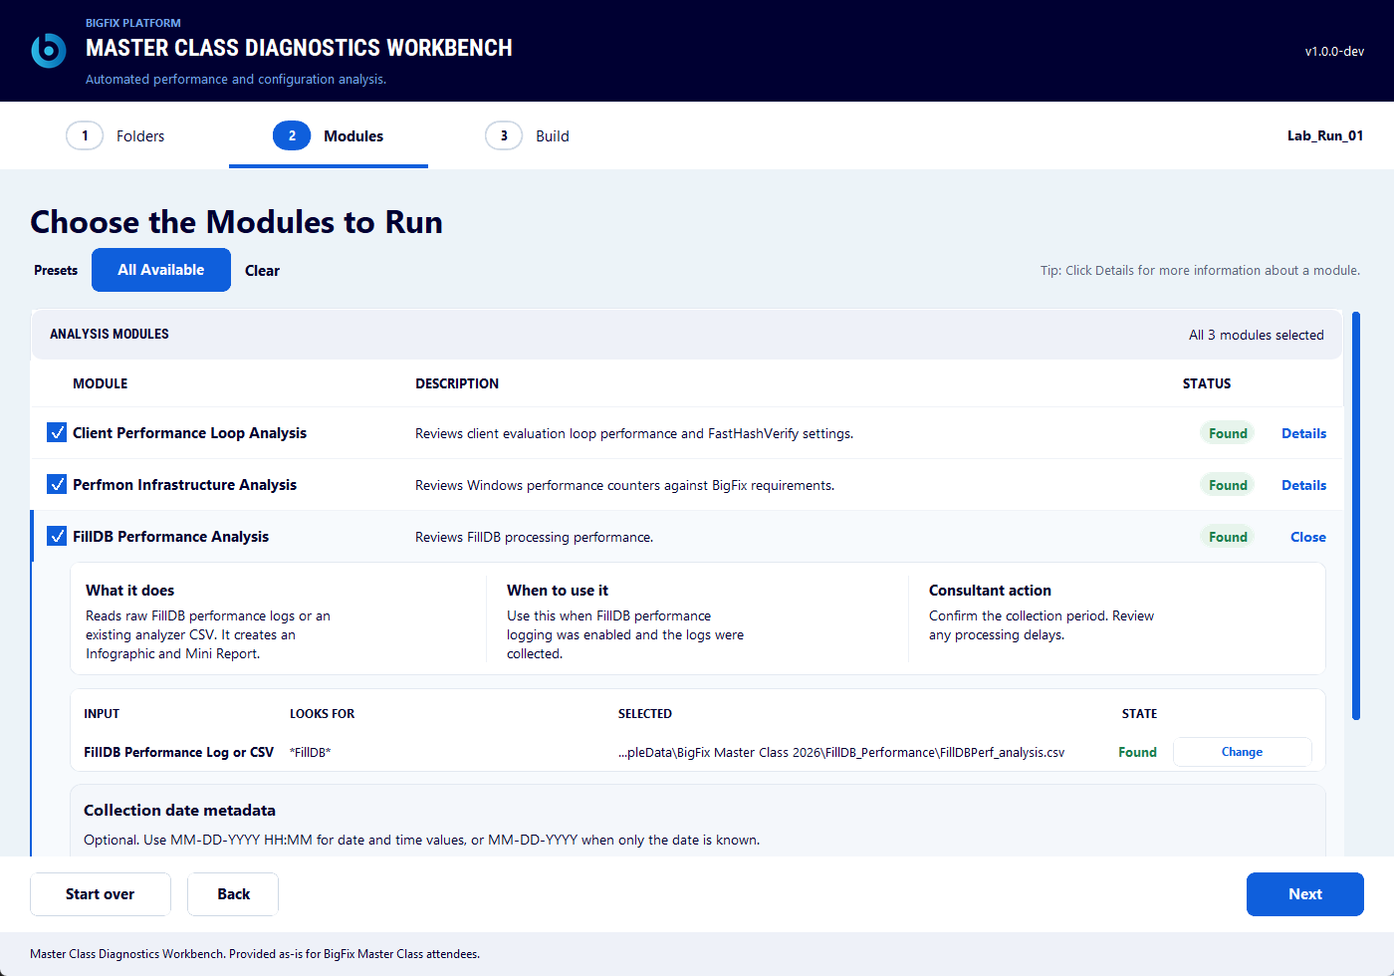
- Click Next and click Build.
- When the status is Done, click Open Output and open the Mini Report and the Infographic in the FillDB_Performance folder.
Review the result
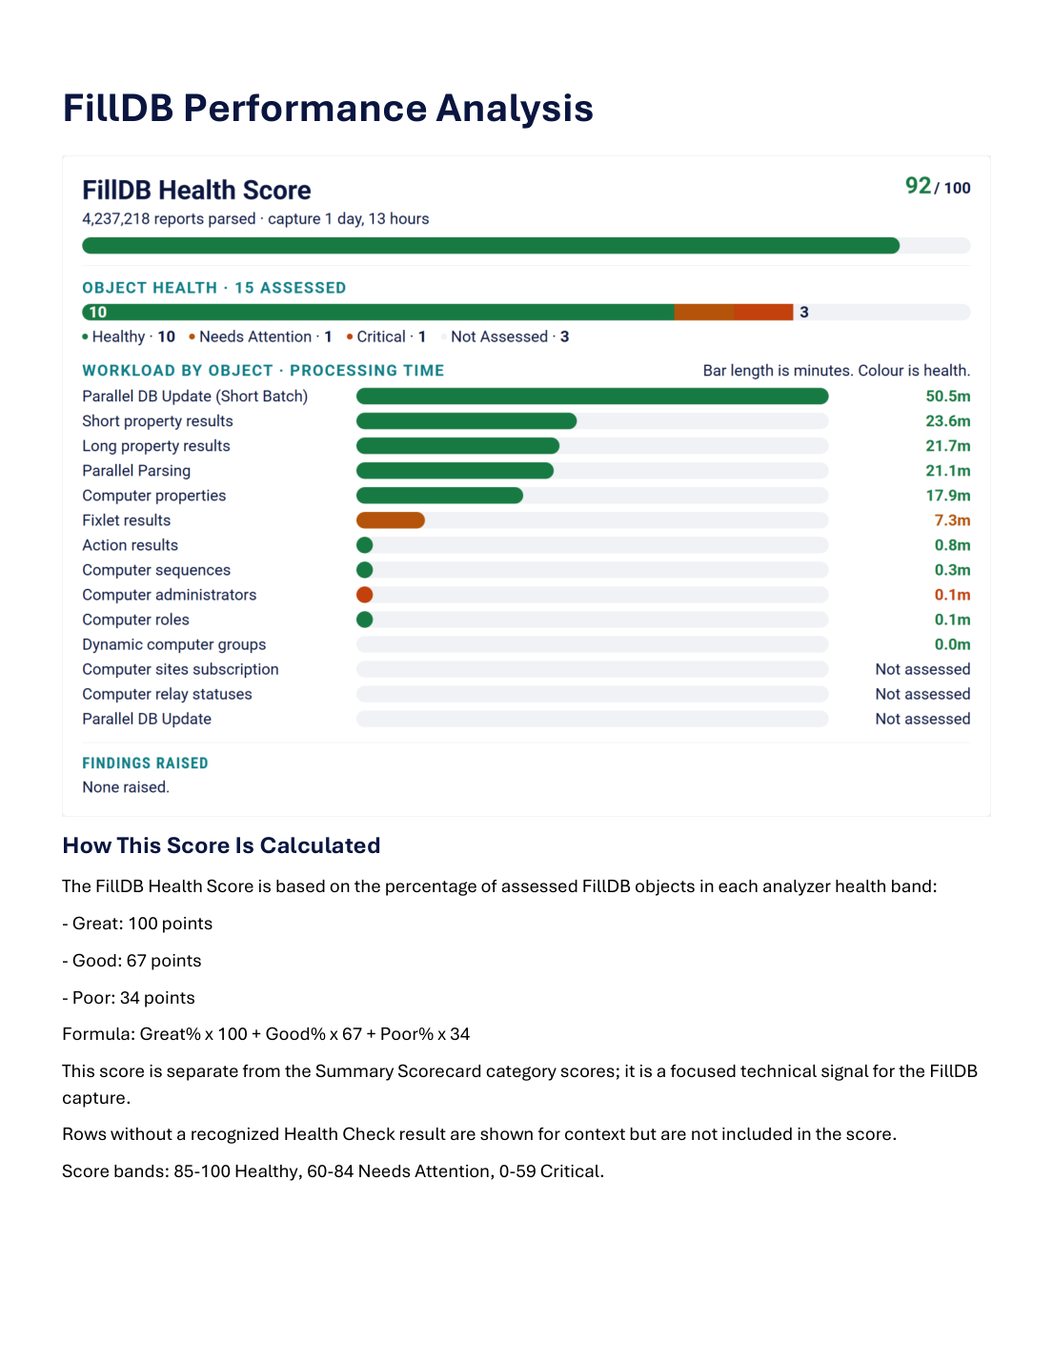
- Review the processing time summary and any objects that stand out.
- Connect the result to the collection window and the deployment activity at that time.
You have now successfully completed Exercise 3.

Reading the Mini Report
Each Mini Report is the narrative result for one module. Start with the score at the top, then use the supporting tables and charts to understand the evidence behind it.
- Confirm the report identifies the intended run and data window.
- Read the score or status together with the supporting measurements.
- Use the detailed tables to trace an observation back to the collected data.
- Write down one evidence-based next question. The lab is about interpreting operational data, not about making an untested configuration change.
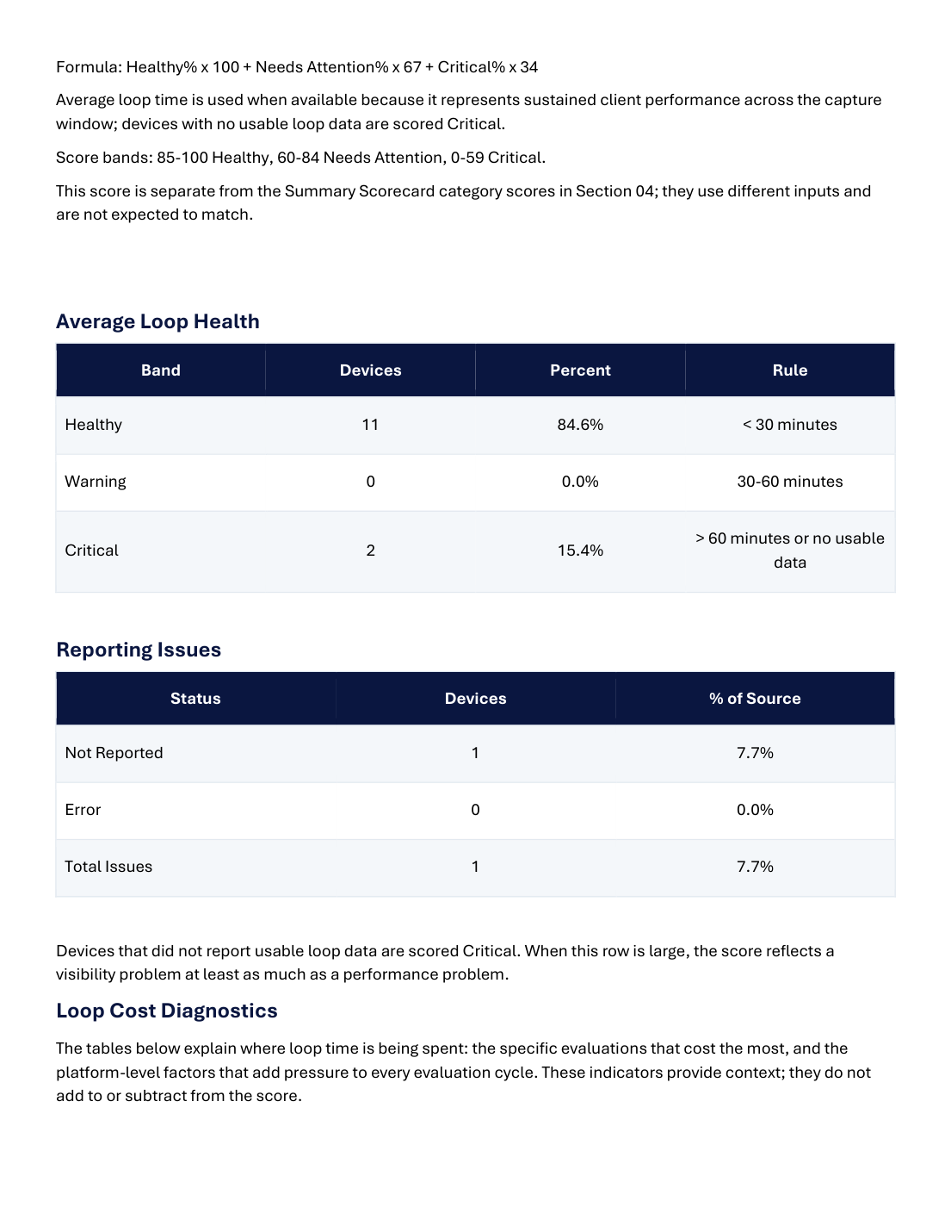
The Infographic is the one page visual of the same result. The Excel workbook, where a module writes one, carries the source data and the per item detail.
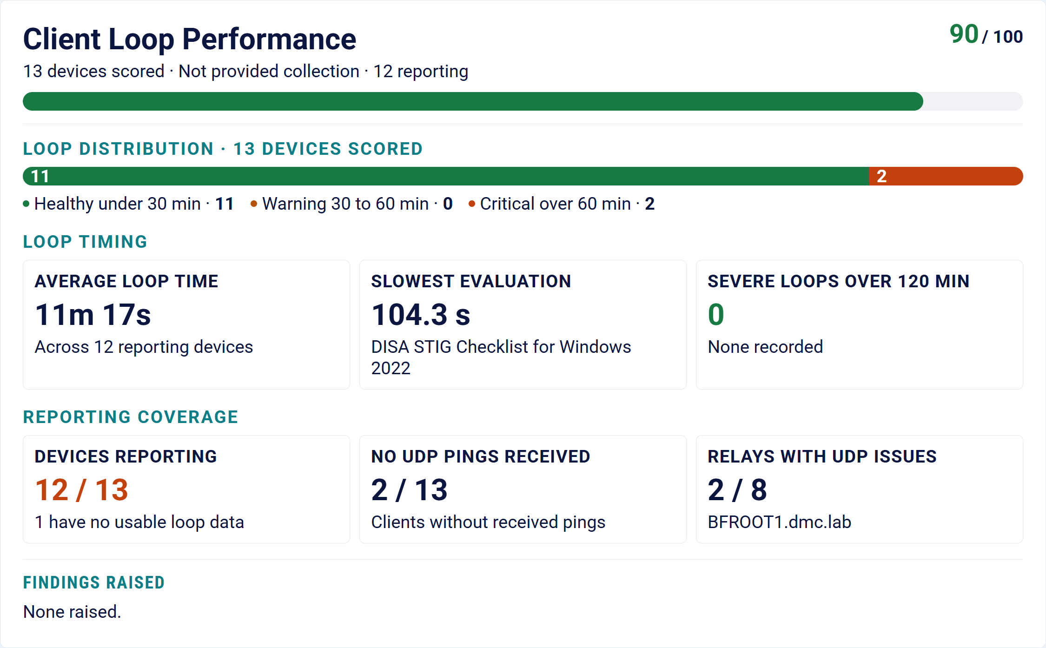

Completion checklist
Exercise | Collection complete | Data retrieved | Mini Report reviewed
Agent Performance | [ ] | [ ] | [ ]
Perfmon | [ ] | [ ] | [ ]
FillDB (optional) | [ ] | [ ] | [ ]

Troubleshooting
Symptom | What to check
The Workbench shows Needs A File | Confirm the folder layout and the file names. Open Details and choose the file with Change.
The Workbench shows Needs Review | The input was found but a required value is blank. Open Details and fill in the dates or the RAM value.
Agent Performance data is missing | Confirm the Basic analysis is active and reporting, then confirm the collection task completed on the root server.
Perfmon data is missing | Confirm the .blg was copied from the target machine and is under the Perfmon folder. The counter set must be stopped first.
The build reports a failed module | Open View Logs. The log names the input and the reason.
No Infographic was written | The Workbench needs Edge or Chrome installed to render it. The Mini Report is still produced.
The app does not start after a Python upgrade | Delete the .venv folder and run the launcher again.

End of lab guide

