BigFix Master Class 2026
Student Workbook

June 2024


For more information
To learn more about BigFix, contact your HCLSoftware representative, HCL Business Partner, or visit www.BigFix.com.

About HCLSoftware
HCLSoftware, a division of HCLTech, develops, markets, sells, and supports software for digital transformation, data, analytics and insights, AI and automation, and enterprise security. HCLSoftware is the cloud-native solution factory for enterprise software and powers millions of apps at more than 20,000 organizations, including more than half of the Fortune 1000 and Global 2000 companies. HCLSoftware's mission is to drive ultimate customer success through relentless product innovation.
https://www.hcltechsw.com

© Copyright 2026 HCL

Produced in the United States of America.

All product names, trademarks and registered trademarks are property of their respective owners.

Contents
BigFix Master Class 5
Student exercises 5
Overview 5
Accessing Lab Environment 8
Exercise 1: Starting the Environment 10
EXAMPLE: BigFix Foundation – BigFix Post-Installation Tasks 11
Overview 11
Exercise 2: Starting the Environment 11
Exercise 3 - Validate the Root Server 11
Exercise 4: Enabling External Sites 15
Exercise 5: Post-Install Steps – Activating Analyses 21
Exercise 6: Post-Install Steps – Install the BigFix Agent 23

Release Date | Version | Authors | Comments
June 2024 | 1 | Kathy Nguyen | Initial version

BigFix Master Class

Student exercises

Overview

In this lab you will learn how to:
- Download BigFix
- Install BigFix Server - Windows
- Install BigFix Server - Linux
- Install BigFix Console
- Install BigFix Client(s)
- Install BigFix WebUI

The exercises in this lab guide focus on installing and configuring the BigFix Server, BigFix Console, BigFix Client and BigFix Relay on separate virtual machines.
The exercises in this lab guide are based on VMware Workstation v12, but other versions of VMware Workstation could be used. VMware Fusion could also be used.
NOTE: This is not a deployment guide and it is not designed to show a secure implementation.

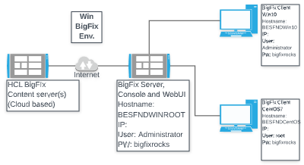
Lab Environment

The below table contains a summary of the VM images used in this lab guide:

 | Host Name | BigFix Components | OS | IP Address | Userid &  Password
1 | BESFNDWINROOT | BigFix Windows based Server, Console, WebUI, and Client | Windows  2016 | 10.0.0.1 | Administrator  bigfixrocks
2 | BESFNDWIN10 | BigFix Client, Console | Windows 10 | 10.0.0.2 | tecuser  bigfixrocks
3 | BESFNDCENTOS | BigFix Client | CentOS7 | 10.0.0.3 | root bigfixrocks
 | All | BigFix Console creds |  |  | adminmo  B1gfixrocks

Accessing Lab Environment
The BigFix Lab environment is currently being hosted in Skytap’s (www.skytap.com). To access this environment, you will need the url, id, and password sent to your registered email address (this would be from Skytap.com). If you are a USA Federal customer – your instructor will provide you your credentials and access url(s).
Students will receive an email (this is the email address you provided when you registered for the course) from Skytap that contains the url to YOUR Skytap environment, the login id and password for this specific course. It will look something like this:
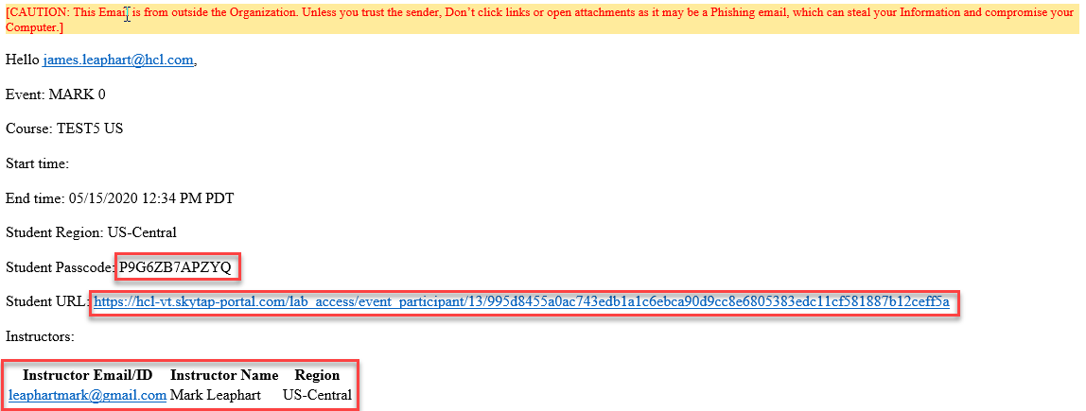
Click on the url provided in your email and provide your credentials (if asked). You will be taken into Skytap and you will see your provisioned environment.
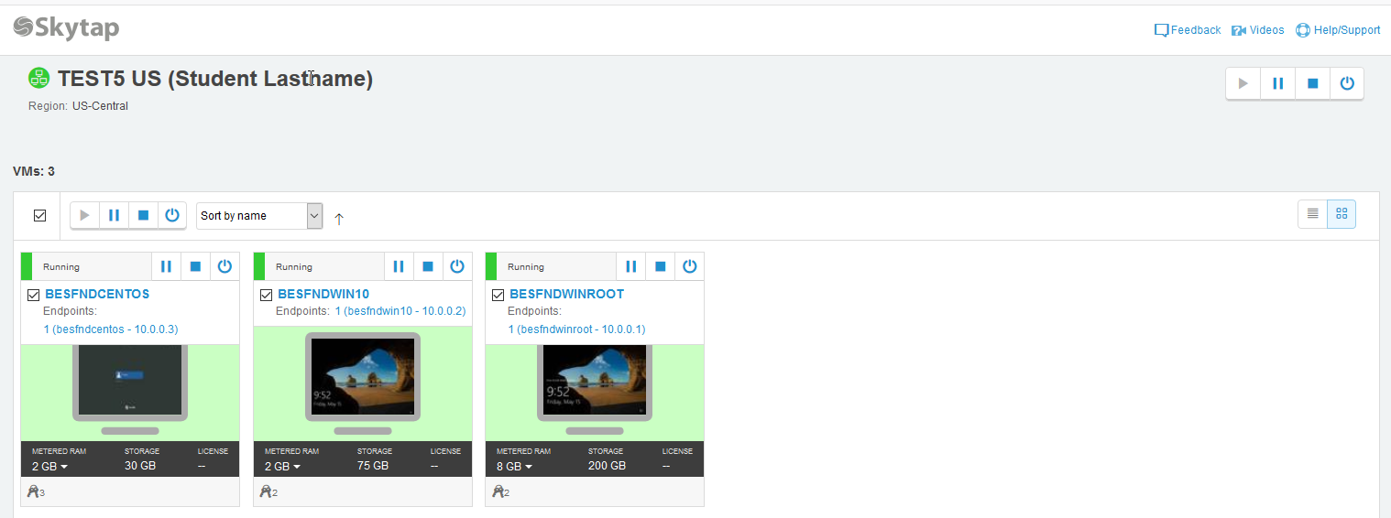

The vm’s provided here are accessible via your browser (rdp is not required). Click on a vm and your browser will present your vm:
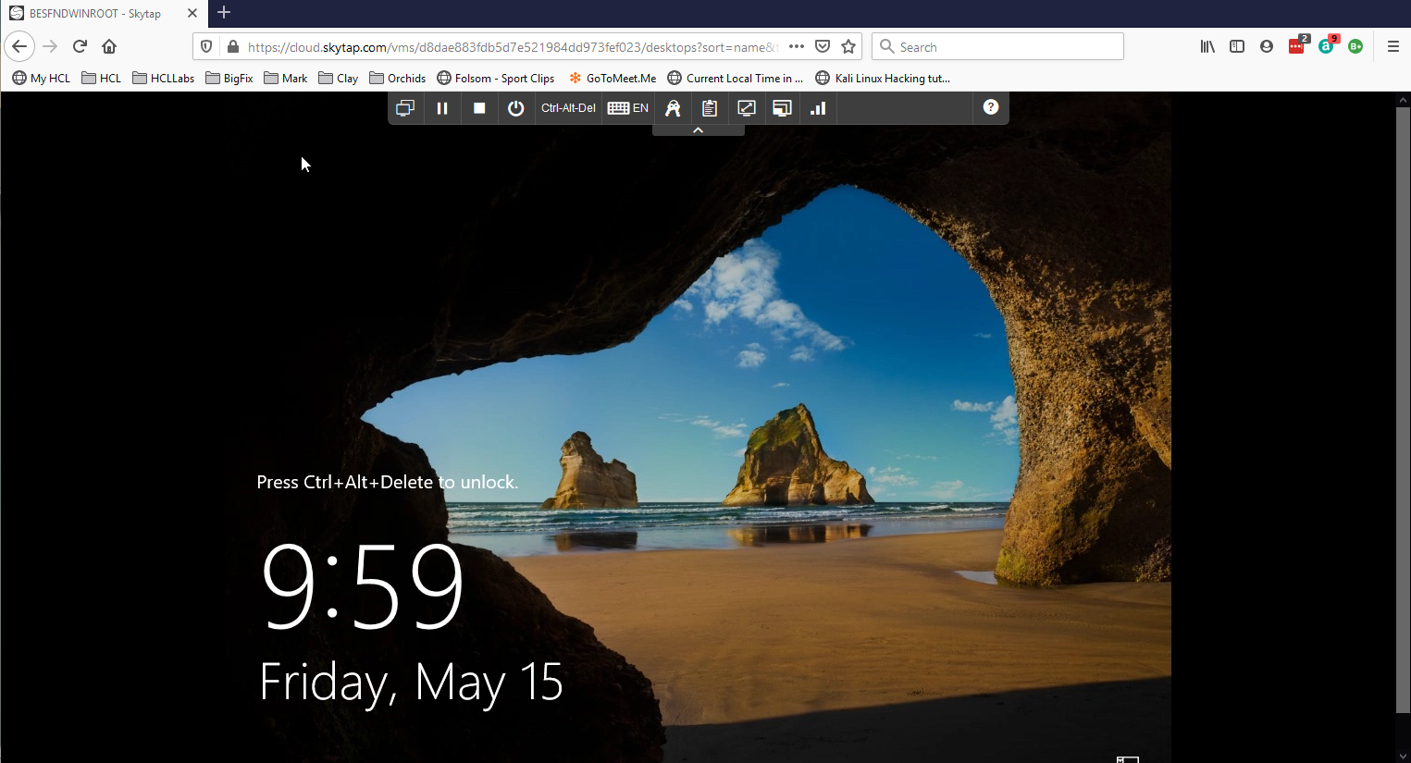
Now let’s look at the controls in the browser for this vm.
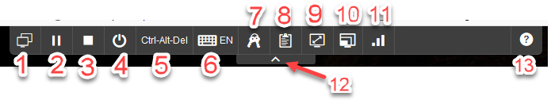
- Environment VM’s: View all vm’s in your environment or switch to another vm in your environment
- Suspend this vm
- Shutdown this vm
- Power options for vm - a) shutdown, b) reset, c) power off
- Ctrl-Alt-Del is passed to the vm
- Keyboard layout and or inject key combinations
- Credentials: operating system and applications in this vm
- VM Clipboard
- Fit to window
- Change video resolution
- Network Quality Indicator
- Hide this tool bar
- Help
When you open any of the Windows vm’s, always answer YES to the network connection question.

Exercise 1: Starting the Environment
In this exercise, you will install BigFix and start the configuration process.

- Verify that the following virtual machines are started:

- BigFix Server: BESFNDWINROOT
- BigFix Windows Client: BESFNDWIN10
- BigFix Linux Client: BESFNDCENTOS

- Switch to the BESFNDWINROOT virtual machine. If you are logged off, log in as Administrator with a password of bigfixrocks.

NOTE: This lab guide has been created for installing/configuring BigFix on only the image set using a Windows Root Server.
You have now successfully completed Exercise 1.

EXAMPLE: BigFix Foundation – BigFix Post-Installation Tasks

Overview

The lab exercises in this section describe the post installation tasks that are done to access the external site content and configure your BigFix deployment for managing your endpoints. In these exercises you perform the following activities:
- Post-Install Steps – Windows Root Server
- Enabling products/sites in BigFix

NOTE: These labs are not a production deployment guide. It is not designed to show a secure BigFix implementation.

Exercise 2: Starting the Environment
In this exercise, you start the required virtual machines and open the BigFix console.

- Verify that the following virtual machines are started:

- BigFix Server: BESFNDWINROOT
- BigFix Windows Client: BESFNDWIN10
- BigFix Linux Client: BESFNDCENTOS

- Switch to the BigFix Server virtual machine: BESFNDWINROOT. If you are logged off, log in to the server as Administrator with a password of bigfixrocks.
- Log in to the BigFix Console by double-clicking the BigFix Console icon on the Windows desktop.
- Enter adminmo as the user name, and enter B1gfixrocks as the password. Click Login. The Console opens.
You have now successfully completed Exercise 3.

Exercise 3 - Validate the Root Server

In this exercise, you will configure the BigFix Server.

- From the Windows Start menu select BigFix -> BigFix Diagnostics Tool. The BigFix Diagnostics Tool opens.
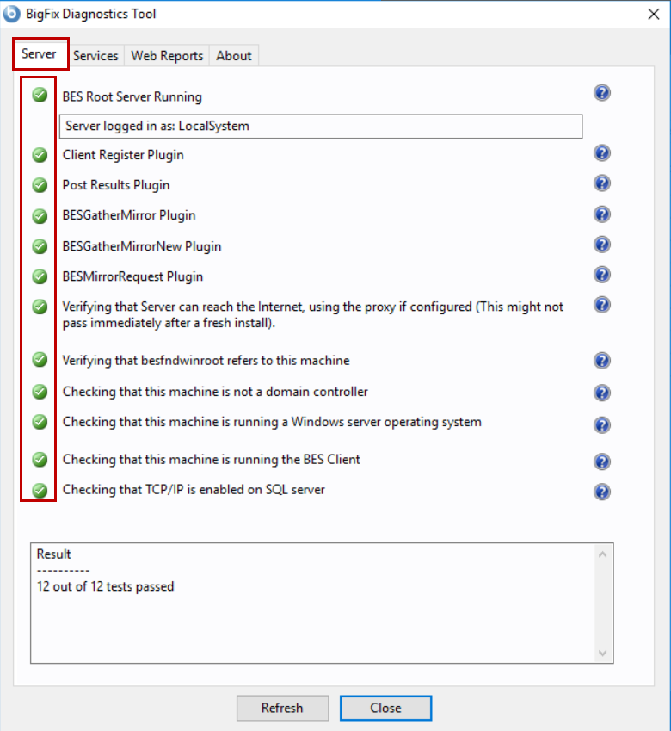
- Select the Server tab if it is not already selected and verify that there is a green checkmark beside all the checks.

- Select the Services tab. Verify that there is a green checkmark beside all the BigFix services.
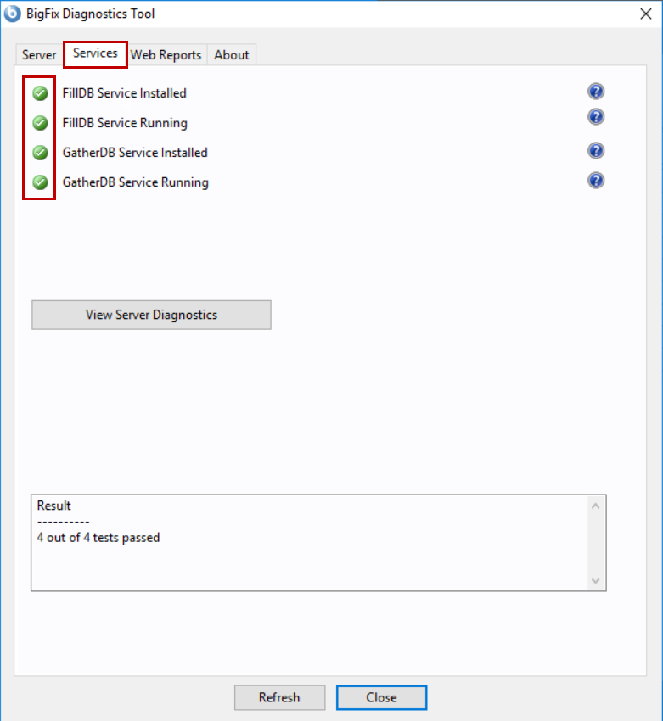
- Select the Web Reports tab. Verify that the Web Reports Server is running.
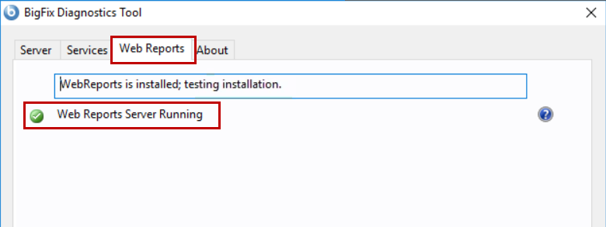

- Select the About tab. Verify that the Server Diagnostics version matches the version of the BigFix platform that you installed.
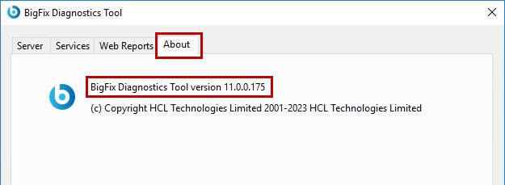
- Click CLOSE. The BigFix Diagnostics Tool closes.
- Return to the BigFix Console. If it is not open, then double-click the BigFix Console icon on the Windows Desktop. Enter adminmo as the user name and B1gfixrocks as the password and click Login.
The BigFix Console opens.
- Select the Computers node in the All Content domain and verify that the BESFNDWINROOT computer object appears in the list. Review the Last Report Time and ensure that the computer has reported recently. Review the Console connection information in the lower-right portion of the Console.
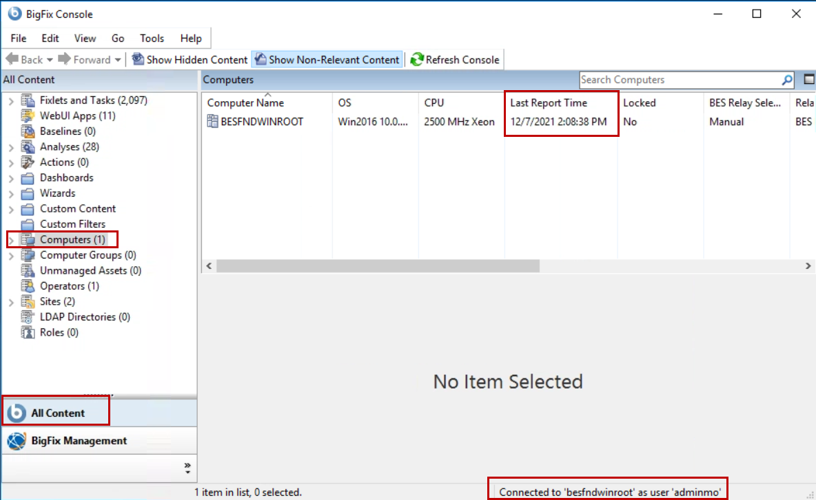
You have now successfully completed Exercise 4.

Exercise 4: Enabling External Sites
MASTER OPERATOR REQUIRED

You have validated that the environment is installed and running. You now enable external sites and configure BigFix. This process could take up to 30 min to complete because the BigFix Server must perform a full gather and import of all the enabled external sites
- Return to the BigFix Console. If you are logged off, log in as adminmo with a password of B1gfixrocks.
- Click the BigFix Management domain in the lower-left portion of the Console. The navigation pane is updated to show only content from the BigFix Management domain.
- Select License Overview in the navigation pane. The License Overview dashboard opens.
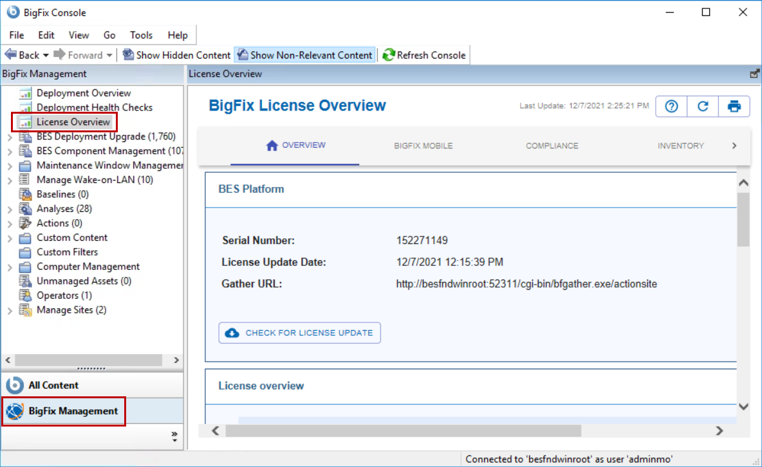

- Using the arrow in the upper-right portion of the License Overview dashboard, scroll to the right until you locate Lifecycle. Click LifeCycle. The Product EULA Info for LifeCycle is displayed in the lower portion of the dashboard.
- Scroll down and click Accept. The dashboard view updates to show a list of external sites that are associated with the LifeCycle domain.
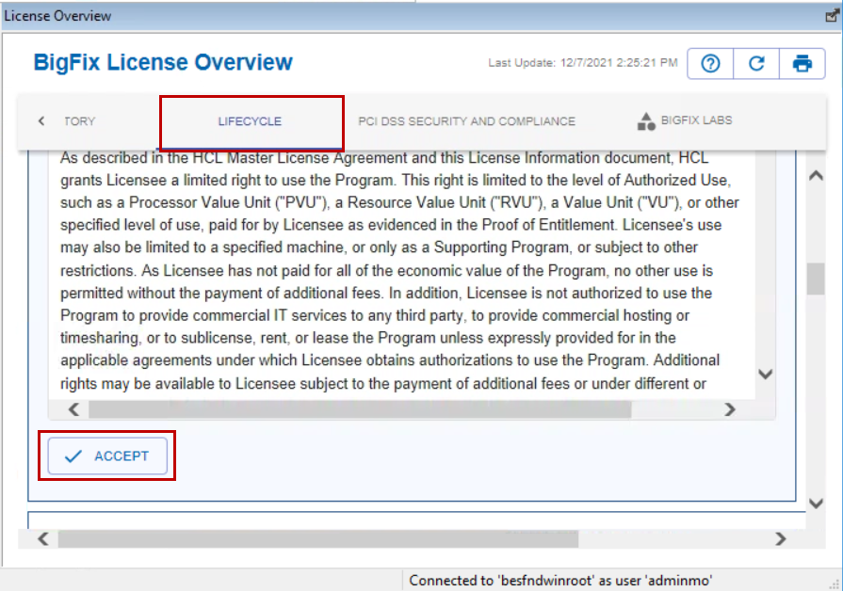

- Select BIGFIX LABS in the products section at the top of the BigFix License Overview dashboard. Place a checkmark beside I agree in the lower-portion of the dashboard.
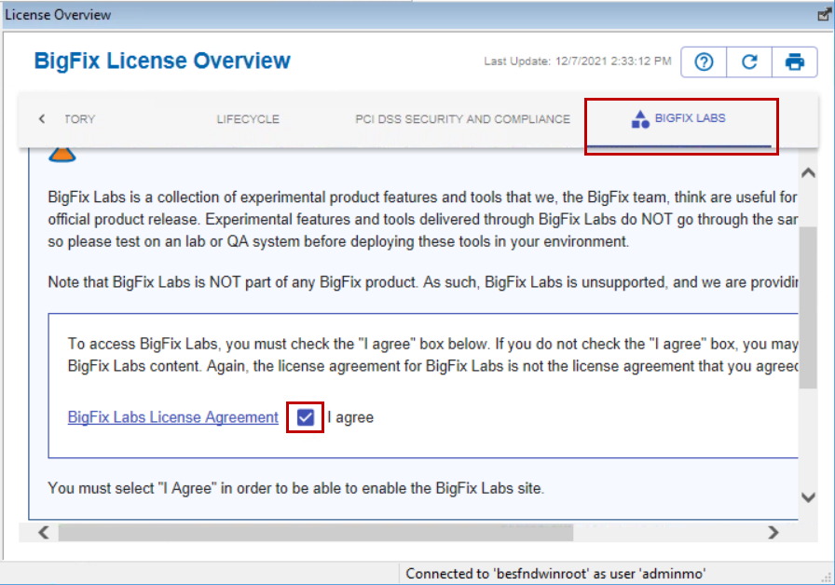
- Select LIFECYCLE in the products section of the BigFix License Overview dashboard. You now enable external sites and subscribe computers to those sites. Enabling a site allows BigFix to gather content for this site making the site content available for subscribed endpoints to evaluate.
- Click the Enable for each of the following sites.
NOTE: Please enable only the sites listed below so that you do not exceed the drive space on the BESWINROOT virtual machine. As you click the Enable link, each site will be move to the top of the list and the Enable link changes to Enabled:
  - BES Asset Discovery
  - BES Inventory and License
  - Patches for CentOS7 Plugin R2
  - Patches for RHEL 7
  - Patches for Windows (English)
Note: This site is displayed as Enterprise Security after it is gathered.
  - Patching Support
  - Software Distribution
  - Updates for Windows Applications
  - cyberfocus
Important: The License Overview dashboard displays 50 sites at a time by default. You might have to change the displayed Rows per page at the bottom of the dashboard to locate every all of the external sites in the list.
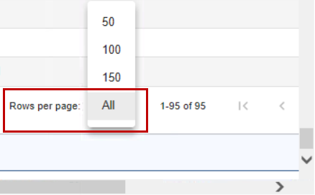

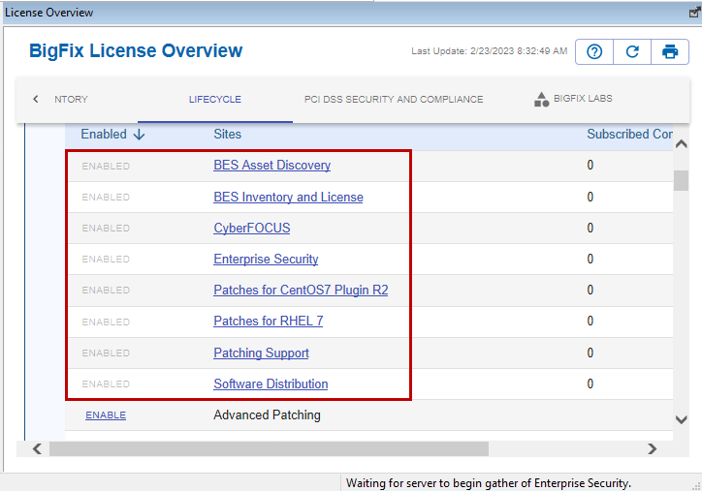
You now subscribe computers for each of the external sites that you enabled. Before computers can be subscribed, the BigFix Server must gather and import the site contents into the BigFix Enterprise DB.
- Select the BigFix Management domain in the lower-left portion of the Console and then click the Warnings node in the navigation pane. The List pane is updated to show a list of the external sites that do not currently have computers subscribed.
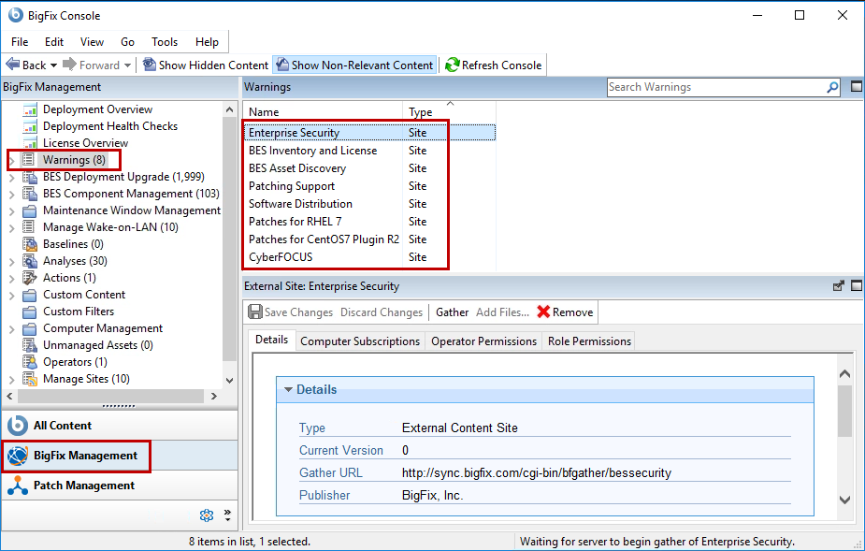

- Click an external site name that is displayed in the list area. The details for the selected site are shown in the work area below.
- Select the Computer Subscriptions tab. Click the All Computers radio button and then click Save Changes to keep your chosen subscriptions.
Important: You are only able to subscribe computers to those sites whose content has been gathered by the BigFix Server and imported into the database. If the Current Version shown on the Details tab is 0 then all the options on the Computer Subscriptions tab will be greyed out. You must wait until the site has been gathered before you can subscribe computers.
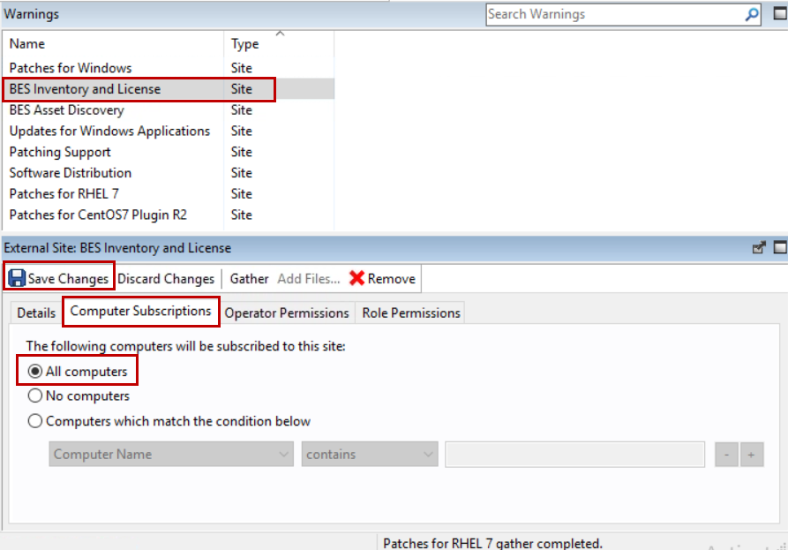
- Repeat the previous step for each of the external sites that are shown in the list area. As the site subscriptions are completed, they will be removed from the list of sites that are displayed in the list area.
You have now successfully completed Exercise 5.

Exercise 5: Post-Install Steps – Activating Analyses
MASTER OPERATOR REQUIRED

In this section, you activate several analyses that are delivered with the external site content. These Analyses are a key part of BigFix. They allow BigFix to gather information from the subscribed endpoints and use that information to populate various dashboards. As additional external sites are enabled, you must review the Analyses that are associated with those sites and Activate the ones that are required.

- Return to the BigFix Console. If you are logged off, log in as adminmo with a password of B1gfixrocks.
- Select the All Content domain in the lower-left portion of the Console. Then select the Analyses node in the navigation pane. The list area is updated to show a list of all the Analyses that are associated with the external sites that you enabled in the previous exercise.
- Verify that the Show Non-Relevant Content button at the top of the Console is enabled. When enabled, the Console shows all content whether that content is Relevant to any computers or not.

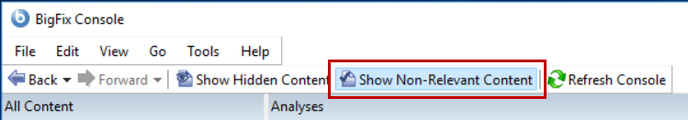

- Click the Name column in the List Area of the Console. The Analyses are sorted in ascending order by their name and an arrow appears above the Name column to show the sort order for the display.
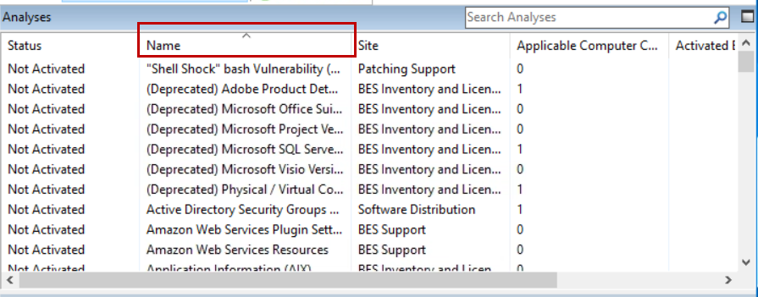
- Select any Analysis in the list. You can then type Ctrl-A to select every Analyses in the list and then while depressing the Ctrl key select each of the Analyses with (Deprecated) in the name. The result is that all Analyses except the Deprecated ones are selected.

- Right-click in the list-area over any selected Analysis and choose Activate from the Context menu.
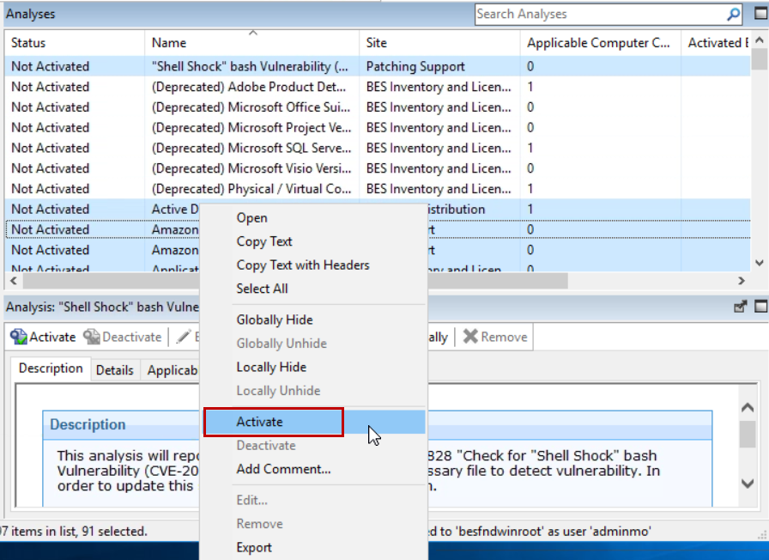
The status for each of the select Analyses changes from Not Activated to Activated Globally.
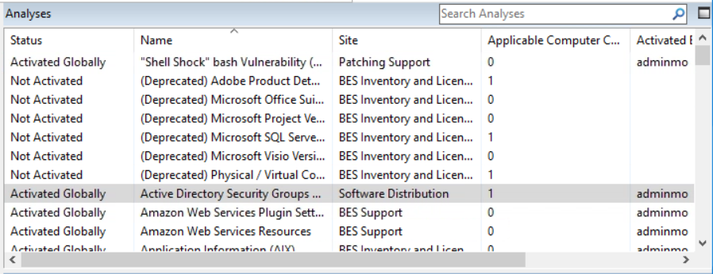
Tip: Make sure that you choose Activate from the Context menu. If you choose the Activate button that is shown in the Work area, then only that selected Analysis is activated.

You have now successfully completed Exercise 6.

Exercise 6: Post-Install Steps – Install the BigFix Agent
MASTER OPERATOR REQUIRED
In this exercise, you use the Client Deploy Tool to remotely install the BigFix Agent on client computers.


Important: Installing agent remotely using the Client Deploy Tool has sever prerequisites. There are several things that will prevent this from working as desired in this lab. None of which BigFix can address directly. These include things like ACL’s, Firewall Rules, open ports, services configured for remote install. You will need to review the documentation for the Client Deploy Tool target prerequisites to ensure that the Windows 10 target is configured to support remote installs. You can review the documentation: here. Please review each prerequisite and make the changes accordingly before attempting the remote install.

- Switch to the BESFNDWINROOT virtual machine and return to the BigFix Console as adminmo with a password of B1gfixrocks.
- Verify that none of the virtual machines in the image set are in a suspended state. The virtual machines automatically suspend after 2 hours with no activity.
- Select the BigFix Management domain in the lower-left portion of the Console. The navigation pane updates to show only the BigFix Management content.
- Select the BES Deployment Upgrade node in the navigation pane. The List area in the upper-right portion of the Console is updated to show the Deployment Upgrade content.
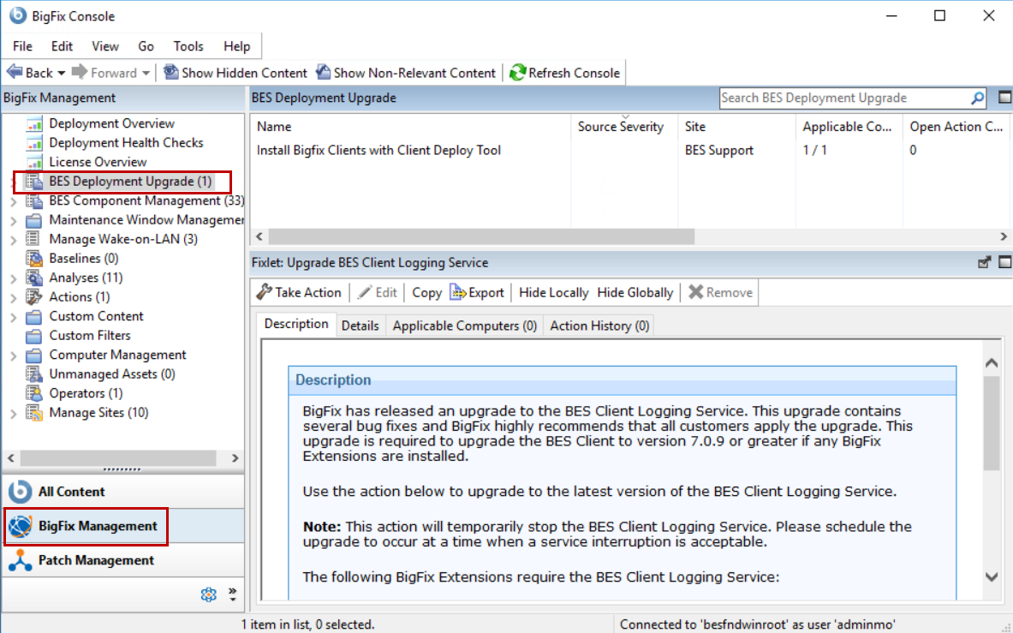
- Click the Install Bigfix Clients with Client Deploy Tool Task in the list area. The details for the selected Task are shown in the work area below.
- Verify that the Description tab is selected in the work area. Scroll down in the Description tab and locate the parameters that must be entered on the Description tab before taking the action. Enter the parameters as follows:
      - Operating systems: Place a check beside the Windows OS and Linux Intel options.
      - Client Version: Select 11.0.0.175 from the drop-down list. The selected version should match or be older than the Root Server/Relay version.
      - Client Deploy Tool Computer credentials:
        - Username: Administrator
        - Password: bigfixrocks
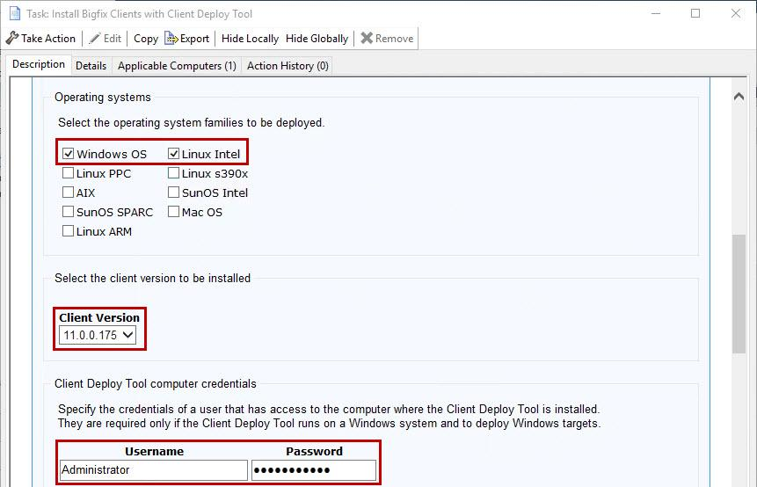

- Enter the following information for the BESFNDWIN10 client in the Targets section of the Description tab:
  - Computers: besfndwin10
  - Username: tecuser
  - Password: bigfixrocks
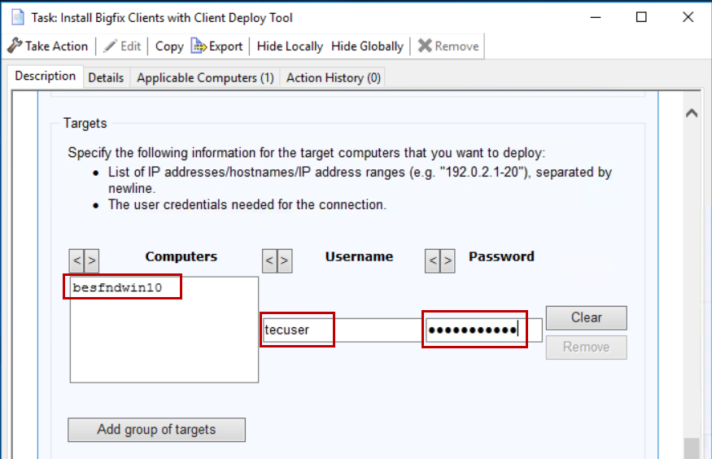
- Click Add group of targets. A new Computers section opens in the Description tab where you can specify the Linux target information.

- Enter the following information for the BESFNDCENTOS client in the Targets section of the Description tab:
  - Computers: besfndcentos
  - Username: root
  - Password: bigfixrocks
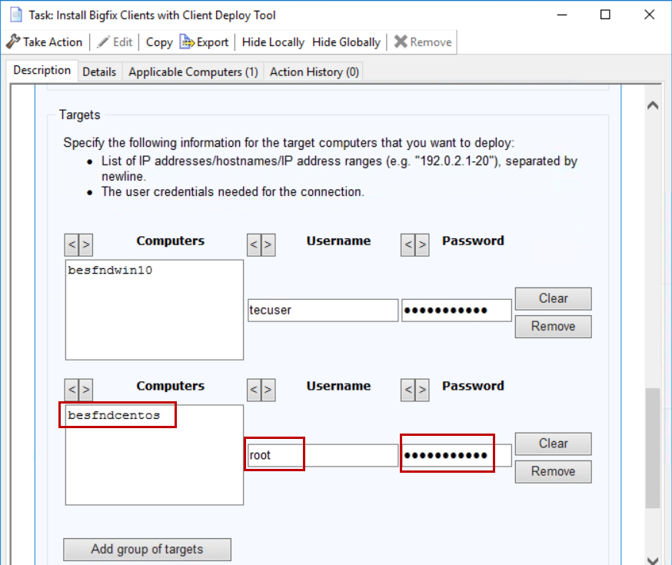

- Click Take Action. The Take Action window opens.
- Select the Target tab if it is not already selected and select BESFNDWINROOT from the list of available targets.
- Click: OK to initiate the action. Monitor the status of the action and wait for the status to change to Completed before continuing.
- Click the All Content domain in the lower-left portion of the Console, then click the Computers node in the navigation pane. The list area shows a list of all computers with the BigFix Agent installed.

- Review the list of managed computers in the list area. You should now see 3 computers in the list.
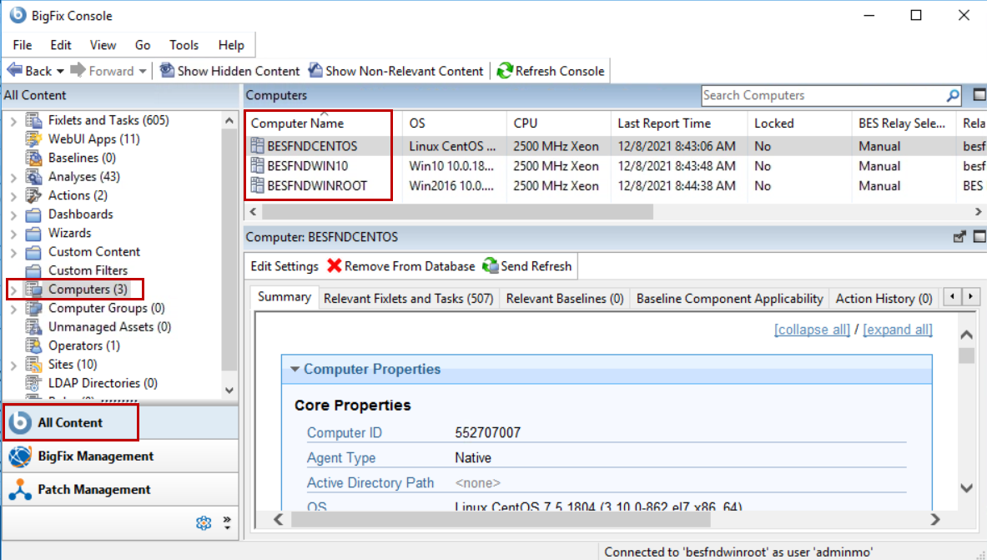
Tip: If you do not see 3 managed computers in the list, the most likely cause is a missed BigFix Client Deploy Tool prerequisite or an incorrect password. You can go back and review the target prerequisites to verify that they have all be completed correctly. You can also review the BESClientDeployTool.log file located in the following directory on the BESFNDWINROOT virtual machine:
C:\Program Files (x86)\BigFix Enterprise\BES Console\BesClientDeploy
You have now successfully completed Exercise 7.

