BigFix Master Class 2026

Automated Performance and Configuration Analysis
Student Lab Guide

October 5, 2026


For more information
To learn more about BigFix, contact your HCLSoftware representative, HCL Business Partner, or visit www.BigFix.com.

About HCLSoftware
HCLSoftware, a division of HCLTech, develops, markets, sells, and supports software for digital transformation, data, analytics and insights, AI and automation, and enterprise security. HCLSoftware is the cloud-native solution factory for enterprise software and powers millions of apps at more than 20,000 organizations, including more than half of the Fortune 1000 and Global 2000 companies. HCLSoftware's mission is to drive ultimate customer success through relentless product innovation.
https://www.hcltechsw.com

© Copyright 2026 HCL

Produced in the United States of America.

All product names, trademarks and registered trademarks are property of their respective owners.

Contents
Lab Environment 5
Accessing Lab Environment 6
Diagnostics Workbench Lab 8
Overview 8
Before You Start 8
Exercise 1: Collecting the Data 10
Client Performance Counter Analysis 10
Deployment Information 12
Collect Client Performance Counter Analysis Data 13
Perfmon Counters 14
Exercise 2: Run the Workbench 17
Step 1: Folders and Run Details 17
Step 2: Choose the Modules 17
Step 3: Build the Outputs 19
Exercise 3: Read the Client Performance Output 22
Exercise 4: Read the Perfmon Analysis Output 23
Appendix A: FillDB Performance (Bonus Round) 26
Collect the logs 26
Run the module 28

Release Date | Version | Authors | Comments
October 5, 2026 | 1.0 | Duncan McCalla | First version.

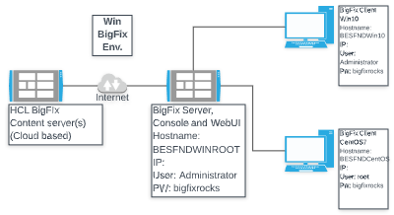
Lab Environment

The below table contains a summary of the VM images used in this lab guide:

 | Host Name | BigFix Components | OS | IP Address | Userid &  Password
1 | BESFNDWINROOT | BigFix Windows based Server, Console, WebUI, and Client | Windows  2016 | 10.0.0.1 | Administrator  bigfixrocks
2 | BESFNDWIN10 | BigFix Client, Console | Windows 10 | 10.0.0.2 | tecuser  bigfixrocks
3 | BESFNDCENTOS | BigFix Client | CentOS7 | 10.0.0.3 | root bigfixrocks
 | All | BigFix Console creds |  |  | adminmo  B1gfixrocks

Accessing Lab Environment
The BigFix Lab environment is currently being hosted in Skytap’s (www.skytap.com). To access this environment, you will need the url, id, and password sent to your registered email address (this would be from Skytap.com). If you are a USA Federal customer – your instructor will provide you your credentials and access url(s).
Students will receive an email (this is the email address you provided when you registered for the course) from Skytap that contains the url to YOUR Skytap environment, the login id and password for this specific course. It will look something like this:
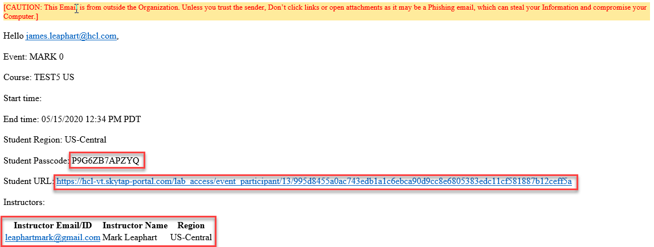
Click on the url provided in your email and provide your credentials (if asked). You will be taken into Skytap and you will see your provisioned environment.
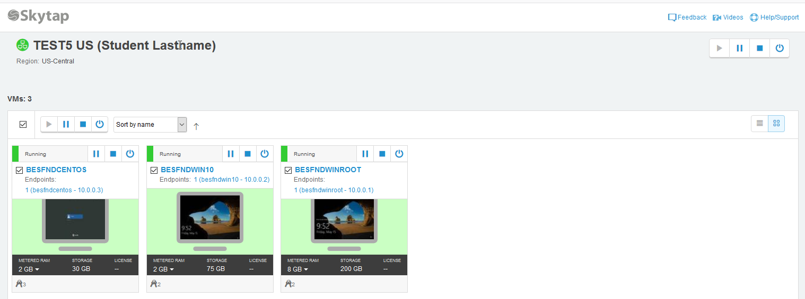
The vm’s provided here are accessible via your browser (rdp is not required). Click on a vm and your browser will present your vm:
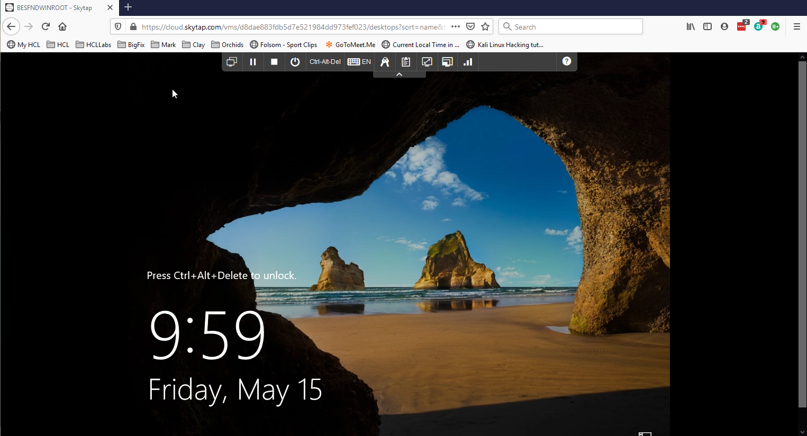
Now let’s look at the controls in the browser for this vm.
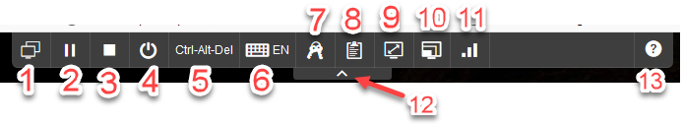
- Environment VM’s: View all vm’s in your environment or switch to another vm in your environment
- Suspend this vm
- Shutdown this vm
- Power options for vm - a) shutdown, b) reset, c) power off
- Ctrl-Alt-Del is passed to the vm
- Keyboard layout and or inject key combinations
- Credentials: operating system and applications in this vm
- VM Clipboard
- Fit to window
- Change video resolution
- Network Quality Indicator
- Hide this tool bar
- Help
When you open any of the Windows vm’s, always answer YES to the network connection question.

Diagnostics Workbench Lab

Overview
In this lab you will run the Master Class Diagnostics Workbench. You'll cover the two modules from the session today. The FillDB module is considered to be the Bonus Round and can be done if you finish the first two modules early OR you can do them at home/work later.
- Perfmon Infrastructure Analysis reviews the Windows performance of a BigFix server.
  - This can be any BigFix server (Web Reports, WebUI, etc.) and the SQL server(s) supporting the Platform.
  - The Workbench Perfmon module allows for the optional analysis of TWO perfmon files in a single pass. Many customers will have a perfmon file from their root server and another one from SQL server.
- Client Performance Analysis reviews how quickly the BigFix clients evaluate content, respond to notifications, and how they are configured for performance.
The lab takes roughly 20 minutes:
Part | Time
Before You Start | 2 minutes
Exercise 1: Collect the Data | 5 minutes
Exercise 2: Run the Workbench | 5 minutes
Exercise 3: Read the Client Performance Output | 4 minutes
Exercise 4: Read the Perfmon Analysis Output | 4 minutes

NOTE: The FillDB exercise is waaaaay back in Appendix A.

Before You Start
In production environments, the collection tasks may need hours of client reporting and a 24-hour Perfmon capture. In this lab you run them only to see how they work. The Workbench then builds from the sample data that ships with it.
Every module follows the same path:
BigFix deployment Collection task Captured data Workbench module Mini Report
The Workbench is on the BigFix Server virtual machine in:
C:\Users\Administrator\Desktop\BigFixSrc\Master Class Diagnostics Workbench
The sample data is in:
C:\Users\Administrator\Desktop\BigFixSrc\Master Class Diagnostics Workbench\SampleData\BigFix Master Class 2026\Results
NOTE: The Workbench is provided as-is to BigFix Master Class attendees only. It has no warranty or support. Do not redistribute it without approval.

Exercise 1: Collecting the Data
In this exercise, you will run the collection content for both modules from the BigFix Console. Exercise 2 will have you run it through the Workbench.

Client Performance Counter Analysis
In this exercise you will simply enable an analysis that gathers various Client performance properties for use later by the Collect Client Performance Counter Analysis Data (2.0) task.
- Switch to the BigFix Server virtual machine. Log in to the BigFix Console with the console credentials in the Lab Environment table.
- Select the All Content domain. Expand Sites > Custom Sites. Select the Performance and Config Analysis site.
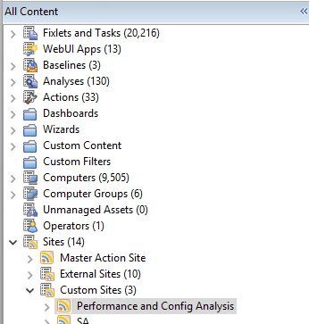
- Within that site, select Analyses then the BigFix Master Class -- Client Performance Counters - Basic (2.0) analysis. Review the Description to get familiar with what it does.
NOTE: Be sure to click the '+' sign next to Full Description & Deployment Notes to view all of the details.
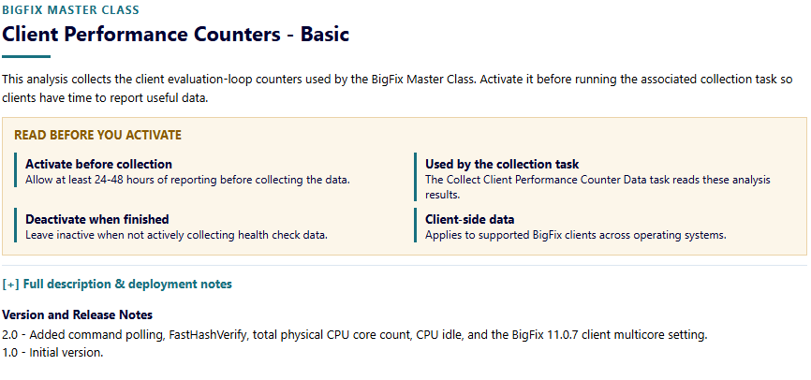
- Finally, in the top navigation pane, right-click on the BigFix Master Class -- Client Performance Counters - Basic (2.0) analysis and choose Activate. The status changes to "Activated Globally" (Globally because you are logged on as a Master Operator right now) and the Results tab will appear. Data will then start to show up.

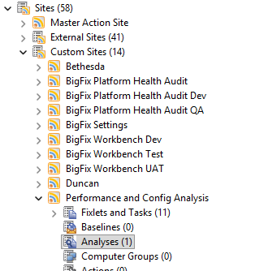

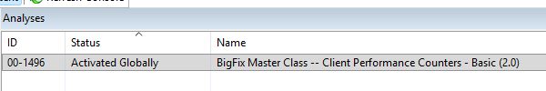
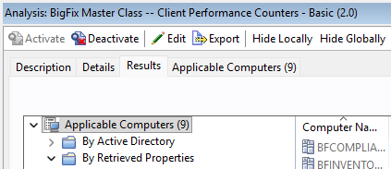

NOTE: In typical troubleshooting / health check scenarios, the analysis should be activated for 24 to 48 hours before you collect data. This is to ensure that you get as many computers reporting in as possible.

Deployment Information
- From the Performance and Config Analysis site, select Fixlets and Tasks and then BigFix Master Class -- Collect Deployment Information (2.0). The task description opens in the work area. Spend a minute or so reviewing the details in the Description tab.
NOTE: Be sure to click the '+' sign next to Full Description & Deployment Notes to view all of the details.
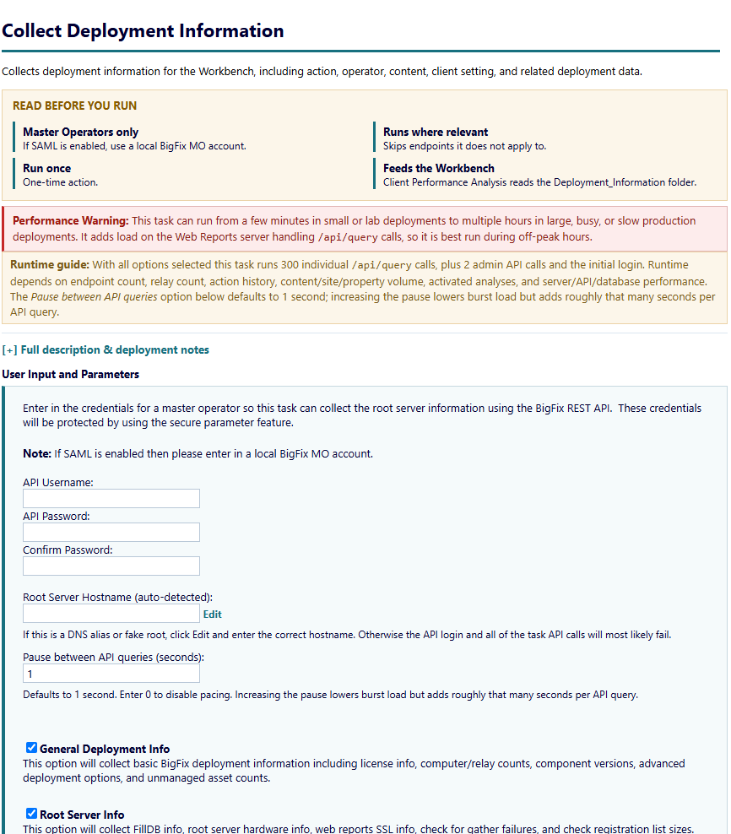

- Enter the console user name in API Username then enter the console password in API Password and Confirm Password fields. Leave Root Server Hostname as it is. Change it only for a DNS alias or fake root.
- Click Take Action. On the Target tab select the BESFNDWINROOT. Click OK.
- The action starts. Do not wait for it to complete as this task queries a lot of information and can take a while to run. Continue on with the next step.

Collect Client Performance Counter Analysis Data
In this lab you will run an action that pulls the results from the analysis you activated in the Client Performance Counter analysis exercise. That data is retrieved and formatted in such a way as to make it useful for the Workbench's Client Performance module.
- Select BigFix Master Class -- Collect Client Performance Counter Analysis Data (2.0). The task description opens in the work area. Spend a minute or so reviewing the details in the Description tab.
NOTE: Be sure to click the '+' sign next to Full Description & Deployment Notes to view all of the details.
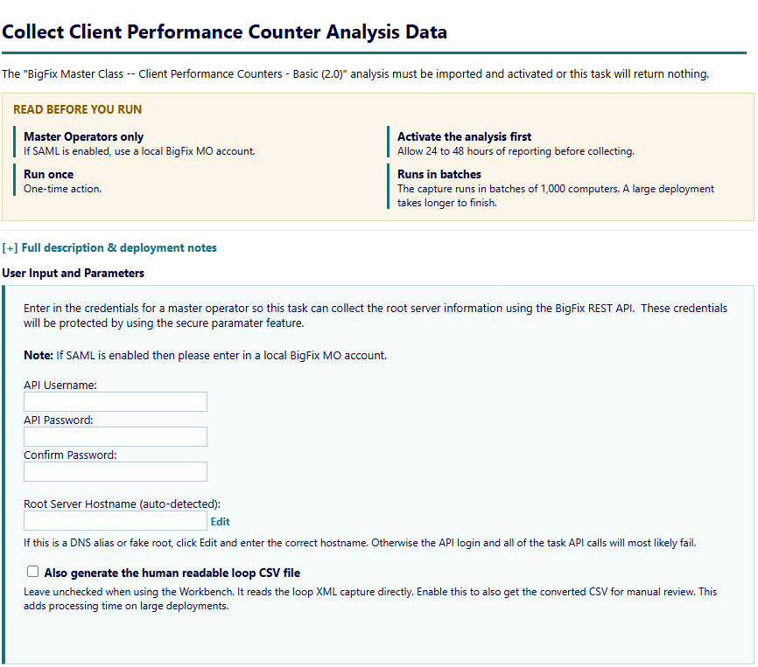

- Enter the console user name in API Username. Enter the console password in API Password and Confirm Password. Leave the Root Server Hostname as it is.
- Leave "Also generate the human readable loop CSV file" cleared.
- Click Take Action. On the Target tab select BESFNDWINROOT. Click OK.
- Wait for the action status to change to Completed.

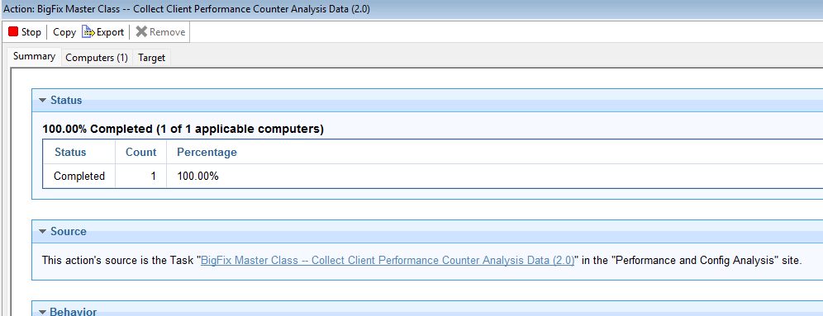

- You can view the data by opening the "C:\BigFix_Master_Class\Platform\Results\Client_Loop\" folder.

Perfmon Counters
In this lab you will run an action that configures and runs a custom Windows Perfmon data collector / counter set. The resulting file (.blg) is then used as the input for the Workbench's Perfmon Analysis module.
- Select BigFix Master Class -- Setup and Run Perfmon Counters (2.0). The task description opens in the work area. Spend a minute or so reviewing the details in the Description tab.
NOTE: Be sure to click the '+' sign next to Full Description & Deployment Notes to view all of the details.
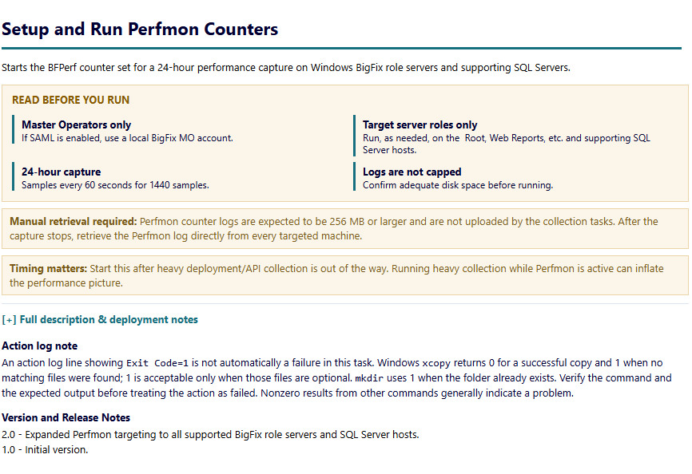
- Click Take Action. On the Target tab select BESFNDWINROOT. Click OK.
- Wait for the action status to change to Completed.
- Now let's verify the new "BFPerf" collector set is present and active in Performance Monitor.
- Using the Windows Start menu, type "perf" (for performance) and then open the Performance Monitor application.

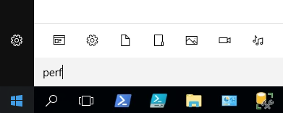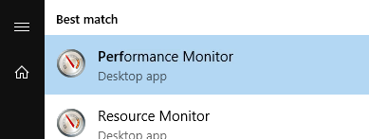

- In the Performance Monitor app, use the navigation tree and go to Data Collector Sets > User Defined. You should see "BFPerf" under that folder and it has a small green "play button" icon. This confirms that the new perfmon counter set has been properly configured and is running.
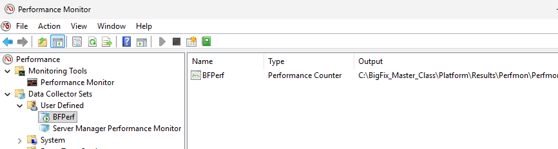
NOTE: The capture takes a sample every 60 seconds and stops on its own after 24 hours. You do not need to stop it. The Workbench uses the sample capture in Exercise 2.
- You can view the data by opening the "C:\BigFix_Master_Class\Platform\Results\Perfmon\" folder. Note that active perfmon counter files will report a 0-size file until perfmon capture is stopped.
You have now successfully completed Exercise 1.

Exercise 2: Run the Workbench
In this exercise you run the two lab modules against the sample data.

Step 1: Folders and Run Details
- On the BigFix Server open C:\Users\Administrator\Desktop\BigFixSrc\Master Class Diagnostics Workbench\Launchers. Double-click Run Diagnostics Workbench.cmd. The Workbench opens on step 1.
- Click Browse next to Data Folder. Select C:\Users\Administrator\Desktop\BigFixSrc\Master Class Diagnostics Workbench\SampleData\BigFix Master Class 2026\Results. The Workbench reports Data found for 3 of 3 modules.
- Leave the Output Folder at C:\Users\Administrator\Documents\Master Class Diagnostics. A timestamped run folder is created there.
- Enter a Run Name such as MC Lab Exercise. Any name works. The run folder and every output file use it.
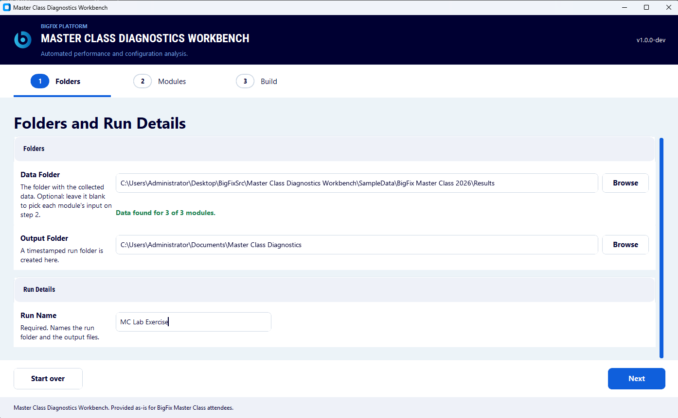
- Click Next. The Choose the Modules to Run page opens.

Step 2: Choose the Modules
- The page opens with every module selected. Click Clear. Select Client Performance Analysis and Perfmon Infrastructure Analysis. Both rows show Needs Review until you fill in their details.
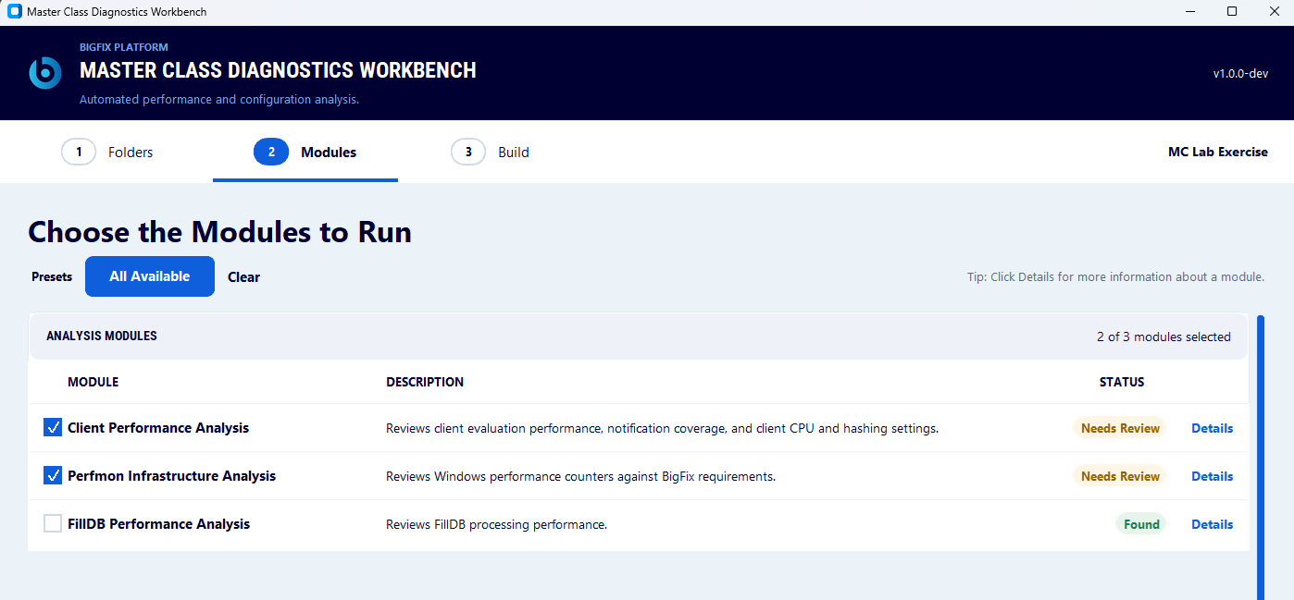

- Click Details on the Client Performance Analysis row. Enter a Report Start Date and a Report End Date. Any dates work. The report shows this range. The row changes to Found.
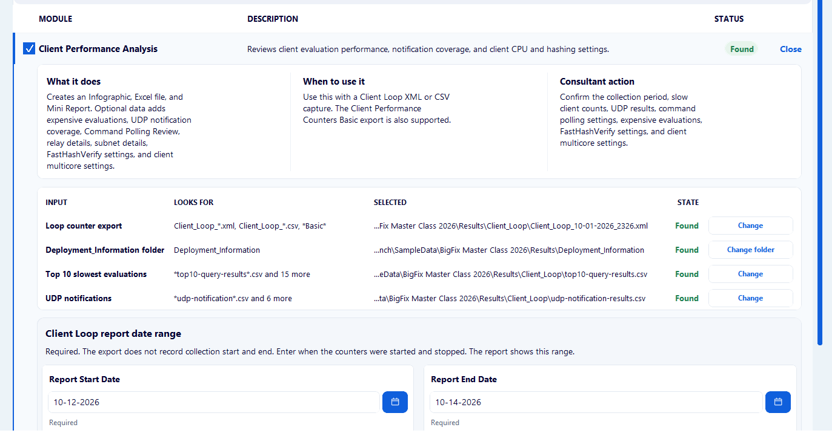

- Click Details on the Perfmon Infrastructure Analysis row. In Capture 1 enter 12 in RAM. Select Virtual machine. CPUs and Disks are read from the capture. The row changes to Found.
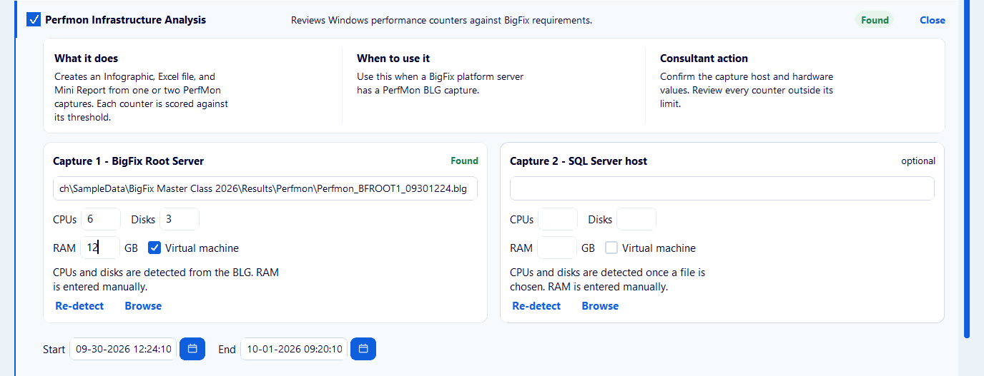

NOTE: RAM is not in the Perfmon capture. Without it the Memory Health counter (PRF-INF-09) is not scored.
- Click Next. The Build the Outputs page opens.

Step 3: Build the Outputs
- Check the Run Details. Click Build.
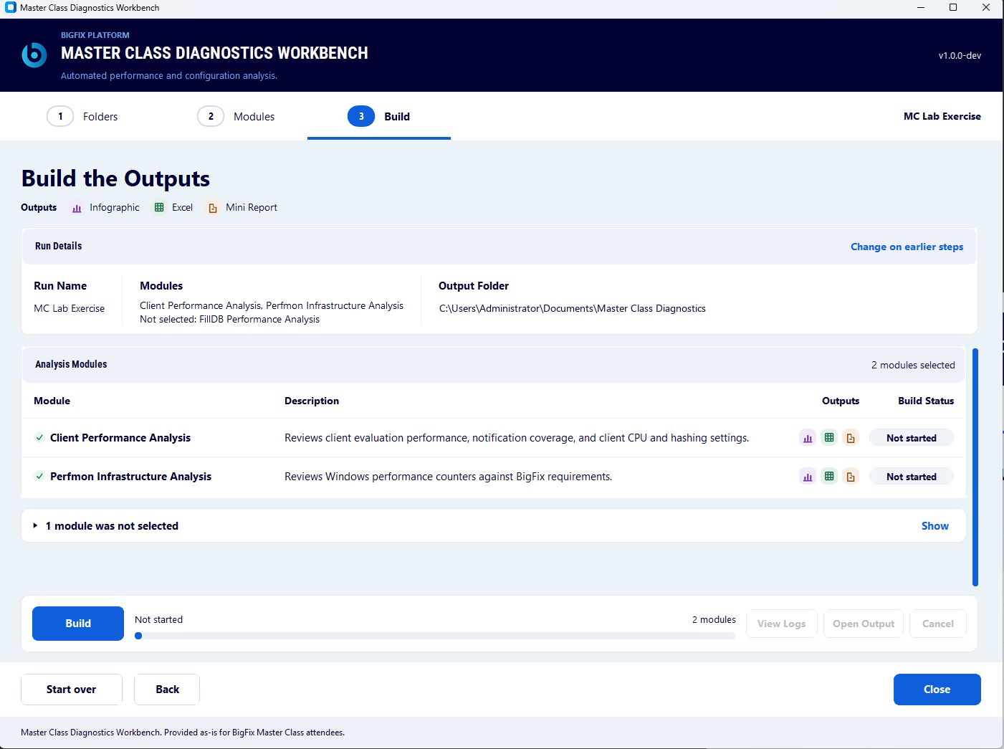

- Wait for the Build Status of each module to change from Not started to Running to Done.
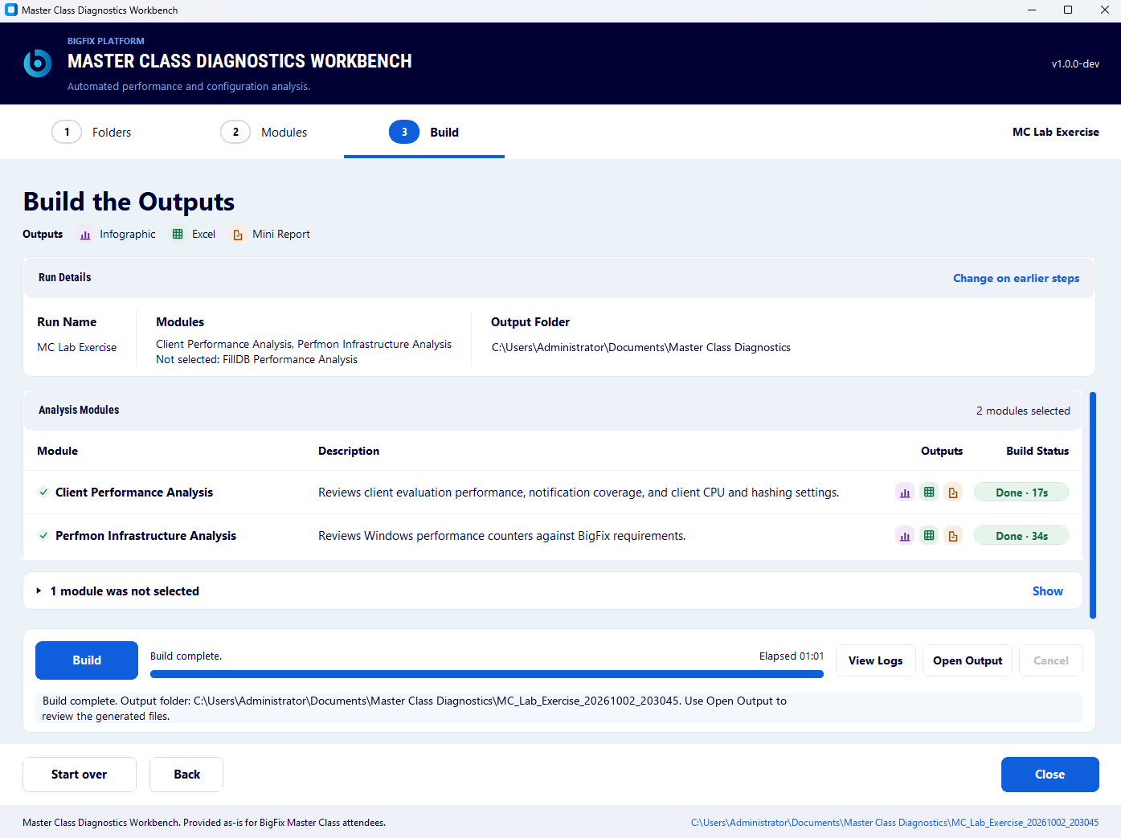

- Click Open Output. The run folder opens. It holds a folder for each module and the run log.
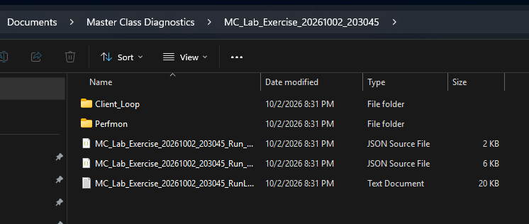

You have now successfully completed Exercise 2.

Exercise 3: Read the Client Performance Output
In this exercise, you read the Client Performance outputs. Each module writes a Mini Report, an Infographic, and an Excel workbook.
- Open the Client_Loop folder at C:\Users\Administrator\Documents\Master Class Diagnostics\<run name>_<date>_<time>\Client_Loop
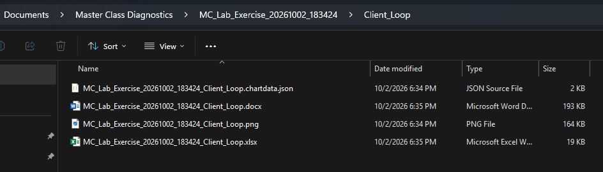
- Open and review the Mini Report .docx. Discussion questions will be presented to class.
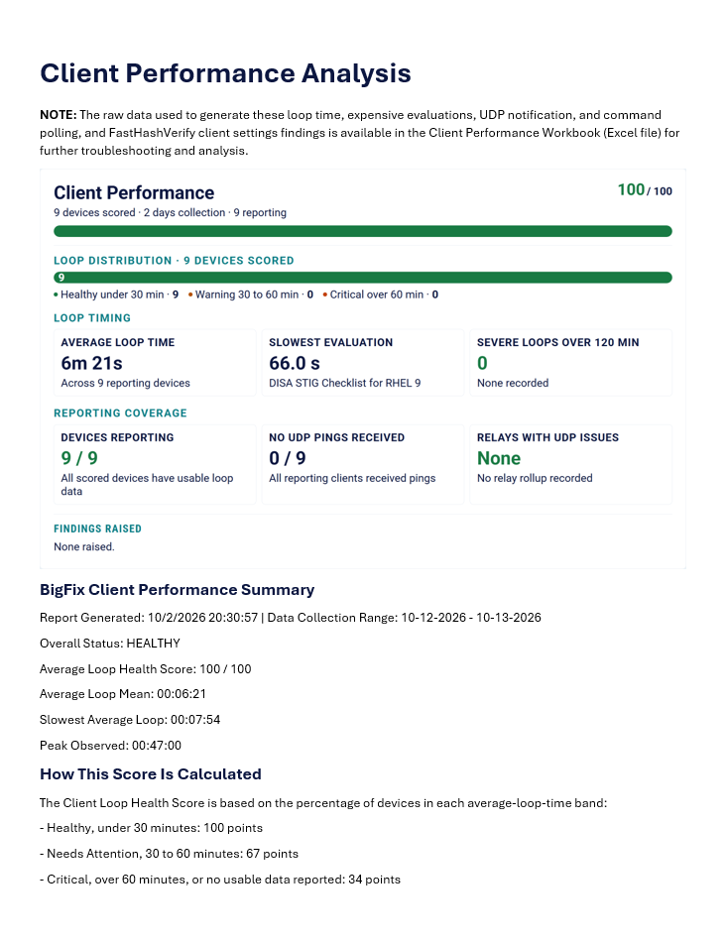
You have now successfully completed Exercise 3.

Exercise 4: Read the Perfmon Analysis Output
In this exercise, you will review the Perfmon analysis outputs. Each counter is scored against its target in the NFR guide. The NFR guide standards and thresholds are listed below for your convenience.
- Open the Perfmon folder C:\Users\Administrator\Documents\Master Class Diagnostics\<run name>_<date>_<time>\Perfmon
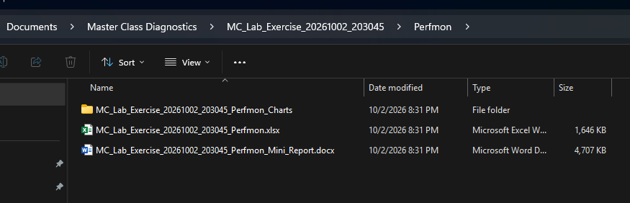
- Open and review the Mini Report .docx. Discussion questions will be presented to class.
The source is BigFix Non-Functional Requirements: A Checklist Approach, v11.x.4.

ID | Area | Performance counter | Standard
PRF-INF-01 | Storage Queue Depth | Physical Disk: Current Disk Queue Length | ≤ 1 per physical device
PRF-INF-02 | Storage Latency | Physical Disk: Avg. Disk sec/Transfer | ≤ 1 ms per physical device
PRF-INF-03 | Storage Operations | Physical Disk: Disk Transfers/sec | No saturation under load. DBMS storage supports 5,000 transfers per second.
PRF-INF-04 | CPU Utilization | Processor: % Processor Time | Virtual: 50% to 80%. Physical: ≤ 80%.
PRF-INF-05 | CPU Latency | System: Processor Queue Length | ≤ 4
PRF-INF-06 | CPU Privileged Time | Processor: % Privileged Time | ≤ 10% of aggregate CPU
PRF-INF-07 | Network Health | Network Interface: Packets Outbound Discarded, Packets Outbound Errors, Packets Received Discarded, Packets Received Errors | All counters approach zero per interface
PRF-INF-09 | Memory Health | Paging File: % Usage Peak | ≤ 5% of aggregate physical memory
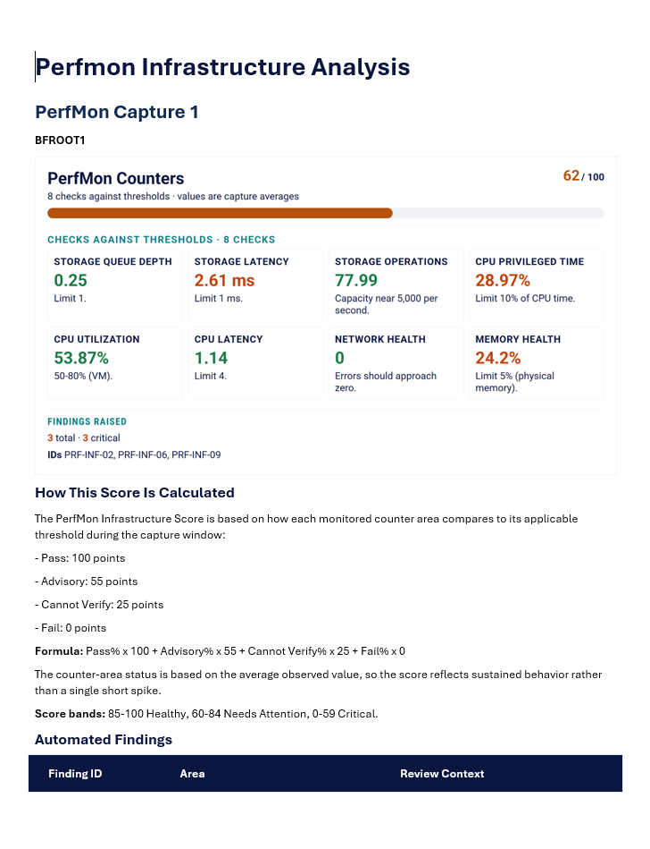

You have now successfully completed Exercise 4.

Appendix A: FillDB Performance (Bonus Round)
FillDB is not part of the live lab. Run it if time permits or after the session. The sample data includes a FillDB analyzer CSV, so you can run the module without collecting logs. FillDB Performance Analysis reviews how quickly the root server processes client reports.

Collect the logs
- In the Performance and Config Analysis site select BigFix Master Class -- Enable FillDB Performance Logging (2.0).

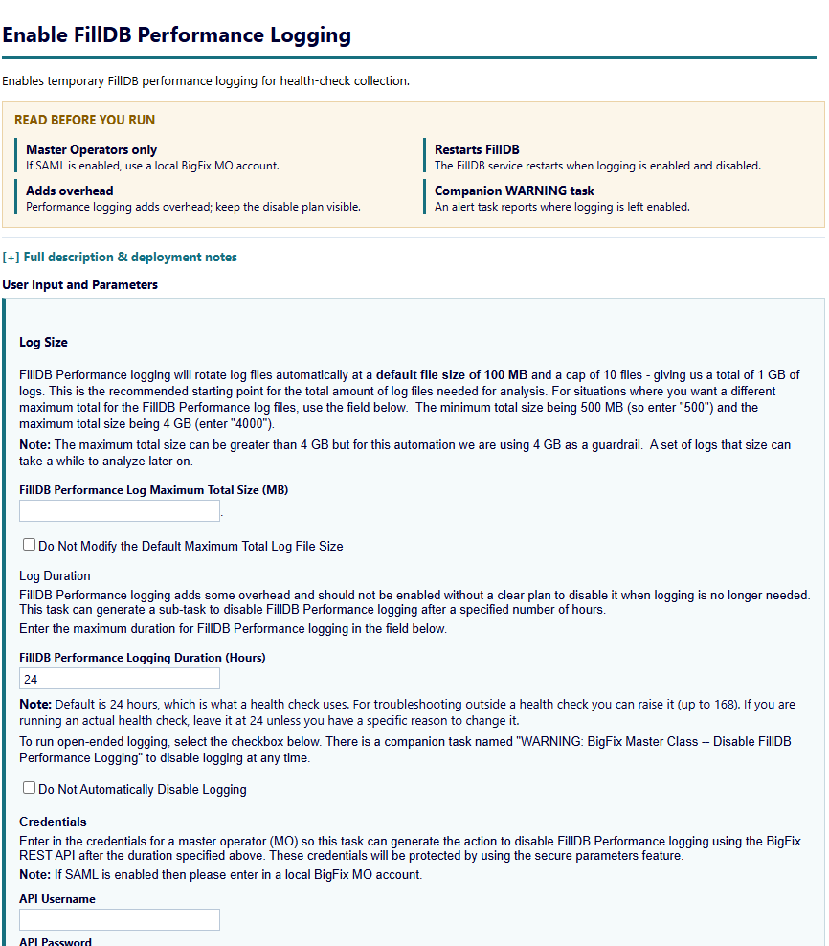
- Enter the console user name in API Username. Enter the console password in API Password and Confirm Password. Keep the default duration.
- Click Take Action. On the Target tab select BESFNDWINROOT. Click OK.

- Logging stops on its own after the duration. If you selected Do Not Automatically Disable Logging, run WARNING: BigFix Master Class -- FillDB Performance Logging is Enabled (2.0) to stop it.
- FillDB writes FillDBPerf.log and its rollover files to C:\BigFix_Master_Class\Platform\Results\Logs\FillDB_Performance on the root server. Copy them into a FillDB_Performance folder under your data folder.

Run the module
- Run the Workbench. On step 2 click Clear and select FillDB Performance Analysis. Click Details to check the log. The collection dates are optional.
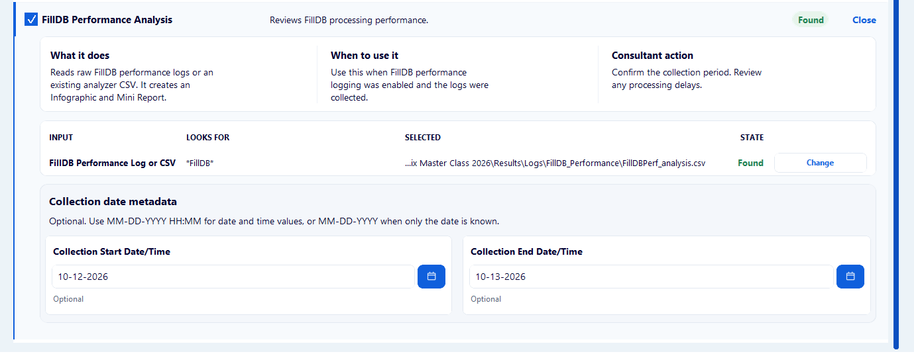
- Click Next and click Build.
- Open the FillDB_Performance folder in the run folder. Open the Mini Report.

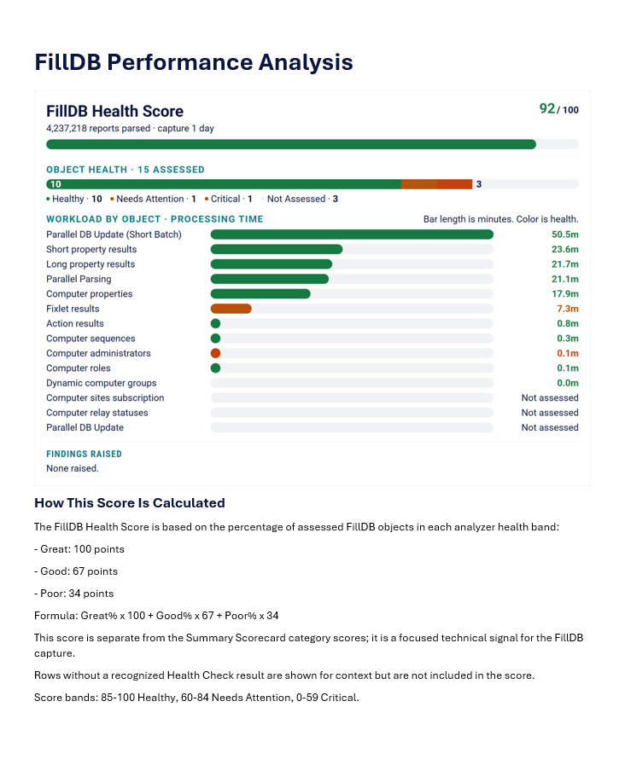
- If FillDB processing is poor, what is the first thing you would look at? Second?

First is SQL latency! FillDB lives and dies by insertion rates which are in turn controlled by SQL read and write latency. Remember that FillDB operates like a woodpecker. Lots of sequential operations and those operations need to be completed in < 1ms each. Second, SQL latency is often a reflection of disk performance, so have a look at perfmon results from the SQL server. By now you should have a very good idea of what your issue is.

