Individual Summary Report

40434771 Daniel McClean

# Key Development Contributions

The first of my key contributions to the development of our project was that at the beginning of the project I created a template html page along with some basic css styling and layout and a proposed structure for Javascript at this stage of the project for the other group members to use in their areas of the game in order to keep the layout of the game cohesive between all areas.

At the beginning of development I created an HTML version of my dungeon as well as the village area within the game. These HTML pages were eventually removed and replaced with the dynamic loading from the database. The other area that was solely my responsibility was the creation of the map area of the game.

Later in development I was the key developer of the current system where each decision in the game is loaded dynamically from the database and I am responsible for the majority of the JavaScript code that fetches data from the database and uses it to modify my base HTML page. The store the entire game in the database and only have code to load it means that it enables us to have multiple different text adventure games using the same code and just changing minor variables to load different data.

This is one of the key functions I developed to load the next decision from the database: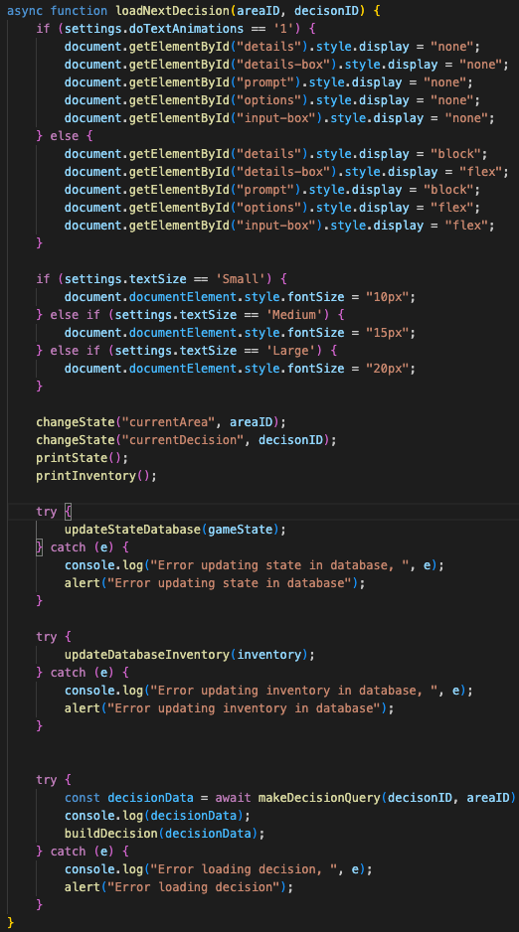

I am also responsible for the development of all the code for saving and loading the game. This is a key feature of our project that allows for auto saving that restores progress at the start of the last decision reached.

As well as these features all of the HTML, CSS and JavaScript used on any of the statistics and summary pages was created by myself.

I was responsible for the creation of the timerBar, popupMenu, dragDropGame and textEntry web components. I also was the first to create them.

Finally the code that creates the page loading animation was created by myself as well as the settings used to control whether this is enabled and what speed it should run at.

# Database & SQL Work

I carried out a large portion of database and SQL work within our project. The majority of the database tables that store data related to the decisions within our dungeon were created by myself as well as the SQL to create them. I also created the SQL to insert the decision data for the Starter Dungeon as well as the Village and Map areas.

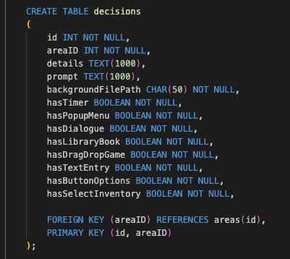

Some of the SQL I wrote to create the decisions tables

I also wrote the main function to execute a query on the database as well as the other query functions that execute a premade query with arguments passed by the developer. These massively aid development by decreasing complexity of the main UI code. The most complex of these queries that I wrote was the one to fetch decisions, but I also wrote the queries to query areas, map, NPCs and Settings. The piece of code that pings the database to check the connection is also solely my development.

In addition I also had a large portion of development in the PlayerCharacter table and the settings, playerInventory and playerInventoryLog tables are solely my creation.

Finally all of the SQl Queries found on the Global Analytics, User Analytics, Achievements and Game Summary pages are solely of my creation.s

# Technical Complexity & UX Enhancements

The most technically complex aspects of this project I worked on was the database design for storing the game, the way this is constructed it would allow for a whole new game to be created and played by creating new areas, decisions and map within the database and then only having to change a few variables within the JavaScript code in order to change what game is played. This makes our program much more flexible than alternative solutions of multiple HTML pages or loading the game dynamically where the data is embedded within the JavaScript files.

The other area of technical complexity that I worked on was the creation of web-components to enable for complex, reusable segments of HTML with their own attached JavaScript and CSS to be created and act as self contained sections that can be used without having to copy paste large segments of code. The most complex component I created was that of the DragDropGame. This component creates a box on screen that has a variable number of items that must be dragged across the screen. There is also a variable time limit for the game as well as the ability to insert custom css for the background of the destination boxes.

This element provides an enhanced bit of interactivity to the text based adventure and the use of an external library to handle the touch events for drag and drop enable this to function on mobile as well as desktop.

# Generative AI Use

Within development I used AI primarily as a debugging tool. It was mainly used to help with debugging my css styles, usually the more complex layout stylings. It was also used to explain the more in depth use of browser support primarily for the creation of my drag drop game component. I used it to help me to learn how to create drag drop elements before adapting this to fit the use case of my game. I also used it to help integrate the library to handle the drag drop touch events so that I could make this game function on mobile devices.

I also made use of AI to create all of the artwork for my dungeon and the NPC characters that I created.

The AI I used for this was ChatGPT-4o as well as Nightcafe for image generation.