Individual Summary Report

# Use of Generative AI:

AI was used in two separate instances of my part of the project:

1. The background image seen throughout the entire dungeon that I developed (the Palace). It was created by prompting ChatGPT to produce an image of a golden palace interior
2. Minor debugging and error checking in a specific SQL file. It didn’t resolve the issue, however, it suggested methods to better format the code. The only improvement that was taken was changing the main descriptive text of each room of the dungeon to be on one line. This ensured it was displayed properly when ported from separate .html files to the single SQL file

# Development Contributions:

My primary role in the development of this project was to create one of the dungeons that the player goes through in the game. This was the Palace. It was created as multiple .html files, one for each room of the dungeon and certain other events, and multiple .js files, one for each .html file.

.html files:

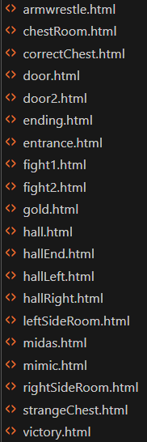

.html file example:

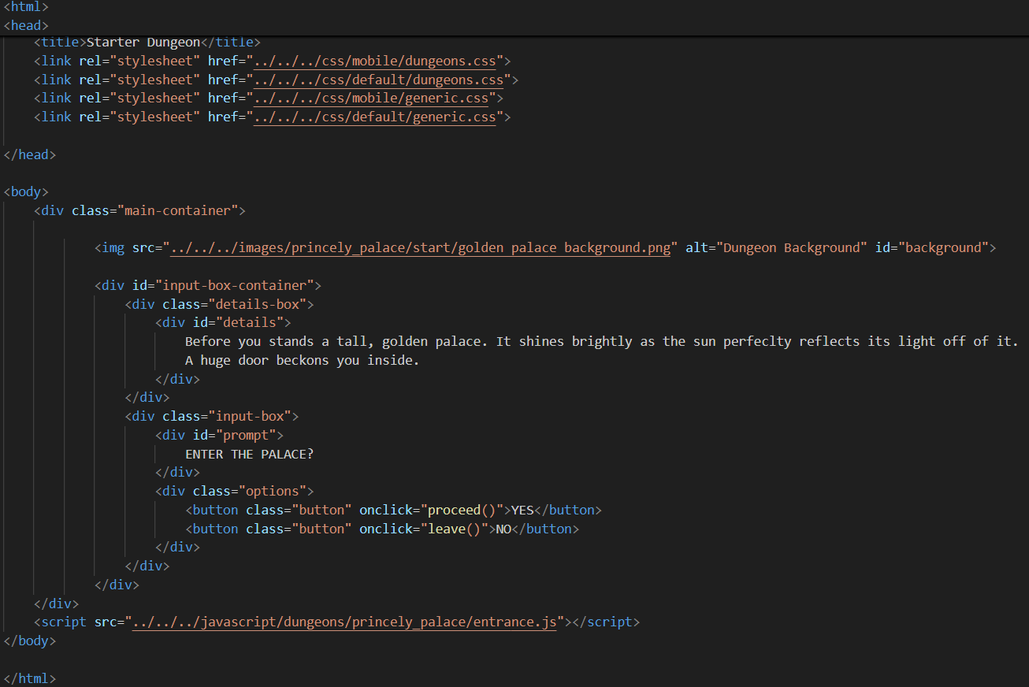

.js files:

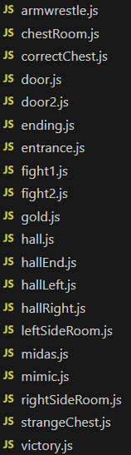

.js file example:

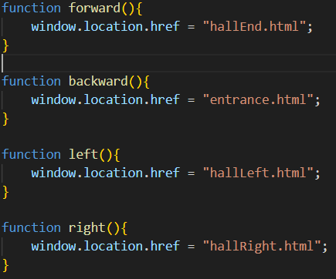

As well as that dungeon, I created multiple menu screens to be used by the player. These being:

* The main landing page
* The “Play Game” page
* The settings page

They were then further edited by other members of the group

# Database and SQL:

My contribution to the database portion of the project was porting my whole dungeon to SQL. All of the .html and .js files were compiled into three SQL files:

