Inherent spatiotemporal variation trumps fire and grazer effects in an Oklahoma tallgrass prairie
McGlinn, Daniel J.^{1,2*}; Earls, Peter G.^{1,3}; & Palmer, Michael W.^{1,4}
¹Botany Department, Oklahoma State University, Stillwater, OK 74078 USA;
²Biology Department, University of North Carolina, Chapel Hill, NC 27599 USA;
³E-mail pete.earls@okstate.edu;
⁴E-mail mike.palmer@okstate.edu;
*Corresponding author; E-mail danmcglinn@gmail.com

Abstract
Prescribed fire and grazing influences plant species richness and composition in many ecological communities. However, the majority of knowledge of such effects is largely based upon fine-scale or short-term manipulative studies, which are not ideally suited to quantify the importance of management relative to inherent landscape heterogeneity. The purpose of our study was to quantify the importance of fire and grazing by bison and/or cattle relative to inherent site and year effects on the vascular plant community. Our study system is the Nature Conservancy’s Tallgrass Prairie Preserve in Osage County, Oklahoma, which we monitored for 11 years with 20 permanent 100 m² plots.
The management objectives of the preserve are to maintain community heterogeneity through the application of randomized burning and freely-ranging grazers. We used multiple regression and canonical ordination to perform variation partitioning on species richness and species composition respectively. Site effects, probably edaphic in origin, explained the majority of variation in richness and composition. Year effects, related to seasonal precipitation, were more strongly correlated with variation in richness than composition. Interannual variation in fire and grazer species was unimportant relative to inherent site and year effects with respect to both richness and composition. Nevertheless, the effects of fire and grazer variables were significant and interpretable, and bison management was positively correlated with plant richness. The strength of inherent landscape heterogeneity on the plant community suggests that fine-tuning the application of fire and particular grazer is not critical for maintaining this intact tallgrass prairie plant community as long as fire and grazing remain part of the system.

Keywords: bison, Flint Hills, Oklahoma, restoration, tallgrass prairie, variation partitioning, vascular plants, vegetation monitoring

Introduction
Natural variability concepts of land management, which promote spatial and temporal variability, are increasingly used in restoration ecology (Palmer et al. 1997, Fuhlendorf et al. 2006). Underlying these concepts are two premises: 1) historical conditions and processes can provide guidance for management, and 2) spatial and temporal variability generated by disturbance are vital components of nearly all ecosystems (Landres et al. 1999). Proponents of natural variability concepts believe that managing for historical conditions will benefit species that have evolved in that system and will therefore minimize local extinctions of native taxa (Swanson et al. 1994, Cissel et al. 1999). Additionally, spatial and temporal variability in environmental heterogeneity is thought to maintain biological diversity (MacArthur 1965, Petraitis et al. 1989). Although these concepts are grounded in ecological theory, as Palmer et al. (1997) note, the importance of managing for natural variability is rarely examined experimentally.
The application of natural variability concepts is relevant to the conservation and restoration of the North American tallgrass prairie ecosystem. In this ecosystem, fire and grazing were important components of the pre-Columbian North American disturbance regime (Anderson 1990) and still are today (Daubenmire 1968, Abrams et al. 1986, Collins 1992). Although historically the region was grazed by bison (Bison bison) and was burned in a variety of seasons (Higgins 1986, Howe 1994, Allen et al. 2009), presently much of the remaining tallgrass prairie ecosystem is managed for cattle with annual spring burns (Fuhlendorf and Engle 2001). The purpose of annual spring burning is to maximize yields of palatable C4 grasses (Towne and Owensby 1984). Howe (1994) also noted that many restoration efforts on prairie remnants promote production of C4 grasses with spring season burning and a lack of grazing. These management practices may be a threat to the ecosystem’s biodiversity by only benefiting one competitively superior plant functional group and by homogenizing an entire region’s disturbance regime (Howe 1994, Fuhlendorf and Engle 2001, Nekola and White 2002).
Fuhlendorf and Engle (2001, 2004) suggested that natural variability may be restored to grazing systems by capitalizing on the interaction between fire and grazing could be used in a more variable manner in space and time to create a shifting mosaic in contrast to the traditional homogenous application of these management tools. They argued that a mosaic of burned and unburned patches more closely approximates the historical variability that would have existed on the landscape and will result in higher biodiversity than traditional homogenous management practices (annual spring burning). This hypothesis is guiding the management of The Nature Conservancy’s Tallgrass Prairie Preserve (TGPP), one of the largest tallgrass prairie preserves (Hamilton 1996, 2007, Allen et al. 2009).
The scale of the TGPP (15,700 ha) coupled with the spatially and temporally varying application of fire, the usage of both native and exotic grazers, and intact native vegetation provides both important opportunities and challenges for experimentally evaluating aspects of the natural variability hypothesis. Specifically, the TGPP is an ideal setting for conducting a long-term observational study on the relative importance of variation in grazing and fire in an unplowed tallgrass prairie ecosystem that is presumably in somewhat of a more pre-Columbian state. This opportunity is valuable because the majority of our knowledge on tallgrass prairie ecology either originates from relatively small scale experiments (e.g., Hulbert 1988) or from strictly controlled watershed treatments (e.g., Knapp et al. 1998).

Due to the long-term observational nature of our study, differences due to variation in fire and grazing within sites are likely to be confounded by year-to-year variation in climate (Anderson 1982, Gibson and Hulbert 1987, Adler and Levine 2007) and between sites by variation in soil (Anderson and Fly 1955, Critchley et al. 2002) and topography (Abrams and Hulbert 1987, Briggs and Knapp 1995). However, these confounding differences can be statistically controlled and separated from one another using variation partitioning (Borcard et al. 1992, Økland and Eilertsen 1994). Variation partitioning provides estimates of the independent and shared importance of several groups of variables relative to one another.
In this study, we apply variation partitioning to quantify the importance of variability in prescribed burning and grazer species (i.e., cattle vs. bison) on plant species richness and composition at the TGPP relative to in situ site and year variation. Our goal is not to directly test whether or not variation in fire and grazing are effective tools for meeting specific conservation targets, but rather to examine the relative influence that variation in these variables has on the plant community. Lastly we wish to examine the implications of our findings for management practices.

Methods

Study Site
The TGPP is a 15,700 ha nature preserve located between 36.73° and 36.90° N latitude, and 96.32° and 96.49° W longitude, in Osage County, Oklahoma and owned by The Nature Conservancy (TNC, Allen et al. 2009). Over the course of the 11 year study period (1998-2008), total annual rainfall varied from 490 to 1250 mm. The preserve is situated at the southern extent of the Flint Hills region. The elevation of the preserve ranges from 253 to 366 m, and the underlying bedrock of the region is characterized by soils deriving from Permian limestone, sandstone, and shale (Oviatt 1998). Due to the proximity of bedrock to the surface and the relatively steep terrain, the Flint Hills region has experienced long-term erosion leaving surface layers of soil that are thin and young. Because of this rockiness the Flint Hills region, including the Tallgrass Prairie Preserve, has remained unplowed and has been instead utilized primarily as rangeland for cattle. Prior to the acquisition of the preserve by TNC in 1989, the majority of the site was managed for cow-calf and yearling cattle production with a 4- to 5-year rotation of prescribed burning and aerial application of broadleaf herbicides (1950-1989) (Hamilton 2007).
Approximately 90% of the TGPP consists of grasslands. The majority of the grasslands are composed of tallgrass prairie habitats dominated by Andropogon gerardii, Sorghastrum nutans, Sporobolus compositus, Panicum virgatum, and Schizachyrium scoparium. Shortgrass prairie habitat occurs to a lesser extent on more xeric sites and is dominated by Bouteloua spp. Despite the application of herbicide earlier in the 20th century, the flora of the preserve appears relatively intact with a total of 763 species of vascular plants (to date) of which 12.1% are exotic (Palmer 2007).

Management Plan
The management plan at the TGPP encompasses a wide range of spatial and temporal variation in the application of prescribed fire and cattle or bison grazing (Hamilton 1996, 2007). In 1993, 300 bison were introduced year-round onto a 1,960 ha portion of the preserve. As the bison herd increased in size, the area allotted to the herd was increased eight times to an area of 8,517 ha by 2007 (Fig. 1, 54% of preserve area). Initial bison stocking rates were increased in 1999 to 2.1 animal-unit months ha⁻¹ (see Hamilton 2007 for additional details). Within the bison unit, animals were allowed to range freely and their movement was not obstructed by internal fences. Watersheds within the bison unit were considered randomly for burning only if they met the minimum fuel criteria of 900 kg ha⁻¹ of fine fuels. Within a given year, the season of burn of the bison unit was split as follows: 40 % dormant spring (March - April), 20 % late growing season (August - September), and 40 % dormant winter (October - December). The remainder of the preserve was seasonally grazed by cattle and typically burned more frequently in the dormant spring season, but some of the cattle pastures were utilized for smaller scale (2,350 ha) patch-burn experiments in which only one-third of a given management unit was burned annually (Hamilton 2007). Stocking within the cattle pastures included both intensive-early stocking and season-long stocking, which contrasted with the year-round stocking in the bison unit.

Data collection
The management units were spatially aggregated and temporally variable; therefore, a spatially stratified semi-random sampling design was necessary to ensure that samples were representative of the broader variation in grassland communities across the preserve (Palmer 1995). We selected twenty 100 m² plots to resample through time (Fig. 1) from a set of 157 permanent plots that were located on a 1-km UTM grid within the TGPP (Palmer et al. 2002). The only criteria that we imposed on the selection of the resample plots were that they had no standing water and less than 20 % cover of woody plants or exposed rock. We opted to annually resample the sites to observe the vegetation at a given site in multiple management states (e.g., one year post burn, bison vs. cattle grazed), and to provide information on inherent year-to-year variation. At each site we recorded species presence/absence for plants rooted within each of the four corners of the 10 x 10 m quadrats at four nested spatial scales 0.01, 0.1, 1, and 10 m² (see McGlinn et al. 2010 for a sampling diagram). At the 100 m² spatial scale we visually estimated species cover.
Each year we combined four 15 cm soil cores collected at each corner of the plot and sent these to Brookside Labs (New Knoxville, Ohio) to be analyzed for soil variables. We recorded topographic data on slope and aspect in the field. We obtained total monthly precipitation data from the Oklahoma Mesonet Foraker site (36.841° N, -96.428° W; elevation: 330 m; Fig. 1), which is located on the preserve (McPherson et al. 2007). We calculated total precipitation for three arbitrarily defined season variables (four months each): June through September (summer), October through January (winter), and February through May (spring).
To examine the importance of variation in fire and grazing we employed three variables: years of bison grazing, years since burn, and number of burns in the past five years, from a GIS database that we developed based on TNC’s recorded burn and grazing history. We recognize that the number of burns in the past five years is negatively correlated with years since last burn (see Appendix A) and reflects somewhat of an arbitrary cutoff point (five years), but we chose to include this variable in our models despite these shortcomings because we wished to quantify the short-term burn history of a site which is not captured by “years since burn”. Additionally the detailed fire record does not extend beyond five years prior to the beginning of the study. We chose not to include season of burn as an explanatory variable because 83% (67 out of 80) of the prescribed fire events recorded on our study sites took place during the dormant season.
It is important to note two aspects of the fire and grazer variables: 1) the application of fire and grazer was heterogeneous in space and time (i.e., there were no fixed treatments), and 2) the variables “time since fire” and “number of burns in the past five years” are inherently temporally variable (i.e., even if a site had experienced a fixed fire-return interval, these variables would display variation through time).
We grouped species into five functional groups to aid in the ecological interpretation of patterns of species richness and composition we observed. The functional groups were forbs, legumes, C3 grasses, C4 grasses, and shrubs.
All of the data used in this study are archived and available to the public online (McGlinn et al. 2010).

Data analysis
Our analysis was composed of two parallel analyses: those on species richness and those on species composition. In both cases our goal was to 1) examine visually if the response variable changed directionally through time, and 2) examine the degree to which site, year, and management variables explained heterogeneity in the response. We used variation partitioning to estimate the independent and shared fractions of explained variance for both richness and composition.
We coded site and years as dummy variables to quantify site and year effects relative to fire and grazing variables. We then performed a post-hoc examination of the specific environmental variables (described in Data collection) that we believed may explain the site and year effects. Given the observational nature of this study, many of our environmental variables (e.g., soil cations, total spring rain) were strongly collinear and likely act as proxy variables. Therefore, to increase the clarity of our results, we only examined a small number of environmental variables. Additionally we note that the primary objectives of this study did not depend on elucidating the specific environmental sources of spatial and temporal heterogeneity. We selected calcium as the soil variable to examine because previous work indicated it acted as a proxy for limestone (rather than sandstone) derived soils and was strongly correlated with richness (Palmer et al. 2003, Brokaw 2004). We included field measurements of slope and aspect in the analysis which we expect to reflect variation in the degree of moisture and solar exposure. Aspect was converted to an index of northness [northness = cos(aspect)] (Roberts 1986). We did not include a corresponding index of eastness as exploratory results indicated it was unimportant (not shown).
We first used ordinary least squares (OLS) and generalized least squares (GLS) to dissect relationships between species richness and our various explanatory variables. OLS is ideal for providing interpretable estimates of variance explained; however, exploratory analyses revealed the presence of year-to-year temporal autocorrelation in richness which violates one of OLS’s assumptions. We therefore used first-order autoregressive GLS models to correct for the temporal autocorrelation. First-order autoregressive models are some of the simplest models of temporal autocorrelation, and they attempt to correct for short-term autocorrelation between samples within a site (Pinheiro and Bates 2000, p. 228-229). The GLS models were fit with a restricted maximum likelihood algorithm, which is the preferred method for generating unbiased estimates of variance in models that have a relatively large number of parameters (Diggle et al. 1994). The R package nlme version 3.1-90 (Pinheiro et al. 2008) was used to carry out all GLS model fitting and diagnostics.
We used variation partitioning (or commonality analysis) to estimate the unique and shared fractions of explained variation in three groups of variables (or factors), sites, years, and fire and grazing on richness (Legendre and Legendre 1998, Peres-Neto et al. 2006). Sites and years were coded as dummy variables and the fire and grazer group was composed of the three fire and grazer variables described above. The independent component of variation attributable to fire and grazer should be interpreted as variation within-sites which was independent of specific years and was associated with temporal changes in the fire variables and the single grazer variable that occurred over the study period. For example, over the course of the study, seven of the sites changed from cattle grazed to bison grazed. The analysis associated changes in these sites after their change in grazer that was independent of a specific year effect with the variable “years of bison grazing”. In contrast, if a site remained in the cattle unit for the duration of the study then the variable “years of bison grazing’’ would not have been associated with explained temporal variance at that particular site.
We carried out partitioning with OLS as well as with GLS multiple regressions. For each fraction of the OLS analysis, we report both the coefficient of determination and its adjustment for number of variables, 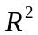 and 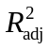 respectively. For the GLS fractions we calculated a generalized formulation of the coefficient of determination, 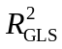, that is appropriate for GLS models (Nagelkerke 1991). We used approximate, conditional (type III) F-tests to assess if a group or variable explained a significant amount of variance in richness.
In all analyses we treated species richness as a continuous variable with normally distributed error. We recognized that in some modeling contexts it is more appropriate to consider richness as a Poisson distributed variable (Candy 1997, Palmer and Hussain 1997). However, because the normal distribution provides a good approximation of a Poisson random variable when the mean is larger than approximately 20; we feel that our usage of normal errors (instead of Poisson) is justified given that richness was never below 48 in our samples. We also recognize that some authors consider richness to only be one facet of grassland biodiversity and that other diversity indices can yield more insight into the ecology of the system (Wilsey et al. 2005, Chalcraft et al. 2009). However, in this study richness was so strongly correlated with all of the indices examined in Wilsey et al. (2005) that additional analyses on various diversity indices would have yielded little additional insight (see Appendix B).
We used both indirect and direct gradient analyses to examine species composition. Prior to all ordinations, we square-root transformed all species cover data to decrease the influence of the most abundant species on the analysis, and we down-weighted rare species. Detrended Correspondence Analysis (DCA; Hill and Gauch 1980) was used to display directionality of change in the plant composition through time and to illustrate the magnitude of temporal variation relative to spatial variation. Results from non-metric multidimensional scaling (NMS) were qualitatively similar to those of DCA and had identical interpretations, and are therefore not shown.
We carried out variation partitioning using partial canonical correspondence analysis (pCCA) (Borcard et al. 1992, Økland 1999) to assess species composition. The groups used in the variation partitioning were as defined above for richness. We calculated Peres-Neto et al.’s (2006) formulation of the adjusted fraction of variation explained in CCA using a permutation approach (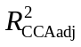). To our knowledge, correlational models for the residuals have not been theoretically developed within the direct ordination context and therefore these methods were not applied in our analysis of species composition. However, when testing the importance of dependent variables that accounted for the within-site variability in species composition, we conducted a toroidal shift Monte Carlo test (Legendre 1993, ter Braak and Šmilauer 2002b). This method of permutation maintains the observed order of the samples within a site while nullifying the temporal relationship of samples between sites. When the constraining variable was site specific, we carried out permutations that randomly shuffled samples only within their year of occurrence to conform with our assumption of spatial independence between sites but not years. All randomization tests were conducted with 999 iterations to determine significance of all canonical axes for all partial CCA axes under the reduced model (Legendre and Legendre 1998, p308). As in the analysis on richness, we constructed models to examine the importance of specific explanatory variables with estimates of variation explained and conditional F-tests. We performed multivariate analyses with CANOCO version 4.5 (ter Braak and Šmilauer 2002a) and the R package vegan version 1.15-1 (Oksanen et al. 2008, R Development Core Team. 2008). A total of 25 tests were performed, and to minimize our Type I error rate we used the Bonferroni alpha level of 0.002 (= 0.05/25) to judge significance.

Results

Variance in species richness
The average species richness over the 11 year study at the 100 m² grain was 76.24 (± 0.86) of which between 5-7% were exotic species. The between-year variance (σ = 9.13) in richness was approximately equal to the between-site variance (σ = 8.93). There were not strong directional changes in total richness or in the five functional groups through time (Fig. 2). Forbs were more species-rich than all other functional groups. Variation partitioning of the unbiased OLS estimate of variance explained (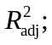Table 1), indicated that between-site differences accounted for the majority of variance in richness (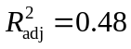), followed by year-to-year differences (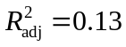). However, after within-site temporal autocorrelation was considered (using a first-order auto-regressive term), the strength of site identity relative to year identity was diminished substantially according to Nagelkerke’s (1991) generalized definition of the coefficient of determination. In both OLS and GLS based variation partitioning, the fire/grazer class of variables accounted for a much smaller percentage of explained variance in richness (2–4 %) than the site and year variables, but still contributed a significant amount of explained variation (Table 2). There was a large shared fraction of variation (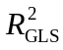= 0.25) between site and year that was only apparent after correcting for the inherent temporal autocorrelation. The shared fractions of variance between the fire/grazer class of variables and each of the other groups were approximately equal to the independent effect of the fire/grazer group (2-4%).
The most important variable for explaining site-to-site differences in richness was log Ca, which was negatively correlated with richness (standardized coefficient, β = -0.42) (Table 2). Topography did not seem to have a strong influence on richness as neither slope nor northness explained much variation in richness.
Temporal variation in richness within the sites was attributable to both climate and fire and grazing variables. The most important seasonal rainfall variable was summer rain, which was negatively correlated with richness (β = -0.19); winter rain and spring rain appeared equally important and both were positively associated with richness (β = 0.15 and 0.14, respectively). The single most important fire and grazing variable was years of bison, which was positively associated with richness (β = 0.46). Both years since burn and number of burns in the past five years were negatively associated with richness but neither variable was found to explain significantly more variation in richness than due to chance at the Bonferroni corrected alpha level of 0.002 (Table 2).

Variance in species composition
The DCA scatterplot did not illustrate a strong directional change in species composition (Fig. 3). Furthermore, sites remained relatively separate from one another in ordination space, which indicates that among-site variation in species composition was greater than temporal variation within sites, despite a dynamic fire regime. There was not a strong difference in sample scores between sites that were bison- versus cattle-grazed along the first through fourth DCA axes (third and forth axes not shown). Furthermore, when samples switched from cattle to bison, their trajectory through time did not change substantially. The results of the NMDS (not shown) corroborated these qualitative results.
Variation partitioning based upon pCCA indicated that site effects explained the majority of the variation in species composition (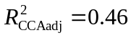, Fig. 4). Year and fire and grazing effects on species composition were negligible after adjustment, but both were still found to be significant in randomization tests at the 0.05 level (Table 3). There was a relatively large shared site and fire and grazing fraction (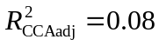) of explained variation. The pCCAs that considered site specific explanatory variables after factoring out year and fire and grazing effects indicated that log Ca was the most important site specific variable (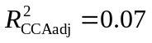; Table 3).
The pCCA biplot displays only the 90 most abundant species (although all 307 species were included in the analysis) with respect to the three fire and grazing variables after factoring out year and site effects as dummy variables (Fig. 5). Although the variation explained by these variables was slight (Table 3), it was interpretable. It appeared that both C3 and C4 grasses (open and filled black circles on biplot respectively) appeared to decrease in cover with increased years of bison grazing. Lespedeza cuneata (sericea lespedeza), an invasive species, was positively correlated with years of bison grazing. However, this species is a target for spot herbicide application by the TNC so care must be taken in interpretation of this result. Annual and ruderal species, such as Chamaesyce nutans (eye bane), Plantago virginica (Virginia plantain), Ambrosia artemisiifolia (annual ragweed), and Andropogon virginicus (broomsedge bluestem), all were positively associated with the number of burns in the past five years.

Discussion
The purpose of our study was to examine the influence of variation in fire and grazing on plant richness and composition relative to intersite and interyear variability. Our results suggest that the grasslands of the TGPP are not undergoing strong directional changes in richness or composition through time (i.e. they do not appear to be on a clear trajectory). Rather, sites appear to maintain their differences over time. This is not to say that the effects of variation in fire and grazing on richness and composition independent of site and year were irrelevant and uninterpretable, but simply that fire and grazing were relatively unimportant relative to inherent temporal and spatial heterogeneity.

Role and drivers of site-to-site variation
The bulk of the variation in richness and composition was due to differences between sites, which we believe primarily reflects belowground environmental differences. We found that soil calcium explained the predominant amount of site-to-site variability in both richness and composition (Table 2). We interpret calcium’s importance to be due to its role as a proxy variable for many other soil properties which are generally indicative of limestone derived soils (Palmer et al. 2003, Brokaw 2004). Using the same 20 sites analyzed in this study (only for the year 2002), Brokaw (2004) found that out of a set of 12 different soil nutrients and total carbon that the two most important variables for explaining plant composition (using pCCA) were total carbon and residual phosphorus. These two variables were strongly positively correlated with the majority of soil nutrients and calcium which Brokaw (2004) interpreted as general indicators of limestone parent materials. These findings suggest that the important role that calcium, as an indicator of bedrock, played in our study does not necessary contradict the body of work that suggests that below ground nutrients other than cations are the predominant drivers of plant richness and composition in tallgrass prairie ecosystems (Turner et al. 1997, Burke et al. 1998, Baer et al. 2003, 2004).
Why was the relationship between calcium and richness negative? The positive relationship between calcium and soil nutrients (that Brokaw [2004] found in our samples) suggests one possible explanation. If soils high in calcium are the productive, nutrient rich sites, then plant species at these sites may experience stronger competitive exclusion and therefore have lower richness (Grime 1973, Tilman 1982). Pärtel’s (2002) species pool hypothesis offers an alternative hypothesis for the negative correlation between richness and calcium. The species pool hypothesis postulates that negative correlations between richness and pH (or calcium given their tight correlation) will occur in regions in which habitats high in pH were evolutionarily scarce. Palmer et al. (2003) found that the data from the Tallgrass Prairie Preserve (including this study’s sites as well as many others) appeared to support Pärtel’s (2002) hypothesis in the grasslands but not in the woodlands.

Role and drivers of year-to-year variation
Year-to-year variation was more influential for richness than species composition. This indicates that year-to-year changes in richness were primarily by rarer species that were not strongly positively associated with one another. Year effects explained almost equal amounts of variation in richness as site effects (21% compared to 25%, respectively) with 9 fewer parameters. With respect to species composition, year effects were much less than the site effects and were more comparable with the small influence of the fire and grazer effect (both were < 1%).
Climatic variability is the most obvious candidate for a driver of year-to-year variation (that is independent of fire and grazing effects). In grassland plant communities, water is typically viewed as an important limiting resource, and it is generally positively associated with richness (Cornwell and Grubb 2003, Adler and Levine 2007, Wilson 2007). In our study, richness was positively correlated with the winter and spring seasonal precipitation variables, but negatively correlated with the summer precipitation variable. In fact the negative correlation between richness and summer rainfall resulted in the strongest partial correlation (Table 2). Following Adler and Levine (2007), increased precipitation may act on richness directly by making the environment more benign and thus allowing more species to coexist. However, if this was generally true, then it is difficult to explain the strong negative correlation observed for summer rainfall. An alternative season specific hypothesis that may explain the negative relationship with summer rainfall is that increased precipitation in the summer previous to sampling yields higher aboveground cover of C4 grasses. High yields of aboveground biomass could act to both inhibit germination of annuals and biennials at the beginning of the next growing season as well as increase asymmetric light competition due to increased litter (Grace 2001). The positive influence of spring and winter rains may also be explained by the critical role that rainfall plays in stimulating germination in the annuals and biennials during the dormant seasons. To be clear in both of these explanations precipitation is viewed as a non-resource variable that indirectly influences richness by increasing aboveground primary productivity the summer prior to sampling and/or by influencing germination of species-rich plant groups (Grace 2001, Adler and Levine 2007).

Fire and grazer effects
Fire and grazer effects explained a significant component of the variance we observed in richness and composition, but these effects appeared relatively unimportant compared to contextual spatial and temporal heterogeneity. The historical and regional context of our study site may have contributed to this result. Specifically, prior to TNC’s ownership, the site was managed using prescribed burning and cattle grazing (Hamilton 2007). These management practices are common in the Flint Hills region (Malin 1942, Kollmorgen and Simonett 1965) and are likely one of the primary reasons this region has maintained intact tallgrass prairie vegetation (Samson and Knopf 1994). Without this land management legacy, it is likely that we would have observed a much stronger influence of fire and grazing because our study sites would have initially contained higher abundances of disturbance-sensitive species, such as Juniperus virginiana (eastern redcedar) which we seldom observed (and only as seedlings) in our sites but has aggressively invaded much of the southern Great Plains due to fire suppression (Briggs et al. 2005). Additionally, we did not compare our samples to control sites that received no burning and/or grazing, although some of our sites went as long as 10 years without fire. We expect that longer periods without fire (than typically observed in our study) would have resulted in both increased cover of woody plants (as described above) and a stronger negative correlation between time since fire and richness due to the gradual accumulation of litter which would have suppressed richness (e.g., Lamb 2008). Therefore, in light of the fact that our study site represents a relatively intact tallgrass prairie with a long history of fire and grazing; it is not necessarily surprising that landscape soil heterogeneity and climatic variation had a stronger influence.
Although the fire and grazing variables explained little variation overall, years of bison grazing had a strong positive relationship with richness (Table 2). This suggests that TNC’s system of bison management at the TGPP is having a positive influence on plant species richness. We stress bison management rather than the influence of bison directly because the average fire-return interval was generally longer and the season of burn was more variable in the bison units when compared with the cattle units (Hamilton 2007). In addition, the bison units were grazed year round, while the cattle units were only seasonally grazed. Therefore, we are fairly confident bison management is having a positive effect on richness, but we are less confident that this is due to the presence of bison in comparison to cattle.
Other authors have proposed that bison may indirectly increase plant richness because they show grazing preference for graminoids rather than forbs (in contrast to cattle which behave more as generalists) (Coppedge et al. 1998b, Knapp et al. 1999). This dietary behavior may release forbs from competitive exclusion due to the dominant C4 grasses. In our study, years of bison grazing was negatively correlated with the cover of the majority of C3 and C4 species (Fig. 5). The increase in richness and decrease in graminoid cover in the bison managed sites lend modest support to the hypothesis that bison may increase richness of tallgrass prairie by decreasing the cover of graminoids relative to sites that were grazed seasonally by cattle.
Towne et al. (2005) undertook a more controlled approach to investigating the effects of bison and cattle grazing on plant richness and composition at the Konza Prairie LTER over a 10 year period in annually burned pastures. They also found that overall the differences between bison and cattle were slight but that bison grazed patches had a higher cover of some forb species and gained forb species at a more rapid rate through time. They concluded the differential responses of vegetation to bison or cattle grazing may be predominately due to differences in management of these grazers rather than inherent differences in their biology. A similar effect may be taking place at our study site as well.
Years since last burn was most strongly correlated with changes in species composition (Fig. 5), but the other two fire and grazing variables explained comparable amounts of variation (Table 3). Other studies have noted the strong positive relationship between the cover of legumes and C4 grasses with frequency of dormant season burning (Hulbert 1988, Towne and Knapp 1996, Coppedge et al. 1998a, Peterson et al. 2007), although 84% of the burns in our samples occurred during the dormant season, there was not a clear relationship between fire frequency and either of these functional groups (Fig. 5). We found anecdotal evidence that ruderal species were positively associated with the number of burns in the past five years (Fig. 5), which is to be expected given that these samples were likely to have higher grazing pressure due to their more nutritious regrowth (Coppedge and Shaw 1998, Fuhlendorf and Engle 2001).

Management implications
The results of our study demonstrated that plant richness and composition may be relatively insensitive to fire frequency and grazer type in an intact tallgrass prairie with a long legacy of prescribed fire and grazing. This suggests that fine-tuning a management plan with respect to fire frequency or grazer identity may be of less importance given the potentially large sources of inherent landscape heterogeneity on the landscape (Knapp et al. 1999). This may be welcome news for land managers because it suggests that intact tallgrass prairie plant communities may be relatively resilient to uncertainty in the prescription of fire frequency and grazer choice as long as some combination of fire and grazing is present on the landscape.
Although our study did not examine long-term unburned and/or ungrazed sites, it is worth noting that tallgrass prairie landscapes managed in this way are likely to experience increased woody encroachment (e.g., Briggs et al. 2002), in which case decisions about fire frequency and grazer species may become critical to restoring the plant community (Peterson and Reich 2001, Peterson et al. 2007, Papanastasis 2009).
At our study site, TNC is utilizing a variable application of prescribed fire to meet several objectives. One goal is to maintain or increase the biological diversity of the plant community (Hamilton 2007). The non-directional changes in species richness and composition coupled with the high overall magnitude of average richness and low proportion of exotic species we observed during the 11-year period, suggest that the management decisions are at the very least are not detrimental to the plant community. TNC is also attempting to manage for wildlife habitat and diversity. Structural heterogeneity in the vegetation, attributed to the variable application of fire, resulted in the development of suitable habitat for a wider breadth of grassland bird species at the TGPP (Fuhlendorf et al. 2006, Coppedge et al. 2008). These results in conjunction with our findings suggest that the management decisions at the preserve are contributing to important conservation goals, even if their effects on plant richness and composition are slight.

Conclusions
In a relatively intact tallgrass prairie the influence of spatiotemporal variation in fire and grazing on plant richness and composition was relatively minor relative to inherent variation between sites and years. Nevertheless, variation in fire and grazing had significant and interpretable effects, and we detected a significant positive correlation between bison management and plant richness. Given the overriding influence of inherent landscape heterogeneity on the plant community, fine-tuning management prescriptions that incorporate the variable application of fire and grazing may not be crucial for maintaining native tallgrass prairie plant communities.

Acknowledgments
Z. Roehrs, M. Allen, and S. Fuhlendorf provided comments that improved the quality of this manuscript. DJM received funding from the U.S. Environmental Protection Agency (EPA) under the Greater Research Opportunities Graduate Program. The U.S. EPA has not officially endorsed this publication, and the views expressed herein may not reflect the views of the Agency. MWP acknowledges support from NSF Grant Number EPS-0447262 and EPS-0919466, The Oklahoma State University College of Arts and Science, The Oklahoma Nature Conservancy, The Spatial and Environmental Information Clearinghouse, The Philecology Trust, The Oklahoma Water Resources Research Institute. Additionally we thank Bob Hamilton, members of Laboratory for Innovative Biodiversity and Analysis, and the Osage Nation and numerous other researchers for assisting us at various stages in the field.

Literature Cited
Abrams, M. D. and L. C. Hulbert. 1987. Effect of topographic position and fire on species composition in tallgrass prairie in northeast Kansas. American Midland Naturalist 117:442-445.
Abrams, M. D., A. K. Knapp, and L. C. Hulbert. 1986. A ten-year record of aboveground biomass in a Kansas tallgrass prairie: effects of fire and topographic position. American Journal of Botany 73:1509-1515.
Adler, P. B. and J. M. Levine. 2007. Contrasting relationships between precipitation and species richness in space and time. Oikos 116:221-232.
Allen, M. S., R. G. Hamilton, U. Melcher, and M. W. Palmer. 2009. Lessons from the Prairie: Research at The Nature Conservancy's Tallgrass Prairie Preserve. Oklahoma Academy of Sciences, Stillwater, Oklahoma, USA.
Anderson, E. 1990. The historic role of fire in North American grassland.in S. L. Collins and L. L. Wallace, editors. Fire in North American tallgrass prairies. University of Oklahoma Press, Norman, OK, USA.
Anderson, K. L. and C. L. Fly. 1955. Vegetation-soil relationships in Flint Hills bluestem pastures. Journal of Range Management 8:163-169.
Anderson, R. C. 1982. An evolutionary model summarizing the roles of fire, climate, and grazing animals in the origin and maintenance of grasslands: an end paper. Pages 297-308 in J. R. Estes, R. J. Tyrl, and J. N. Brunken, editors. Grasses and grasslands: systematics and ecology. University of Oklahoma Press, Norman, OK, USA.
Baer, S. G., J. M. Blair, S. L. Collins, and A. K. Knapp. 2003. Soil resources regulate productivity and diversity in newly established tallgrass prairie. Ecology 84:724-735.
Baer, S. G., J. M. Blair, S. L. Collins, and A. K. Knapp. 2004. Plant community responses to resource availability and heterogeneity during restoration. Oecologia 139:617-629.
Borcard, D., P. Legendre, and P. Drapeau. 1992. Partialling out the spatial component of ecological variation. Ecology 73:1045-1055.
Briggs, J. M., G. A. Hoch, and L. C. Johnson. 2002. Assessing the rate, mechanisms, and consequences of the conversion of tallgrass prairie to Juniperus virginiana forest. Ecosystems 5:578-586.
Briggs, J. M. and A. K. Knapp. 1995. Interannual variability in primary production in tallgrass prairie - climate, soil-moisture, topographic position, and fire as determinants of aboveground biomass. American Journal of Botany 82:1024.
Briggs, J. M., A. K. Knapp, J. M. Blair, J. L. Heisler, G. A. Hoch, M. S. Lett, and J. K. McCarron. 2005. An ecosystem in transition: causes and consequences of the conversion of mesic grassland to shrubland. Bioscience 55:243-254.
Brokaw, J. M. 2004. Comparing explanatory variables in the analysis of species composition of a tallgrass prairie. Proceedings of the Oklahoma Academy of Science 84:33-40.
Burke, I. C., W. K. Lauenroth, M. A. Vinton, P. B. Hook, R. H. Kelly, H. E. Epstein, M. R. Aguiar, M. D. Robles, M. O. Aguilera, K. L. Murphy, and R. A. Gill. 1998. Plant-soil interactions in temperate grasslands. Biogeochemistry 42:121-143.
Candy, S. G. 1997. Poisson vs normal-errors regression in Mac Nally (1996). Austral Ecology 22:233-235.
Chalcraft, D. R., B. J. Wilsey, C. Bowles, and M. R. Willig. 2009. The relationship between productivity and multiple aspects of biodiversity in six grassland communities. Biodiversity and Conservation 18:91-104.
Cissel, J. H., F. J. Swanson, and P. J. Weisberg. 1999. Landscape management using historical fire regimes: Blue River, Oregon. Ecological Applications 9:1217-1231.
Collins, S. L. 1992. Fire frequency and community heterogeneity in tallgrass prairie vegetation. Ecology 73:2001-2006.
Coppedge, B. R., D. M. Engle, C. S. Toepfer, and J. H. Shaw. 1998a. Effects of seasonal fire, bison grazing and climatic variation on tallgrass prairie vegetation. Plant Ecology 139:235-246.
Coppedge, B. R., S. D. Fuhlendorf, W. C. Harrell, and D. M. Engle. 2008. Avian community response to vegetation and structural features in grasslands managed with fire and grazing. Biological Conservation 141:1196-1203.
Coppedge, B. R., D. M. Leslie, and J. H. Shaw. 1998b. Botanical composition of bison diets on tallgrass prairie in Oklahoma. Journal of Range Management 51:379-382.
Coppedge, B. R. and J. H. Shaw. 1998. Bison grazing patterns on seasonally burned tallgrass prairie. Journal of Range Management 51:258-265.
Cornwell, W. K. and P. J. Grubb. 2003. Regional and local patterns in plant species richness with respect to resource availability. Oikos 100:417-428.
Critchley, C. N. R., B. J. Chambers, J. A. Fowbert, R. A. Sanderson, A. Bhogal, and S. Rose. 2002. Association between lowland grassland plant communities and soil properties. Biological Conservation 105:199-215.
Daubenmire, R. 1968. Ecology of fire in grasslands. Advances in Ecological Research 5:209-266.
Diggle, P. J., K.-Y. Liang, and S. L. Zeger. 1994. Anaylsis of Longitudinal Data. Clarendon Press, Oxford, UK.
Fuhlendorf, S. D. and D. M. Engle. 2001. Restoring heterogeneity on rangelands: ecosystem management based on evolutionary grazing patterns. Bioscience 51:625-632.
Fuhlendorf, S. D. and D. M. Engle. 2004. Application of the fire-grazing interaction to restore a shifting mosaic on tallgrass prairie. Journal of Applied Ecology 41:604-614.
Fuhlendorf, S. D., W. C. Harrell, D. M. Engle, R. G. Hamilton, C. A. Davis, and D. M. Leslie. 2006. Should heterogeneity be the basis for conservation? Grassland bird response to fire and grazing. Ecological Applications 16:1706-1716.
Gibson, D. J. and L. C. Hulbert. 1987. Effects of fire, topography and year-to-year climatic variation on species composition in tallgrass prairie. Plant Ecology 72:175-185.
Grace, J. B. 2001. The roles of community biomass and species pools in the regulation of plant diversity. Oikos 92:193-207.
Grime, J. P. 1973. Competitive exclusion in herbaceous vegetation. Nature 242:344-347.
Hamilton, R. G. 1996. Using fire and bison to restore a functional tallgrass prairie landscape. Pages 208-214 Transactions of the 61st North American Wildlife and Natural Resources Conference. Wildlife Management Institute, Washington D.C.
Hamilton, R. G. 2007. Restoring heterogeneity on the Tallgrass Prairie Preserve: applying the fire-grazing interaction model. Pages 163-169 in R. E. Masters and K. E. M. Galley, editors. Proceedings of the 23rd Tall Timbers Fire Ecology Conference: Fire in Grassland and Shrubland Ecosystems. Allen Press, Tall Timbers Research Station, Tallahassee, Florida, USA.
Higgins, K. F. 1986. Interpretation and compendium of historical fire accounts in the Northern Great Plains. U.S. Fish and Wildlife Service Resource Publication 161.
Hill, M. O. and H. G. Gauch. 1980. Detrended Correspondence analysis: an improved ordination technique. Vegetatio 42:47-58.
Howe, H. F. 1994. Managing species-diversity in tallgrass prairie - assumptions and implications. Conservation Biology 8:691-704.
Hulbert, L. C. 1988. Causes of fire effects in tallgrass prairie. Ecology 69:46-58.
Knapp, A. K., J. M. Blair, J. M. Briggs, S. L. Collins, D. C. Hartnett, L. C. Johnson, and E. G. Towne. 1999. The keystone role of bison in North American Tallgrass Prairie. Bioscience 49:39-50.
Knapp, A. K., J. M. Briggs, D. C. Hartnett, and S. L. Collins. 1998. Grassland Dynamics: long-term ecological research in tallgrass prairie. Oxford University Press, Oxford, UK.
Kollmorgen, W. M. and D. S. Simonett. 1965. Grazing operations in the Flint Hills-Bluestem pastures of Chase county, Kansas. Annals of the Association of American Geographers 55:260-290.
Lamb, E. G. 2008. Direct and indirect control of grassland community structure by litter, resources, and biomass. Ecology 89:216-225.
Landres, P. B., P. Morgan, and F. J. Swanson. 1999. Overview of the use of natural variability concepts in managing ecological systems. Ecological Applications 9:1179-1188.
Legendre, P. 1993. Spatial autocorrelation: trouble or new paradigm? Ecology 74:1659-1673.
Legendre, P. and L. Legendre. 1998. Numerical ecology. Elsevier, Boston, Mass., USA.
MacArthur, R. H. 1965. Patterns of species diversity. Biological Reviews 40:510-533.
Malin, J. C. 1942. An introduction to the history of the Bluestem-Pasture region of Kansas. Kansas Historical Quaterly 11:3-28.
McGlinn, D. J., P. G. Earls, and M. W. Palmer. 2010. A 12-year study on the scaling of vascular plant composition in an Oklahoma tallgrass prairie. Ecology 91:1872.
McPherson, R. A., C. A. Fiebrich, K. C. Crawford, J. R. Kilby, D. L. Grimsley, J. E. Martinez, J. B. Basara, B. G. Illston, D. A. Morris, K. A. Kloesel, A. D. Melvin, H. Shrivastava, J. M. Wolfinbarger, J. P. Bostic, D. B. Demko, R. L. Elliott, S. J. Stadler, J. D. Carlson, and A. J. Sutherland. 2007. Statewide Monitoring of the Mesoscale Environment: A Technical Update on the Oklahoma Mesonet. Journal of Atmospheric and Oceanic Technology 24:301-321.
Nagelkerke, N. J. D. 1991. A note on a general definition of the coefficient of determination. Biometrika 78:691-692.
Nekola, J. C. and P. S. White. 2002. Conservation, the two pillars of ecological explanation, and the paradigm of distance. Natural Areas Journal 22:305-310.
Økland, R. H. 1999. On the variation explained by ordination and constrained ordination axes. Journal of Vegetation Science 10:131-136.
Økland, R. H. and O. Eilertsen. 1994. Canonical correspondence-analysis with variation partitioning - some comments and an application. Journal of Vegetation Science 5:117-126.
Oksanen, J., R. Kindt, P. Legendre, B. O'Hara, G. L. Simpson, P. Solymos, M. H. H. Stevens, and H. Wagner. 2008. Vegan: community ecology package.
Oviatt, C. G. 1998. Geomorphology of Konza Prairie. Pages 35-47 in A. Knapp, J. Briggs, D. Hartnett, and S. Collins, editors. Grassland Dynamics: long-term ecological research in tallgrass prairie. Oxford University Press, Oxford.
Palmer, M. A., R. F. Ambrose, and N. L. Poff. 1997. Ecological theory and community restoration. Restoration Ecology 5:291-300.
Palmer, M. W. 1995. How should one count species? Natural Areas Journal 15:124-136.
Palmer, M. W. 2007. The vascular flora of the Tallgrass Prairie Preserve, Osage county, Oklahoma. Castanea 72:235-246.
Palmer, M. W., J. R. Arévalo, M. C. Cobo, and P. G. Earls. 2003. Species richness and soil reaction in a northeastern Oklahoma landscape. Folia Geobotanica 38:381-389.
Palmer, M. W., P. G. Earls, B. W. Hoagland, P. S. White, and T. Wohlgemuth. 2002. Quantitative tools for perfecting species lists. Environmetrics 13:121-137.
Palmer, M. W. and M. Hussain. 1997. The unimodal (species richness-biomass) relationship in microcommunities emerging from soil seed banks. Proceedings of the Oklahoma Academy of Sciences 77:17-26.
Papanastasis, V. P. 2009. Restoration of degraded grazing lands through grazing management: can it work? Restoration Ecology 17:441-445.
Pärtel, M. 2002. Local plant diversity patterns and evolutionary history at the regional scale. Ecology 83:2361-2366.
Peres-Neto, P. R., P. Legendre, S. Dray, and D. Borcard. 2006. Variation partitioning of species data matrices: Estimation and comparison of fractions. Ecology 87:2614-2625.
Peterson, D. W. and P. B. Reich. 2001. Prescribed fire in oak savanna: Fire frequency effects on stand structure and dynamics. Ecological Applications 11:914-927.
Peterson, D. W., P. B. Reich, and K. J. Wrage. 2007. Plant functional group responses to fire frequency and tree canopy cover gradients in oak savannas and woodlands. Journal of Vegetation Science 18:3-12.
Petraitis, P. S., R. E. Latham, and R. A. Niesenbaum. 1989. The maintenance of species diversity by disturbance. Quarterly Review of Biology 65:393-418.
Pinheiro, J., D. Bates, S. DebRoy, D. Sarkar, and R. C. Team. 2008. nlme: Linear and Nonlinear Mixed Effects Models.
Pinheiro, J. C. and D. M. Bates. 2000. Mixed-effects models in S and S-PLUS. Springer, New York, USA.
R Development Core Team. 2008. R: A Language and Environment for Statistical Computing. R Foundation for Statistical Computing, Vienna, Austria.
Roberts, D. W. 1986. Ordination on the basis of fuzzy set theory. Vegetatio 66:123-131.
Samson, F. and F. Knopf. 1994. Prairie conservation in North America. Bioscience 44:418-421.
Swanson, F. J., J. A. Jones, D. A. Wallin, and J. H. Cissel. 1994. Natural variability -- implications for ecosystem management Pages 80-94 in M. E. Jense and P. S. Bourgeron, editors. Eastside forest ecosystem health assessment. Volume II. Ecosystem management: principles and applications. US Forest Service, General Technical Report PNW-GTR-318, Pacific Northwest Research Station, Portland, OR, USA.
ter Braak, C. J. F. and P. Šmilauer. 2002a. Canoco for Windows version 4.5. Biometris-Plant Research International, Wageningen, The Netherlands.
ter Braak, C. J. F. and P. Šmilauer. 2002b. CANOCO Reference manual and CanoDraw for Windows User's guide: Software for Canonical Community Ordination (version 4.5). Microcomputer Power, Ithaca, NY, USA.
Tilman, D. 1982. Resource Competition and Community Structure. Princeton University Press, Princeton, NJ.
Towne, E. G., D. C. Hartnett, and R. T. Cochran. 2005. Vegetation trends in tallgrass prairie from bison and cattle grazing. Ecological Applications 15:1550-1559.
Towne, E. G. and A. K. Knapp. 1996. Biomass and density responses in tallgrass prairie legumes to annual fire and topographic position. American Journal of Botany 83:175-179.
Towne, G. and C. Owensby. 1984. Long-term effects of annual burning at different dates in ungrazed Kansas tallgrass prairie. Journal of Range Management 37:392-397.
Turner, C. L., J. M. Blair, R. J. Schartz, and J. C. Neel. 1997. Soil N and plant responses to fire, topography, and supplemental N in tallgrass prairie. Ecology 78:1832-1843.
Wilsey, B. J., D. R. Chalcraft, C. M. Bowles, and M. R. Willig. 2005. Relationships among indices suggest that richness is an incomplete surrogate for grassland biodiversity. Ecology 86:1178-1184.
Wilson, S. D. 2007. Competition, resources, and vegetation during 10 years in native grassland. Ecology 88:2951-2958.

Tables
Table 1. Variation partitioning of species richness into its components for site, year, and fire/grazer variables. Note that the groups: site, year, and fire and grazer consist of q explanatory variables. The site and year groups were coded as dummy variables (see Methods for explanation). The partitioning was conducted with respect to the unadjusted and adjusted OLS coefficients of determination (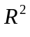and respectively) as well as coefficients of determination for GLS models () incorporating a single autoregressive term.
 |  | OLS |  |  |  | GLS (AR1)
Explanatory Groups (q) | Covariable Groups
site (19) | year + fire/grazer | 0.48 | 0.48 |  | 0.27
year (10) | site + fire/grazer | 0.13 | 0.13 |  | 0.18
fire/grazer (3) | site + year | 0.04 | 0.04 |  | 0.02
site + year | fire/grazer | 0.01 | -0.02 |  | 0.25
site + fire/grazer | year | 0.05 | 0.05 |  | 0.04
year + fire/grazer | site | 0.08 | 0.07 |  | < 0.01
site + year + fire/grazer | NA | -0.01 | -0.02 |  | < 0.01
Total (32) |  | 0.77 | 0.74 |  |  | 0.77

Table 2. The conditional explanatory power of specific variables on species richness estimated with the GLS autoregressive models. The classes site, year, and fire and grazer consist of q explanatory variables. Each model incorporated only a single autoregressive term. Provided are the standardized regression coefficient (β) indicating strength and direction of the response of richness, an estimate of variation explained (), and the results of conditional F-tests (approximate tests).
Explanatory Variables | Covariables | β |  | F-ratio | p-value
Groups (q)
site (19) | year + fire/grazer | NA | 0.27 | 11.53 | < 0.001
year (10) | site + fire/grazer | NA | 0.18 | 13.17 | < 0.001
fire/grazer (3) | site + year | NA | 0.02 | 6.40 | < 0.001
Site Specific Variables
log Ca | slope + northness + year + fire/grazer | -0.42 | 0.04 | 25.39 | < 0.001
slope | log Ca+ northness + year + fire/grazer | -0.12 | < 0.01 | 1.88 | 0.172
northness | log Ca + slope + year + fire/grazer | 0.17 | 0.01 | 4.02 | 0.047
Year Specific Variables
summer rain | winter rain + spring rain + site + fire/grazer | -0.19 | 0.03 | 26.65 | < 0.001
winter rain | summer rain + spring rain + site + fire/ grazer | 0.15 | 0.02 | 15.47 | < 0.001
spring rain | summer rain + winter rain + site + fire/ grazer | 0.14 | 0.01 | 11.43 | 0.001
Fire/Grazer variables
years of bison | years since burn + # of burns in 5 years + site + year | 0.46 | 0.01 | 12.00 | < 0.001
years since burn | years of bison + # of burns in 5 years + site + year | -0.14 | < 0.01 | 5.67 | 0.018
# of burns in 5 years | years of bison + years since burn + site + year | -0.15 | < 0.01 | 2.82 | 0.095
Table 3. The results of Monte Carlo randomization tests using the results of pCCA under the reduced model. Each randomization test was conducted with 999 iterations. The groups site, year, and fire and grazer consist of q explanatory variables. Cells marked as “--” indicate that their values are identical to cells above.
Explanatory Variable | Covariables | Randomization Type* | 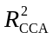 | 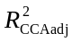 | F-ratio | p-value
Groups (q)
site (19) | year + fire/grazer | random shuffle | 0.50 | 0.46 | 13.471 | 0.001
year (10) | site + fire/grazer | toroidal shift | 0.04 | < 0.01 | 2.248 | 0.001
fire/grazer (3) | site + year | random shuffle | 0.01 | < 0.01 | 2.145 | 0.001
-- | -- | toroidal shift | -- | -- | -- | 0.001
Site Specific Variables
log Ca | slope + northness + year + fire/grazer | random shuffle | 0.13 | 0.12 | 19.735 | 0.001
slope | log Ca+ northness + year + fire/grazer | random shuffle | 0.03 | 0.03 | 8.152 | 0.001
northness | log Ca + slope + year + fire/grazer | random shuffle | 0.02 | 0.01 | 5.219 | 0.001
Fire/Grazer Variables
years of bison | years since burn + # of burns in 5 years + site + year | random shuffle | < 0.01 | < 0.01 | 2.314 | 0.001
-- | -- | toroidal shift | -- | -- | -- | 0.001
years since burn | years of bison + # of burns in 5 years + site + year | random shuffle | < 0.01 | < 0.01 | 2.102 | 0.001
-- | -- | toroidal shift | -- | -- | -- | 0.001
# of burns in 5 years | years of bison + years since burn + site + year | random shuffle | < 0.01 | < 0.01 | 1.616 | 0.001
-- | -- | toroidal shift | -- | -- | -- | 0.021
* random shuffle permutations were constrained to occur within a year, toroidal shifts were constrained within a given a site and preserved the temporal order of samples (see Methods for more explanation)

Figures
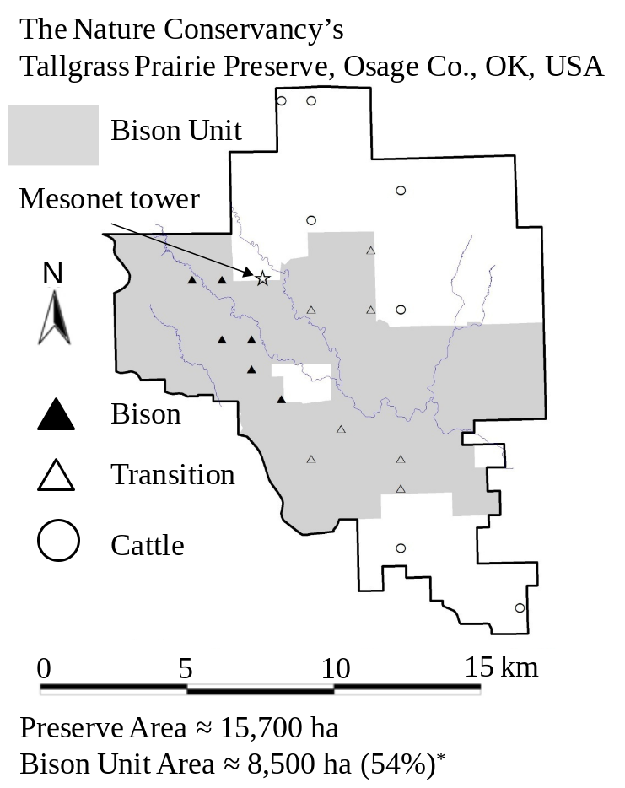
Fig. 1. A map of the Tallgrass Prairie Preserve. The shaded area denotes the bison unit which increased in area during the study period. The Mesonet tower where the climate data was recorded is marked on the map as a star ( ). The twenty plots sampled each year of this study are displayed on the map. The sites that were bison at the beginning of the study (1998) are displayed with filled triangles (▲), those that transitioned during the study from cattle to bison are denoted by unfilled triangles (Δ), and the other cattle grazed samples are denoted by unfilled circles (○). *Area of bison unit is as of 1 May 2008.
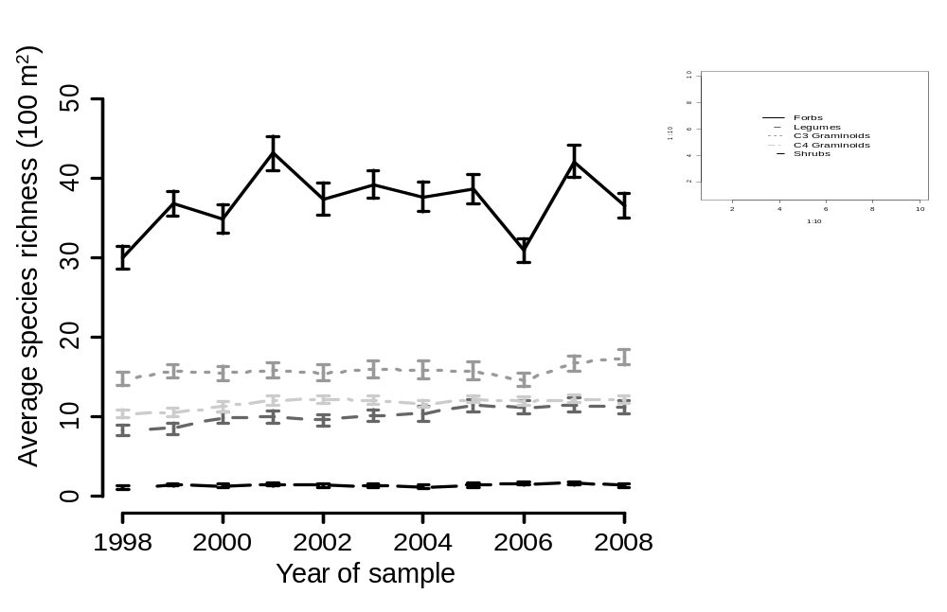
Fig. 2. The average species richness of five functional groups: forbs (that are not legumes), legumes, C3 graminoids (grasses, sedges, and rushes), C4 graminoids (grasses), and shrubs (woody plants) over the course of the study. The error bars display ± 1 standard error.
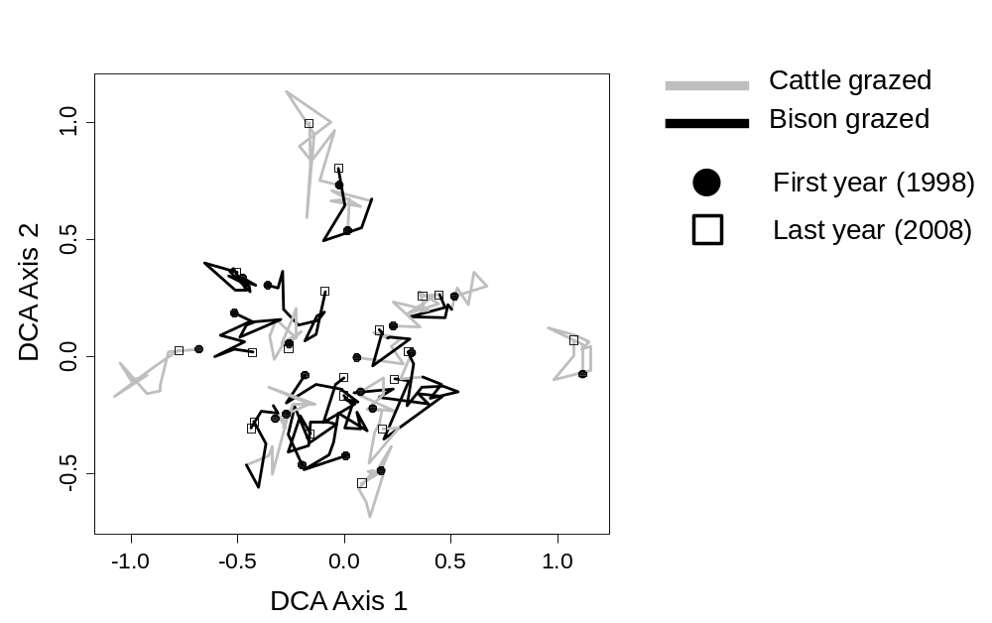
Fig. 3. DCA scatterplot displaying the 20 sites from 1998 to 2008. The eigenvalues were 0.152 and 0.108 for the first and second axis respectively. The time series is indicated by a line segment (—) with joints at each year, a black line joins years in which the plot experienced bison grazing and a grey line demarcates years in which the plot experienced cattle grazing. The 1998 samples are indicated by circles (●) and the 2008 samples are indicated by squares (□).
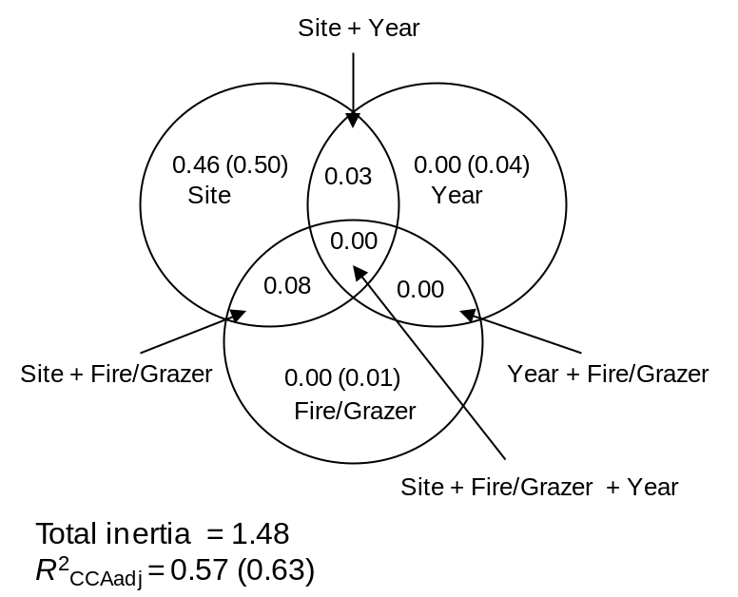
Fig. 4. A Venn diagram displaying the 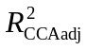 (followed by 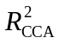in parentheses) of each fraction resulting from the variation partitioning of species composition using pCCA. The three groups (classes of explanatory variables) were sites, years, and fire and grazing. Note that in this context should not be interpreted as the fraction of explained variance but rather as the fraction of explained inertia. For the shared fractions we only report the unbiased values.
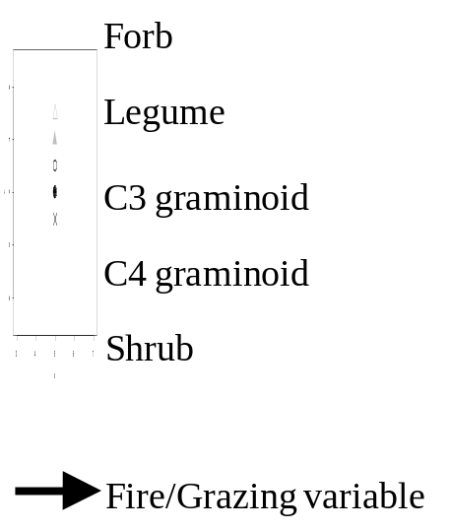
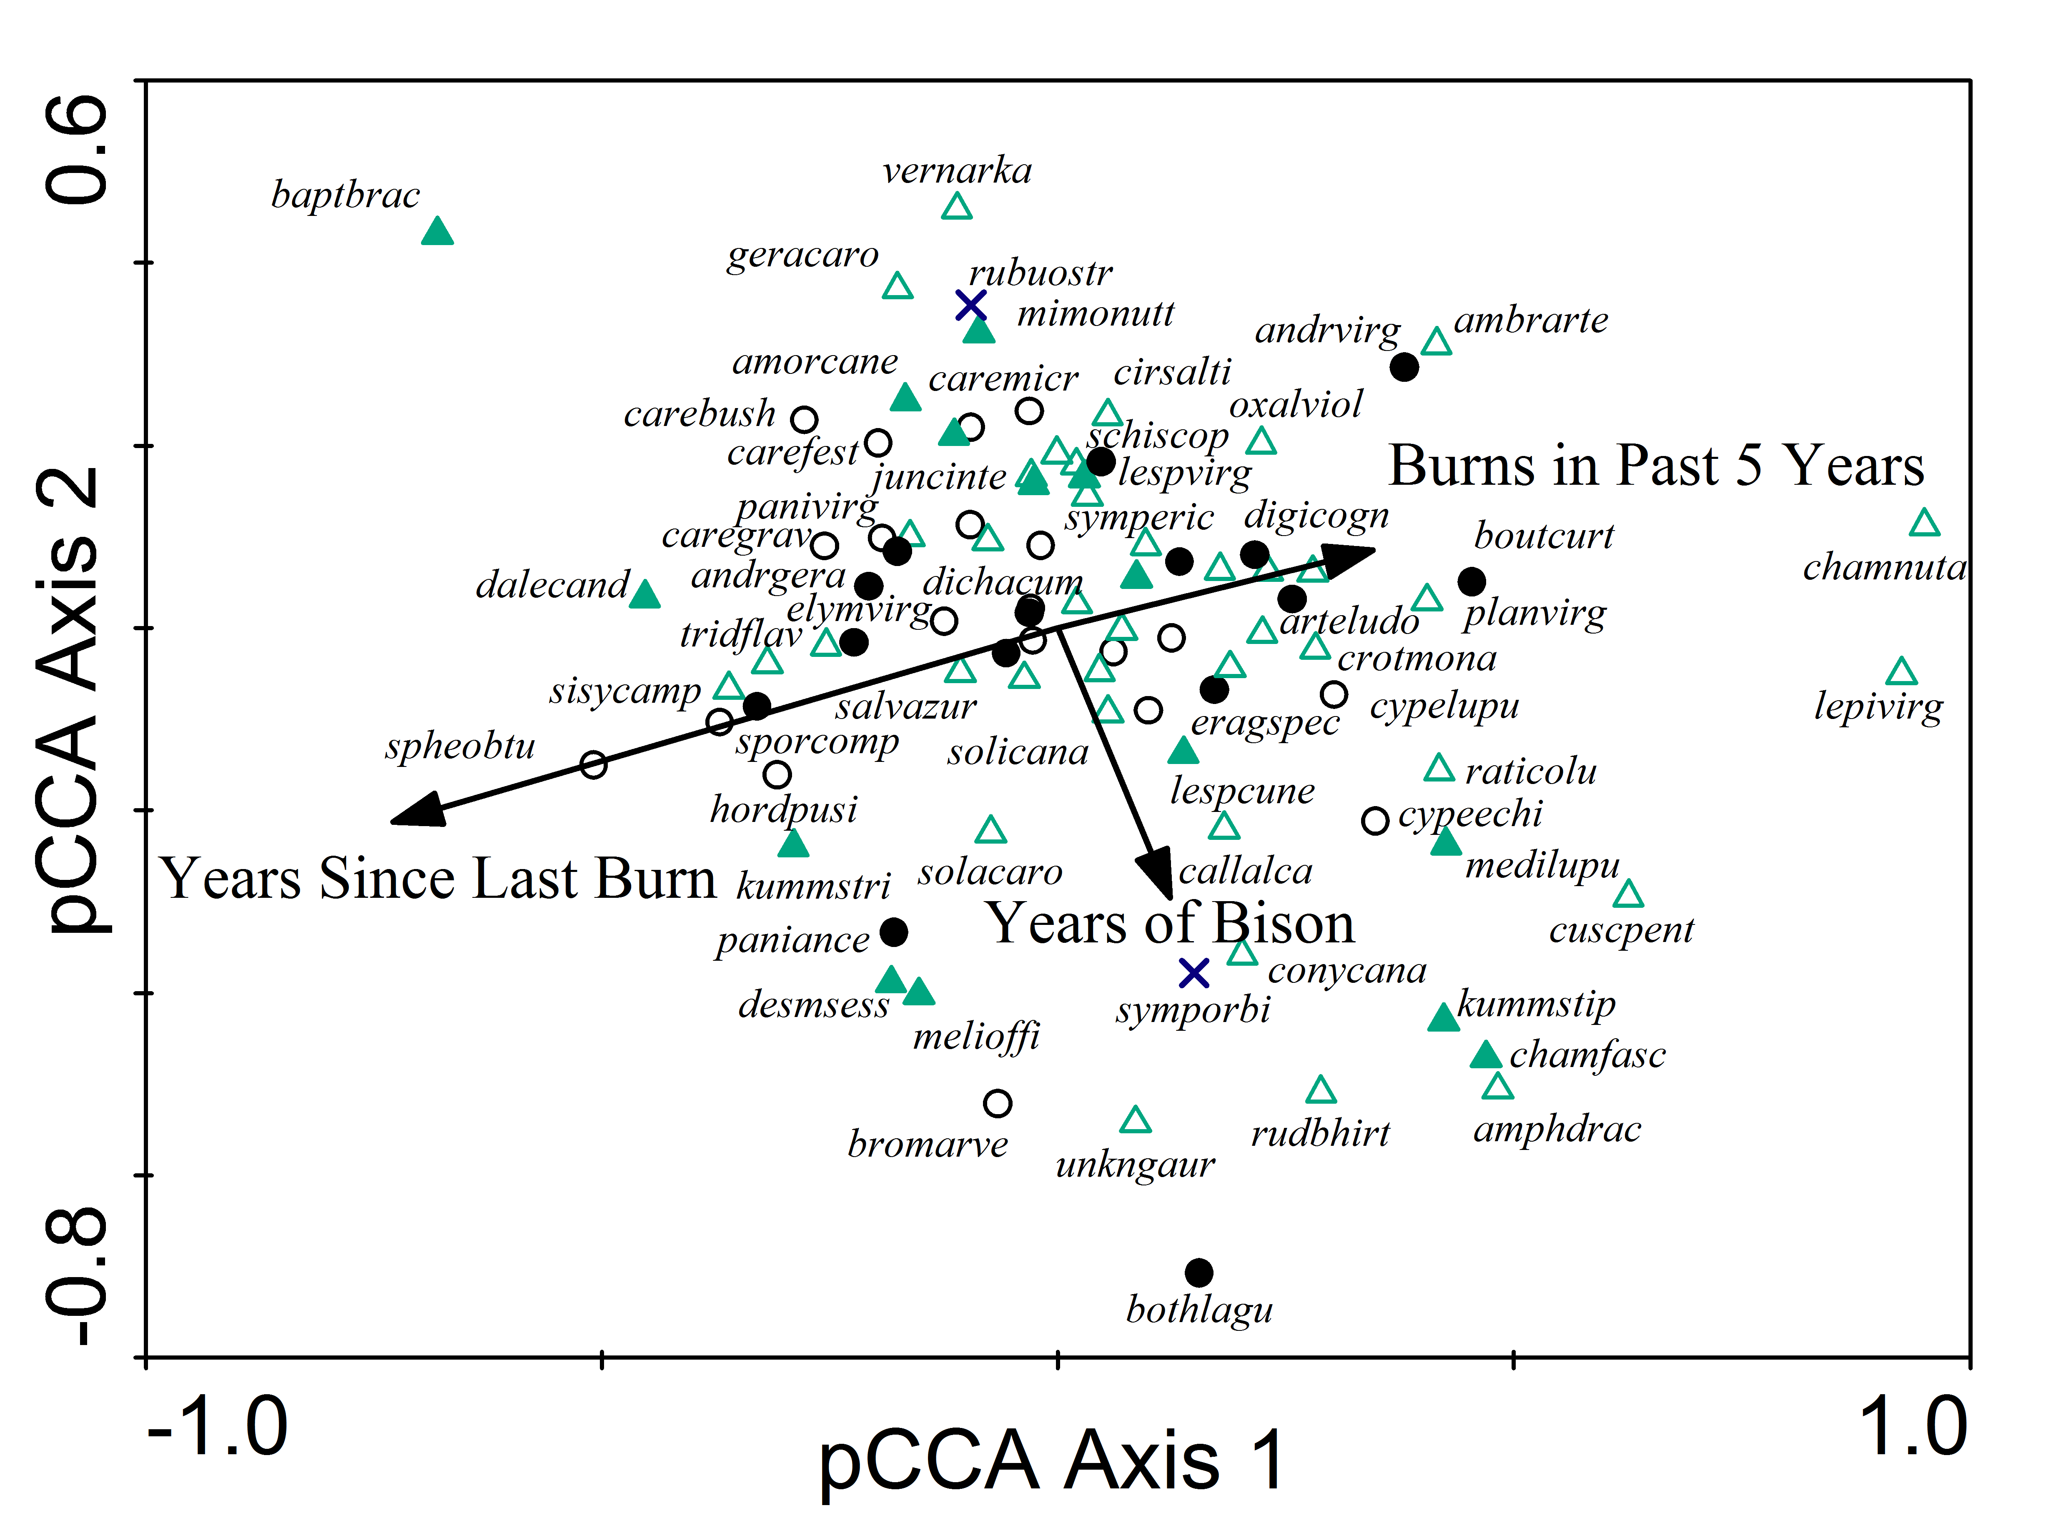
Fig. 5. A pCCA biplot displaying the influence of the fire and grazer variables with the sites and years as covariables. The fire and grazer variables in the model are indicated by black arrows. Only the 90 most abundant species of the 307 total are displayed for clarity. Abbreviations represent the first four letters of the genus and the first four of the letters of the species (see Appendix C). The symbol of each species depends on which functional type it belongs to (see legend).

