Appendix A. The frequency distribution and collinearity of the management variables. 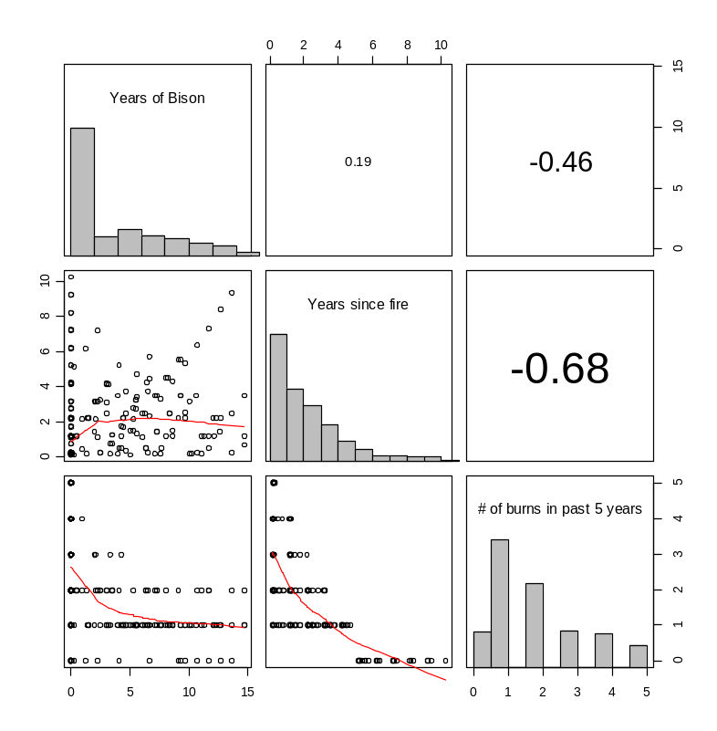
Fig. A.1. Each management variable displaying a histogram of the number of observations of a given value over the entire course of the study. The magnitude and direction of the correlation of two variables is indicated by the cells in the upper triangle. The lower triangle indicates the scatterplot of the two variables. A lowess smoothing function (red line) was applied to the scatterplots to aid visual interpretation.
Appendix B. The relationship between richness and the diversity indices examined in Wilsey et al. (2005).

In our study we only examined the patterns related to richness and ignored other diversity indices due to their strong correlations (positive and negative) with richness. 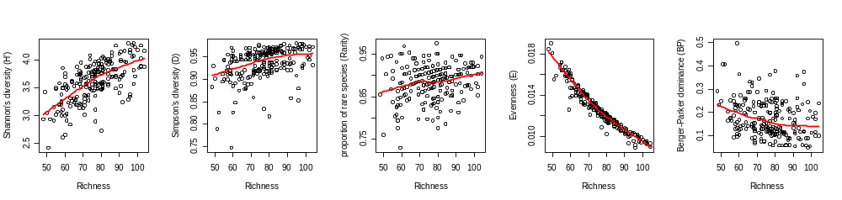
Fig. B1. The bivariate relationship between richness and each diversity index (see Wilsey et al. (2005) for definitions of the diversity indices). A lowess smoothing function (red line) was applied to the scatterplots to aid visual interpretation. Abundance of each species was assessed by the visual cover class at the 100 m² grain.

Literature Cited
Wilsey, B. J., D. R. Chalcraft, C. M. Bowles, and M. R. Willig. 2005. Relationships among indices suggest that richness is an incomplete surrogate for grassland biodiversity. Ecology 86:1178-1184.
Appendix C. The abbreviations for the species name in Fig. 5 the pCCA biplot of management effects. Only the 90 most abundant species were displayed symbolically and of those only 59 names were displayed to decrease visual clutter

Table C.1. nomenclature follows the PLANTS database (USDA and NRCS 2008)
Abbreviated name | Binomial | Functional Group
ambrarte | Ambrosia artemisiifolia | Forb
amphdrac | Amphiachyris dracunculoides | Forb
arteludo | Artemisia ludoviciana | Forb
callalca | Callirhoe alcaeoides | Forb
chamnuta | Chamaesyce nutans | Forb
cirsalti | Cirsium altissimum | Forb
conycana | Conyza canadensis | Forb
crotmona | Croton monanthogynus | Forb
cuscpent | Cuscuta pentagona | Forb
gaurunko | Gaura sp. | Forb
geracaro | Geranium carolinianum | Forb
lepivirg | Lepidium virginicum | Forb
oxalviol | Oxalis violacea | Forb
planvirg | Plantago virginica | Forb
raticolu | Ratibida columnifera | Forb
rudbhirt | Rudbeckia hirta | Forb
salvazur | Salvia azurea var. grandiflora | Forb
sisycamp | Sisyrinchium campestre | Forb
solacaro | Solanum carolinense | Forb
solicana | Solidago canadensis | Forb
symperic | Symphyotrichum ericoides | Forb
vernarka | Vernonia arkansana | Forb
amorcane | Amorpha canescens | Legume
baptbrac | Baptisia bracteata | Legume
chamfasc | Chamaecrista fasciculata | Legume
dalecand | Dalea candida | Legume
desmsess | Desmodium sessilifolium | Legume
kummstip | Kummerowia stipulacea | Legume
kummstri | Kummerowia striata | Legume
lespcune | Lespedeza cuneata | Legume
lespvirg | Lespedeza virginica | Legume
medilupu | Medicago lupulina | Legume
melioffi | Melilotus officinalis | Legume
mimonutt | Mimosa nuttallii | Legume
bromarve | Bromus arvensis | C3 grass
carebush | Carex bushii | C3 grass
carefest | Carex festucacea | C3 grass
caregrav | Carex gravida | C3 grass
caremicr | Carex microdonta | C3 grass
cypeechi | Cyperus echinatus | C3 grass
cypelupu | Cyperus lupulinus | C3 grass
dichacum | Dichanthelium acuminatum | C3 grass
elymvirg | Elymus virginicus | C3 grass
hordpusi | Hordeum pusillum | C3 grass
juncinte | Juncus interior | C3 grass
spheobtu | Sphenopholis obtusata | C3 grass
andrgera | Andropogon gerardii | C4 grass
andrvirg | Andropogon virginicus | C4 grass
bothlagu | Bothriochloa laguroides ssp. torreyana | C4 grass
boutcurt | Bouteloua curtipendula | C4 grass
digicogn | Digitaria cognata | C4 grass
eragspec | Eragrostis spectabilis | C4 grass
paniance | Panicum anceps | C4 grass
panivirg | Panicum virgatum | C4 grass
schiscop | Schizachyrium scoparium | C4 grass
sporcomp | Sporobolus compositus | C4 grass
tridflav | Tridens flavus | Shrub
rubuostr | Rubus ostryifolius | Shrub
symporbi | Symphoricarpos orbiculatus | Shrub

Literature Cited
USDA and NRCS. 2008. The PLANTS Database. National Plant Data Center, Baton Rouge, LA 70874-4490 USA.
Wilsey, B. J., D. R. Chalcraft, C. M. Bowles, and M. R. Willig. 2005. Relationships among indices suggest that richness is an incomplete surrogate for grassland biodiversity. Ecology 86:1178-1184.

