ECE 510 EmbV II – Lab 3

[Daniel](javascript://) Christiansen

Rakhee Bhojakar

**Simulation of a Hardware Implementation of the Back-Propagation Algorithm**

**1.Program**

**2.Numerical analysis**

**3.Fixed point back propagation results**

Weights learned by both implementations

Epochs = 2000, Learning rate = 0.1

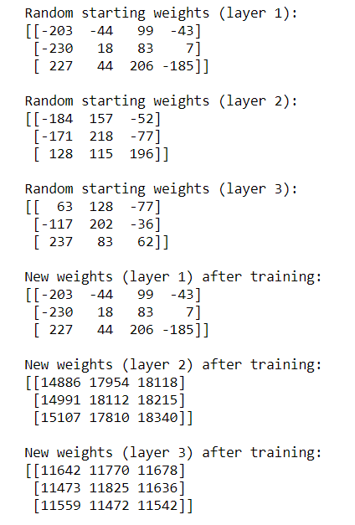 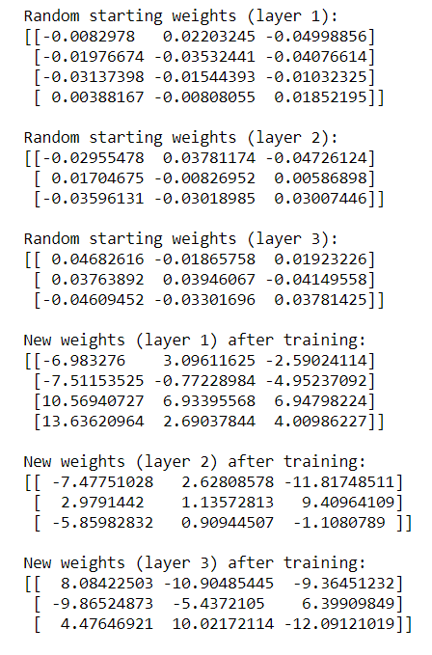

**4: Accuracy comparison**

**Fixed Point Implementation**  **Floating Point Implementation**

For epochs = 500

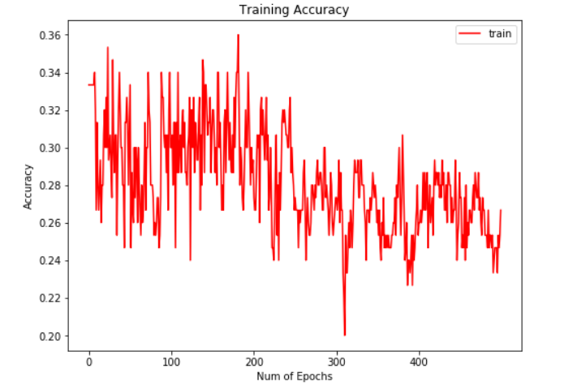 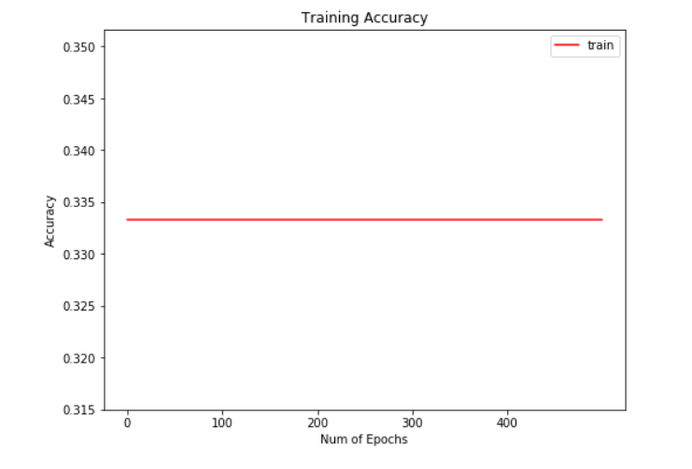

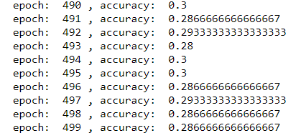 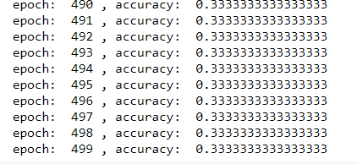

For epochs = 1000

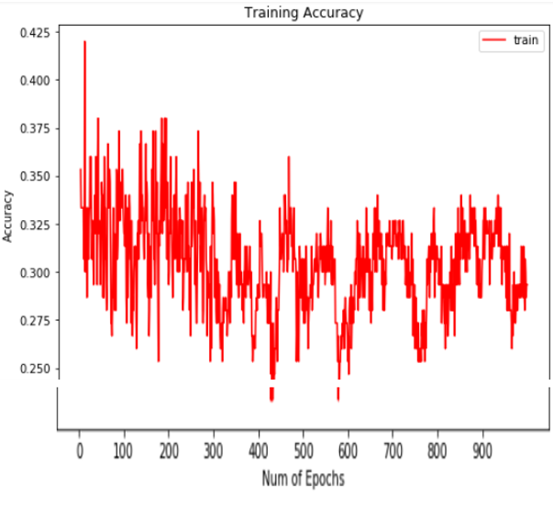 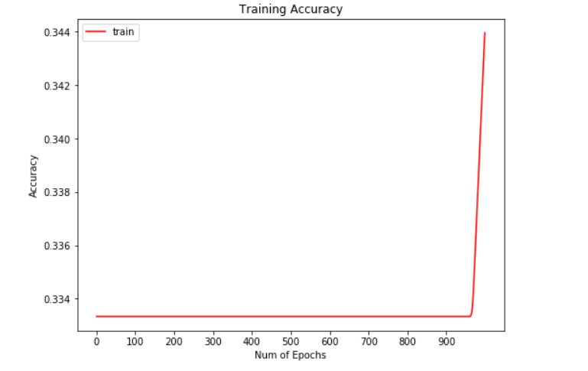

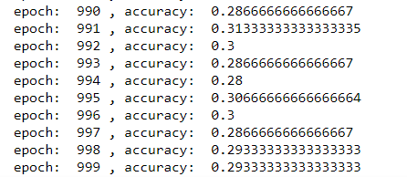 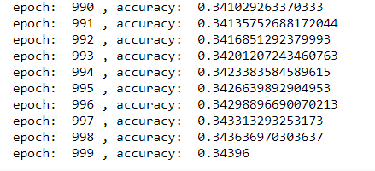

For epochs = 2000

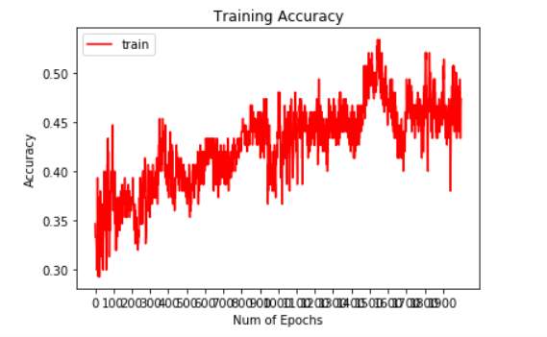 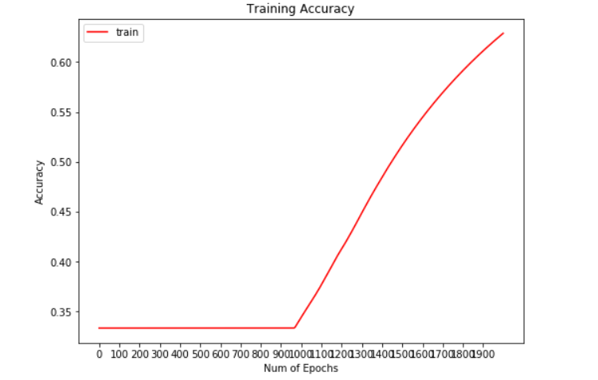

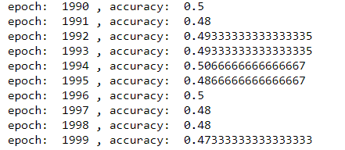 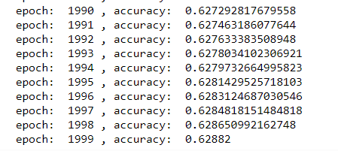

For epochs = 4000

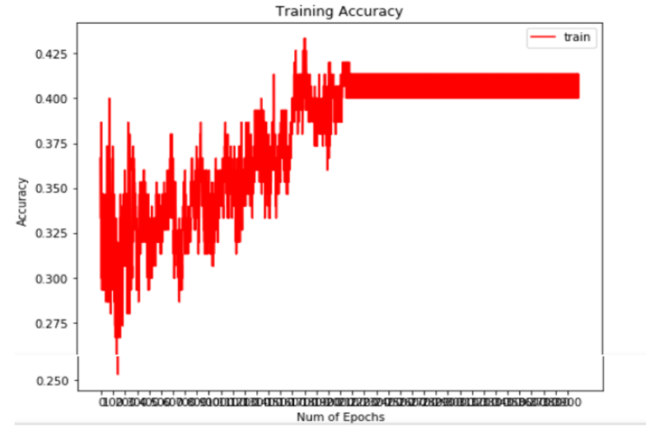 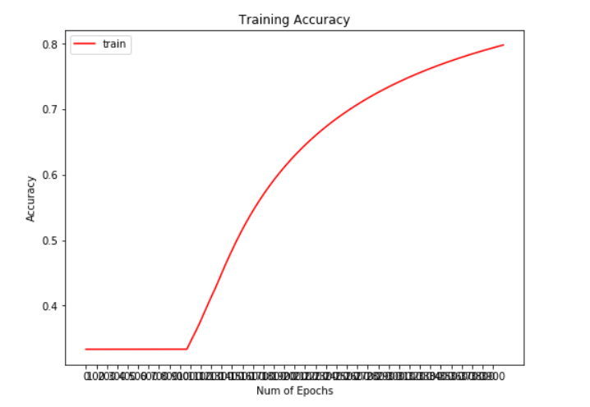

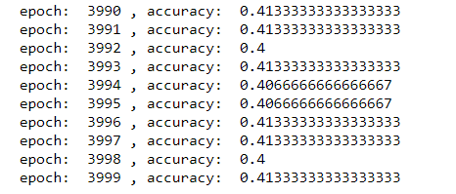 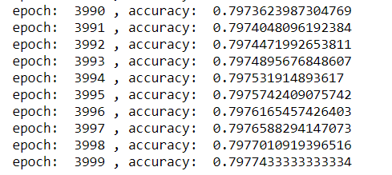

**5: Conclusions**

* Using floating point arithmetic is an easy way to preserve accuracy and GPUs are designed to accelerate these calculations
* Fixed point computation of weights is slower on CPU compared to floating point computation of weights as CPU has dedicated FPU’s
* Performance/accuracy is significantly worse with fixed point
* Fixed point requires additional instructions compared to floating point for operations such as multiplication