Team Name: KMP Web Services

Team Members: Sarah Kovar, Diandra McKenzie, Kimberly Pierce

Team Captain: Kimberly Pierce

GitHub Repository: <https://github.com/kimmypie21/KMPWebServices>

Application Specifications:

* Single Page Application utilizing knockout.js
* Custom CSS, HTML, no third-party templates
* Quiz style interface: user should be able to navigate forward and backwards within the quiz questions.
* 10 total questions referencing JavaScript material from previous course work in WEB 231
* Application will provide user score, rank, review of questions and answers, and specify each answer as correct or incorrect.
* User ranking will follow provided ranking criteria based on quiz score

Sarah Kovar

Sarah Kovar has fourteen years’ experience in the infrastructure and support side of technology. She is a student at Bellevue University working towards a degree in Web Development. She has two Associate’s degrees from Metropolitan Community College in Omaha, NE; one in Multimedia Design and one in Programming for Database and Web with an emphasis in Java and C#. She started her career in print media at a local magazine in Lincoln, NE; however, quickly diverged to Information Technology due to the more diverse opportunities that could be obtained via on-the-job training or certifications. She and her husband have a 1.5-year-old daughter that keeps them busy. When they aren’t chasing after their toddler, their two large dogs and three cats keep them busy dehairing everything they come in contact with. They recently purchased a bike trailer they hope their daughter will enjoy but can also use it to transport their zoo around. Pre-parenthood she enjoyed playing guitar, traveling, and metal engraving.

Diandra McKenzie

Diandra McKenzie is from Long Island, NY where she works as a Production Manager/Walmart Administrator in the Makeup Division at FunWorld/ Easter Unlimited. She has learned a lot in her 12 years’ experience managing product supply chains but now she is ready to take the leap and pursue a new career in the tech field. She has always had a love for art and playing around on computers, so she decided to go back to school to pursue a bachelor’s degree that combines her two passions. She has entry-level experience in Full-Stack Web Development, with a concentration in the MEAN Stack. After she completes the matriculation requirements for her online degree at Bellevue University, she plans on making a career move into the Web Development field. One of her personal mantras is, “Never stop learning, because life never stops teaching.” In her spare time, Diandra enjoys spending time with her husband and kids, cooking delicious and nutritious meals and seeing art that inspires her.

Kimberly Pierce

Kim is a native of Knoxville, TN where she lives with her husband Dan and their three dogs and two cats. She is passionate about web design and volunteering with animal welfare organizations. She works for Pellissippi State Community College, the largest community college in Tennessee, in the Enrollment Services Department assisting students with the admissions process. Kim earned her Associate of Applied Science with a Media Technology: Web Design concentration from Pellissippi State in fall of 2018. She chose Bellevue University to pursue her Bachelor of Science Degree in Web Development and began the accelerated cohort program in fall of 2019. Kim also interns with the Pellissippi Academic Center for Excellence (PACE), creating and managing content for the department website and social media channels. After graduation from Bellevue University, Kim plans to remain with Pellissippi State and pursue a position with the college’s web team.

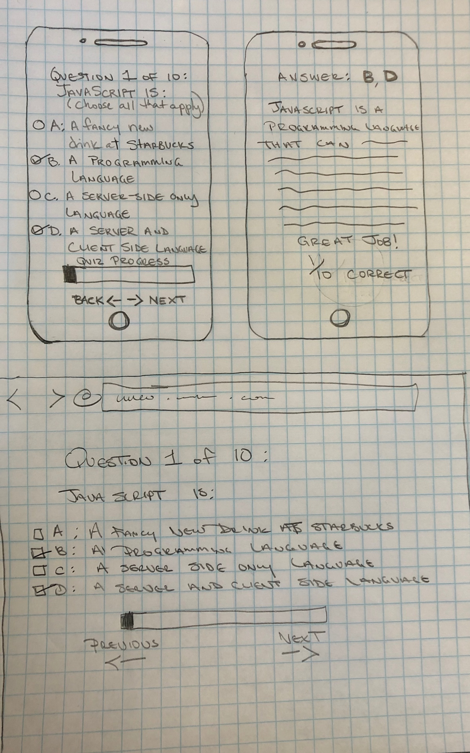

Kimberly Pierce Wireframe Sketch

Sarah Kovar Wireframe Sketch

Sarah Kovar Wireframe Sketch

Diandra McKenzie Wireframe Sketch