|  |  |
| --- | --- |
| MegaShield V1.2 |  |

# Overview

MegaShield

This device is for extending the connections of the Arduino Mega namely for the Bos-Cart project at UWT for the Children’s Therapy Unit in Puyallaup, WA. The features of this board include:

1. 4 connections for a SPDT momentary switch, as well as a transistor slot for relay startup and shutdown.
2. A slot for a 9v voltage regulator
3. Slot for a md31b Pololu motor driver. This also supplies power to the 9v regulator
4. An 8-wire cat-5 conn header that currently connects
   * Tx, Rx, 9v, Gnd, and Header connection
5. A voltage divider for measuring higher voltages
6. 16 connection points on the bottom row for digital devices, with a voltage choice of 5 or 3.3 volts
7. 2 connections powered strait from the Pololu for high voltage needs.

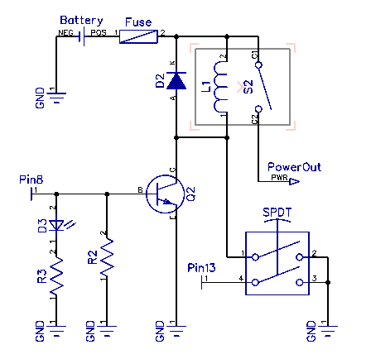**Specifics:**

1. Power Control.

Power Control

This shield was originally designed for the Bos cart system with the specifications needed as such. However much of this design can be reused for other projects as well. The requirements were for a switch that could both power on the cart, as well as shut it off. In addition, a timed shutdown was wanted to conserve power. We chose to accomplish this with a SPDT switch, and a transistor. As seen in the *Power Control* figure.

When the SPDT momentary switch is held, the power the through the switch Pin 8 supplies the necessary voltage to hold open the transistor, this allows the relay to open, power circulates through the motor controllers then powers the Arduino Mega. In the setup of the Mega code, Pin 8 is set high, opening the transistor, and turning on the LED and allowing the Relay inductor a path to ground without the switch. At this point the user can see the LED is on and release the switch.

1. 9 Volt regulator.

This is a simple 3 pin slot for a 9 volt regulator. It feeds off the Pololu board then powers the Arduino. If when starting up the relay activates, but the Arduino fails to power, i.e. the led never turns on and the relay clicks off when button is not held, then it is possible that the regulator is no longer functioning.

1. The Pololu Slot is specific for the md31b motor controller, but should fit any of that model. It is connected to pins 9 and 10, and provides the power for the Arduino. If a different motor controller is desired, these pins can still be used as such, just not directly as a drop-in module.
2. The Conn connection is fairly specific for this setup. It is connected to Rv, Tx, Gnd, the 9v regulator, and a drain connection for a second momentary SPDT switch. The other three connections remain open and unused for this generation, but will likely include analog and digital connections in future models to make use of the lines in a positive way.
3. 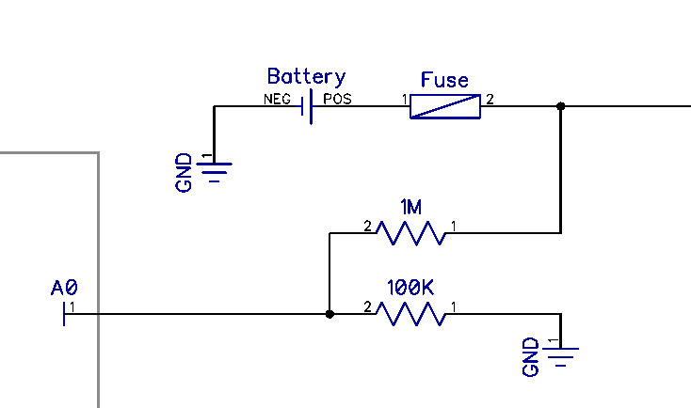The Voltage divider is connected to Analog 0 and has a recommended 1M and 100K ohm resistor slots, but this can be modified as the user needs for different power sources.

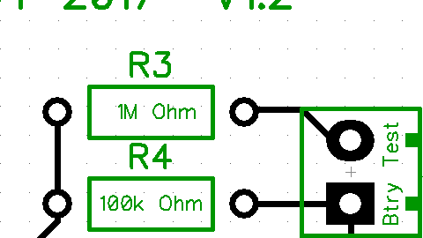

Figure . Voltage Measure

Figure 2. Voltage Measure

Since the Arduino Analog pin can only measure up to 5v, more will damage the pin, the voltage divider provides a linear range that can be safely measured. Using Figure 1, if Voltage In (Vin) is applied to the pin next to test, and the common ground below, the measured Voltage Out (Vout) on the left side of the figure should equal:

$V_{out}= V_{in}\frac{R_{4}}{R_{3}+R_{4}}$ so for measuring up to 50v, $V_{out}= 50v\frac{100k}{1M+100k}=4.55v$

This is set for a measuring a large power source and has a great deal of impedance. This will result in slower readings, but honestly should not make a difference if being used for a measuring a large battery. If speed is needed, smaller resistors of the appropriate ratio can be used. Important to note that this has an inherit error of up to 10%. If **INTERNAL2V56** is used, this can be reduced to 5%. If further accuracy is needed, an external reference voltage is needed. See <http://www.skillbank.co.uk/arduino/measure.htm>

1. The 16 pin at the bottom of the shield are specifically set up for ultra sonic sensors, but can be used as needed. The 8 pins on the left include 4 digital connections [53, 52, 39, 38] 2 Gnd, and 2 voltage connections. These voltage connections can be set to either 5 volts or 3.3 by connecting the center pin of Switch1 to either the left or right pins via a switch or just a header. The right 8 pins follow in the exact same way with Switch2.

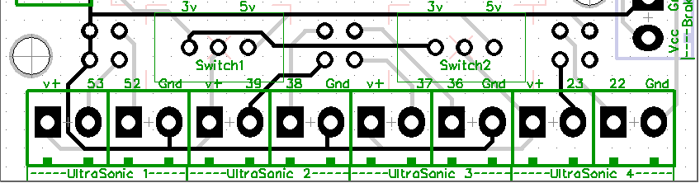

|  |  |
| --- | --- |
| COMPANY INFORMATION | |
| Company name: | University of Washington, Tacoma Campus |
| Date Completed: | March 2017 |