Curriculum Vitae
PERSONAL INFORMATION Betty Smith
32 Reading rd,Birmingham B26 3QJ United Kingdom
+44


2012345679 +44 7123456789
smith@kotmail.com
AOL Instant Messenger (AIM) betty.smith
Sex Female | Date of birth 01 March 1975
JOB APPLIED FOR European project manager
WORK


EXPERIENCE
August 2002 – Present Independent consultant
British Council
123, Bd Ney, 75023 Paris (France)
Evaluation of European Commission youth training support measures for youth national
agencies and young people
March 2002 – July 2002 Internship
European Commission, Youth Unit, DG Education and Culture
200, Rue de la Loi, 1049 Brussels (Belgium)
- evaluating youth training programmes for SALTO UK and the partnership between the
Council of Europe and European Commission
- organizing and running a 2 day workshop on non-formal education for Action 5 large scale projects
focusing on quality, assessment and recognition
- contributing to the steering sroup on training and developing action plans on training for
the next 3 years. Working on the Users Guide for training and the support measures
Business or sector European institution
October 2001 – February 2002 Researcher / Independent Consultant
Council of Europe, Budapest (Hungary)
Working in a research team carrying out in-depth qualitative evaluation of the 2 year Advanced
Training of Trainers in Europe using participant observations, in-depth interviews and focus groups.
Work carried out in training courses in Strasbourg, Slovenia and Budapest.
EDUCATION AND

TRAINING
1997 – 2001 PhD - Thesis Title: 'Young People in the Construction of the Virtual
University’, Empirical research on e-learning
Brunel University, London United Kingdom
1993 – 1997 Bachelor of Science in Sociology and Psychology
Brunel University, London United Kingdom
- sociology of risk
- sociology of scientific knowledge / information society
- anthropology
E-learning and Psychology
- research methods
© European Union, 2002-2013 | http://europass.cedefop.europa.eu Page 1 /






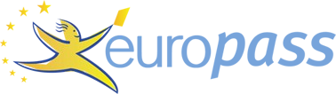

2

Curriculum Vitae Betty Smith
PERSONAL

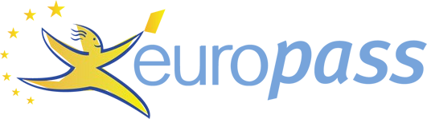

SKILLS
Mother tongue(s) English
Other language(s)
UNDERSTANDING SPEAKING WRITING
Listening Reading Spoken interaction Spoken production
French C1 C2 B2 C1 C2
German
A2 A2 A2 A2 A2
Levels: A1/A2: Basic user - B1/B2: Independent user - C1/C2: Proficient user
Common European Framework of Reference for
Languages
Communication skills
- team work: I have worked in various types of teams from research teams to national league hockey.
For 2 years I coached my university hockey team
- mediating skills: I work on the borders between young people, youth trainers, youth policy and
researchers, for example running a 3 day workshop at CoE Symposium ‘Youth Actor of Social
Change’, and my continued work on youth training programmes
- intercultural skills: I am experienced at working in a European dimension such as being a rapporteur
at the CoE Budapest ‘youth against violence seminar’ and working with refugees.
Organisational / managerial skills
- whilst working for a Brussels based refugee NGO ‘Convivial’ I organized a ‘Civil Dialogue’
between refugees and civil servants at the European Commission 20th June 2002
- during my PhD I organised a seminar series on research methods
Computer skills - competent with most Microsoft Office programmes
- experience with HTML
Other skills Creating pieces of Art and visiting Modern Art galleries. Enjoy all sports particularly hockey, football
and running. Love to travel and experience different cultures.
Driving licence A, B
ADDITIONAL
INFORMATION
Publications
‘How to do Observations: Borrowing techniques from the Social Sciences to help Participants do
Observations in Simulation Exercises’ Coyote EU/CoE Partnership Publication, (2002).
© European Union, 2002-2013 | http://europass.cedefop.europa.eu Page 2 /
2

