
BRAND GUIDELINES
Your Future. One Smart Step Away.
Prepared for
MagicWorks IT Solutions Private Limited
distancembacollege.com
Version 2.0 — Final | June 2026

01 Introduction

How to use this document
This is the single source of truth for the Distance MBA College brand. It defines how the brand looks, sounds, and behaves across every touchpoint, with primary focus on the web platform and digital marketing channels that drive the business.
Anyone designing, developing, writing, or marketing for Distance MBA College should follow these rules. Consistency is not aesthetic preference, it is what turns recognition into trust, and trust into the leads that power the business.

What is new in version 2.0
- Refined logo system. The original house+arc icon has been kept and crisped, with the wordmark reset in Poppins and “MBA” elevated as the hero word. A complete suite of variants, including reverse, monochrome, monogram, and icon-only, is now provided.
- Brand elements. A repeating house pattern, a verified-trust seal, and a section divider are now defined as part of the visual system.
- Application examples. Three full application mockups, website hero, A4 one-pager, and counsellor-led email, demonstrate the brand in real use.
- Implementation roadmap. A phased rollout sequence so the brand can be adopted across web, marketing, and operations without disrupting current lead flow.

Brand at a glance
Brand | Distance MBA College
Parent Company | MagicWorks IT Solutions Private Limited
Incorporated | 29 September 2012
Founder & Director | Mr. Swapnil Avdhutrao Ughade
Category | Higher Education Discovery & Advisory Platform
Business Model | Lead generation for distance and online MBA programmes from accredited Indian universities
Current Scale | Approximately 100 qualified leads per day from the web platform

02 Brand Foundation

The story we tell
Most learners chasing a distance MBA in India are not students in a hostel. They are working professionals between twenty four and thirty eight, balancing jobs, families, EMIs, and a quiet hunger to grow. They face a wall of confusing options, agent-driven advice, and brochures that all sound identical. Decisions worth lakhs of rupees and years of effort get made on incomplete information.
Distance MBA College exists to fix that asymmetry. We bring every credible distance and online MBA programme into one place, lay it open for comparison, and pair the data with human counsellors who give honest guidance, not commission-driven nudges. We are the calm, structured guide between confusion and clarity.

Mission
To make every learner's decision about a distance or online MBA simple, transparent, and right for their life, by combining a comprehensive university directory with sincere, expert counselling.

Vision
To be India's most trusted starting point for working professionals choosing a flexible MBA, recognised for the quality of our guidance and the careers it helps build.

Brand values
- Clarity. We replace jargon with plain language and choices with comparisons.
- Honesty. We say what is right for the learner, not what is easiest to sell.
- Discipline. Education is a long game. Our counselling reflects that seriousness.
- Accessibility. Every working professional, regardless of city or background, deserves the same quality of guidance.
- Outcome focus. A course is a means. A career is the end. We orient every conversation around that.

Brand promise
“Talk to us once and you will know exactly which programme is right for you, and why.”

03 Personality and Positioning

Target audience
Segment | Description
The Stuck Professional (Primary) | Aged 26 to 38. Two to twelve years of work experience. Hit a ceiling, watching peers with MBAs promoted past them. Needs a credible MBA without quitting the job.
The Career Switcher | Aged 24 to 32. Wants to move from a technical role into management. Uses the MBA as a credential bridge.
The Returning Learner | Aged 30 to 45. Often women returning after a career break, or professionals from tier 2/3 cities.
The Aspirant Family | Parents and spouses researching on behalf of the learner. The silent decision influencer.

Brand archetype
Primary: The Sage with a touch of The Caregiver.
The Sage gives knowledge, perspective, and clarity. The Caregiver gives reassurance and human warmth. Sage alone reads as cold or academic. Caregiver alone reads as unserious. The blend, expert who actually cares, is the precise emotional gap our audience needs filled.

Positioning statement
For working professionals in India who feel stuck without a management degree, Distance MBA College is the honest advisory platform that brings every credible distance and online MBA into one comparable view, paired with counsellors who care about the right fit, not the easy sale.

04 Voice and Tone

Our voice in one line
A senior, well-read mentor explaining a serious decision over a cup of chai. Warm, but never wasteful with the listener's time.

Voice principles
- Plain over polished. If a sentence sounds like a brochure, rewrite it.
- Specifics over slogans. “UGC-DEB recognised programmes from 47 universities” beats “the best courses around.”
- Calm over urgent. We do not shout, blink, or threaten. Authoritative brands earn trust through composure, not pressure.
- Helpful over clever. Clarity wins.
- Honest about trade-offs. Every programme has a downside. We say it. That honesty is our moat.

Words we use, words we avoid
Say this | Not this
Programme, course | Cutting-edge curriculum
Working professionals | Aspirants, candidates
Free counselling, honest advice | Hassle-free, one-stop solution
UGC-DEB recognised, AICTE approved | Best, top-rated, premier (without proof)
Right fit for your career | Life-changing opportunity
Speak to a counsellor | Get a callback now, hurry

05 Logo System
The Distance MBA College logo evolves the original house+arc icon you have used since launch, with three deliberate refinements: cleaner geometric construction, exact brand-tuned colours, and Poppins typography. “MBA” is now the hero word in saffron, with “Distance” and “College” in navy framing it. This single change preserves the recognition equity of your existing identity while making the wordmark read as a serious advisory brand instead of a generic listing site.

Primary logo
The full lockup. This is the default mark. Use it wherever space allows.


Construction logic
- The icon. The house silhouette signals home, the natural setting of distance learning. Open at the base for accessibility. The saffron arc beneath reads as both foundation and forward path.
- The wordmark. Poppins Medium for “Distance” and “College”, Poppins Bold for “MBA.” Letter-spacing pulled in slightly for confidence.
- Colour split. Navy for the framing words and the house outline. Saffron for the arc and the hero word “MBA.” Two notes of warmth, three notes of authority. Restrained, deliberate, and instantly recognisable.

Variants
The system includes five primary variants for different contexts and surfaces.

Reverse — for use on Navy

When the surface is Navy or a dark photograph, the icon and framing words become white, the saffron accents remain. This is the second-most common context after the primary, and the only variant approved for dark surfaces.

Monochrome — single-colour reproduction

For embossing, single-colour printing, fax, photocopying, and any context where the saffron cannot be reproduced. All elements collapse to Navy.

Stacked — for narrow horizontal spaces
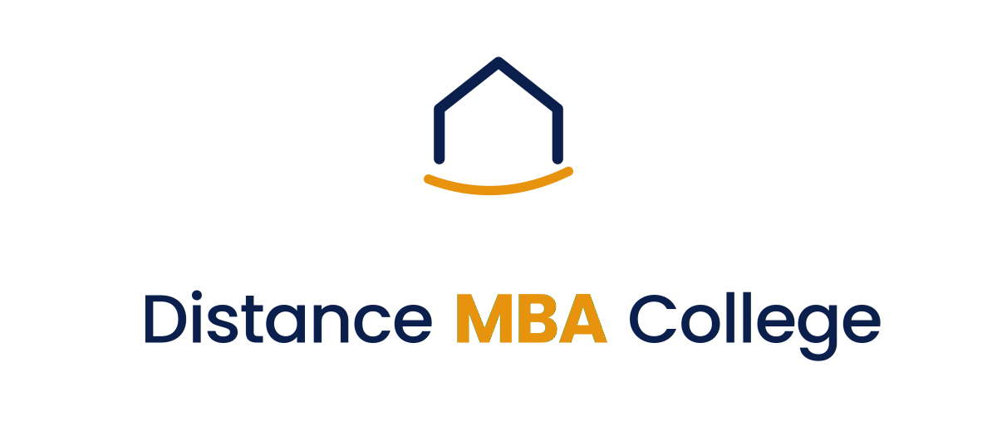
When width is constrained but height is available, such as banner ads, vertical print formats, or partnership lockups. Icon centred above the full wordmark.

Icon only — favicon, watermark, social
 | 
The icon alone has earned its recognition over the years. Use it as the watermark on photography, the favicon at small browser sizes, and on social media where the wordmark would be illegible.

Monogram DMC — for very small or square contexts
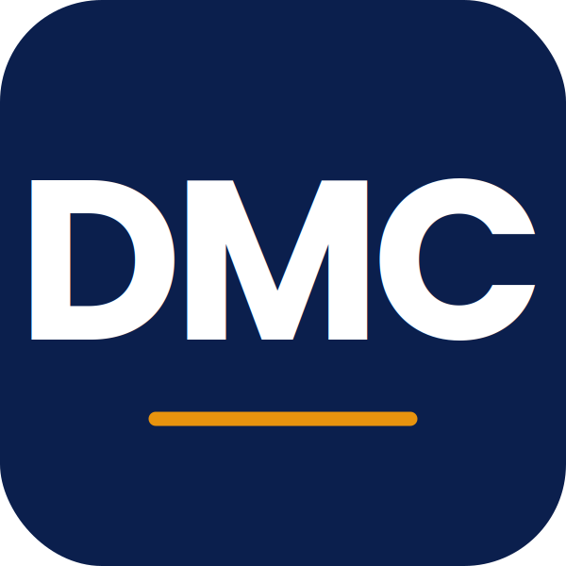 | 
The DMC monogram with a saffron underline is reserved for tight contexts: WhatsApp business profile, app icons under 60 px, profile avatars, and any context where the icon's house silhouette would lose detail.

06 Logo Usage Rules

Clear space
Always reserve clear space around the logo equal to the height of the capital “D” in “Distance.” No other element, image, or text may enter this zone. This is non-negotiable on the website header, favicon area, and any partner co-branding.
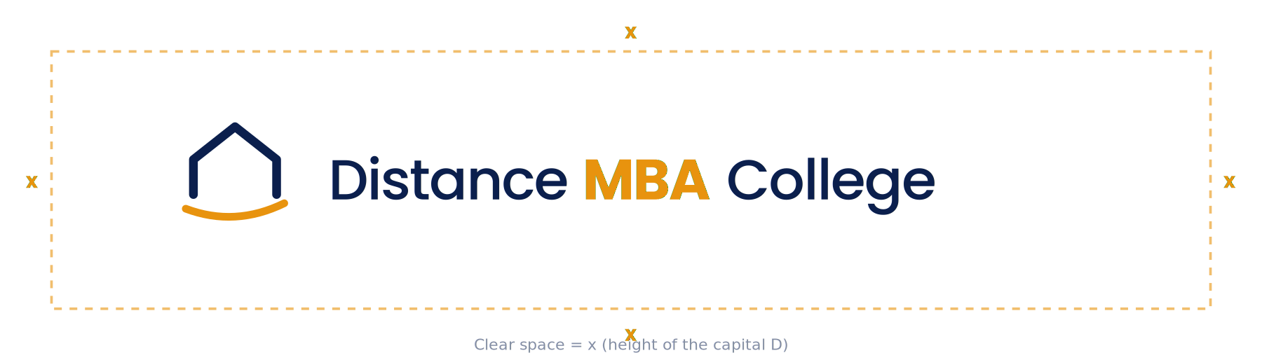

Minimum sizes
- Digital primary lockup: 180 px width minimum. Below this, switch to the icon or monogram.
- Print primary lockup: 32 mm width minimum at 300 dpi.
- Favicon and app icons: use the monogram (DMC), not the full logo.
- Watermark on photography: use the icon-only variant at 8-12% opacity.

Approved backgrounds
- Light surfaces. White, Cream, Mist, light photography. Use the primary lockup.
- Navy. Use the reverse variant.
- Saffron or cream-yellow backgrounds. Avoid. The MBA word loses contrast. Use monochrome navy instead.
- Busy photography. Place the logo inside a navy or cream rectangle so contrast is preserved.

Misuse — these are not approved
The four examples below demonstrate violations that compromise brand integrity. Any of these in production should be flagged and corrected.
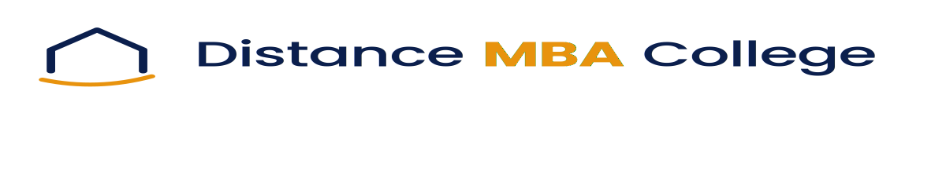  Don't stretch or squash |   Don't recolour
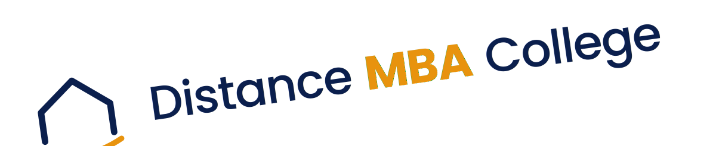  Don't rotate or tilt |   Don't add shadows or effects

07 Colour System
Every colour below is chosen on two grounds simultaneously. First, alignment with the brand's strategic positioning as a trusted advisor. Second, the demonstrable performance of these colours in education and trust-led categories.

Primary palette
Navy  HEX #0B1F4D  RGB 11, 31, 77  CMYK 86, 60, 0, 70 | Saffron  HEX #E8930E  RGB 232, 147, 14  CMYK 0, 37, 94, 9
The spine of the identity. Logo primary, headlines, navigation, trust surfaces. | The warmth. CTAs, accents, highlights, the MBA word, and the arc.

Supporting palette
Counsel Blue  #1E3A8A | Soft Gold  #FBBF24 | Cream  #FAF7F0
Italic emphasis, secondary headings, link hover states. | Light highlights, badges, accent backgrounds. | Page background tone. Softens whitespace without dulling it.

Functional palette
Ink  #1F2937 | Slate  #475569 | Mist  #F1F5F9 | Verify Green  #10B981
Primary body text | Secondary text, captions | Section backgrounds, cards | Verified, success states

Colour ratio (60-30-10)
- 60% — Whites, Cream, Mist. The breathing room. Education brands lose trust when crowded.
- 30% — Navy and Counsel Blue. Headlines, navigation, primary copy, trust elements.
- 10% — Saffron and Soft Gold. Reserved for CTAs, highlights, and what we want clicked.

08 Typography
Type is doing 80% of the design work on a content-heavy education website. The system below is built for web first, free for commercial use, and available on Google Fonts.

Type families
Role | Family | Why
Display & Headings | Poppins (500, 600, 700) | Geometric, modern, professional. Used in the logo wordmark. Trusted by Indian education brands.
Body | Inter (400, 500, 600) | Designed for screen legibility. Excellent at small body sizes.
Voice & emphasis | Lora (400 italic, 500 italic) | A measured serif for the human-voice moments in headlines, testimonials, and counsellor quotes. The italic Lora inside a Poppins headline is the typographic signature of the brand.

Typographic rules
- The italic signature. Lora italic appears inside Poppins headlines for the human-voice phrase, sparingly. Two to four words per headline, no more. This is the brand's typographic fingerprint.
- Body line length: 60 to 75 characters per line. Anything longer fatigues readers.
- Hierarchy gap: Each heading level at least 25% smaller than the one above.
- Numerals: Tabular figures for prices, fees, and dates so they align in columns. Inter supports this natively.

09 Brand Elements
Beyond the logo, three brand elements form the visual system. They appear in supporting roles, never overpowering the logo or copy, and they give the brand a consistent visual texture across surfaces.

The house pattern

A subtle repeating motif using the icon's house and arc, in Navy at 12% opacity over Cream. Use as a watermark background on certificate templates, partnership letters, and case-study PDFs. Never use on the website hero or any copy-dense surface, the pattern is for ceremonial or document contexts only.

The verified trust seal

A circular stamp containing the icon, used to mark verified partner programmes, accreditation callouts, and counsellor sign-offs. The seal can be customised with the verification text in the inner ring (“UGC-DEB Verified”, “Counsellor Approved”, “DMC Advisory”). Use sparingly, the seal loses meaning when overused.

The section divider

Two hairline rules flanking the icon, used to separate major sections in long-form documents and the printed one-pager. On the website, prefer simple horizontal hairlines without the icon to keep the rhythm calm.

10 Application — Website
The website is the primary lead engine, around 100 qualified enquiries per day. The application example below shows how the brand system manifests on the homepage hero, the most consequential surface in the business.

Homepage hero
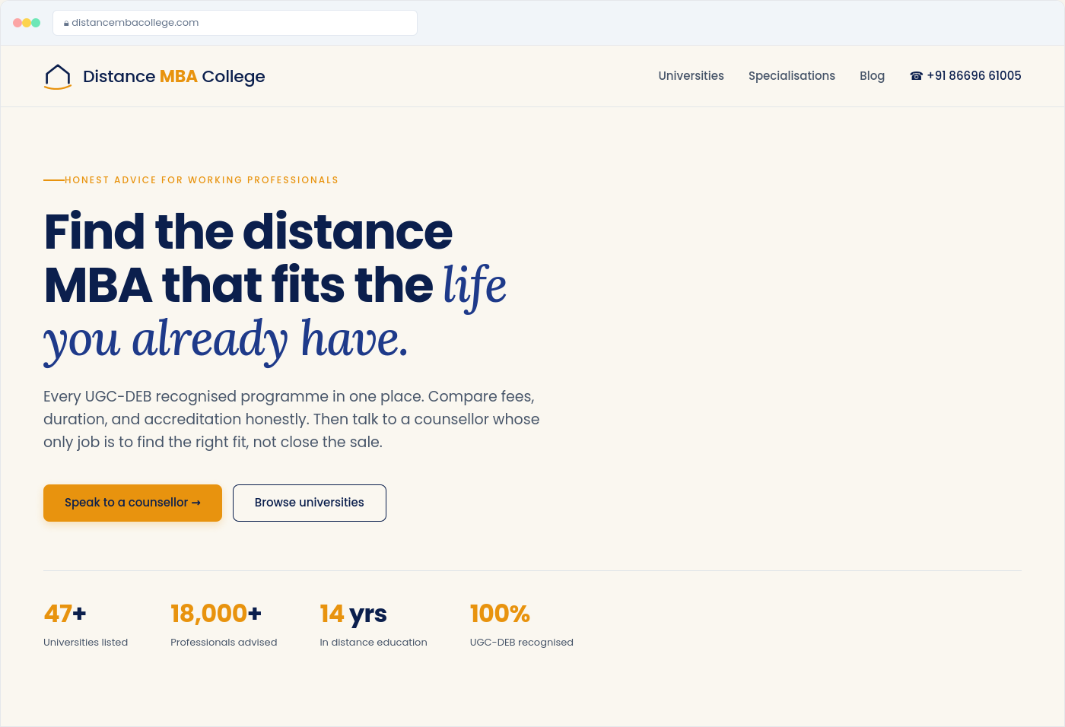

What is happening here
- Calm hero, no stock photography. The default for edtech is a cheering-graduates photo behind gradient text. We do the opposite. Editorial typography is the hero, no image at all. This separates Distance MBA College visually from every competitor in the category.
- The italic signature. “life you already have” set in Lora italic inside the Poppins headline. Structured geometric sans paired with warm humanist serif. Two faces of type, one brand voice.
- Saffron-only CTA. The primary action carries the saffron, the secondary action stays quiet. Never two saffron buttons in the same view.
- Trust strip beneath. Specific numbers, accreditation badges. We earn clicks through credibility, not urgency.
- Single sticky element. On mobile, only the phone-call float. No popups in the first 30 seconds.

Layout rules
- Max content width: 1200 px, 24 px gutter, 12-column grid.
- Section padding: minimum 80 px on desktop, 48 px on mobile.
- Cards: elevated white surfaces over Cream page background. 1 px hairline border, 16 px radius, soft shadow.
- Buttons: 8 px radius, 14-16 px vertical padding, 26-30 px horizontal. Never sharp rectangles or pills.

11 Application — One-Pager
The A4 one-pager is the print and PDF deliverable used for outreach to corporate L&D teams, university partnership conversations, and counsellor-led WhatsApp follow-ups. The version below is fully production-ready.
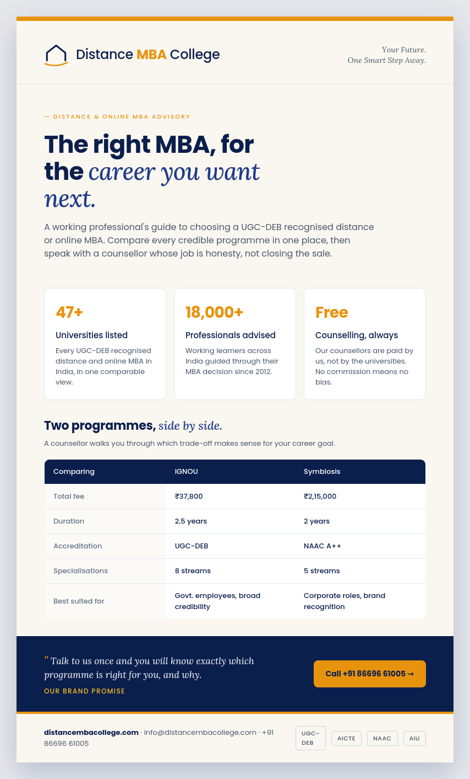

What is happening here
- The saffron bar. An 8 px Saffron stripe at the top is the brand's print signature, repeated quietly in the footer. Two warm notes framing serious content.
- Brand tagline beside the logo. “Your Future. One Smart Step Away.” set in Lora italic, right-aligned to balance the logo's horizontal weight.
- Editorial headline + comparison table. The same typographic pairing as the website hero, scaled for print. The comparison table is the deliverable, everything else frames it.
- Promise band in Navy. The brand promise quote sits in a saffron-and-navy band near the foot, with the call-to-action button to its right. This is the moment of trust before the contact strip.
- Accreditation badges at the foot. Greyscale, restrained. They authenticate, they do not decorate.

Production specifications
- Size: A4 portrait, 210 × 297 mm, with 12 mm bleed for print.
- Print: CMYK conversion required. Use the print-ready logo files with the saffron set in CMYK 0/37/94/9.
- Digital PDF: RGB, hyperlinked phone number and website. Compress images to 150 dpi for email distribution.

12 Application — Email
Email is the highest-leverage nurture channel because the audience is researching over weeks, not minutes. The brand voice carries furthest here. The example below shows a Day 2 nurture email from a counsellor, the format that produces the highest reply rates in the category.
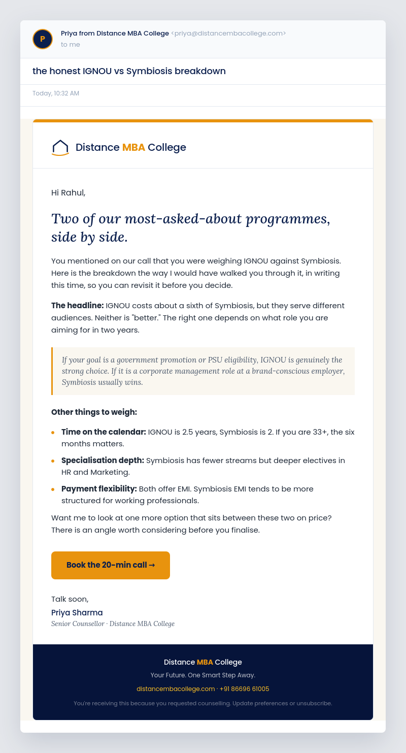

What is happening here
- Sender is a person, not the brand. “Priya from Distance MBA College” opens 30-40% higher than brand-name senders. The counsellor avatar (initial P) sits at the top, navy with the saffron border, the institutional signature.
- Lowercase, specific subject line. “the honest IGNOU vs Symbiosis breakdown” outperforms title-case marketing subjects. It reads as a personal note.
- Italic editorial headline. Lora italic inside the email body. The same typographic signature as the website, scaled for inbox readability.
- The saffron-bordered pull quote. One key insight pulled into a Cream block with a saffron left border. Lora italic. This is the email's takeaway, designed to be screenshotted and forwarded.
- Specific bullets, bolded leads. Each bullet has a bolded category lead and a one-line specific claim. Readers can skim and still learn.
- Single CTA. One saffron button, mid-email, calling for a 20-minute call. Not a generic “learn more.”
- Personal sign-off. Counsellor name in navy bold, role in Lora italic slate. The human voice closes the email.

Email production rules
- Width: 640 px content width. Renders well across Gmail, Outlook, Apple Mail.
- Fonts: Use the web fallback stack. Email clients vary in font support; Poppins falls back to system-ui, Lora falls back to Georgia.
- Images: Logo and avatar only. No header banner images, they trigger spam filters.
- Plain text version: Always paired with the HTML. The plain-text version maintains the voice and the call to action.

13 Brand Do's and Don'ts
Do | Don't
Lead with the audience's problem, not our product. | Open with “We are India's leading platform.”
Show real photos, real names, real outcomes. | Use stock photos of cheering graduates.
Use saffron only for what we want clicked. | Decorate the page with saffron everywhere.
Use Lora italic for human-voice moments, sparingly. | Set entire paragraphs in italic.
Mention accreditation by name (UGC-DEB, AICTE). | Say “government approved” without specifics.
Keep counsellor tone advisory and listening-led. | Push, pressure, or use scarcity tactics.
Send emails from a person's name. | Send from “no-reply@distancembacollege.com.”
Maintain Navy as the dominant identity colour. | Introduce red, purple, or competitor-blue accents.

14 Implementation Roadmap
This guideline is meant to be applied in clear phases, not all at once. The order below sequences each move so that current lead flow (around 100/day) is protected throughout the transition.

Phase 1 — Weeks 1 to 3: Foundation
- Logo rollout: Replace the existing logo with the refined primary lockup across the website header, footer, favicon, and social profiles. Use the monogram for WhatsApp Business and small avatars.
- Design tokens: Codify the colour, type, and spacing system as CSS variables and a Figma library. Hand off to development.
- Trust audit: Verify and update every accreditation claim with linked source. Replace stock photos with real photography brief.

Phase 2 — Weeks 4 to 8: Web rebuild
- Homepage: New hero matching the application example. Restructured trust elements, simplified lead form, counsellor introduction.
- Course and university templates: Rebuild as the card-led directory with consistent metadata and CTAs.
- Blog template: Apply the new typography. Rewrite the top 20 traffic pages to a single tonal standard before scaling new content.
- Performance pass: Core Web Vitals targets. LCP under 2.5s, INP under 200ms, CLS under 0.1.

Phase 3 — Weeks 9 to 14: Marketing rollout
- One-pager production: Print 500 of the A4 one-pager for partnership outreach. Distribute the digital PDF to corporate L&D teams.
- Email overhaul: Move from brand-sent to counsellor-sent. Rewrite the welcome sequence using the email template provided.
- Paid creative refresh: Rebuild all active Meta and Google creatives on the new template. Run a 30-day A/B against the old to measure lift.
- Social establishment: Launch the content calendar across Instagram and LinkedIn with the new visual template.

Phase 4 — Ongoing
- Monthly brand review: 30 minute team review of where the brand was applied well and where it slipped. Document and correct.
- Quarterly content quality pass: Audit 10 pages per quarter for tonal drift, factual accuracy, and conversion performance.
- Annual guideline update: Revise this document once per year. Brand guidelines that do not evolve become brand guidelines that get ignored.

15 Governance and Contact
This document is owned by the Director, Mr. Swapnil Avdhutrao Ughade, and the appointed brand custodian within MagicWorks IT Solutions. No change to the logo, colour palette, typography, or positioning statement may be made without sign-off from the brand custodian.
External vendors (designers, developers, agencies, content creators) must be issued this document at the start of any engagement. Their work will be reviewed against these standards before publication.

Quick-reference summary
Primary colour | Navy #0B1F4D
Accent colour | Saffron #E8930E
Heading & logo font | Poppins (Google Fonts) — 500, 600, 700
Body font | Inter (Google Fonts) — 400, 500, 600
Voice font | Lora italic (Google Fonts)
Primary tagline | Your Future. One Smart Step Away.
Brand archetype | The Sage with a touch of The Caregiver
Voice in one line | A senior mentor explaining a serious decision over chai. Warm but never wasteful.


— End of Brand Guidelines, Version 2.0 Final —

