/*

* Name: Daniel DelyMcShane

* Login: cs232

* Date: 02/05/2015

* File: hw3.c

* Sources of Help: None

* General description of the program: Prints out conversions between Fahrenheit and Celsius

* NOTE: Initially I had done all the operations in the printf statement, but I was unsure if using the *calculations in the printf statements would be considered hard coding

*So I stored them all in variables to make sure that they weren't "Hardcoded", even though I think it makes it look kind of cryptic and hard to read this way because of redundant variable names

*/

#include <stdio.h>

int main()

{

//F = C * 1.8 + 32.0

//C = (F – 32.0) / 1.8

//Initialize Fahrenheit values

double F_Degree_1 = 98.60;

double F_Degree_2 = 0.00;

double F_Degree_3 = -4.20;

//Initialize Celsius Values

double C_Degree_1 = -8.35;

double C_Degree_2 = 0.00;

double C_Degree_3 = 100.0;

//Store Fahrenheit to Celsius Conversions and sum/ave operations

double F_To_C1 = (F_Degree_1 - 32.0) / 1.8;

double F_To_C2 = (F_Degree_2 - 32.0) / 1.8;

double F_To_C3 = (F_Degree_3 - 32.0) / 1.8;

double F_To_C_Sum = F_To_C1 + F_To_C2 + F_To_C3;

double F_To_C_Ave = (F_To_C1 + F_To_C2 + F_To_C3) / 3;

//Store Celsius to Fahrenheit Conversions and sum/ave operations

double C_To_F1 = (C_Degree_1 * 1.8) + 32;

double C_To_F2 = (C_Degree_2 * 1.8) + 32;

double C_To_F3 = (C_Degree_3 * 1.8) + 32;

double C_To_F_Sum = C_To_F1 + C_To_F2 + C_To_F3;

double C_To_F_Ave = (C_To_F1 + C_To_F2 + C_To_F3) / 3;

//print out Fahrenheit to Celsius Conversions

printf("\nConverting Fahrenheit to Celsius:\n");

printf("%.2f degrees F = %.2f degrees C\n", F_Degree_1, F_To_C1);

printf("%.2f degrees F = %.2f degrees C\n", F_Degree_2, F_To_C2);

printf("%.2f degrees F = %.2f degrees C\n\n", F_Degree_3, F_To_C3);

//print out Fahrenheit to Celsius operations

printf("The sum of %.2f, %.2f, and %.2f is %.2f\n", F_To_C1, F_To_C2, F_To_C3, F_To_C_Sum); //prints out the sum of Converted Fahrenheit values

printf("The average of %.2f, %.2f, and %.2f is %.2f\n\n", F_To_C1, F_To_C2, F_To_C3, F_To_C_Ave); //prints out the average of converted Fahrenheit value

//print out Celsius to Fahrenheit operations

printf("Converting Celsiues to Fahrenheit:\n");

printf("%.2f degrees C = %.2f degrees F\n", C_Degree_1, C_To_F1);

printf("%.2f degrees C = %.2f degrees F\n", C_Degree_2, C_To_F2);

printf("%.2f degrees C = %.2f degrees F\n\n", C_Degree_3, C_To_F3);

//print out Fahrenheit to Celsius operations

printf("The sum of %.2f, %.2f, and %.2f is %.2f\n", C_To_F1, C_To_F2, C_To_F3, C_To_F_Sum); //prints out the sum of Converted Fahrenheit values

printf("The average of %.2f, %.2f, and %.2f is %.2f\n\n", C_To_F1, C_To_F2, C_To_F3, C_To_F_Ave); //prints out the average of converted Fahrenheit value

return 0;

}

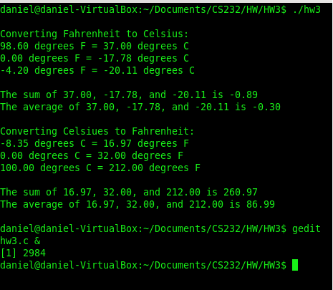

1. I spent .75 hours to finish this assignment.
2. I have 100 (percent) finish this assignment.
3. I expect **A** of this assignment.
4. I think this assignment is **E**  (A: Very Hard, B: Hard, C: Somewhat hard, D: Reasonable, or E: Easy).
5. This assignment helps me learn how to programing with C. Circle a number to indicate how much the project is helpful.

1 ( * **2**\*) 3 4 5

(Less helpful) (More helpful)

1. I expect **C** homework (A: More, B: Less, C: No more no less)

Comments: Pasting my source code into a word document really hurts my feelings because it ruins the format and I always try to spend a little extra time to make my code look pretty ☺ (And I think it makes it harder to read)