Screenshot output:

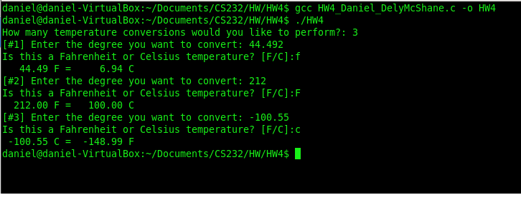

Source code (raw file attached):

/*

* Name: Daniel DelyMcShane

* Login: cs232

* Date: 02/12/2016

* File: hw4.c

* Sources of Help: The C Programming Language

* Temperature conversion program. User inputs number of converts they need to do and the convert type, also, the 8 in %8.2 makes the output wonky but I left it in because it’s required.

*/

#include <stdio.h>

//F = C * 1.8 + 32.0

//C = (F – 32.0) / 1.8

//declare functions

double Convert_F_To_C(double far);

double Convert_C_To_F(double cel);

int main()

{

int counter = 0; //counter for while loop

//ask user for amount of temp conversions and store them in counter var

printf("How many temperature conversions would you like to perform?: ");

scanf("%d", &counter);

getchar();

//int i is iterator for while loop, temp stores user input and type stores temp type

int i = 0;

double temp = 0;

char type;

while( i < counter)

{

printf("[#%d] Enter the degree you want to convert: ", i + 1);

scanf("%lf", &temp);

getchar();

printf("Is this a Fahrenheit or Celsius temperature? [F/C]:");

scanf("%c", &type);

getchar();

//if statement checks for if user inputs cel or far, and if invalid runs loop again

if(type == 'c' || type == 'C')

{

double f = Convert_C_To_F(temp);

printf("%8.2f C = %8.2f F\n", temp,f );

}

else if (type == 'f' || type == 'F')

{

double c = Convert_F_To_C(temp);

printf("%8.2f F = %8.2f C\n", temp,c );

}

else

{

printf("Invalid temperature input");

i--; //subtract one from iterator so that loop stays on the same iteration as the invalid input

}

i++;

}

return 0;

}

double Convert_F_To_C(double far)

{

double cel = (far - 32.0) / 1.8;

return cel;

}

double Convert_C_To_F(double cel)

{

double far = (cel * 1.8) + 32.0;

return far;

}

Text Output:

How many temperature conversions would you like to perform?: 3

[#1] Enter the degree you want to convert: 44.492

Is this a Fahrenheit or Celsius temperature? [F/C]:f

44.49 F = 6.94 C

[#2] Enter the degree you want to convert: 212

Is this a Fahrenheit or Celsius temperature? [F/C]:F

212.00 F = 100.00 C

[#3] Enter the degree you want to convert: -100.55

Is this a Fahrenheit or Celsius temperature? [F/C]:c

-100.55 C = -148.99 F

1. I spent 1 hours to finish this assignment.
2. I have 100 (percent) finish this assignment.
3. I expect A (A, B, C, or F) of this assignment.
4. I think this assignment is D (A: Very Hard, B: Hard, C: Somewhat hard, D: Reasonable, or E: Easy).
5. This assignment helps me learn how to programing with C. Circle a number to indicate how much the project is helpful.

1 2 3  **\*\* 4 \*\*** 5

(Less helpful) (More helpful)

1. I expect C homework (A: More, B: Less, C: No more no less)