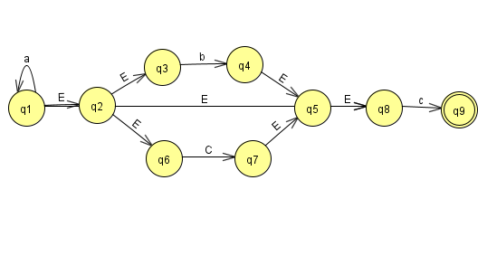Problem 1:

1.

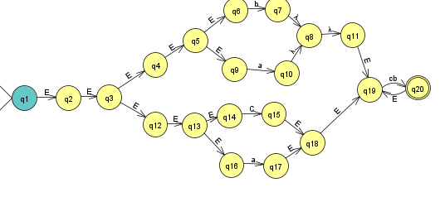

2.

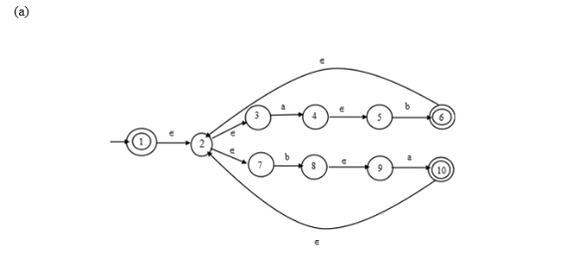Problem 2: 1.

Step 1: Remove the NULL state between the states 4 and 5,8 and 9 and redraw the NFA as follows.

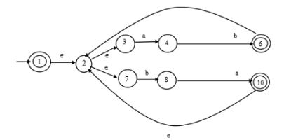

Step 2: In this NFA, one state from each end is eliminated. Here, the states 5 and 9 are deleted.

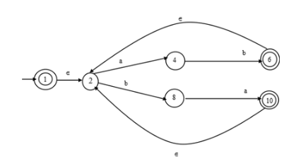Remove the Null state (E) between the states 2 and 3, 2 and 7 and redraw the NFA as follows:

Step 3: In this NFA, states 3 and 7 are eliminated.

Now, remove the states 4 and 8 and merge the characters as ‘ab’ and ‘ba’ respectively.

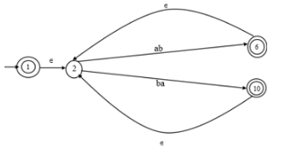

Introduce two states, which will act as the final states originating from state 6 and 10 as follows:

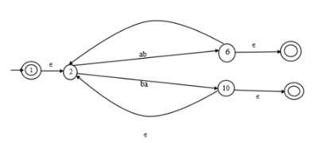

Now, eliminate the states 6 and 10 and redraw the NFA as follows:

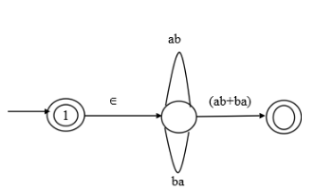

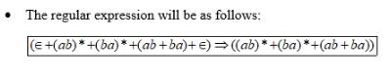

2.

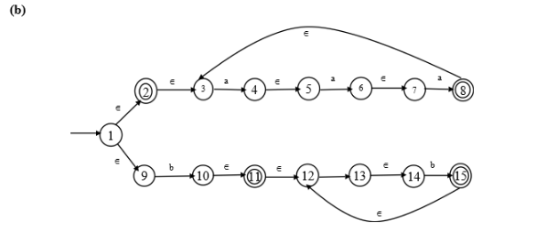

Steps: Redraw the NFA by introducing more states as follows:

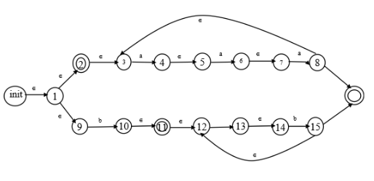

Now, remove the states 4,5,6,7 and 10,13,14 and redraw the NFA as follows:

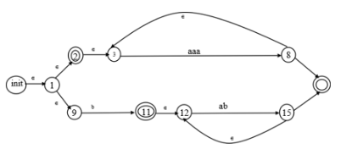

Also, remove the states 1 and 9 as follows:

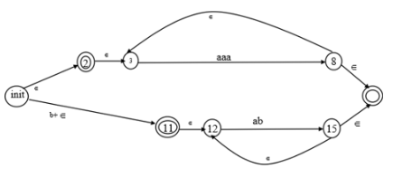

Now, remove the states 8 and 15 and redraw the NFA as follows:

