**Problem 1**

1. The set of strings over the alphabet Σ ={a,b}with more a’s than b’s

Solution🡺

S → TaT

T → T T | aTb | bTa | a | ε

T generates all strings with at least as many a’s as b’s, and S forces an extra a.

**2.** The complement of the language{a^n b^n|n≥0}

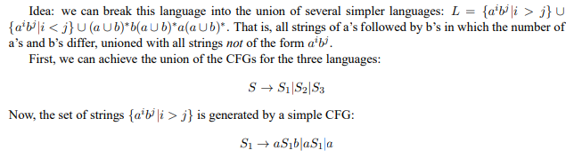

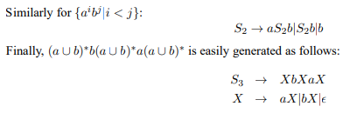

**Problem 2**

Give context-free grammars (CFGs) generating the following language:

A={a^i b^j c^k | i =j or j = k where i, j, k ≥ 0}

Is your grammar ambiguous? Why or why not? If yes, please provide an example of two different left-most derivations that generate the same string.

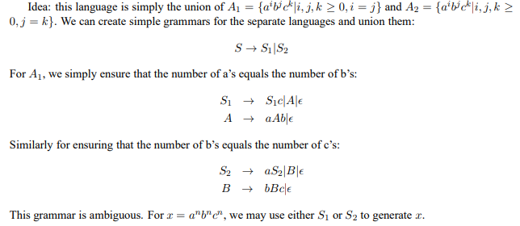

**Problem 3**

Exercise 2.14. Convert the following CFG into an equivalent CFG in Chomsky normal form, using the procedure given in Theorem 2.9.Please provide all intermediate steps with comments on how you transform from the grammar from one version to another (these steps are critical for your work to be graded).

