## Title

Forward Drive

## Name

Daniel Eggers

## 2D or 3D

2D

## Genre

Arcade, racing

## Relevant Games for comparison

|  |  |
| --- | --- |
| Road Fighter (MSX / NES game) | Oil Crisis (from Mario Party 7) |
| See the source image |  |

## Detailed Description

You control a vehicle with limited fuel that is propelled forward automatically. You must avoid obstacles while collecting scattered fuel canisters. Obstacles include other cars (moving in the same direction at a slower speed) and potholes in the road. There are two types of enemy cars: a standard red one and a more aggressive green one. There are two green cars in total with the first one being right at the halfway point of the game and the second being just before the end.

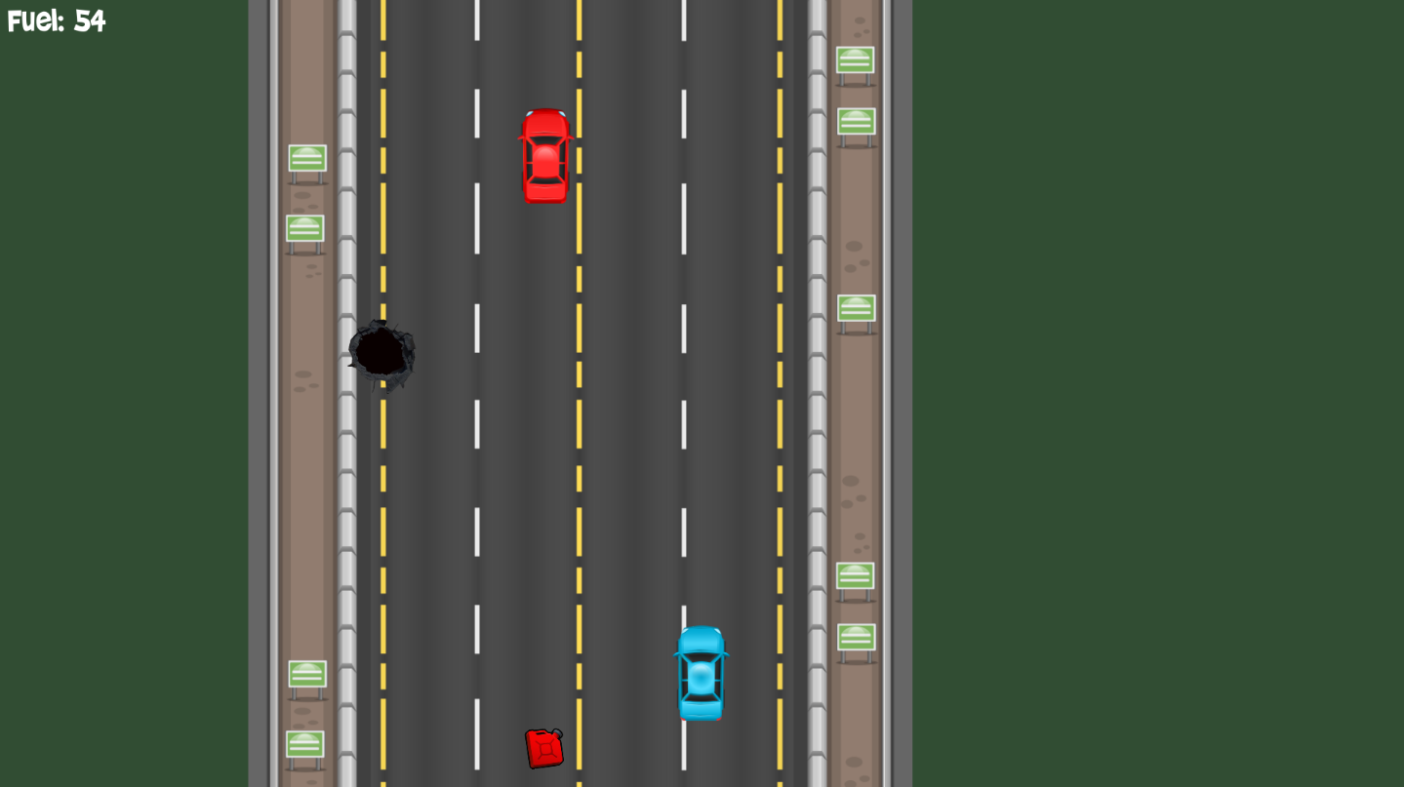

## User Controls

|  |  |  |
| --- | --- | --- |
| **Steering** | A, D | Left arrow, Right arrow |
| **Quick Restart** | R |  |

## Object of the Game

To win, you must get from the starting zone to your destination. You will need to collect fuel cans along the way to stay alive and running.

## How to Lose

You lose if you either collide with an obstacle or run out of fuel before reaching the end.