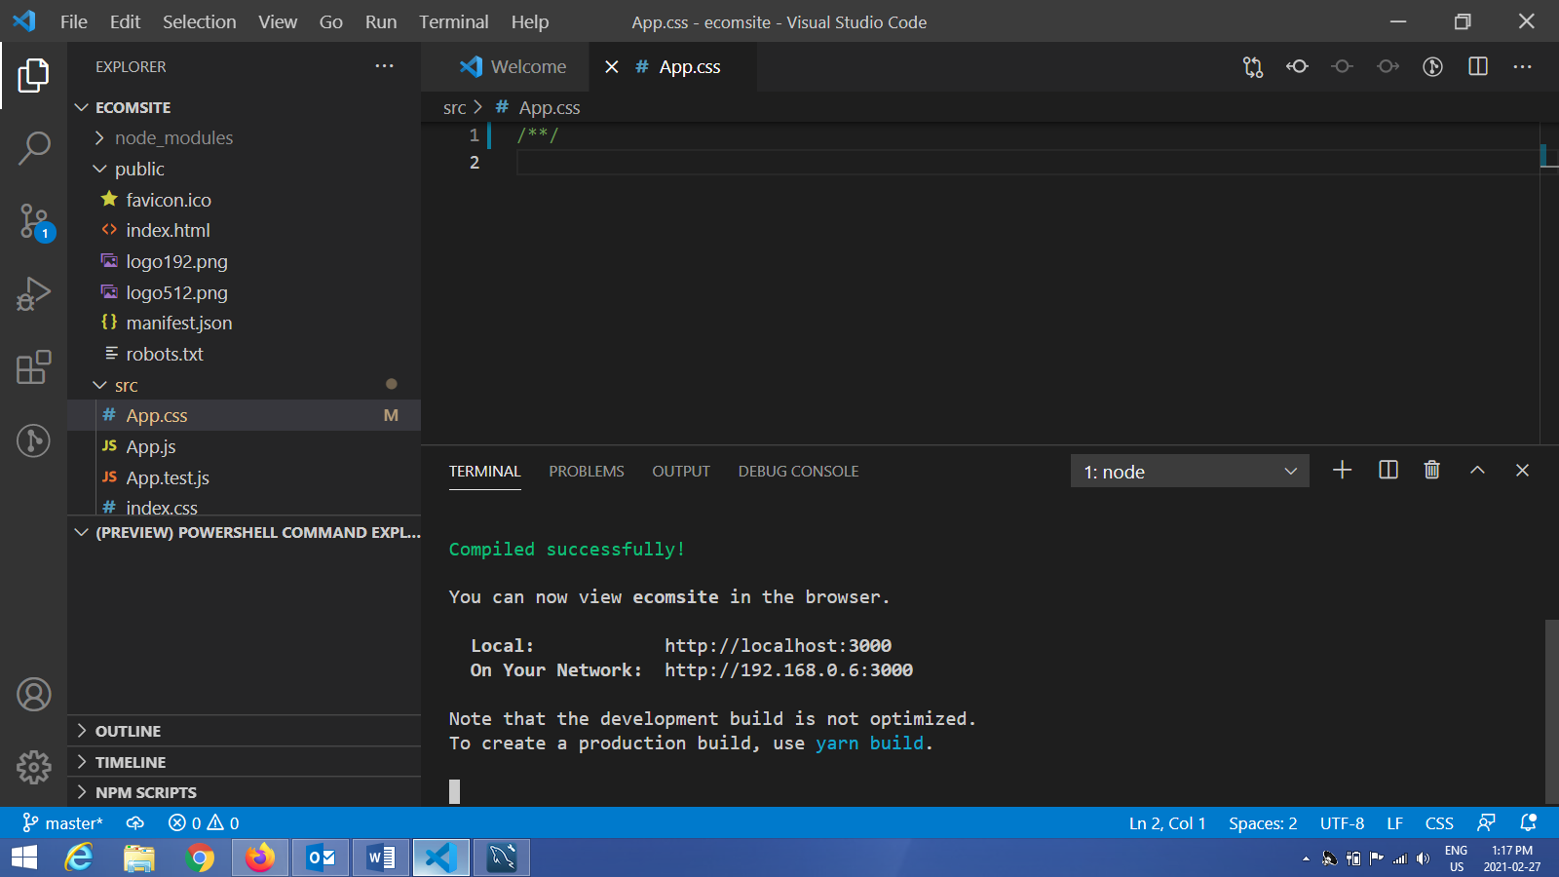

192.160.0.6:3000 to run locally

I have been occupying my time by building personal pet projects (for learning purposes)while sending out resumes this time a factious ecommerce site based around selling bikes. I used Reactjs along with the ContextAPI to maintain state throughout the site. Features that I built into the site were full search capabilities with a left bar for further drill down. Detailed screen of the product after it has been selected from the main list. A checkout screen showing what has been accumulated in the cart which keeps ongoing total. The data came from a couple of json files. The site is both mobile and desktop friendly. This was another fun project to build with many new concepts being learned. Hope everyone is keeping safe through these challenging times.