12. You run a farm-to-table restaurant and buy produce from local farms. When you see a local farm for sale, you realize it could provide most of the vegetables you need. If you buy the farm, which one of the following is *unlikely* to be an advantage of that vertical integration?
a) Eliminate the holdup problem
b) Reduce transaction costs
c) Eliminate supplier market power
d) Increase intra-brand competition

13. Suppose you are opening a hot cocoa stand on a street that already has two hot cocoa stands, as pictured. Potential customers only choose which hot cocoa stand based on what is closest. Suppose that customers are spread evenly along the street when they get the desire for hot cocoa strikes. Where of the following four spots should you place your hot cocoa stand? (C is in the very center; A is very close to Stand 1, D is very close to stand 2)

1 -- A --- 2 --C -----D------- E
NOTE: I’ll draw this picture better, but for now it has A and D very close to the stands at the end of the street. C is dead center. And B is between A and C.

a) A
b) B
c) C
d) D
e) E

14. Firms engage in advertising in order to
a) reduce their own costs
b) increase the demand for their products
c) make the demand for their product more elastic
d) make the demand for their product less elastic
e) b and c
f) b and d

15. The hold-up problem is responsible for
a) increased expenditures for private security.
b) preventing some investments that would be beneficial for both a supplier and its customer from being made.
c) increased investment-specific relationships.
d) a reduction in vertical integration from what would otherwise be observed.

16. If a firm can perfectly price discriminate, then
a) its MR curve is equal to its demand curve.
b) its MR curve is below its demand curve, as usual for firms with market power.
c) its MC curve is irrelevant to how it sets prices and how much quantity it sells.
d) a and c

17. Your favorite fast food restaurant charges $3 for a standalone drink, but only $1 dollar if you add the drink to a meal. *Of the following*, what is the *best* explanation *for why the restaurant prices the drink that way*?
a) The drink is cheaper for the restaurant to prepare and serve if they're already preparing a meal for you.
b) The restaurant believes that people who want just a drink have a higher WTP for a drink than people who are getting the drink along with a meal and so can increase its profits.
c) The restaurant's MC of a drink is less than $1
d) The restaurant prefers to sell food to drinks so discourages people from buying just drinks by raising the price of drinks.

18. Suppose a movie theater was charging $10 per ticket for all customers but last week it tried a new, two-price system where it charges $12 per ticket for nonstudents and $8 per ticket for students. (It picked the new prices based on a guess, not on a careful understanding of demand.) Which one of the following outcomes is most likely to be true?
a) total consumer surplus would increase
b) total producer surplus would increase
c) total consumer surplus for students would increase and consumer surplus for nonstudents would decrease
d) total consumer surplus for students would increase and total consumer surplus for nonstudents would either increase or decrease.

19. Suppose that there are two types of potential customers for your product: those who have a reservation price of $10 and those who have a reservation price of $5. If you can't price discriminate, what price should you charge?
a) $5, to ensure the maximum number of customers.
b) Something between $5 and $10, to increase your total revenue.
c) It depends on the marginal revenue curve.
d) It depends on your marginal cost curve.

20. In the figure below, which expression represents the *profit* of a profit maximizing firm with market power? FIGURE FROM PRACTICE PROBLEM 6
a) P4 x Q1
b) (P4-P2) x Q1
c) (P4-P1) X Q1
d) P3 X Q2

21. A person who is risk averse will
a) always prefer a certain smaller win over an uncertain larger win
b) have a utility curve that slopes downward
c) diminishing marginal utility of income
d) a and c

22. An risky investment with a positive expected financial value
a) might not be made by a risk-averse person, even if the expected financial gains from the investment value is very high relative to the person's initial wealth.
b) that would not be made by any one person might be made if the risk were spread over multiple people who were equally risk-averse (that is, who had the same utility curves (by utility curve, I mean a graph with utility on the y-axis, wealth on the x-axis)).
c) would be made by a rational individual only if the expected utility from the investment was greater than the expected utility from not making that investment.
d) all of the above.

23. The following graphs show the utility functions of three people. The dots represent each person’s current wealth. Who is the most risk-averse among them?
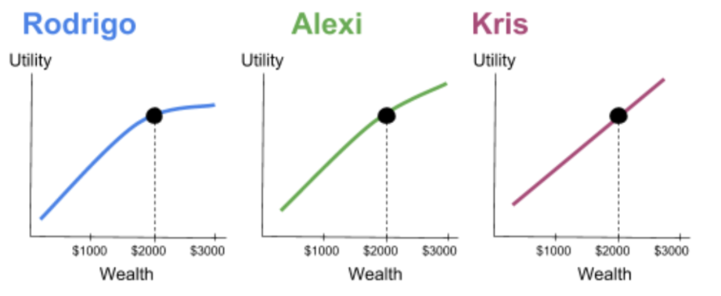
a) Rodrigo
b) Alexi
c) Kris

