ECON 001 – Fall 2022 – Final Exam – DRAFT

Please do not open this exam until instructed to.

While you’re waiting, write your name and bubble in your Canvas ID number.

Enter your responses in the Scantron sheet.

Choose the best response. (However, if you think two responses are correct, you are probably overlooking something. :o)

Good luck!a

- Consider a (completely hypothetical) neighborhood whose population is 50 percent full-time college students at an elite college, and 50 percent old, wealthy people. In that neighborhood, income inequality (measured using annual income) is quite high,
  - but wealth inequality could be quite low.
  - but inequality measured using permanent income is lower than that inequality measured using annual income.
  - so, if the federal government cares about helping people in need, it should devote welfare funds to that neighborhood.
  - NONE OF THE ABOVE IS CORRECT.

- A new government imposes a tax system where people pay 20 percent of their annual income between $0 and $20,000; 15 percent of their annual income between $20,001 and $40,000; and 10 percent of any income above $40,000.
  - People with higher annual incomes pay more taxes (in dollars) than people with lower incomes.
  - The tax system is regressive, because people with higher annual incomes have a lower average tax rate than people with lower annual incomes.
  - The tax system is progressive, because people with higher annual incomes have a higher marginal tax rate than people with lower annual incomes.
  - a and b

- Diminishing marginal utility of income
  - means that some people don’t benefit from more income.
  - justifies redistributing money from higher-income people to lower-income people on utilitarian grounds.
  - means that a graph of utility (on y axis) over income (on x axis) could be a straight line.
  - NONE OF THE ABOVE IS CORRECT.

- A profit-maximizing firm that faces a flat demand curve
  - has no market power.
  - has a MR curve beneath its demand curve.
  - does not necessarily sell at the quantity at which that MR = MC.
  - sells a differentiated product.

- A firm with market power
  - sets the price as high as it thinks it can while still maintaining some sales.
  - maximizes the average profit (i.e., profit per unit).
  - sells a quantity such that MR = MC.
  - b and c.

- For a firm with market power, marginal revenue is
  - equal to the price.
  - the amount of money it gets paid by the last customer.
  - equal to the average revenue.
  - less than the price, because of the discount effect.

- Assuming that the product the firm sells already has been invented, if a firm has market power, then, relative to if the firm sets the price where MC = AR,
  - producers have higher producer surplus.
  - consumers have lower consumer surplus.
  - deadweight loss is larger.
  - ALL OF THE ABOVE.

- The government sometimes awards patents to firms, which give the firms with patents monopoly power for a certain period of time. Patents therefore have the effect of
  - clearly making society worse off than if patents did not exist.
  - allowing a firm with a patent to charge consumers higher prices than it could otherwise.
  - providing firms an incentive to develop new products which could benefit consumers.
  - b and c

- Suppose all the firms in an oligopoly (in the market for an identical good) collude by agreeing to sell the good at a certain price.
  - The outcome will be the same as if they did not collude, because they already have market power.
  - There will be great temptation for each firm to break the agreement to collude, because a firm who breaks the agreement could enjoy high profits if the other firms stick to the agreement.
  - We can’t be sure whether the price they agreed on would be lower or higher than the price when they don’t collude.
  - consumers might be better off.

- Governments tend to take charge of (or regulate) roads and electricity provision because
  - private firms are not very skilled at managing roads or electricity provision.
  - governments are always looking for an additional source of revenue.
  - in those markets, competition tends to be restricted naturally, so outcomes would be especially inefficient if the roads or electricity provision were managed by a for-profit firm.
  - governments in different towns can trade tips with each other about how to best manage these public goods.

- The following graph is evidence that
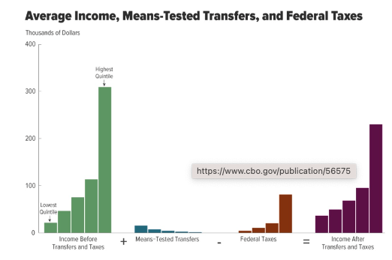
  - the social safety net is redistributive.
  - the social safety reduces inequality.
  - some groups get more in benefits than they pay in taxes.
  - ALL OF THE ABOVE.

- An average cost curve tends to be “U-shaped” because as the quantity increases
  - average fixed cost declines, but average variable cost tends to increase.
  - average fixed cost is unrelated to quantity, but average variable cost increases.
  - profits increase.
  - the price must fall.

- In the following picture
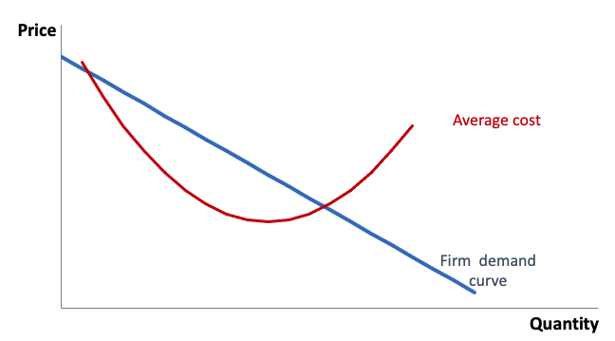
  - the firm should sell a quantity that maximizes the gap between the AC and the demand curve.
  - we can determine the profit-maximizing price, even though the axes don’t show any units or numbers.
  - profit at the quantity-price pairs where the AC and firm demand curves intersect is 0.
  - NONE OF THE ABOVE.

- A profit-maximizing firm
  - tries not to engage in price competition.
  - could have zero economic profits.
  - could have MR > MC at the quantity it chooses to sell.
  - NONE OF THE ABOVE.

- Suppose all the firms in a market sell an identical good and have the same cost curves. Then entry will occur
  - as long as there are no barriers to entry.
  - until all the firms have zero economic profit.
  - until each firm provides a quantity of exactly one good, because that would be the cheapest at which a firm could provide a good.
  - NONE OF THE ABOVE.

- Suppose that firms in a market sell an identical good but have different cost curves. Then
  - there will always be some firms entering and exiting the market.
  - in the long-run equilibrium, no firms will have economic profit.
  - whenever a new firm enters the market, we expect all firms’ profits to shrink, although not necessarily to 0.
  - NONE OF THE ABOVE.

- Consider a firm that supplies parts to both Huawei and Samsung. The firm can make an investment that would enable the firm to better supply Huawei but would make the firm unable to supply Samsung. Depending on whether it makes the investment, the firm expected the revenues as shown in the table for the next year.
 | Revenues from Samsung | Revenues from Huawei
Without the investment | 50 | 40
With the investment | 0 | 110
Nonetheless, the firm chose not to make the investment. That could be because
  - the investment was too costly.
  - of concern about the hold-up problem.
  - the prisoner’s dilemma.
  - a and b

- When a profit-maximizing firm can perfectly price discriminate,
  - the final outcome is efficient, with 0 deadweight loss.
  - the MR curve is the demand curve.
  - there is zero consumer surplus.
  - ALL OF THE ABOVE.

- Suppose Mr. X and Mr. Y are faced with the same bet. Mr. X takes it, but Mr. Y does not. Possible explanations include:
  - They have different utility curves (on a graph with utility on the vertical axis and wealth on the horizontal axis).
  - They have different initial levels of wealth.
  - Mr. X is less risk averse than Mr. Y.
  - ALL OF THE ABOVE.

- Alan and Bertie both have initial wealth of $100, and they are considering a gamble which would either lose them $20 or win them $30. Their utility curves are shown in the below figure. With regards to this bet,

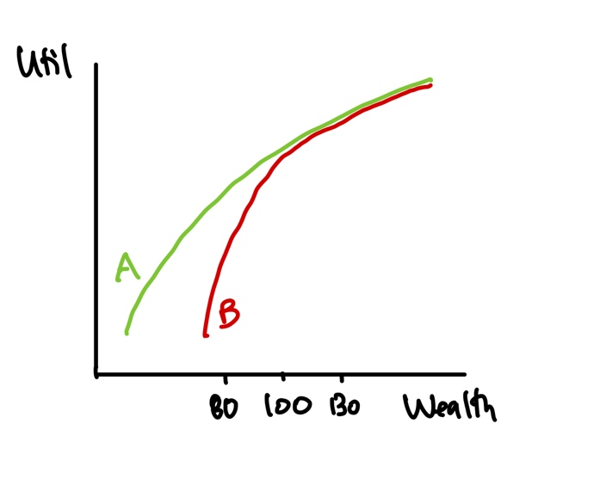
- Alan is more risk averse than Bertie.
- Bertie is more risk averse than Alan.
- We can’t say who is more risk averse without knowing the probabilities of the bet.
- Neither one will take the bet.

- Maria is in Vegas. She determines that if she goes to the casino, there is a 60 percent chance she will lose $1,000 and a 40 percent chance she will win $4,000. What is her expected financial payout of going to the casino?
  - .6(1000) + .4(4000)
  - .6(-1000) + .4(4000)
  - .5(-1000) + .5(4000)
  - .6(-1000) + .4(3000)

- Continuing from the previous problem. Suppose Maria’s utility if she lost $1,000 (which would happen with 60 percent probability) would be 10, her utility if she won $4,000 (40 percent probability) would be 20, and her utility if she does not go to the casino would be 13. Will she go to the casino?
  - Yes.
  - No.
  - Can’t say without more information.
  - She’s indifferent between going to the casino and not going.

- Advertising
  - can reduce efficiency if competitors are simply stealing each other’s business from one another without actually gaining any new customers.
  - probably improves a firm’s profits, but could not improve economic efficiency (i.e., could not increase total economic surplus in society).
  - is supposed to shift the firm demand curve (i.e., the demand curve a firm faces) in towards the vertical axis.
  - a and b

- Suppose a movie theater had been naively managed, and was charging a single price of $10 for all tickets (and it wasn’t clear that $10 was the optimal price). The theater hires you as a consultant, and after doing an (accurate) analysis you determine the theater should charge nonstudents $12 and should charge students $8. If the theater adopts your recommendation
  - its producer surplus will increase.
  - total consumer surplus will certainly increase
  - total consumer surplus will certainly fall.
  - a and b

- Basil owns a bookstore and has observed that college graduates read more than people without degrees. He considers offering a 10% discount to customers who have a college degree. That plan might be bad for business because
  - it’s not easy to verify that someone has a college degree.
  - people with college degrees are likely to have a higher willingness to pay for books than people without college degrees.
  - people who read more books are likely to have a higher willingness to pay than people who read fewer.
  - ALL OF THE ABOVE

- Suppose on Jan 1, 2022, Rebekah rented a cookie stand for the whole year for $1,000 (fixed cost). She was expecting to sell $4,000 of cookies each half of the year and to have $2,000 of additional (variable) financial costs each half of the year. Halfway through the year, she checked her numbers and she met her expectations for the first half of the year! Unfortunately, for the second half of the year, while she expected her revenue to stay the same ($4,000), she now expected her variable financial costs to increase to $3,000 (up from her original expectation of $2,000). Assuming Rebekah is a rational businessgirl,
  - Rebekah will stay in the market, because she’s still making a profit for the second half of the year.
  - Rebekah will exit the market immediately, because her costs were higher than she expected.
  - Rebekah will stay in the market through the end of the year and then exit.
  - Rebekah might exit the market or she might stay; we can’t be sure without more information.

- Suppose the demand faced by a firm is $Q = 12 – P$, its marginal revenue is $MR = 12 – 2Q$, and its marginal costs are $MC = 4$. What is the efficient quantity?
  - 2
  - 4
  - 6
  - 8

- For the above problem, what is the profit-maximizing price?
  - 2
  - 4
  - 6
  - 8

- For the above two problems, what is the profit (assuming there are no fixed costs, so the MC curve reflects the total costs)?
  - 4
  - 8
  - 16
  - Can’t say without more information.

- Suppose two people are falsely accused of a crime and put in prison. If one person confesses and the other does not, the one who confesses will be released immediately and the other will spend 20 years in prison. If neither confesses, each will be held only for a few months. If both confess, they will each be jailed 15 years. If both parties act in their own self-interest and are not able to guarantee they can cooperate with each other,
  - they will both confess and thus spend 15 years in prison.
  - they will both not confess, and thus spend only a few months in prison.
  - it’s completely random what will happen: no one outcome is more likely than another.
  - the efficient outcome is likely to occur.

- Very important: bubble in A.

