Record your response on a separate sheet of paper.

- Assume that allowing a cheat sheet does not affect the exam or how it is graded. Also assume that the benefits and costs of having a cheat sheet could be measured in dollars for each student. Allowing a cheat sheet on exam would be efficient
  - if, for most students, the benefits of the cheat sheet outweigh the costs of the cheat sheet.
  - if the sum of the total benefits each student gets from a cheat sheet were greater than the sum of the total costs to each student.
  - if, before the exam, most students voted that a cheat sheet should be allowed.
  - a and b

- A 30-year-old’s consumption decisions (i.e., how he spends money) this year are best explained by which of the following options?
  - His wealth this year.
  - His income this year.
  - His permanent income.
  - His opportunities for advancement.

- Suppose if you press a certain large, red button, it would transfer $10,000 from each person in the richest 10 percent of the population to each person in the poorest 10 percent. Pressing the button would result in an immediate
  - increase in total economic surplus.
  - decrease in total economic surplus.
  - reduction in efficiency and reduction in inequality
  - only an effect on (in)equality but no effect on efficiency

- A new government imposes a tax system where people pay 20 percent of their annual income between $0 and $20,000; 15 percent of their annual income between $20,001 and $40,000; and 10 percent of any income above $40,000. [E.g., if someone had an income of $25,000, they would pay 20 percent on the first $20,000 and 15 percent on the next $5,000.]
  - People with higher annual incomes pay more taxes (in dollars) than people with lower incomes.
  - The tax system is regressive, because people with higher annual incomes have a lower average tax rate than people with lower annual incomes.
  - The tax system is progressive, because people with higher annual incomes have a higher marginal tax rate than people with lower annual incomes.
  - a and b

- Diminishing marginal utility of income
  - means that some people don’t benefit from more income.
  - justifies redistributing money from higher-income people to lower-income people on utilitarian grounds.
  - means that a graph of utility (on y axis) over income (on x axis) could be a straight line.
  - NONE OF THE ABOVE IS CORRECT

- A profit-maximizing firm that faces a flat demand curve
  - has no market power.
  - has a MR curve beneath its demand curve.
  - does not necessarily sell at the quantity at which that MR = MC.
  - sells a differentiated product.

- A firm with market power
  - sets the price as high as it thinks it can while still maintaining some sales.
  - maximizes the average profit (i.e., profit per unit).
  - sells a quantity such that MR = MC.
  - b and c

- For a firm with market power, marginal revenue is
  - equal to the price.
  - the amount of money it gets paid by the last customer.
  - equal to the average revenue.
  - less than the price, because of the discount effect.

- Assuming that the product the firm sells already has been invented, if a firm has market power, then, relative to if the firm sets the price where MC = AR,
  - producers have higher producer surplus.
  - consumers have lower consumer surplus.
  - deadweight loss is larger.
  - ALL OF THE ABOVE

- The government sometimes awards patents to firms, which give the firms with patents monopoly power for a certain period of time. Patents therefore have the effect of
  - making society worse off than if patents did not exist.
  - allowing a firm to force consumers to pay more for new goods than they are willing to.
  - incentivizing firms to develop new products.
  - a and b

- Governments tend to take charge of (or regulate) roads and electricity provision because
  - private firms are not very skilled at managing roads or electricity provision.
  - governments are always looking for an additional source of revenue.
  - in markets for those goods competition tends to be restricted naturally, so outcomes would be especially inefficient if the roads or electricity provision were managed by a profit-maximizing firm.
  - governments in different towns can trade tips with each other about how to best manage these public goods.

- The graph in Figure 1 (last page) is evidence that
  - the social safety net is redistributive.
  - the social safety reduces inequality.
  - some groups get more in benefits than they pay in taxes.
  - ALL OF THE ABOVE

- An average cost curve tends to be “U-shaped” because as the quantity increases
  - average fixed cost declines, but average variable cost tends to increase.
  - average fixed cost is unrelated to quantity, but average variable cost increases.
  - profits increase.
  - the price must fall.

- In Figure 2 (last page)
  - the firm should sell a quantity that maximizes the gap between the AC and the demand curve.
  - we can determine the profit-maximizing price, even though the axes don’t show any units or numbers.
  - profit at the quantity-price pairs where the AC curve and firm demand curve intersect is 0.
  - NONE OF THE ABOVE

- A profit-maximizing firm
  - does not engage in price competition.
  - could have zero economic profits.
  - could have MR > MC at the quantity it chooses to sell.
  - NONE OF THE ABOVE

- Suppose all the firms in a market sell an identical good and have the same cost curves. Then entry will occur
  - as long as there are no barriers to entry.
  - until all the firms have zero economic profit.
  - until each firm provides a quantity of exactly one good, because that would be the lowest price at which a firm could provide a good.
  - NONE OF THE ABOVE

- Suppose that firms in a market sell an identical good but have different cost curves. Then
  - there will always be some firms entering and exiting the market.
  - in the long-run equilibrium, no firms will have economic profit.
  - whenever a new firm enters the market, we expect all firms’ profits to shrink, although not necessarily to 0.
  - NONE OF THE ABOVE

- When a profit-maximizing firm can perfectly price discriminate,
  - the final outcome is efficient, with 0 deadweight loss.
  - the MR curve is the demand curve.
  - there is zero consumer surplus.
  - ALL OF THE ABOVE

- Suppose Mr. X and Mr. Y are faced with the same bet. Mr. X takes it, but Mr. Y does not. Possible explanations include:
  - They have the same wealth but different utility curves (on a graph with utility on the vertical axis and wealth on the horizontal axis).
  - They have different initial levels of wealth but the same utility curves.
  - Mr. X is less risk averse than Mr. Y.
  - ALL OF THE ABOVE

- Alan and Bertie both have initial wealth of $100, and they are considering a gamble which would either lose them $20 or win them $30. Their utility curves are shown in Figure 3 (last page). With regards to this bet,
- Alan is more risk averse than Bertie.
- Bertie is more risk averse than Alan.
- We can’t say who is more risk averse without knowing the probabilities of the bet.
- Neither one will take the bet.

- Maria is in Vegas and has initial wealth of $10,000. She determines that if she goes to the casino, there is a 60 percent chance she will lose $1,000 and a 40 percent chance she will win $4,000. What is her expected financial payout of going to the casino? [Note, I am not asking about expected wealth.]
  - .6(9000) + .4(14000)
  - .6(-1000) + .4(4000)
  - .6(14000) + .4(9000)
  - .6(4000) + .4(-1000)

- Continuing from the previous problem. Suppose Maria’s utility if she lost $1,000 (which would happen with 60 percent probability) would be 10, her utility if she won $4,000 (40 percent probability) would be 20, and her utility if she does not go to the casino would be 13. Will she go to the casino?
  - Yes.
  - No.
  - Can’t say without more information.
  - She’s indifferent between going to the casino and not going.

- Advertising
  - can increase efficiency.
  - is supposed to make demand more inelastic.
  - is supposed to shift the firm demand curve (i.e., the demand curve a firm faces) in towards the vertical axis.
  - a and b

- Suppose a movie theater had been naively managed and was charging a single price of $10 for all tickets (and it wasn’t clear that $10 was the optimal price). The theater hires you as a consultant, and after doing an (accurate) analysis you determine the theater should charge nonstudents $12 and should charge students $8. If the theater adopts your recommendation
  - its producer surplus will increase.
  - total consumer surplus will certainly increase
  - total consumer surplus will certainly fall.
  - a and b

- Basil owns a bookstore and has observed that college graduates read more than people without degrees. He considers offering a 10% discount to customers who have a college degree. That plan might not increase Basil’s profits because
  - it’s not easy for a bookstore to verify that someone has a college degree.
  - people with college degrees are likely to have a higher willingness to pay for books than people without college degrees.
  - people who read more books are likely to have a higher willingness to pay than people who read fewer.
  - ALL OF THE ABOVE are possible reasons this might be a bad strategy

- Rebekah owned a bakery. In January, she paid rent (her only fixed cost) for the whole year. Unfortunately, demand was not as strong as she had hoped it would be, and in July she realized her total costs for the year would be greater than her total revenue (i.e., she realized her total costs were great than total benefits). She also knew (with certainty) that her economic profits in the next year would be negative. Thus, in July, Rebekah
  - would have closed the bakery immediately.
  - might have closed the bakery immediately, but might have waited.
  - would have kept running the bakery this year but would not run the bakery next year.
  - raised her prices.

- Consider the demand faced by a firm given in Table 1 (last page).
  - When lowering the price, the output effect dominates the discount effect.
  - For certain quantities the MR is positive and for others it is negative.
  - The firm might find it optimal to set a price of 5.
  - b and c.

- Suppose the demand faced by a firm is $Q = 10 – P$, its marginal revenue is $MR = 10 – 2Q$, its marginal costs are $MC = 6$, and its average total costs are $AC=6+\frac{2}{Q}$. What is the profit-maximizing quantity?
  - 1
  - 2
  - 3
  - 4

- For the above problem, what is the deadweight loss?
  - 0
  - 1
  - 2
  - 3

- For the above two problems, what is the profit?
  - 1
  - 2
  - 4
  - 6

Do not turn this over until instructed to. Unless otherwise stated, chose the best option using the models we discussed in class. Good luck!

Figure 1
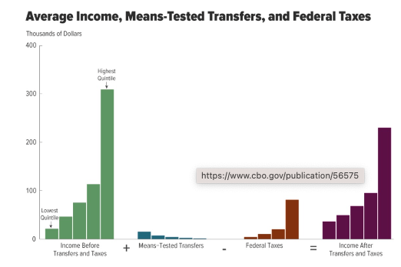

Figure 2  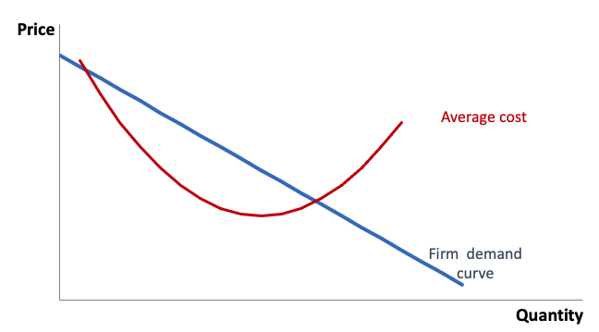 | Figure 3  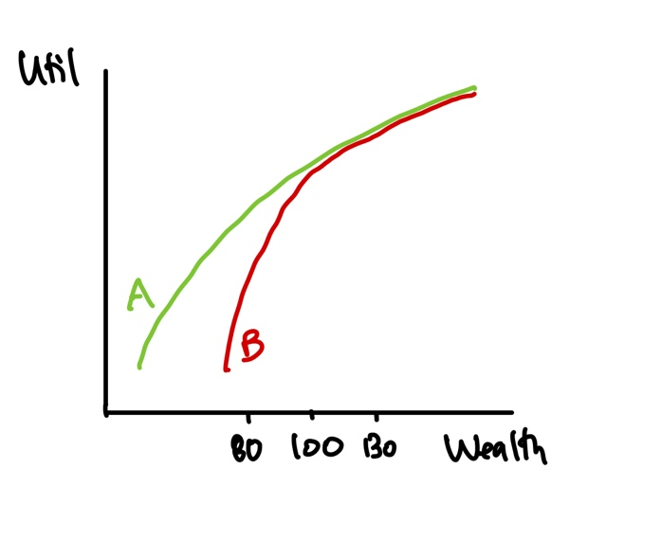

Table 1
P | Q
7 | 5
6 | 6
5 | 7

