Respond to problems 24 and 25 on the back side of your response sheet.

- Note to 2026 Spring students: This Fall 2025 problem was based on a presentation that TA Saachi gave in lecture last semester. I heavily hinted that a question about her presentation would be on the final and gave the students specific practice problems. You did not get Saachi’s mini-lecture or the advice to study it, so this problem will be harder for you. That said, it is a good problem that requires you to understand efficiency—which is important for you to understand for our final. So I am leaving it here as a stretch problem. But it is a bit “out of bounds” for our Spring 2026 final exam.

Consider the story of an incumbent firm and barriers to entry. As always, assume all the individuals are rational and purely self-interested. Answer only on your response sheet.
- A professor for a class assigns a Classic Textbook to his 1,000 students.
- The author of the Classic Textbook earns $1 profit per student.
- Morris has a written a New Textbook which is cheaper and just as good as the Classic Textbook. Morris does not care if anyone uses his textbook (he enjoys no benefits and suffers no costs).
- If the professor assigned the New Textbook, each student would benefit $2 relative to the situation where the professor assigns the Classic Textbook.
- The professor is very easy to influence (by providing him nice meals and gifts).

- What is the efficient outcome? Briefly explain on your response sheet.
- Why is it likely the professor will not assign the new book? Briefly explain on your response sheet.
- Under what conditions would the professor assign the New Textbook? Continue to assume that all individuals are rational and self-interested. Briefly explain on your response sheet. (Spring 2026 students: this is the part that is a stretch for you.)

- Based on the information in the table, answer the following questions. Answer on the back of your Response Sheet (do not answer on this page).

$$Q = 10 - P$$
$$MR = 10 - 2Q$$
$$MC = 6$$
$$AC=6+\frac{2}{Q}$$

  - What is the efficient quantity?
  - What is the profit-maximizing price?
  - What is the DWL?
  - What is the profit?

DO NOT TURN OVER UNTIL INSTRUCTED TO.

Write your name and Canvas ID on both sides of your response sheet. We will only grade the response sheet.

Good luck!

Figure 1
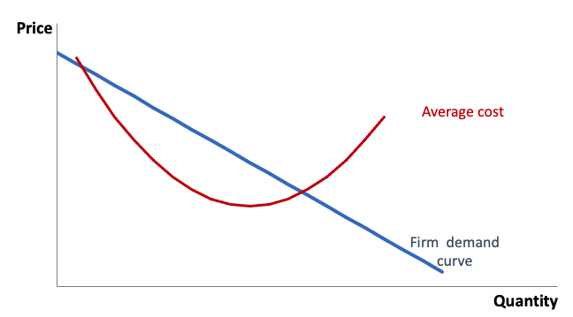

Table 1
 | Group A’s WTP | Group B’s WTP
Big Game | 5 | 4
Big Win | 2 | 3

Table 2
P | Q
7 | 5
6 | 6
5 | 7

Table 3
 | B chooses to Honor | B chooses to Break
A chooses to Honor | (6, 6) | (4, 7)
A chooses to Break | (7, 4) | (5, 5)
Note: Payoffs are (A’s payoff, B’s payoff).

