For each problem, fill in your single choice on the Scantron sheet.

- Aunt Zhentao’s Bottled Water Company operates in the perfectly competitive market for bottled water. The market price for a bottle of water is $2.00. At Aunt Zhentao’s current production quantity, the marginal cost for producing one more bottle of water is $0.50. What price should Aunt Zhentao charge for a bottle of water in order to maximize her company’s profits?
  - Anything above $0.50 but below $2.00.
  - Something just above $2.00.
  - Something just below $2.00.
  - Exactly $2.00.

- Ilana thought she was going to miss her 6pm Amtrak train. Originally, she paid the great price $100 for the ticket (nonrefundable). When she thought she would miss the 6pm train, she called Amtrak to see if she could change her ticket to the 7pm train. Fortunately, there was an extra seat, and she paid a (nonrefundable) $50 “change fee” to make that change. However, she ended up getting to the train station in time to catch the original 6pm train! So she called again to switch her ticket back to the 6pm train. She had to pay an additional $30 fee to make that second change. We know that Ilana’s willingness to pay to catch the 6pm train instead of the 7pm train was
  - at least $30.
  - at least $80.
  - at least $100.
  - at least $180.

- A politician said “A ban on assault weapons will lead to less violence.” That statement is
  - positive.
  - normative.
  - unarguably true.
  - transitive.

- Suppose an economist sees Tremont buy four cookies. The economist assumes that Tremont’s economic surplus associated with this purchase
  - might be greater if he bought five cookies.
  - was maximized by buying four cookies.
  - is zero.
  - [Can’t say anything about this because the economist does not observe the benefits Tremont gets from those four cookies.]

- Kricket will study a total of five hours for her sociology midterm and her psychology midterm. Consider her production possibility frontier (PPF) in Figure 1 (last page), which shows the additional number of additional points she could get (relative to not studying at all), depending on how she spends her study time. Based on this PPF, Kricket’s marginal (opportunity) cost of getting a point on the psychology exam
  - decreases as she gets more points on the psych exam.
  - increases as she gets more point on the psych exam.
  - is constant regardless of how she splits her time.
  - [Cannot say without more information.]

- Your demand curve for a good slopes downward because
  - as you buy more of the good, it costs more to make additional units of the good.
  - as you buy more of the good, it costs less to make additional units of the good.
  - the benefit you get from an additional unit of the good falls as you get more of the good.
  - [None of the above help to explain why your demand curves slope down.]

- Suppose there is a surprise fall in the price of gasoline. That causes Brillo’s demand curve for gasoline to
  - shift out.
  - shift in.
  - bend.
  - [None of the above]

- Suppose that milk and cereal are complements. When a milk truck crashes, causing the price of milk to rise in your town, you expect the equilibrium price of cereal to
  - rise.
  - fall.
  - be unaffected.
  - [Can’t say]

- This morning two things happened before Jhumpa went to the grocery store: She got a raise (i.e., her income increased) AND the price of Ramen noodles fell. As a result, Jhumpa bought more ramen noodles than she did last week. Therefore,
  - ramen noodles are a normal good for Jhumpa.
  - ramen noodles are an inferior good for Jhumpa.
  - Jhumpa’s demand for Ramen noodles is elastic.
  - [Can’t say without more information]

- A supplier’s marginal cost for producing lemonade increases as the supplier produces more lemonade. That could be because
  - the marginal cost of lemons increases as the supplier buys more lemons.
  - the productivity of additional workers eventually falls as the supplier hires more labor (assuming it can hire as much labor as it wants at the market wage).
  - demanders are willing to pay more for more lemonade.
  - a and b

- The market for solar panels is in equilibrium. Then engineers find a way to make solar panels more cheaply. It is such an important finding that social media and traditional news outlets talk about solar panels constantly for the next week. As a result, many people who previously never thought about buying solar panels now want to buy them. Consequently, in equilibrium
  - the price and quantity of solar panels increases.
  - the quantity of solar panels increases, but the price falls.
  - the quantity of solar panels increases, but it is not clear what the effect on price will be.
  - the quantity and price fall.

- Rebekah sells cookies using a secret recipe. She is the only seller of these cookies, so she has the power to set the price. After doing some research, she determines that at the current price her customer’s demand is inelastic (with respect to price). As a result of this information, Rebekah—whose goal is to maximize profits—should
  - raise the price.
  - lower the price.
  - keep the price the same but increase the size of the cookies.
  - [Can’t say]

- Baz won the lottery! He could choose: Option 1) to receive $100,000 right now OR Option 2) to receive $30,000 a year for the next four years. Baz—always rational—chose Option 1). That could be because
  - he thought he could invest the $100,000 and get more money over the next four years than by choosing option 2).
  - he really needed the $100,000 now, even though he recognized he might get more total money over four years if he chose option 2).
  - he was worried he would die in the next four years and thus wouldn’t be able to collect all his winnings if he chose option 2).
  - [All of the above are sensible possible explanations for choosing option 1).]

- Suppose the supply curve for rice in John’s small country is horizontal (completely flat!). In effort to raise money for the country, the government decides to tax suppliers of rice $1 per pound. That leads to
  - the price suppliers get for a pound of rice to fall by $1.
  - the price demanders pay for a pound rice to increase by $1.
  - the price demanders pay for a pound of rice to increase, but by less than $1.
  - the quantity of rise purchased to increase.

- Suppose you suffer a fall in income, which causes your (straight-line, downward-sloping) demand curve for cookies to shift so that the new curve is parallel to the original curve. (Cookies are a normal good for you and that shift in your demand has no effect on the price of cookies.). As a result of the fall in income, the price elasticity of your demand for cookies
  - becomes more elastic.
  - becomes less elastic.
  - does not change.
  - [Cannot say]

- Suppose the current equilibrium rental price for a one-bedroom apartment in your town is $2,000 a month. The mayor is considering a price ceiling which would limit the price to $1,000 a month. An economist expects that such a price ceiling would
  - hurt landlords (i.e., people who own and rent out apartments) of one-bedroom apartments.
  - hurt some renters of one-bedroom apartments.
  - reduce the supply of one-bedroom apartments.
  - [All of the above]

- Alene’s willingness to pay for a sandwich is $12. Leo’s WTP for the same sandwich is $10. Which statement is necessarily true?
  - Alene is hungrier than Leo.
  - Alene is wealthier than Leo.
  - Leo already purchased and ate a sandwich before this one.
  - [None of the above are necessarily true.]

- Recent fires in Canada have increased gasoline prices in Nevada, a place otherwise unaffected by the Canadian fires. That means
  - the demand for gasoline in Nevada has shifted out because people will be willing to pay more because the price is higher.
  - the demand curve for gasoline has shifted in because people are deterred from buying gas at the higher prices.
  - there is a downward movement along the demand curve, indicating people are buying more gas.
  - there is an upward movement along the demand curve, indicating people are buying less gasoline.

- In your town, the market for wooden tables is in equilibrium. Making wooden tables creates a lot of sawdust, which table firms used to throw away. But there is a new business which offers to buy sawdust at a pretty good price just opened. As the result of this, we expect
  - firms in your town to sell more wooden tables than they did previously.
  - firms in your town to sell fewer wooden tables than they did previously.
  - the price of wooden tables to fall.
  - a and c.

- The market for cookies is perfectly competitive, and Rebekah operates a cookie stand. To make cookies, Rebekah needs to pay rent for the stand (which is a fixed cost) and pay for ingredients (variable cost). Suppose that last week the market price of cookies was $4, Rebekah’s cookie stand supplied 300 cookies, and she made a profit of $100 for the week. This week, the rent on Rebekah’s cookie stand doubled from $10 to $20. Suppose there were no other changes in the market for cookies or changes in Rebekah’s business. Rebekah will
  - sell fewer than 300 cookies.
  - sell more than 300 cookies.
  - sell 300 cookies.
  - exit the market.

- Figure 2 (last page) shows the market for kimchi. Suppose the government imposes a $4-per-jar tax on suppliers of kimchi. With the tax, what is the price demanders will pay for kimchi?
  - $5
  - $7
  - $9
  - [Can’t say.]

- Figure 2 (last page) shows the market for kimchi. Suppose the government imposes a $4-per-jar tax on suppliers of kimchi. With the tax, what is the tax revenue the government will collect (in millions)?
  - $8
  - $12
  - $16
  - [Can’t say.]

- Several years ago, the DC government legalized the sale of cannabis for medical use. That good is demanded very inelastically (supply is not so inelastic). Desperate for more tax revenue, the DC government now wants to raise taxes on the sale of cannabis by 20 percentage points (e.g., from 15 percent to 35 percent). But the government hesitates to make buyers pay the extra tax, because the government doesn’t want to discriminate against people with medical conditions. If the government imposes the higher tax on suppliers of cannabis, we expect in the new equilibrium (i.e., the equilibrium with the new, higher tax)
  - the price buyers pay to stay the same, but the quantity suppliers sell to fall.
  - the price buyers pay to increase by less than 10 percentage points.
  - the price buyers pay to increase by more than 10 percentage points.
  - the price sellers keep (after paying the tax to the government) to fall by 20 percentage points.

- In the market for widgets, demand is given by $Q_{D}=11-P$ and supply is given by $Q_{S}=\frac{1}{2}P-1$. What is the equilibrium quantity of widgets?
  - 1
  - 3
  - 5
  - None of the above.

- Suppose in the previous problem the government implements a price ceiling of $6. What is the quantity of widgets that will actually be purchased?
  - 2
  - 3
  - 4
  - 5

- Fill in bubble a.

DO NOT TURN THIS OVER UNTIL INSTRUCTED TO.
You are welcome to write on this exam, but you will submit your answers on a Scantron.
GOOD LUCK!

Figure 1
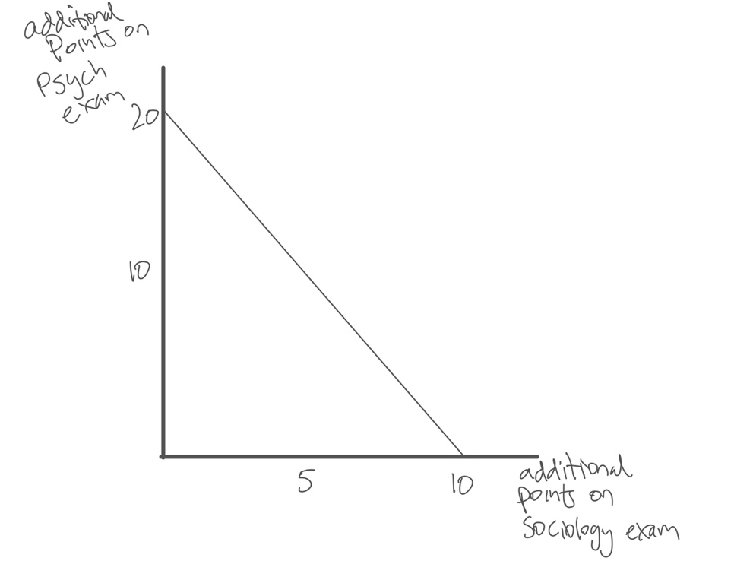

Figure 2
