ECON 001 – Spring 2023 – Midterm I Exam

Please do not open this exam until instructed to.

While you’re waiting, write your name and bubble in your Canvas ID number.

Enter your responses in the Scantron sheet.

Choose the best response. (However, if you think two responses are correct, you are probably overlooking something. :o)

Good luck!

- “Increasing the minimum wage would increase the average household income of low-income families” is a __________ statement.
  - positive
  - negative
  - normative
  - [Not enough information to evaluate, because economists disagree.]

- Robert wants to renovate his kitchen and is choosing between two loans, each for $10,000. Loan A would take him five years to pay back and, at the end of the five years, he would have paid back a total of $15,000. Loan B would take him ten years to pay back and, at the end of the ten years, he would have paid a total of $20,000. If Robert is rational, he will
  - choose Loan A
  - choose Loan B
  - choose neither loan, and instead save the $10,000 he needs before renovating his kitchen.
  - [Can’t say without more information.]

- Kwame entered the cookie shop and bought three cookies. Economic theory indicates that
  - his economic surplus from purchasing three cookies was greater than his economic surplus from purchasing some other number of cookies.
  - he might have enjoyed greater economic surplus from buying more cookies, but perhaps only bought three because he is trying to save money.
  - we don’t know anything about his economic surplus, because we don’t know the benefits or costs associated with those three cookies.
  - if he had been hungrier, he would have bought more cookies.

- Garance loves dark chocolate. When she was visiting her hometown in Belgium last week, she purchased a ten-pound bar of very fine Belgian chocolate. Unfortunately, when she arrived back in Washington, DC, she learned that the dark chocolate contained small amounts of cadmium, which does not affect the taste of the chocolate but is very bad for one’s health.
  - Garance will still eat the chocolate bar, because she cannot return it, so the costs associated with eating it are sunk.
  - Garance will only eat the bar if she decides the cost of eating the cadmium is less than the benefit of enjoying the chocolate.
  - Garance will only eat the bar if she decides the cost of eating the cadmium plus the price she paid for the bar is greater than the benefit of eating the chocolate.
  - Garance will give the bar to someone who does not care about cadmium.

- Suppose that Bruno’s willingness to pay for a cookie is greater than Jehoshaphat’s. It could be that
  - Bruno enjoys cookies more than Jehoshaphat, even though he is poorer than Bruno.
  - Jehoshaphat enjoys cookies more than Bruno, but is poorer than Bruno.
  - Jehoshaphat and Bruno have the same income and the same MB curve, but Jehoshaphat has already had two cookies today, whereas Bruno has not had any.
  - [All of the above]

- Five years ago, Liz bought one Bitcoin at the price of $5,000. Today the price of Bitcoin is $22,000, and when asked to sell her Bitcoin, Liz refused. We infer that, to Liz, her Bitcoin investment is worth (assume Liz behaves rationally—this is an ECON 001 exam, after all)
  - $17,000.
  - $17,000 minus the value of whatever else she would have done with that $5,000.
  - exactly $22,000.
  - Greater than or equal to $22,000.

- The (somewhat unusual) production possibilities frontier in Figure 1 (see last page) shows
  - increasing marginal costs (measured in foregone units of good B) of producing good A.
  - increasing marginal costs (measured in foregone units of good A) of producing good B.
  - [Can’t choose either option a or b because there is no information about costs.]
  - [Both options a and b are correct.]

- Hot dogs and hamburgers are substitutes for consumers in your town. When the price of hot dogs increases, ceteris paribus, …
  - the demand curve for hot dogs shifts out.
  - the demand curve for hamburgers shifts in.
  - the supply curve for hamburgers shifts out.
  - there is no shift in the supply curve for hamburgers.

- Consider the supply curve for Rebekah’s Taco Shoppe, which operates in a perfectly competitive market. Suppose last week there was an unexpected bill of $100, which Rebekah paid immediately. (Rebekah had the cash on hand to pay the bill.) Assuming there was no change in the market price, last week
  - Rebekah shifted the demand curve for tacos.
  - Rebekah supplied more tacos than usual to make up for the bill.
  - Rebekah supplied the same number of tacos as usual.
  - Rebekah supplied fewer tacos than usual to take care of the bill.

- Which of the following scenarios does *not* help to explain why supply curves slope up?
  - The marginal cost of inputs increases as a firm buys more inputs.
  - The marginal cost of inputs is constant, but the marginal productivity of inputs falls as the firm uses more inputs.
  - The marginal cost of production falls because of certain efficiencies, such as a bulk discount on inputs or the specialization of labor.
  - A higher price of the good encourages the firm to work harder to provide more goods.

- Rebekah’s MC for producing widgets is listed in Table 1 (last page). How many units would she supply if the market price were $9? (Assume there are no “partial widgets.”)
  - 3
  - 4
  - 5
  - a or b, can’t be sure.

- Suppose you run a concert venue where you sell drinks in aluminum cans, and, after the concertgoers dispose of the cans, you pay someone to haul away the empty cans (to recycle them, we hope). But there is a new art studio in town that specializes in making sculptures with used aluminum cans, and the studio offers to buy the cans from you. That causes you to
  - increase the price you charge for drinks, because you don’t need to sell as many to make as much money.
  - reduce the price you charge for drinks.
  - adjust the elasticity of demand for drinks in order to maximize your profits.
  - [It has no effect on what you charge for drinks, because the cost to you of purchasing and providing drinks has not changed.]

- Which of the following is *not* true about “market forces”?
  - They are the result of individual demanders and suppliers doing what is best for themselves.
  - They lead each individual person to be as happy as possible, given their income.
  - They tend to push a price towards the equilibrium price.
  - They help to explain the prices of goods and services we actually observe.

- Suppose you know Bobby’s demand curve for widgets. Consider a point at the top part of the demand curve and a point at the bottom part. Which statement is necessarily true?
  - Demand is more elastic at the point with the higher price.
  - Demand is less elastic at the point with the higher price.
  - To compute the price elasticity of demand at those points on that demand curve you would additionally need to know Bobby’s income.
  - [None of the above is necessarily true.]

- Consider the two demand curves in Figure 2 (last page), and the points labelled A and B. (Assume the two lines are parallel and that points A and B are at the same quantity.)
  - Demand is more elastic at point A than at point B.
  - Demand is less elastic at point A than at point B.
  - Demand is equally elastic at point A and point B.
  - [Can’t choose which of the above is true without more information.]

- Renfro is the manager of a firm that sells doodads. Typically, the firm sets a price of $10 and sells 1000 doodads. Last week Renfro tried an experiment: she raised the price to $11, and the firm ended up selling 850 doodads. (Assume that nothing about demand changed between last week and previous weeks. Also, in case it helps, let me whisper to you that $11×850=9350$.) Based on that experiment,
  - the firm should permanently increase its price from the regular price of $10, though not necessarily as high as $11.
  - Perhaps the firm should increase the price from the regular price of $10, but it depends on the costs of producing the doodads.
  - the firm should not increase the price.
  - we have not learned anything useful about the optimal price for the firm.

- Bobby thinks raising the minimum wage would have a large negative effect on the employment of low-skill workers. Anders thinks it would have a small negative effect. Bobby and Andrew …
  - disagree on what is the elasticity of demand for labor.
  - disagree on what is the elasticity of supply for labor.
  - disagree whether the minimum wage is binding for any workers.
  - disagree on how important it is to help low-skill workers.

- Suppose the government wants to raise some tax revenue, and it wants most of the money to come from suppliers rather than demanders. Of the following options, which would best help the government achieve that goal?
  - Placing a tax on expensive goods
  - Placing a tax on employers rather than on workers
  - Placing a tax on suppliers of necessities
  - Placing a tax on demanders of goods that are relatively inelastically supplied

- Assume that Hershey Kisses are a normal good. Suppose that just before Valentine’s Day there was a cocoa bean shortage affected all chocolate manufacturers. What do you think will happen to the equilibrium price and quantity of Hershey Kisses on Valentine's Day, assuming that people purchase more chocolate on Valentine's Day than normally?
  - The price will either increase or decrease; quantity will unambiguously decrease.
  - The price will either increase or decrease; quantity will unambiguously increase.
  - The price will unambiguously decrease; quantity will either increase or decrease.
  - The price will unambiguously increase; quantity will either increase or decrease.

- Last week you bought a non-refundable ticket to a Capitals game that is happening tonight for $100. You can resell this ticket (instantly and conveniently) for $75. In order to attend the game, you must skip 5 hours of work for which you are paid $10/hr. What is the opportunity cost of attending the game?
  - $50
  - $100
  - $125
  - $175

- Suppose you are a supplier of widgets in a market that is perfectly competitive, and the market price for a widget is $10. Then
  - You will sell as many units as you possibly can produce, so long as your total costs are less than your total revenue.
  - You might lower the price a bit to steal some business from your competitors.
  - You will sell the quantity that is determined by where, on a graph, your MC curve intersects the market price line.
  - You might raise the price for your widgets a bit.

- Minah sells very fine boots at her boot shop. She announced that today at 4pm she will begin selling her newest style at a price of $500/pair. In anticipation of the boots selling out, a line of people starts forming at noon. The price of $500 and the long line suggests that
  - Only the people who value the boots the most will get them. (Who else would wait in line for such expensive boots?)
  - Some people who value the boots at $500 or more will not be able to get a pair.
  - Minah has priced the boots on the inelastic portion of her supply curve.
  - Because of congestion effects, the boots will be worth less than they otherwise might have been.

- Let demand be given be given by $Q_{D}=10-P$ and supply be given by $Q_{S}=P$. Suppose the government imposes a $2-per-unit tax on suppliers. What would be the equilibrium quantity with the tax (i.e., the quantity bought and sold when the tax is in place)?
  - 3
  - 4
  - 5
  - 6

- In the previous problem, suppose the tax was split between buyers and sellers (i.e., a $1-per-unit tax was placed on buyers and a $1-per-unit was placed on sellers). Then, relative to the outcome under the tax described in the previous problem,
  - the final outcome would be the same.
  - the quantity would be the same, but the price buyers pay and the price sellers keep could differ.
  - the economic burden of the tax would shift towards buyers.
  - [Can’t say without more information.]

- Suppose the government mandates that every household purchase flood insurance—if a household doesn’t all its inhabitants will be jailed. (Assume the mandate is binding. That is, assume without the mandate not every household would purchase flood insurance.) Then
  - the price of flood insurance with the mandate would be lower than the price of flood insurance without the mandate.
  - some households would be worse off because they would be forced (by the government) to acquire a good whose cost is greater than its benefit.
  - some households who would have bought flood insurance even without the mandate would be worse off.
  - b and c
- Bubble in “A”.

Figure 1
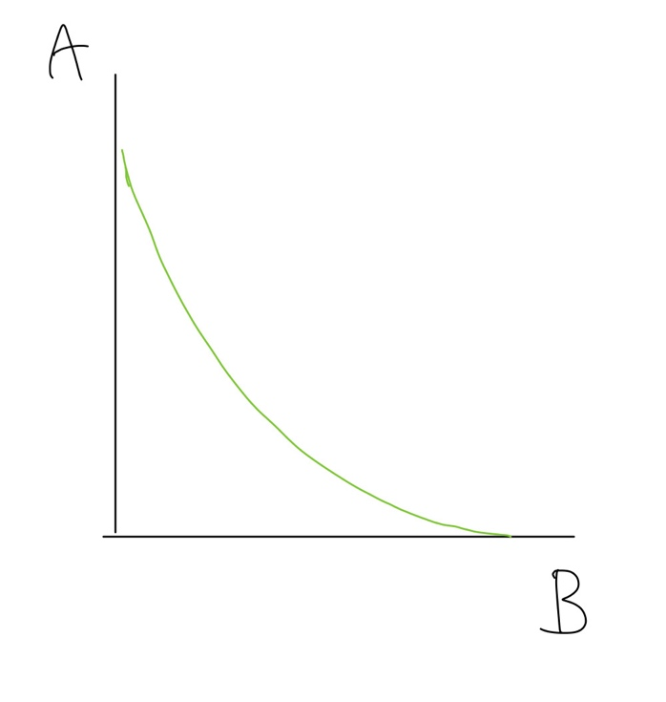

Figure 2
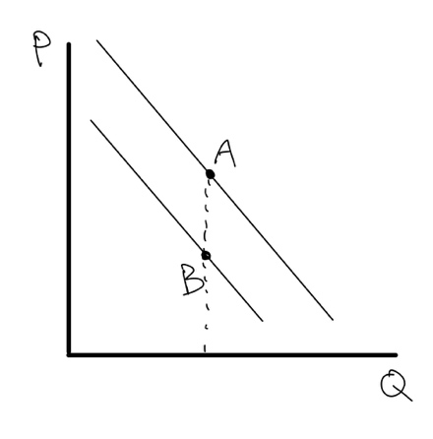

Table 1
Q | 1 | 2 | 3 | 4 | 5
MC | 5 | 6 | 8 | 11 | 15

